StudyFlow: Student Task Management System
A PROJECT REPORT

Submitted by
BHUSHAN T RAO
NN25MCA024
Of

MASTER OF COMPUTER APPLICATIONS
NMAM Institute of Technology, Nitte


(An off-Campus Institution of Nitte (Deemed to be University), MANGALORE)

Nitte Mahalinga Adyanthaya Memorial Institute of Technology, Nitte
Department of MCA
November 2026

1. Application Objective
The primary objective of the Student Task Manager (StudyFlow) is to provide an intuitive, responsive, and centralized web application tailored for students to track academic tasks, assignment deadlines, and lab submissions. The system enables students to:
- Create, view, edit, and delete academic tasks with deadlines and priority levels (High, Medium, Low).
- Maintain dynamic progress tracking through summary statistics (Total, Pending, and Completed tasks).
- Toggle task statuses between 'Pending' and 'Completed' with immediate visual feedback.
- Filter and search tasks live by status and priority.
- Demonstrate full-stack separation of concerns using React functional components on the frontend and an Express GraphQL server on the backend communicating via the native Fetch API.

2. Problem Statement
Students enrolled in technical curricula such as MCA and Computer Science juggle numerous overlapping deadlines across theory assignments, practical lab journals, mini-projects, and seminar presentations. Standard productivity tools are often either over-complicated (enterprise-level tools like Jira/Asana with excessive configuration) or too simplistic (basic to-do lists lacking deadline urgency and priority classifications).
From an architectural standpoint, traditional web applications built with REST APIs frequently suffer from:
- Over-fetching: Receiving unwanted payload attributes when only titles or status badges are required.
- Under-fetching: Requiring multiple HTTP roundtrips to retrieve task records and aggregated dashboard statistics.
- Complex Client Libraries: Relying on heavy client-side SDKs (e.g., Apollo Client) that obscure basic HTTP and API fundamentals.
StudyFlow solves this by implementing a lightweight, single-endpoint GraphQL API where the client requests exact field data in a single POST request using the native Fetch API, backed by an in-memory server store for zero-database deployment.

3. Component Design
The frontend is designed entirely with React Functional Components. The architecture strictly demarcates between Stateful Components (which own and update state using useState) and Stateless / Presentational Components (which consume props).
Component Name | Classification | Responsibility & State / Props Description
App.jsx | Stateful (Root) | Holds global state: tasks array, stats object, active filter, search query, modal open/close states, and toast notifications. Handles initial loading with useEffect.
TaskForm.jsx | Stateful (Modal) | Manages internal form state (formData for title, description, dueDate, priority, status) and input validation errors using useState.
Sidebar.jsx | Stateless | Receives active filters, stats counts, and callback handlers via props. Renders brand logo and navigation filters.
Header.jsx | Stateless | Receives searchQuery and modal triggers via props. Renders dashboard title, live search box, and Add Task button.
TaskStats.jsx | Stateless | Receives stats summary object via props. Calculates completion percentage and renders metric cards.
TaskList.jsx | Stateless | Receives tasks collection and action handlers. Handles conditional rendering for loading, empty, and card grid states.
TaskCard.jsx | Stateless | Receives task object and onToggleStatus, onEdit, onDelete callbacks. Displays formatted dates, priority badge, and status button.
DeleteConfirmModal.jsx | Stateless | Receives task title and confirmation callbacks. Displays danger confirmation before task removal.

4. Event Handling Implementation
Event handling in StudyFlow adheres to React's synthetic event standard. The application demonstrates the three essential event paradigms:
- onClick Event Handling: Used across buttons and interactive elements. In TaskCard.jsx, clicking the status button triggers onToggleStatus(task.id) to switch between Pending and Completed. In Sidebar.jsx, clicking status tabs or priority pills updates the active filter. In Header.jsx, clicking '+ Add Task' triggers onOpenNewTaskModal(). In DeleteConfirmModal.jsx, clicking 'Yes, Delete' triggers task removal.
- onChange Event Handling: Implemented for real-time input capture. In Header.jsx, typing in the search box fires onChange={(e) => onSearchChange(e.target.value)} to filter tasks live. In TaskForm.jsx, a centralized handleChange method dynamically maps e.target.name and e.target.value to update form fields (title, description, due date, priority dropdown).
- onSubmit Event Handling: Configured on the form in TaskForm.jsx (<form onSubmit={handleSubmit}>). Crucially, e.preventDefault() is called to inhibit the browser's default full-page reload. The handler executes client-side validation (ensuring non-empty title and valid deadline) before asynchronously dispatching the GraphQL mutation via onSave(formData).

5. GraphQL Schema, Resolvers, Queries & Mutations
The backend API is powered by Apollo Server mounted on Express at the single endpoint http://localhost:5000/graphql. It decouples data structures into Schema Definitions (typeDefs) and functional logic (resolvers).

5.1. GraphQL Schema (typeDefs.js)
type Task {
id: ID!
title: String!
description: String!
dueDate: String!
priority: String! # 'High' | 'Medium' | 'Low'
status: String! # 'Pending' | 'Completed'
createdAt: String
}
type TaskStats {
total: Int!
pending: Int!
completed: Int!
highPriority: Int!
}
type Query {
getTasks(status: String, priority: String, search: String): [Task!]!
getTaskById(id: ID!): Task
getTaskStats: TaskStats!
}
type Mutation {
createTask(input: TaskInput!): Task!
updateTask(id: ID!, input: TaskUpdateInput!): Task!
deleteTask(id: ID!): Boolean!
toggleTaskStatus(id: ID!): Task!
}

5.2. Server-Side Resolvers (taskResolvers.js)
Resolvers map schema queries and mutations to the in-memory array (tasksData.js):
• Query Resolvers: getTasks filters the array based on status, priority, and search keyword; getTaskStats dynamically calculates totals for Pending, Completed, and High-Priority tasks.
• Mutation Resolvers: createTask prepends a new object using unshift(); updateTask updates the item in-place; deleteTask removes the record via splice(); toggleTaskStatus inverts status between 'Pending' and 'Completed'.

5.3. Fetch API Client Integration (graphqlService.js)
Instead of requiring Apollo Client on the frontend, standard HTTP POST calls are dispatched via the browser's native Fetch API:
const response = await fetch('http://localhost:5000/graphql', {
method: 'POST',
headers: { 'Content-Type': 'application/json' },
body: JSON.stringify({ query, variables })
});
const result = await response.json();
return result.data;

6. Screenshots of the Output
The following screenshots demonstrate the working functionality of the executed application:

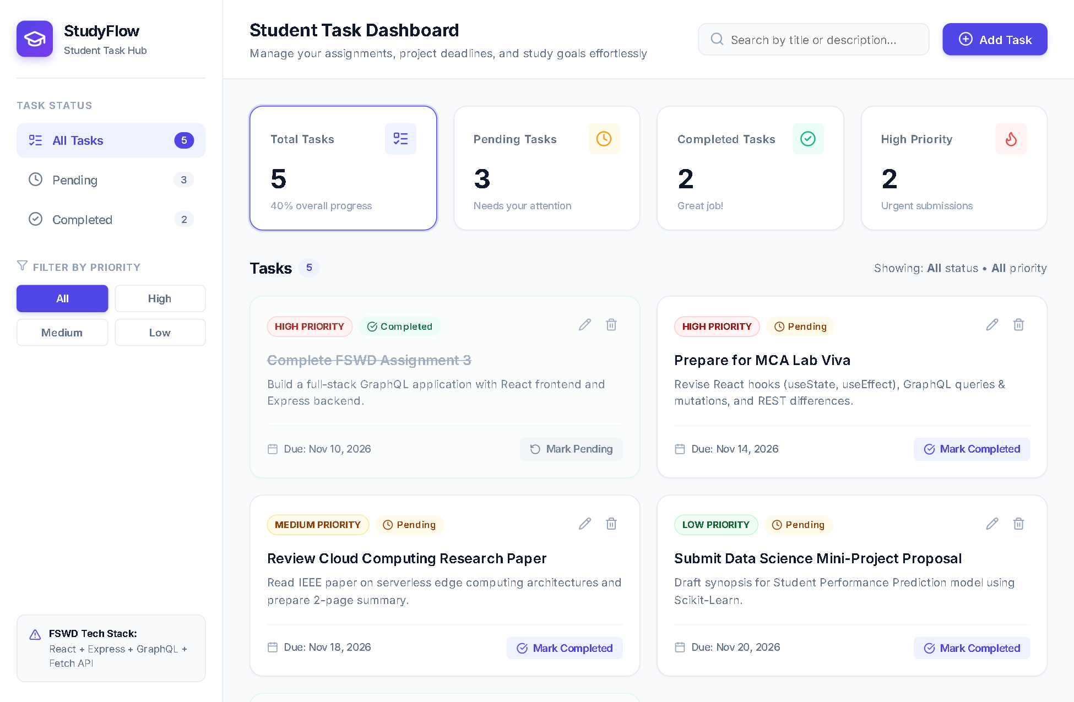
Figure 1: Main Application Dashboard displaying Summary Statistics, Status Sidebar, and Task Cards Grid

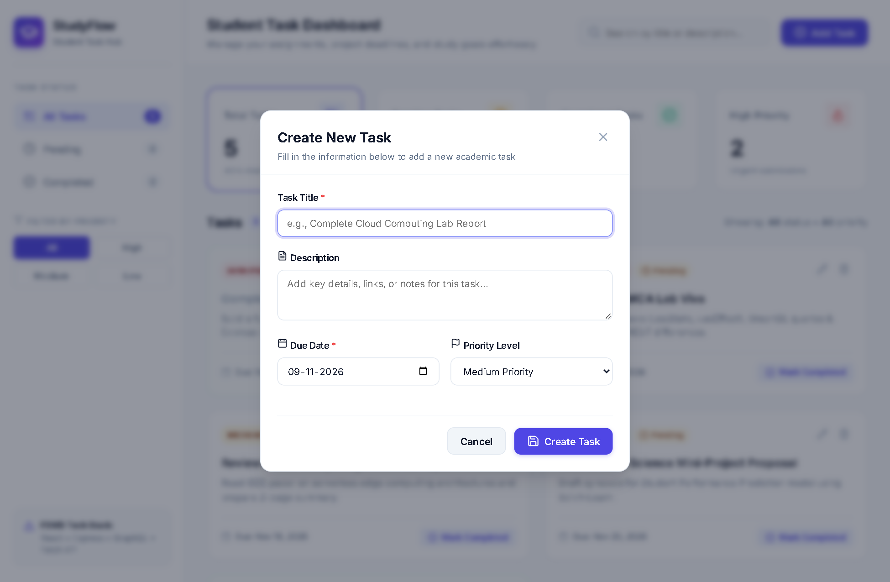
Figure 2: Add New Task Modal Interface with Form Fields, Priority Select, and Due Date Picker

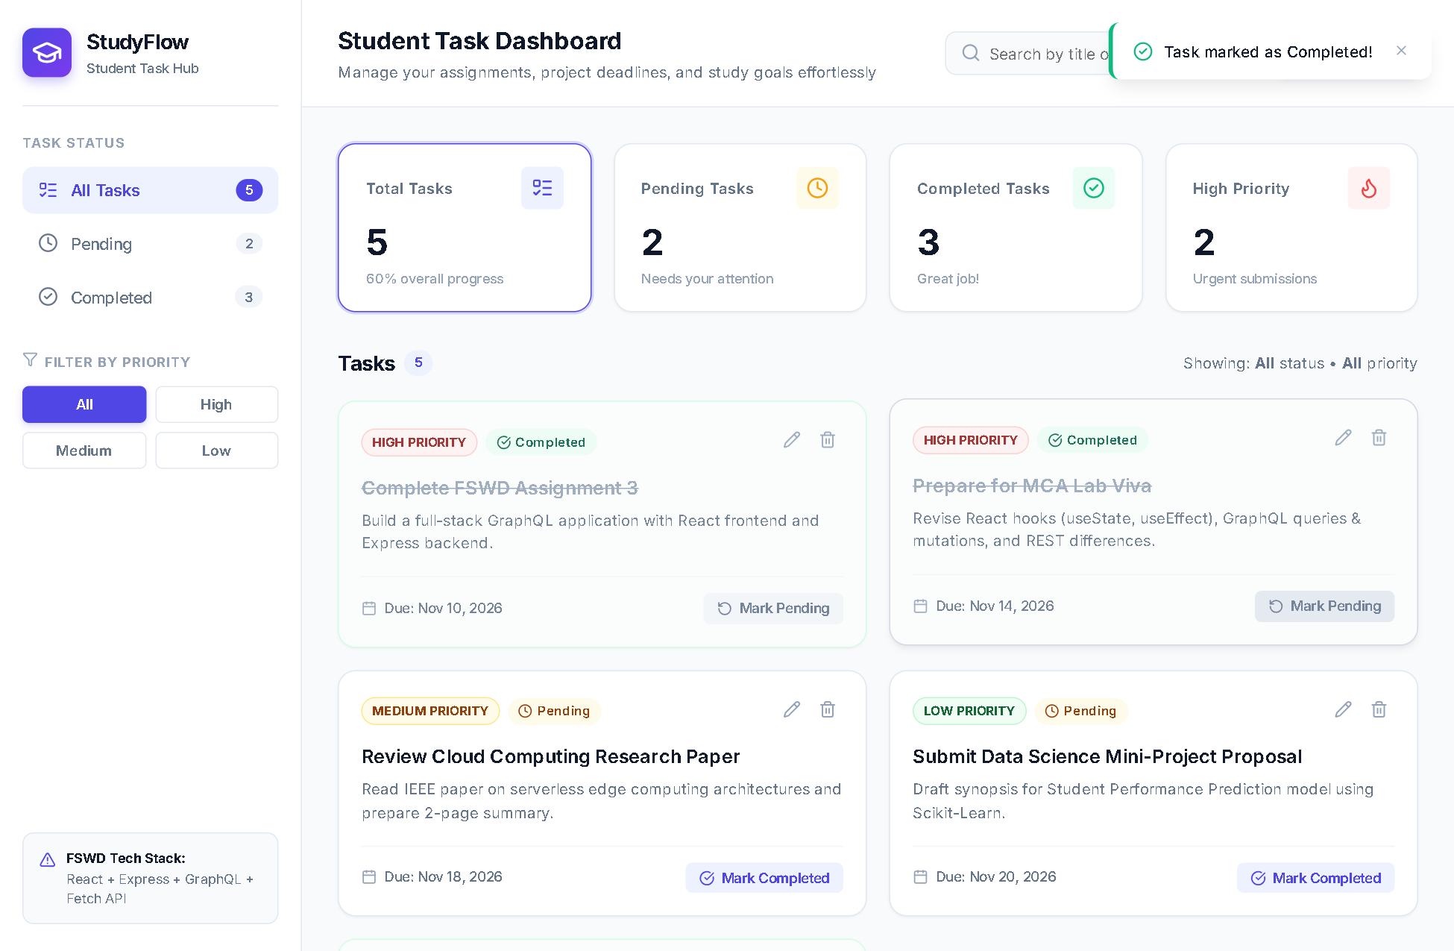
Figure 3: Live Status Toggling showing Completed Strikethrough, Green Status Badge, and Recomputed Progress Counter

7. Running Project & Demonstration Guide
The project has been tested and executes cleanly without runtime errors. Follow these steps to demonstrate:
- Step 1 (Launch All Services): Open terminal in project root directory and run:
npm run dev
This concurrently boots both the backend GraphQL service (port 5000) and frontend React Vite server (port 5173).
- Step 2 (Open in Browser): Navigate to http://localhost:5173 to access the dashboard. Open http://localhost:5000/graphql to view the Apollo GraphQL API.
- Step 3 (Demonstrate Add Task Mutation): Click '+ Add Task', fill in title and select priority. Click 'Create Task'. Verify that the new card appears immediately and Total/Pending metrics increment.
- Step 4 (Demonstrate Status Toggle): Click 'Mark Completed' on any task. Notice the title gains a strikethrough, the status badge turns emerald, and the completed task counter increments.
- Step 5 (Demonstrate Filtering & Search): Click 'Pending' in the sidebar to view only pending tasks. Type in the search box to demonstrate live title filtering via onChange.
- Step 6 (Demonstrate Network Tab in DevTools): Open Chrome DevTools (F12) ➔ Network tab. Filter by Fetch/XHR. Click 'Mark Pending'. Observe the single HTTP POST call to /graphql showing the JSON mutation payload and server response.

