A Mini Project Report

*on*

**Counselling Website**

by

Bhushit Jaiswal T190724221

*Under the guidance of*

Prof. Geetanjali Bansod



Department of Computer Engineering

K J’s Educational Institute

**K J College of Engineering & Management Research, Pune**

**SAVITRIBAI PHULE PUNE UNIVERSITY**

### A logo for a school Description automatically generatedK J College of Engineering & K J College of Engineering & Management Research

##### (Accredited by NAAC)

**CERTIFICATE**

This is to certify that,

Bhushit Jaiswal T190724221

of class **T.E Computer**; have successfully completed their mini project work on **“Counselling Website’’** at **K J College of Engineering & Management Research** in the partial fulfillment of the Graduate Degree course in **T.E** at the department of **Computer Engineering** in the Semester – II as prescribed by the Savitribai Phule Pune University.

### Prof. Geetanjali Bansod Dr. Nikita Kulkarni

**Project Guide Head of Department**

### 

### Acknowledgements

With deep sense of gratitude, we would like to thanks all the people who have lit our path with their kind guidance. We are very grateful to these intellectuals who did their best to help during our project work.

It is our proud privilege to express deep sense of gratitude to **Dr. Suhas S. Khot,** Principal of **K J College of Engineering & Management Research**, Pune for his comments and kind permission to complete this project. We remain indebted to Dr. Nikita Kulkarni, H.O.D. of Computer Engineering Department for her timely suggestion and valuable guidance.

The special gratitude goes to Prof. Geetanjali Bansod for her excellent and precious guidance in completion of this work .We thanks to all the colleagues for their appreciable help for our working project. With various industry owners or lab technicians to help, it has been our endeavor to throughout our work to cover the entire project work.

We also thankful to our parents who providing their wishful support for our project completion successfully. And lastly we thanks to our all friends and the people who are directly or indirectly related to our project work.

Bhushit Jaiswal T190724221

## ABSTRACT

 “The Blaze” is a web-based platform designed to facilitate easy booking of counseling sessions. It serves as a digital sanctuary where individuals seeking guidance can find a listener. The website features a user-friendly interface, complete with intuitive navigation and interactive elements. With a focus on accessibility and user engagement, “The Blaze” aims to streamline the process of connecting clients with professional counselors.

Functional Specification:

1**. Appointment Booking System.**

2. **User Interaction Enhancement.**

3. **Responsive Design and Accessibility.**

4. **Informational Pages Navigation.**

## CONTENTS

**Chapters Page No**

**ACKNOWLEDGEMENT i**

ABSTRACT ii

1. INTRODUCTION TO WT 1
2. SYSTEM SPECIFICATIONS 4
3. IMPLEMENTATIONS 9
4. GRAPHICAL USER INTERFACE 11
5. CONCLUSION & FUTURE ENHANCEMENT 13

**CHAPTER 1**

# INTRODUCTION

Web technology is a broad term that refers to the various tools and methods used to create and manage websites on the internet. It encompasses a range of programming languages, frameworks, databases, and protocols that work together to deliver content and services to users across the world. Here’s an introduction to the key components of web technology:

**HTML (HyperText Markup Language):** The backbone of any website, HTML provides the structure and content of web pages. It uses tags to define elements such as headings, paragraphs, links, and images.

**CSS (Cascading Style Sheets):** CSS is used to control the presentation of HTML elements. It allows web developers to apply styles such as colors, fonts, and layouts to create visually appealing and consistent designs across a website.

**JavaScript:** A scripting language that enables interactive features on web pages. JavaScript can manipulate HTML and CSS to create dynamic content like sliders, modal windows, and form validations.

**Frameworks and Libraries:** These are collections of pre-written code that help developers build robust and efficient websites. Examples include Bootstrap for responsive design, jQuery for simplified JavaScript coding, and React for building user interfaces.

**Web Servers:** Servers are powerful computers that store and serve website content. They respond to requests from users’ browsers and deliver the requested web pages.

**Protocols:** Protocols are rules that define how data is transmitted over the internet. The most common web protocol is HTTP (HyperText Transfer Protocol), which is used for loading web pages.

**Databases:** Databases store and organize data for websites. They can be used to hold user information, product listings, or any other data that a website needs to function.

Together, these technologies enable the creation of websites like “The Blaze,” which can offer personalized experiences, such as booking counseling sessions, and provide information through various web pages. Understanding these technologies is essential for web developers to build and maintain effective and engaging websites.



 **1.1 Objective**

The primary objective of “The Blaze” is to establish a comprehensive online platform that simplifies the process of connecting individuals seeking emotional support with professional counselors. The project aims to create an intuitive and welcoming digital environment where users can effortlessly book counseling sessions. Additionally, the website strives to provide informative content about the services offered, the company’s ethos, and the means to contact the team. Ensuring accessibility and ease of use, the website is designed to cater to a diverse audience, offering a seamless user experience across various devices. Ultimately, “The Blaze” seeks to become a trusted resource in the mental health community, fostering a space where everyone can find the support they need with dignity and convenience.

##### Problem Statement

##### In the current digital age, individuals seeking mental health support often face challenges in finding accessible and personalized counseling services. The absence of a centralized platform that facilitates easy scheduling of appointments and provides comprehensive information about counseling services hinders the ability for many to receive timely assistance. ‘The Blaze’ aims to address this gap by developing a user-centric website that not only streamlines the appointment booking process but also offers an informative and interactive experience. The project seeks to overcome the barriers of accessibility and complexity by introducing a platform where users can engage with mental health professionals in a supportive and secure environment, thereby enhancing the overall efficiency and effectiveness of obtaining mental health care.

**CHAPTER 2**

**SYSTEM AND SOFTWARE REQUIREMENTS AND SPECIFICATIONS**

The program works on Desktop PC and is executed using HTML code.

###### FUNCTIONAL REQUIREMENTS

A description of the facility or feature required. Functional requirements deal with what the system should do or provide for users. They include description of the required functions, outlines of associated reports or online queries, and details of data to be held in the system.

###### NON-FUNCTIONAL REQUIREMENTS:

Non-functional requirements define the overall qualities or attributes of the resulting system.

###### Usability

Usability is the ease with which a user can learn to operate the Hospital and medical facilaties and get status.

###### Security

Security requirements are included in a system to ensure: All questions and users are well secured

###### Reliability

Reliability is the ability of a system to perform its required functions under stated conditions for a specific period of time. Constraints on the run-time behavior of the system can be considered under two separate headings:

Availability: is the system available for service when requested by end-users.

Failure rate: how often does the system fail to deliver the service as expected by end- users.

###### SOFTWARE REQUIREMENTS

Programming language : HTML,CSS,Bootstrap,JS and Django.

Operating system : ANY OS (Recommended**:** Windows8,

Windows Vista, Windows XP) Application required : Standalone desktop application & Xampp Coding language : HTML

###### HARDWARE REQUIREMENTS

CPU : Pentium IV 2.4 GHz or above Memory (Primary) : 512 MB, 1 GB or above

Hard Disk : 40 GB, 80GB, 160GB or above

Monitor : 15 VGA color

**CHAPTER: 3**

##### Source Code:

##### 1.Home.html:

##### <!DOCTYPE html>

##### <html>

##### <head>

##### <script src="https://ajax.googleapis.com/ajax/libs/jquery/3.7.1/jquery.min.js"></script>

##### <title>The Blaze</title>

##### <link rel="stylesheet" href="https://maxcdn.bootstrapcdn.com/bootstrap/4.5.2/css/bootstrap.min.css">

##### <style>

##### /* Styling the body */

##### body {

##### font-family: Arial, sans-serif;

##### margin: 0;

##### padding: 0;

##### background-color: #ab1fca;

##### color: #000000;

##### }

##### 

##### /* Styling the header */

##### header {

##### background-color: #167add;

##### color: #fff;

##### text-align: center;

##### padding: 1rem;

##### }

##### 

##### /* Styling navigation links */

##### nav {

##### background-color: #6b3ba3;

##### text-align: center;

##### padding: 0.5rem 0;

##### }

##### nav a {

##### color: #fff;

##### text-decoration: none;

##### padding: 0 1rem;

##### }

##### nav a:hover {

##### color: #ffcc00;

##### }

##### 

##### /* Styling the main content */

##### section {

##### padding: 1rem;

##### }

##### 

##### /* Styling unordered list items */

##### ul li {

##### list-style-type: square;

##### margin-left: 1rem;

##### }

##### 

##### /* Styling the footer */

##### footer {

##### background-color: #167add;

##### color: #fff;

##### text-align: center;

##### padding: 1rem;

##### }

##### 

##### </style>

##### <style>

##### /* Styling for the button */

##### #getStarted {

##### display: block;

##### margin: 0 auto;

##### padding: 10px 20px;

##### background-color: #fafafa;

##### color: #000000;

##### border: none;

##### border-radius: 5px;

##### cursor: pointer;

##### }

##### /* Styling for the user info section */

##### #userInfo {

##### display: none;

##### margin: 20px auto;

##### padding: 20px;

##### width: 300px;

##### background-color: #f5f5f5;

##### border-radius: 5px;

##### }

##### /* Styling for input fields */

##### #userInfo input[type="text"] {

##### width: calc(100% - 20px);

##### margin-bottom: 10px;

##### padding: 8px;

##### border-radius: 3px;

##### border: 1px solid #ccc;

##### }

##### </style>

##### </head>

##### <body>

##### <!-- Header section -->

##### <header>

##### <h1>The Blaze</h1>

##### <img src="20150460.png" alt="The Blaze Logo">

##### <p>Sometimes even a listner needs a listner too...</p>

##### </header>

##### 

##### <!-- Navigation section -->

##### <nav>

##### <a href="home.html">Home</a> |

##### <a href="about.html">About</a> |

##### <a href="services.html">Services</a> |

##### <a href="contact.html">Contact</a>

##### </nav>

##### <script>

##### $(document).ready(function() {

##### $("input").focus(function() {

##### $(this).css("background-color", "yellow");

##### })

##### });

##### $("input").blur(function() {

##### $(this).css("background-color","green");

##### });

##### </script>

##### 

##### <button id="getStarted">Get Started</button>

##### <div id="userInfo" style="display: none;">

##### <div class="container mt-5">

##### <form>

##### <div class="form-group">

##### <label for="firstName">First Name:</label>

##### <input type="text" class="form-control" id="firstName" placeholder="Enter first name">

##### </div>

##### <div class="form-group">

##### <label for="Age">Age:</label>

##### <input type="text" class="form-control" id="Age" placeholder="Enter Age">

##### </div>

##### <div class="form-group">

##### <label for="email">Email:</label>

##### <input type="email" class="form-control" id="email" placeholder="Enter email">

##### </div>

##### <div class="form-group">

##### <label for="number">Number:</label>

##### <input type="text" class="form-control" id="number" placeholder="Enter Number">

##### </div>

##### <div class="form-group">

##### <label for="YP">Your Problem:</label>

##### <input type="text" class="form-control" id="YP" placeholder="Enter Your Problem">

##### </div>

##### <button type="submit" class="btn btn-primary">Submit</button>

##### </form>

##### </div>

##### </div>

##### <footer>

##### <p>&copy; 2020 The Blaze All rights reserved.</p>

##### </footer>

##### <script>

##### $(document).ready(function() {

##### $("#getStarted").click(function() {

##### $("#userInfo").slideToggle();

##### });

##### });

##### </script>

##### <script src="https://ajax.googleapis.com/ajax/libs/jquery/3.5.1/jquery.min.js"></script>

##### <script src="https://cdnjs.cloudflare.com/ajax/libs/popper.js/1.16.0/umd/popper.min.js"></script>

##### <script src="https://maxcdn.bootstrapcdn.com/bootstrap/4.5.2/js/bootstrap.min.js"></script>

##### </body>

##### </html>

##### 2.About.html:

##### <!DOCTYPE html>

##### <html lang="en">

##### <head>

##### <meta charset="UTF-8">

##### <meta name="viewport" content="width=device-width, initial-scale=1.0">

##### <title>About Us</title>

##### <link rel="stylesheet" href="https://maxcdn.bootstrapcdn.com/bootstrap/4.5.2/css/bootstrap.min.css">

##### <style>

##### section {

##### padding: 1rem;

##### margin: 20px auto;

##### max-width: 800px;

##### }

##### p {

##### margin-bottom: 15px;

##### }

##### </style>

##### </head>

##### <body>

##### <header>

##### <nav class="navbar navbar-expand-lg navbar-dark bg-dark">

##### <a class="navbar-brand" href="#">The Blaze</a>

##### <button class="navbar-toggler" type="button" data-toggle="collapse" data-target="#navbarNav" aria-controls="navbarNav" aria-expanded="false" aria-label="Toggle navigation">

##### <span class="navbar-toggler-icon"></span>

##### </button>

##### <div class="collapse navbar-collapse" id="navbarNav">

##### <ul class="navbar-nav ml-auto">

##### <li class="nav-item">

##### <a class="nav-link" href="home.html">Home</a>

##### </li>

##### <li class="nav-item">

##### <a class="nav-link" href="about.html">About</a>

##### </li>

##### <li class="nav-item">

##### <a class="nav-link" href="services.html">Services</a>

##### </li>

##### <li class="nav-item">

##### <a class="nav-link" href="contact.html">Contact</a>

##### </li>

##### </ul>

##### </div>

##### </nav>

##### </header>

##### <section class="container">

##### <h2 class="mt-4">About Us</h2>

##### <p>Welcome to The Blaze!</p>

##### <p>We are a team dedicated to providing support and guidance to our community. Our mission is to be there for those who need someone to listen, to understand, and to help navigate through life's challenges.</p>

##### <p>At The Blaze, we believe in the power of empathy and human connection. Our platform is designed to create a safe space where individuals can share their thoughts, feelings, and experiences without judgment.</p>

##### <p>Our team consists of experienced counselors and advisors who are passionate about mental health and well-being. Whether you're seeking professional advice or simply looking for a listening ear, we are here to support you.</p>

##### </section>

##### <footer class="bg-dark text-light py-3">

##### <div class="container text-center">

##### <p>&copy; 2024 The Blaze All rights reserved.</p>

##### </div>

##### </footer>

##### <script src="https://ajax.googleapis.com/ajax/libs/jquery/3.5.1/jquery.min.js"></script>

##### <script src="https://cdnjs.cloudflare.com/ajax/libs/popper.js/1.16.0/umd/popper.min.js"></script>

##### <script src="https://maxcdn.bootstrapcdn.com/bootstrap/4.5.2/js/bootstrap.min.js"></script>

##### </body>

##### </html>

##### 3. Services.html:

##### <!DOCTYPE html>

##### <html lang="en">

##### <head>

##### <meta charset="UTF-8">

##### <meta name="viewport" content="width=device-width, initial-scale=1.0">

##### <title>Services</title>

##### <link rel="stylesheet" href="https://maxcdn.bootstrapcdn.com/bootstrap/4.5.2/css/bootstrap.min.css">

##### <style>

##### section {

##### padding: 1rem;

##### margin: 20px auto;

##### max-width: 800px;

##### }

##### h2 {

##### margin-top: 20px;

##### }

##### .service-item {

##### margin-bottom: 10px;

##### }

##### </style>

##### </head>

##### <body>

##### <header>

##### <nav class="navbar navbar-expand-lg navbar-dark bg-dark">

##### <a class="navbar-brand" href="#">The Blaze</a>

##### <button class="navbar-toggler" type="button" data-toggle="collapse" data-target="#navbarNav" aria-controls="navbarNav" aria-expanded="false" aria-label="Toggle navigation">

##### <span class="navbar-toggler-icon"></span>

##### </button>

##### <div class="collapse navbar-collapse" id="navbarNav">

##### <ul class="navbar-nav ml-auto">

##### <li class="nav-item">

##### <a class="nav-link" href="home.html">Home</a>

##### </li>

##### <li class="nav-item">

##### <a class="nav-link" href="about.html">About</a>

##### </li>

##### <li class="nav-item active">

##### <a class="nav-link" href="services.html">Services</a>

##### </li>

##### <li class="nav-item">

##### <a class="nav-link" href="contact.html">Contact</a>

##### </li>

##### </ul>

##### </div>

##### </nav>

##### </header>

##### <section class="container">

##### <h2 class="mt-4">Our Services</h2>

##### <div class="service-item">

##### <h4>Service 1</h4>

##### <p>Individal Counselling</p>

##### </div>

##### <div class="service-item">

##### <h4>Service 2</h4>

##### <p>Couple Counselling</p>

##### </div>

##### <div class="service-item">

##### <h4>Service 3</h4>

##### <p>Group Counselling</p>

##### </div>

##### </section>

##### <footer class="bg-dark text-light py-3">

##### <div class="container text-center">

##### <p>&copy; 2024 The Blaze All rights reserved.</p>

##### </div>

##### </footer>

##### <script src="https://ajax.googleapis.com/ajax/libs/jquery/3.5.1/jquery.min.js"></script>

##### <script src="https://cdnjs.cloudflare.com/ajax/libs/popper.js/1.16.0/umd/popper.min.js"></script>

##### <script src="https://maxcdn.bootstrapcdn.com/bootstrap/4.5.2/js/bootstrap.min.js"></script>

##### </body>

##### </html>

**Graphical User Interface**

**SNAPSHOTS**

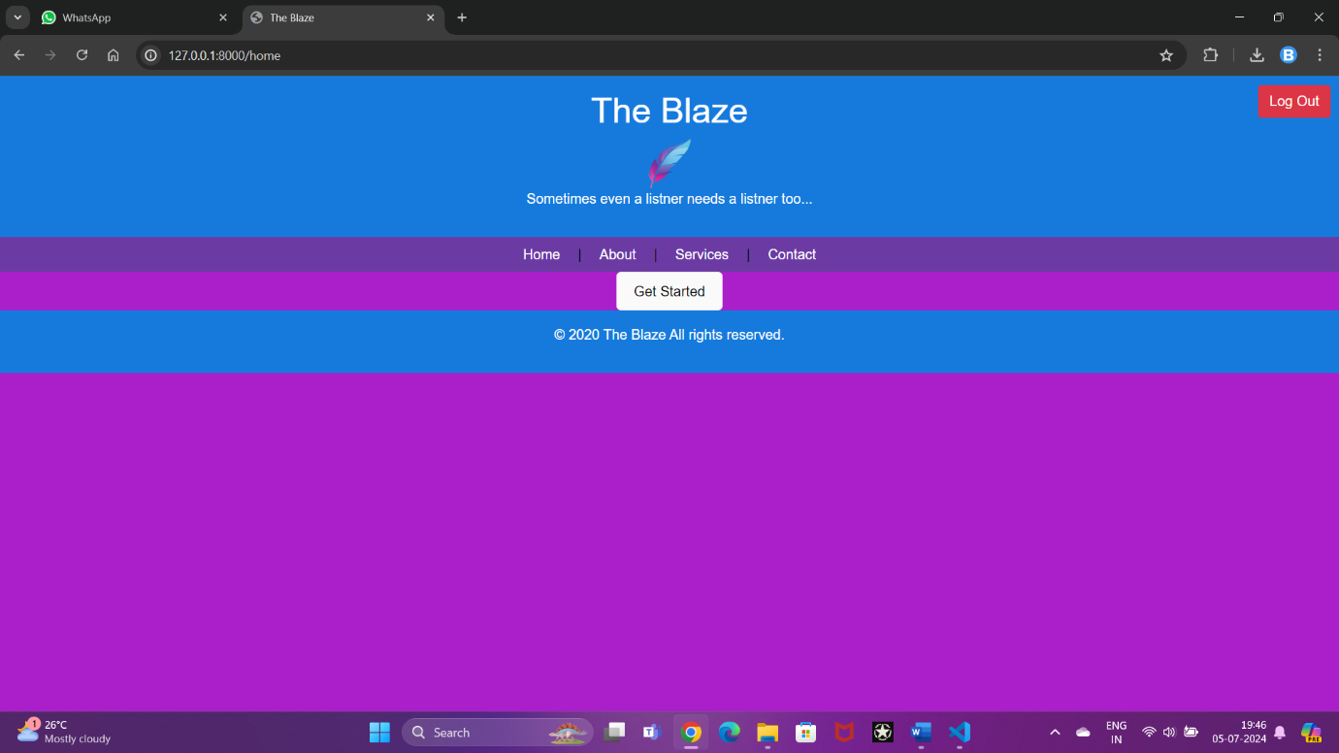

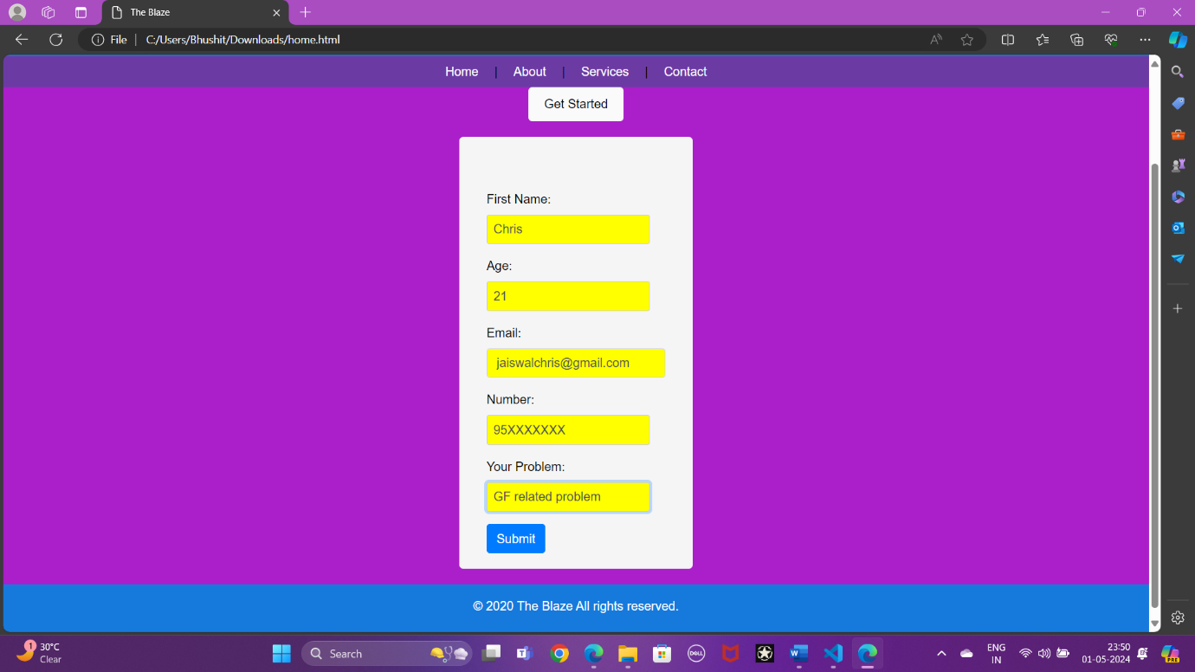

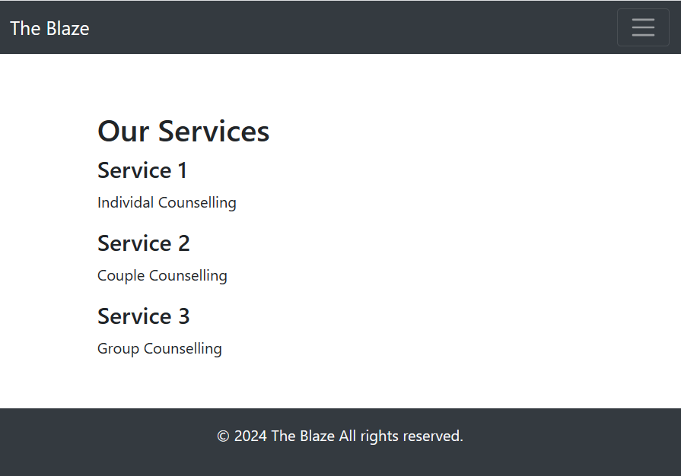

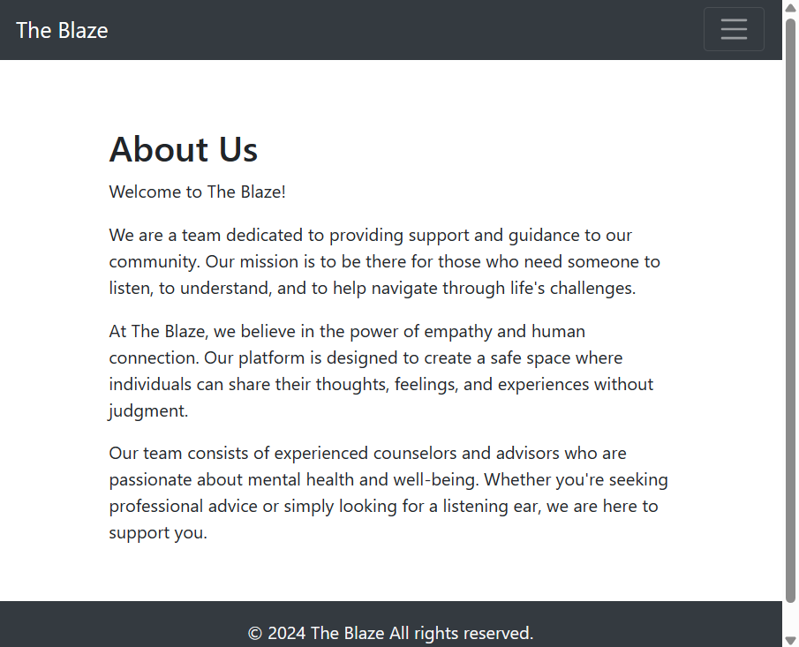

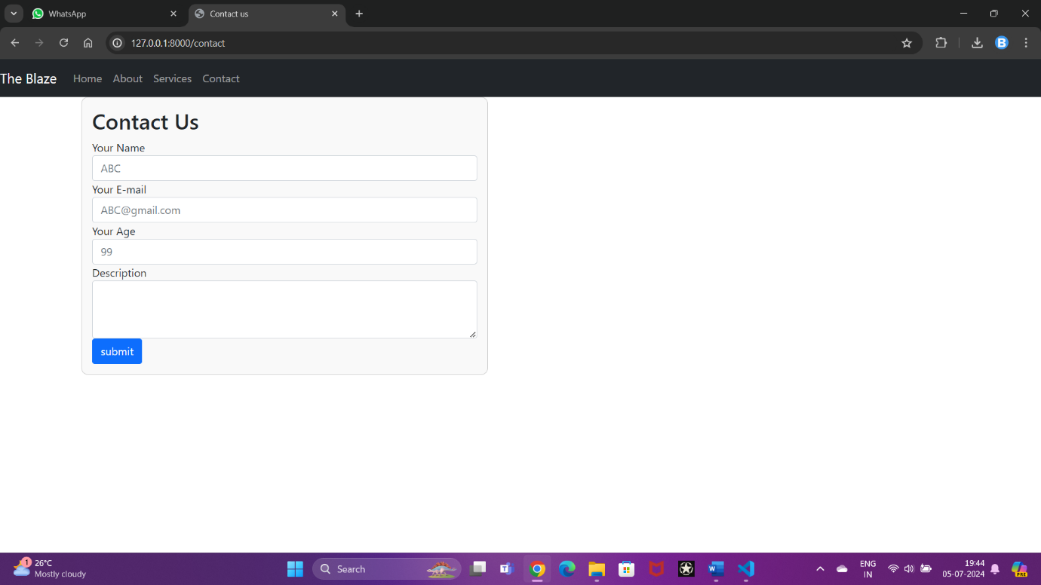

**CHAPTER 6**

# CONCLUSION

In conclusion, “The Blaze” is not just a website; it’s a beacon of hope for those navigating the often turbulent waters of mental health. It represents a commitment to providing a safe harbor where individuals can seek guidance and support without judgment. The project’s conclusion encapsulates its mission to deliver a service that is much more than a mere digital platform—it’s a compassionate companion in the journey towards wellness.

The website’s design and functionality reflect a deep understanding of the needs of those it serves. From the calming color palette to the reassuring ease of navigation, every aspect of “The Blaze” is crafted to create a sense of comfort and trust. The interactive elements are not just tools; they are extensions of a helping hand, offering a personalized touch that can make all the difference in a person’s quest for help.

In essence, “The Blaze” stands as a testament to the power of technology when harnessed with empathy and purpose. It’s a place where silence is broken by the click of a mouse, where distances shrink with the press of a key, and where the first step towards healing begins with the courage to reach out. As the project draws to a close, it leaves behind a legacy of innovation driven by compassion, and a promise of continued support for those who walk through its virtual doors.