

**KJ’s Educational Institute**

KJ COLLEGE OF ENGINEERING AND MANAGEMENT RESEARCH

**Affiliated to Savitribai Phule Pune University (SPPU), Approved by Govt. Of Maharashtra, Recognized by AICTE, New Delhi.**

**DEPARTMENT OF COMPUTER ENGINEERING YEAR 2023 – 2024**

**SEMESTER – V**

**INTERNET OF THINGS AND EMBEDDED SYSTEMS**

**[310245(A)]**

**PROJECT TITLE:**

**Smart Tree**

1

A Mini Project Report

*on*

“**Smart Tree**”

*By*

**BHUSHIT JAISWAL (A-14)**

**ADITYA JHADAV (A-38)**

**SANKET ABNAVE (B-67)**

Under the guidance of Prof. Harsha Jain



Department of Computer Engineering K J’s Educational Institute

**K J College of Engineering & Management Research, Pune SAVITRIBAI PHULE PUNE UNIVERSITY**

**2023-2024**

**K J’s Educational Institute**

## K J College of Engineering & Management Research

**(Accredited by NAAC)**

Affiliated to Savitribai Phule Pune University (SPPU), Approved by Govt. of Maharashtra, Recognized by AICTE, New Delhi.

**CERTIFICATE**

This is to certify that,

**BHUSHIT JAISWAL (A-14)**

**ADITYA JHADAV (A-38)**

**SANKET ABNAVE (B-67)**

of class T.E Computer; have successfully completed their mini project work on “Smart Tree**”** at K J College of Engineering & Management Research in the partial fulfilment of the Graduate Degree course in T.E at the department of Computer Engineering in the academic Year 2023-2024 Semester – I as prescribed by the Savitribai Phule Pune University.

Prof. Harsha Jain Dr. Nikita Kulkarni

Project Guide Head of Department

## Acknowledgements

With deep sense of gratitude, we would like to thanks all the people who have lit our path with their kind guidance. We are very grateful to these intellectuals who did their best to help during

our project works.

It is our proud privilege to express deep sense of gratitude to Dr. Suhas S. Khot, Principal of K J College of Engineering & Management Research, Pune for his comments and kind permission to complete this project. We remain indebted to Dr. Nikita Kulkarni, H.O.D. of Computer Engineering Department for her timely suggestion and valuable guidance.

The special gratitude goes to Dr. Nikita Kulkarni for her excellent and precious guidance in completion of this work. We thanks to all the colleagues for their appreciable help for our working project. With various industry owners or lab technicians to help, it has been our endeavor to throughout our work to cover the entire project work.

We also thankful to our parents who providing their wishful support for our project completion successfully. And lastly we thanks to our all friends and the people who are directly or indirectly related to our project work.

Bhushit Jaiswal (A-14)

Aditya Jhadav (A-38)

Sanket Abnave (B-67)

**Contents**

|  |  |  |
| --- | --- | --- |
| Sr no | Topic | Page No |
| 1 | Acknowledgement | i |
| 2 | Abstract | ii |
| 3 | Introduction | 1 |
| 4 | Literature Review | 2 |
| 5 | Software And Hardware | 4 |
| 6 | Implementation | 6 |
| 7 | Code | 9 |
| 8 | Feature | 10 |
| 9 | Screenshot | 11 |
| 10 | Future Scope | 13 |
| 11 | Conclusion | 15 |
| 12 | References | 16 |

**ABSTRACT**

The prevalence of home security concerns has prompted the development of innovative solutions, including the Smart Tree system. This project proposes a discreet and effective home security system by utilizing a PIR sensor concealed within a tree pot to detect motion and send real-time notifications to the user's mobile phone via the Blynk app. The PIR sensor, connected to a NodeMCU ESP8266 microcontroller, captures motion triggers and relays the information to the Blynk app. A switch controls the charging kit, ensuring the continuous operation of the system through a rechargeable battery. The PIR sensor, seamlessly integrated with a NodeMCU ESP8266 microcontroller, relays motion alerts to the Blynk app, ensuring real-time updates on the user's mobile phone. A switch controls the charging kit, guaranteeing continuous operation through a rechargeable battery.

# Chapter 1: Introduction

In today's world, where homes are not just physical structures but havens of comfort and safety, homeowners are increasingly concerned about protecting their valuables and loved ones. The proliferation of break-ins and burglaries has increased the need for robust security systems that are not only effective but also blend seamlessly into the residential environment.

Traditional security systems, often marred by their intrusive presence and complex operation, have been unable to meet this growing demand. Bulky installations, unsightly cables and complex user manuals often discourage homeowners from investing in these outdated solutions.

Enter the Smart Tree system, a revolutionary innovation that revolutionizes home security by seamlessly integrating into the natural decor of any home. This ingenious system uses a PIR sensor, cleverly hidden in a flower pot, to detect movement and alert homeowners in real time. Carefully connected to a NodeMCU ESP8266 microcontroller, the PIR sensor acts as a watchdog, capturing motion triggers and relaying them to the Blynk app.

The Blynk app, the cornerstone of the Smart Tree system, allows homeowners to receive real-time alerts, ensuring they are always in the loop, no matter where they are. Upon motion detection, the PIR sensor triggers an instant alert and quickly sends a notification to the user's mobile device. This instant awareness allows homeowners to act quickly, whether it's contacting authorities or remotely activating security measures.

Smart Tree's commitment to user friendliness extends beyond its intuitive mobile app. A simple switch controls the charging kit and ensures that the system works continuously without the hassle of frequent battery changes. The rechargeable battery, the heart of the system's 24/7 operation, provides peace of mind and eliminates the need for constant monitoring and maintenance.

The Smart Tree system essentially represents a paradigm shift in home security and offers a harmonious combination of discretion, efficiency and ease of use. Its understated design seamlessly integrates into any living space, while its real-time alerts and user-friendly interface give homeowners a unique sense of security and control. The Smart Tree system is a testament to the power of innovation, transforming home security from a daunting task into a hassle-free, hassle-free experience.

# Chapter 2: Literature Review

Home security has become a prime concern for homeowners around the world with the increasing incidence of break-ins and burglaries. Traditional security systems, often characterized by their striking appearance and complex controls, have failed to satisfy the growing demand for discreet and user-friendly solutions.

The Smart Tree system proves to be an innovative solution that offers a harmonious combination of discretion, efficiency and ease of use. Its unobtrusive design, using a PIR sensor hidden in a flower pot, effectively blends into the surrounding environment and minimizes the risk of detection by potential intruders. This subtle approach adds an element of surprise and deception and potentially deters burglars or intruders from attempting entry.

Real-time notifications, a key aspect of home security, are delivered seamlessly through Blynk, a user-friendly mobile app. Upon detection of motion, the PIR sensor triggers an instant alert and immediately informs the homeowner via their mobile device. This real-time awareness allows homeowners to act quickly, whether it's contacting authorities or remotely activating security measures.

Smart Tree's commitment to user friendliness extends beyond its intuitive mobile app. A simple switch controls the charging kit and ensures that the system works continuously without the hassle of frequent battery changes. The rechargeable battery, the heart of the system's 24/7 operation, provides peace of mind and eliminates the need for constant monitoring and maintenance.

Smart Tree's innovative approach to home security is in line with the growing demand for discreet and efficient solutions. Its unobtrusive design, real-time alerts and user-friendly interface make it a compelling solution for homeowners looking for a reliable and convenient security system. The system's ability to blend seamlessly into any indoor or outdoor environment further enhances its appeal.and customization.

# Chapter 3 : Software and Hardware Requirement Specification

* 1. **: Hardware Requirements**

To create a basic temperature and humidity detection system , we'll need:

**Node MCU 8266**:

The NodeMCU ESP8266 is a popular and versatile development board that integrates the ESP8266 WiFi module, making it a suitable choice for IoT projects, including the IoT-Based Smart Notice Board System. The ESP8266 module on the NodeMCU provides WiFi connectivity, allowing the Smart Notice Board to connect to the internet and communicate with other devices and cloud services.Wireless connectivity enables remote management, facilitating real-time updates of the notice board content without physical intervention.The NodeMCU ESP8266 can be interfaced with various sensors, such as environmental sensors or motion detectors, to collect real-time data. This data can be used to dynamically update the content on the notice board based on environmental conditions or user interactions.

**Connecting Cables:**

onnecting cables involves physically linking two or more electronic or electrical devices to enable the transfer of data, signals, or power between them. This connection is established by plugging, inserting, or attaching the connectors at the ends of the cables into the appropriate ports or sockets on the devices. Cables play a crucial role in various applications, including networking, power supply, data transfer, and signal transmission, and they come in various types to suit different purposes, such as USB, Ethernet, HDMI, and power cables. Proper cable connections ensure that devices can communicate, share resources, and function as intended.

**Jumper Wires:**

Jumper wires are short, flexible wires with connectors at each end that are commonly used in electronics and prototyping. They provide a convenient means to create electrical connections between various components, such as microcontrollers, sensors, and other electronic modules on a breadboard or a circuit board. Jumper wires make it easy to establish temporary or permanent connections, facilitating the assembly and testing of electronic circuits without the need for soldering. They are available in various lengths, colors, and connector types to suit different applications and are an essential tool for electronics enthusiasts, hobbyists, and professionals.

**Charging Kit:**

A charging kit typically includes components like a charging controller, power supply, and connectors .Charging controllers manage the charging process, ensuring that the battery is charged safely without overcharging or overheating .The power supply in the kit provides the necessary electrical power to charge the battery. Connectors enable the connection between the charging kit and the device or battery being charged.

**PIR-sensor:**

PIR sensors are used for motion detection by detecting changes in infrared radiation in their field of view. They are commonly used in security systems, lighting controls, and other applications where motion detection is needed. PIR sensors generate a signal when they detect motion, and this signal can be used to trigger various actions in a circuit or device.

**Charging Kit:**

A charging kit typically includes components like a charging controller, power supply, and connectors.Charging controllers manage the charging process, ensuring that the battery is charged safely without overcharging or overheating. The power supply in the kit provides the necessary electrical power to charge the battery.Connectors enable the connection between the charging kit and the device or battery being charged.

* 1. **: Software Requirements**

1. **Arduino IDE(2.2.1)**

The Arduino Integrated Development Environment (IDE) is a software application designed for the development, programming, and debugging of applications running on Arduino-compatible microcontrollers. This document outlines the essential features and functional requirements of the Arduino IDE.

**Non-Functional Requirements:**

* 1. **User-Friendly Interface:** The IDE should offer an intuitive and user-friendly interface, making it accessible to both beginners and experienced developers.
  2. **Performance:** It should provide efficient code compilation and upload processes with minimal latency.
  3. **Reliability:** The IDE must ensure the reliable compilation and uploading of code to Arduino boards, minimizing errors.
  4. **Security:** Security measures should be in place to prevent unauthorized code uploads to Arduino boards.
  5. **Scalability:** The IDE should be able to support a wide range of Arduino board models and configurations.

1. **Testing:** Extensive testing procedures shall be implemented to verify the functionality, reliability, and security of the Arduino IDE.
2. **Documentation:** Comprehensive documentation, including user guides and reference material, shall be provided to assist users in effectively using the Arduino IDE.
3. **Licensing:** The Arduino IDE shall be open-source software, complying with the GNU General Public License (GPL) or other relevant open-source licenses.

This Software Requirement Specification outlines the key features, performance expectations, and constraints of the Arduino IDE, ensuring that it meets the needs of developers working with Arduino- compatible microcontrollers for a wide range of applications.

# Chapter 4: Implementation

Hardware Setup:

1. Connect GND pin of PIR sensor to GND pin on the Node MCU.
   * Connect the VCC of PIR sensor to 5V pin on the Node MCU.
   * Connect the out of PIR sensor to D1 pin on the Node MCU
   * Connect and integrate VCC of PIR sensor and 5V of Node MCU and connect it on one end of switch.
   * Connect B- and B+ of Charging kit to the -ve and +ve end of the Battery Respectively.
   * Connect OUT- and OUT+ to the GND on the Node MCU and on the other end of the switch.
2. Connect the Node MCU to your computer using a USB cable.
3. Circuit:

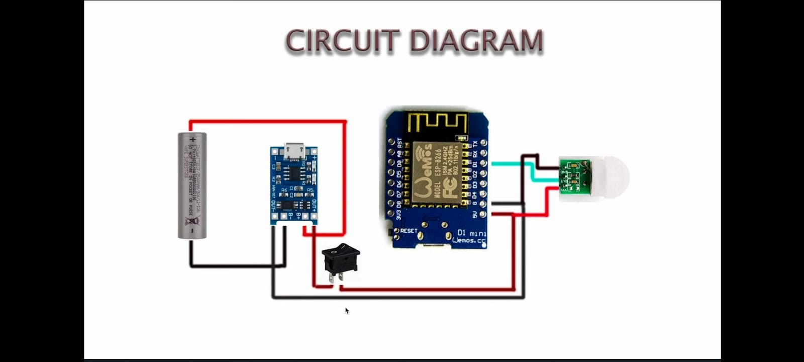

Software Setup:

1.Install Arduino IDE:

-Download and install the Arduino IDE from the[officialwebsite](https:/[/www.arduino.cc/en/softwa](http://www.arduino.cc/en/software))r[e).](http://www.arduino.cc/en/software))

2.Write the Arduino Code:

3. Upload Code to ESP32:

4.Monitor Serial Output: Open the Serial Monitor in Arduino IDE (Tools -> Serial Monitor) to monitor the output. It will display the data on display board.

# Chapter 5: Code

**Coding for Nodemcu in Arduino IDE:**

#define BLYNK_TEMPLATE_ID "TMPL306AT3Fhq"

#define BLYNK_TEMPLATE_NAME "Smart Motion Detector"

#define BLYNK_AUTH_TOKEN "6S6wAQKHMmB6Jh6v5q_QeJiW371mfvpw"

#define BLYNK_PRINT Serial

char auth[] = BLYNK_AUTH_TOKEN;

char ssid[] = "Tarun";

char pass[] ="12345678";

int sensorPin = 5;

#include <BlynkSimpleEsp8266.h>

int sensorData;

bool notificationSent = false;

BlynkTimer timer;

void timeEvent()

{

sensorData = digitalRead(sensorPin);

if (sensorData == HIGH && !notificationSent)

{

Blynk.logEvent("Motion detected!"); // Send a notification to the Blynk app

notificationSent = true;

}

}

void checkSensor()

{

if (notificationSent)

{

notificationSent = false;

}

}

void setup()

{

// Initialize the Serial communication

Serial.begin(115200);

Blynk.begin(auth, ssid, pass);

// Setup a timer to check for motion periodically

timer.setInterval(1000L, timeEvent);

}

void loop()

{

Blynk.run();

timer.run();

}

# Chapter 6 : Features

1. **Discreetness:**

The PIR sensor is cleverly concealed within a tree pot, making it difficult for potential intruders to detect. This inconspicuous design blends seamlessly into the surrounding environment, adding an element of surprise and deception.

1. **Real-time notifications:**

The system utilizes the Blynk app to provide real-time notifications to the user's mobile phone upon detecting motion. This immediate awareness enables homeowners to take prompt action, such as contacting the authorities or remotely activating security measures.

1. **User-friendliness:**

The Blynk app offers a straightforward interface for monitoring and controlling the system. Its intuitive design makes it easy for users of all technical levels to operate the system effectively.

1. **Continuous operation:**

The rechargeable battery ensures uninterrupted operation of the system, eliminating the need for frequent battery replacements. A switch controls the charging kit, ensuring that the battery remains charged and ready for continuous use.

1. **Customizable notifications:**

The user can customize the notification settings to receive alerts for specific types of motion, such as large movements or repetitive movements. This customization allows homeowners to tailor the system to their specific needs and preferences.

1. **Remote monitoring and control:**

The Blynk app enables remote monitoring and control of the system, allowing homeowners to check for motion alerts and activate or deactivate the system from anywhere in the world. This remote access provides an extra layer of security and convenience.

Top of Form

# Chapter 7 : Screenshots

**Following screenshots shows outputs of system:**

**Arduino IDE:**

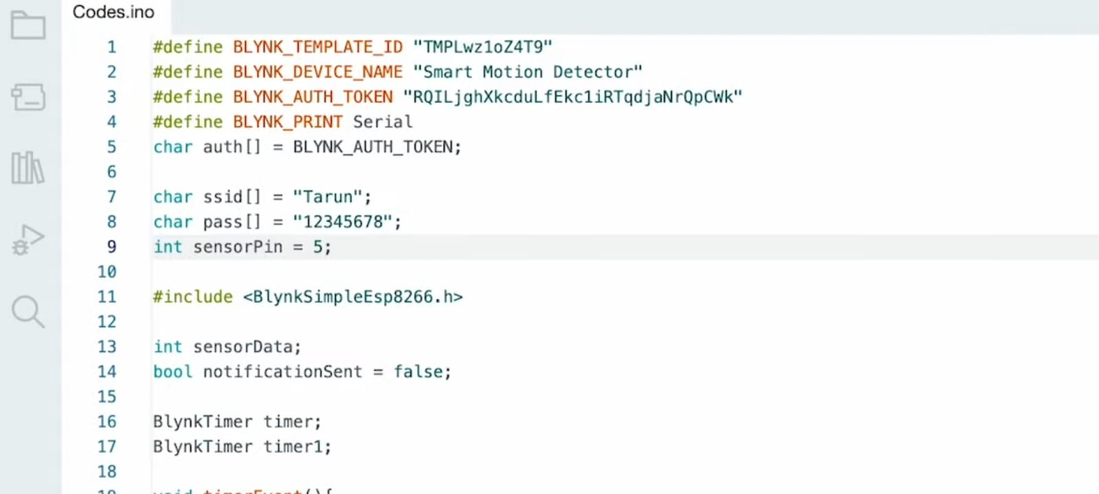

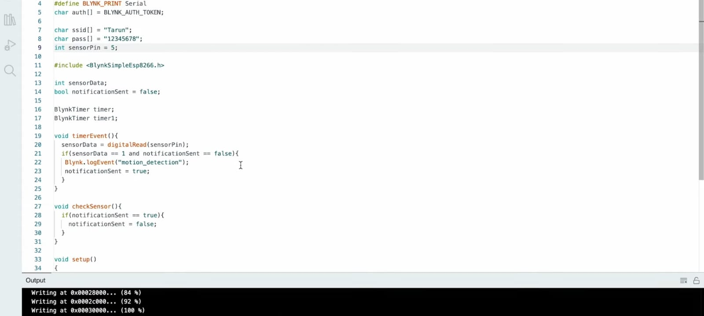

*Figure 1 After compiling and uploading the code*

**Chapter 7 : Future Scope**

1. **Enhanced Sensor Integration:** The system can be augmented with additional sensors, such as temperature, humidity, and light sensors, to provide a more comprehensive monitoring solution. This multi-sensor approach can enable homeowners to detect potential environmental hazards, monitor indoor conditions, and even automate lighting adjustments based on ambient light levels.
2. **Artificial Intelligence Integration:** Incorporating artificial intelligence (AI) algorithms can significantly enhance the system's capabilities. AI can analyze sensor data to identify patterns and anomalies, enabling predictive detection of potential security threats or environmental concerns. This proactive approach can provide homeowners with timely warnings and allow for preventive measures to be taken.
3. **Advanced Motion Detection and Analysis:** Implementing more sophisticated motion detection algorithms can refine the system's ability to differentiate between authorized and unauthorized individuals. This enhanced motion analysis can utilize facial recognition, gait recognition, or other biometric data to provide more accurate and personalized security solutions.
4. **Integration with Smart Home Platforms:** Integrating the Smart Tree system with popular smart home platforms, such as Google Home or Amazon Alexa, can enable seamless voice control and automation. Homeowners could easily arm or disarm the system, receive real-time notifications, and access sensor data using simple voice commands.
5. **Aesthetic Design Enhancements:** Refining the aesthetic design of the system can further enhance its appeal and adaptability to different interior décor styles. Concealing the hardware components within the tree pot and offering a variety of pot styles and finishes can allow the system to blend seamlessly into any home environment.
6. **Customization and Personalization:** Providing users with greater customization options can make the system more versatile and cater to individual preferences. Allowing homeowners to personalize notification settings, adjust motion detection sensitivity, and choose from a variety of alert sounds can enhance the user experience and satisfaction.
7. **Remote Maintenance and Diagnostics:** Implementing remote maintenance and diagnostics capabilities can simplify system upkeep and troubleshooting. The ability to remotely monitor battery levels, check sensor functionality, and receive error notifications can facilitate proactive maintenance and ensure optimal system performance.

# Chapter 9 : Conclusion

In conclusion, the implementation of the Smart Tree project was not successful because of the group’s lack of responsibility and determination. And we need to learn more about NodeMCU esp8266 and Ardunio IDE to make sure that our future projects are implemented successfully. The IoT represents a significant leap forward in transforming traditional communication methods in educational institutions and corporate settings. Through the integration of hardware and software components, the system achieves its objectives of enhancing real-time communication, improving information relevance, and fostering a connected and informed community.

# Chapter 10: References

1. https://youtu.be/qZvhNSMK_Q8?si=xME3kBjsv4BiFrvN.