**Improving the EBFM toolbox with an alternative open source version of Ecopath with Ecosim**

Lucey, S. M.1, K.Y. Aydin2, and S.K. Gaichas1

1NOAA, National Marine Fisheries Service, Northeast Fisheries Science Center, 166 Water Street, Woods Hole, MA 02536

2NOAA, National Marine Fisheries Service, Alaska Fisheries Science Center, 7600 Sand Point Way NE, Seattle, WA 98115

**Abstract**

**Introduction**

As ecosystem-based fisheries management (EBFM) moves from the theoretical stage towards implementation the need for flexible tools will increase. Some of those tools are ecosystem models. Ecosystem models can address many questions not typically covered by more traditional fishery management tools such as how alternative management policies may impact the ecosystem both directly and indirectly. Among a wide range of ecosystem models, a common approach for fisheries related questions are aggregate or box models, including a popular representation of the ecosystem known as a mass balance model.

Mass balance models have been popularized by the Ecopath with Ecosim (EwE) suite of models first developed by Polovina (1984) and later expanded by Walters et al. (Christensen and Walters, 2004; Walters et al., 1997). Mass balance models use a series of equations to balance the energy flow through a system ensuring that energy is conserved. EwE has many strengths including its ease of use both in terms of set-up and run time due to a convenient user interface.

In addition, EwE is open source which means that there is universal access to the code and the code can be redistributed and subsequently improved by any interested users (Steenbeek et al., In Review). This form of open collaboration makes EwE a powerful tool. However, a major draw-back to modifying the EwE code is the Microsoft Visual Basic platform upon which it is built. Many ecologists do not have the skills necessary to modify the code to tailor the model to their needs. Here we introduce a complementary product to EwE built on a more familiar software platform, R.

R is a rapidly growing open source statistical language that is familiar to many ecologists (Tippmann, 2014). It is the software of choice for many scientists looking to move away from costly commercial software packages like SAS and SPSS. A recent search on Elsevier’s Scopus database showed that 1 in 100 scholarly articles cite R or one of its packages with even higher citation rates in the agricultural and environmental sciences (Tippmann, 2014). R also has a rich user community with strong on-line support. R was the 12th most popular programming language on GitHub, a popular version control repository, including the most new forks (i.e. collaborations) per repository which demonstrates that it is being actively used and modified (Smith, 2015). In addition to familiarity, R also boasts a publication quality graphical engine. This allows users to generate figures in the same programming environment that they conducted their statistical analysis.

The R implementation of EwE is called Rpath. We will demonstrate the similarities and differences between EwE and Rpath using a simple fictitious ecosystem. We will also demonstrate the added flexibility of Rpath by incorporating the ecosense routine developed by Aydin et al. (2007) that uses a Bayesian framework to address uncertainty in input parameters. We consider Rpath to be a compliment to the traditional EwE framework that will allow users a more flexible environment to tailor the model to their needs.

**Methods**

**Overview of the Rpath package**

Rpath is the R implementation of the popular EwE modeling software package. The EwE package consists of three main components: Ecopath, Ecosim, and Ecospace. The first designed for trophic mass balance analysis, the second for dynamic modeling capacity, and the third for spatial-temporal dynamics. Rpath incorporates the first two components, Ecopath and Ecosim, but not Ecospace (Table 1). For a detailed explanation of the Ecopath and Ecosim equations, see Walters et al. (1997) or Christensen and Walters (2004). In a similar manner to the EwE package, Rpath is modular with separate functions for the static and dynamic parts of the model (Table 1, Figure 1). In addition to the standalone functions listed in table 1, Rpath uses the functionality of S3 object classes to define methods for R generic functions, print() and summary().

Rpath’s mass balance function is aptly named ecopath(). The function contains the master equations of the Ecopath model first developed by Polovina (1984). Because Rpath does not have a graphical user interface like the standard EwE, the function requires two parameter files as input. The first is a common delimited file containing the model parameters (Table 2). The file consists of 10 standard columns which include the basic inputs (Group name, type, biomass, PB – production to biomass ratio, QB – consumption to biomass ratio, EE – ecotrophic efficiency, ProdCons – production to consumption ratio, BioAcc – biomass accumulation, Unassim – unassimilated food, DetInput – flag for detritus input). In addition, there are a number of columns equal to the number of detrital groups (type 2) plus twice the number of fleets (type 3). The columns corresponding to the detrital groups indicate the detrital fate as a percentage. Whereas the first set of fleet columns indicate the landings and the second set the discards for each fleet. The second input parameter file is a comma delimited diet matrix (Table 3). This file has a number of rows equal to the number of living and dead groups (type 0 – 2) and a number of columns equal to the number of living groups. To assist users of the package, we have developed a function called create.rpath.param() which will generate a skeleton of the various parameter files. These files can then be populated using R or any other spreadsheet program. A sister function, check.rpath.param() will do a cursory check for consistency within the parameter files and flag any egregious errors.

For convenience, we have also developed two complementary functions to ecopath(): write.rpath() and webplot(). The actual S3 object created by ecopath is a list with all of the necessary parameters to initialize a dynamic run using ecosim(). To facilitate a concise summary of the classical EwE parameters we created methods for the generic R functions print and summary. The write.rpath() function allows the user to save the summarized data from the rpath object to a comma delimited file. We have included a simple toggle that will output either the base parameters or the mortalities on each group. The webplot() function plots the food web based on the parameter inputs. We have included a number of options for the plot but users are free to develop their own plots to tailor their needs (Figure 2).

The dynamic or sim part of Rpath is broken into two functions. The first, ecosim.init(), converts the rpath object parameters into rates, sets up multistanza groups if present, and packages everything into a new S3 object class named rpath.sim.init (Figure 1). Ecosim.init() requires a new input parameter file for the multistanza groups. Similar to the model and diet files, the juvenile file is a comma delimited file. This file lists the stanza name, group numbers for the adult and juvenile stanza, The age of recruitment, month of recruitment if pulse spawning, Von Bertalaffany growth coefficient k and D, total mortality (Z) adjusted by biomass accumulation to biomass (BAB), the weight and age at first maturity and 50% maturity to weight/age infinity, and the recruitment power (Table 4).

The second is ecosim.run(). This function uses R’s interface with C++ to run the set of differential equations at the core of EwE’s Ecosim. The ecosim.run() function lets you specify the length of the run while various forcing functions can be set by manipulating the rpath.sim.init object. The output of the ecosim.run() function is a new S3 object named rpath.sim (Figure 1). The two separate functions to initialize and run ecosim allow researchers to develop their own plug-ins such as ecosense.

[Paragraph about ecosense]

**R Ecosystem**

Rpath has been used to investigate several different ecosystems in the Pacific Northwest. However, to leave the focus of this paper on the model rather than the data, we generated a fictitious ecosystem to show the utility of Rpath. The data used here will be distributed as a vignette along with the package. “R Ecosystem” contains 20 living groups, 2 ditrital groups, and 3 fleets (Table 2). Of the 20 living groups, 8 are part of 4 multi-stanza groups each with an adult and juvenile stage. All numbers are fictitious and any resemblance to an actual ecosystem is purely coincidental. However, our goal was to create a realistic ecosystem that functions how a normal ecosystem would.

**Test Scenarios**

We demonstrate the functionality of Rpath to that of EwE using 2 different scenarios. The first is an equilibrium run for 100 years. Here none of the default parameters are changed. The second scenario involves running the model in equilibrium for 25 years before tripling the fishing effort on roundfish1 for 25 years before returning the level back to the equilibrium level. In addition, scenario 2 was run a second time using the ecosense plug-in to demonstrate the flexibility that using Rpath allows. Differences between the two software packages will be measured as the sum of the residuals between all groups.

**Results**

Table of Rpath results and EwE results (Maybe residuals between the two?).

Webplot – EwE version and Rpath version (Figure 2)

Ability to highlight a box (Figure xxx)

Scenario 1 – base run of ecosim

Scenario 2 –

Scenario 3 –

**Discussion**

main points will be the adding flexibility as demonstrated by the ecosense routinue. The improved graphical capabilities over standard EwE. Draw backs include the lack of a user interface, missing ecosense, time series fitting, etc. Our goal is to see some of that functionality be added by other users. Maybe talk about the number of talks at the 30th anniversary EwE conference that used R either for graphics or a one off analysis…the EcoTroph R package that already exists (reference it). Community development will truly make this an impressive flexible tool.

**Tables**

Table 1 – A list and description of the core functions of the Rpath package.

|  |  |
| --- | --- |
| **Function** | **Description** |
| ecopath | Uses a series of linear equations to mass balance an ecosystem based on two input parameter files (model and diet) |
| write.rpath | Outputs basic parameters or mortalities to a .csv file |
| webplot | Plots the resultant food web from the ecopath function |
| ecosim.init | Converts static outputs from ecopath to rates and packages them for ecosim |
| ecosim.run | Dynamic modelling of the ecosystem |

Table 2 – Example model parameter input file. This is the fictitious ‘R Ecosystem’ model file.

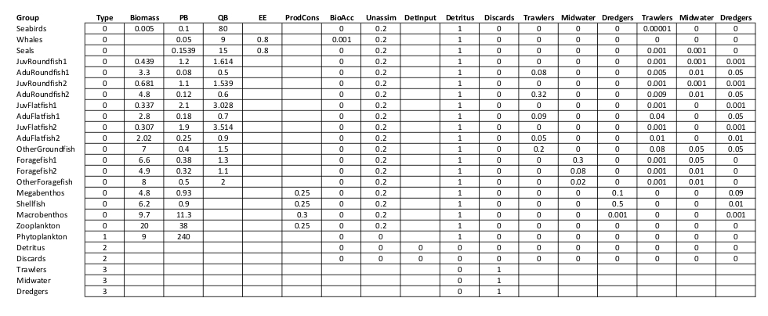

**Figures**

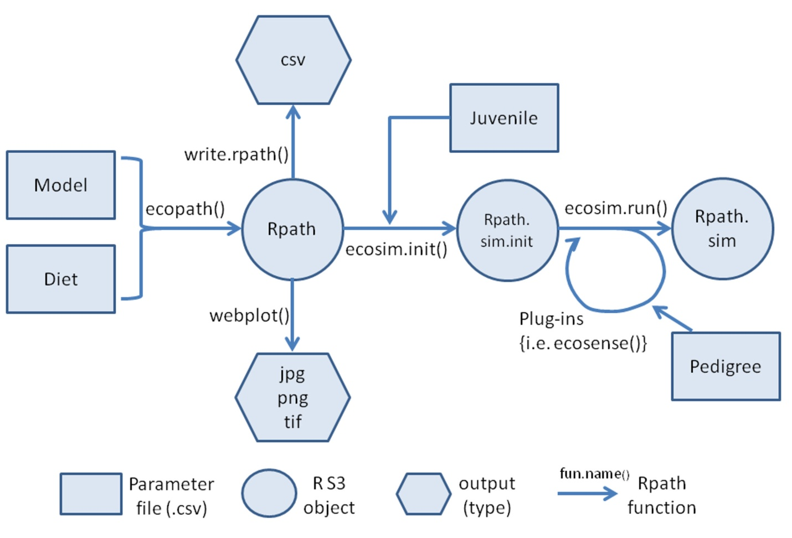

Figure 1 – Flow diagram of the Rpath package. Function descriptions can be found in Table 1.

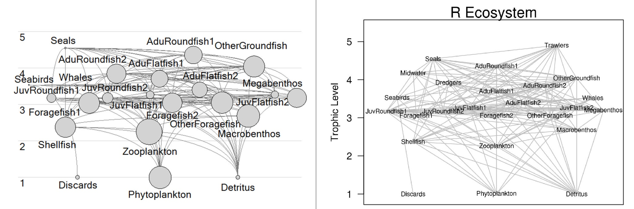

Figure 2 – Food web representation of the fictitious ‘R Ecosystem’. The left panel is the output from EwE version 6.4.3. The right panel is the output generated by the webplot() function of Rpath.

**References**

Aydin, K., Gaichas, S., Ortiz, I., Kinzey, D., Friday, N., 2007. A comparison of the Bering Sea, Gulf of Alaska, and Aleutian Islands large marine ecosystems through food web modeling. US Dep. Commer. NOAA Tech. Memo NMFS-AFSC-178 298.

Christensen, V., Walters, C.J., 2004. Ecopath with Ecosim: methods, capabilities and limitations. Ecol. Model. 172, 109–139. doi:10.1016/j.ecolmodel.2003.09.003

Polovina, J.J., 1984. Model of a Coral-Reef Ecosystem .1. The Ecopath Model and Its Application to French Frigate Shoals. Coral Reefs 3, 1–11. doi:10.1007/Bf00306135

Smith, D., 2015. R among top languages on GitHub.

Steenbeek, J., Buszowski, J., Christensen, V., Akoglu, E., Aydin, K., Ellis, N., Guitton, J., Lucey, S., Kearney, K., Platts, M., Walters, C., In Review. The source code of Ecopath with Ecosim: EwE as a model building toolbox.

Tippmann, S., 2014. Programming tools: Adventures with R. Nature 517, 109–110. doi:10.1038/517109a

Walters, C., Christensen, V., Pauly, D., 1997. Structuring dynamic models of exploited ecosystems from trophic mass-balance assessments. Rev. Fish Biol. Fish. 7, 139–172.