BHUVAN VIKRAM S B  CH.SC.U4CSE24205 | AVL TREE | EXP - 6

AVL tree:
Code:
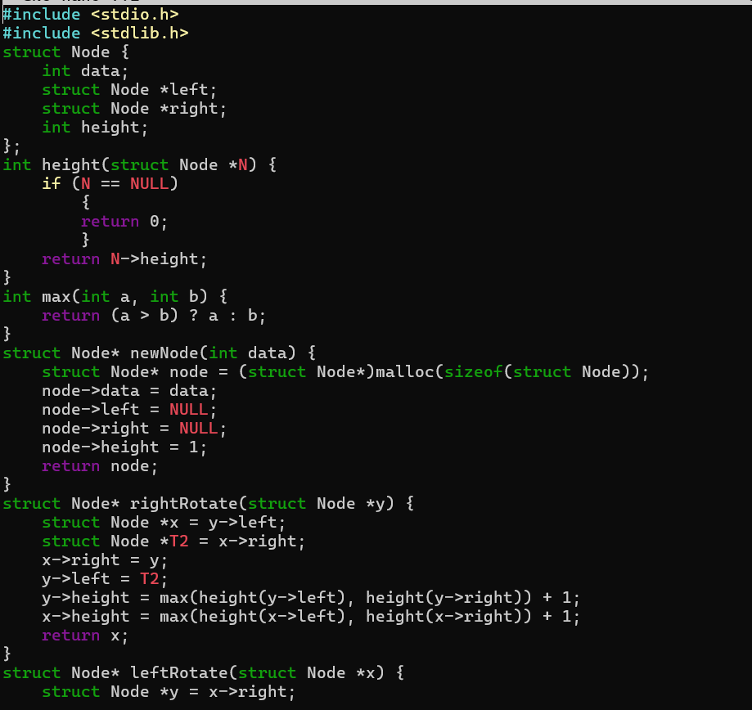
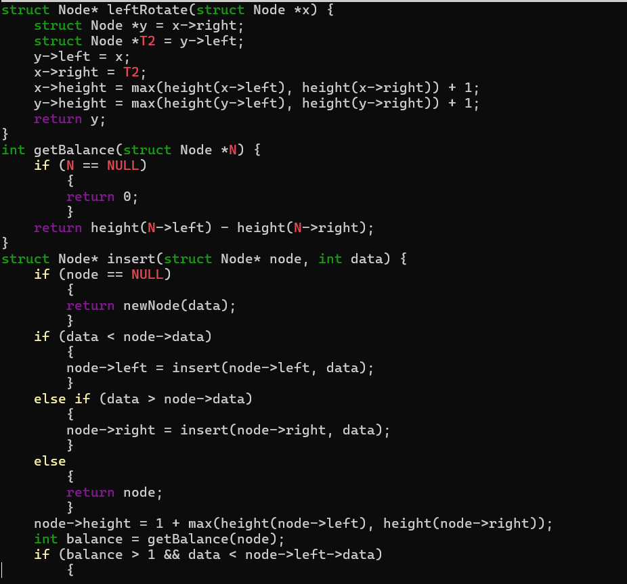
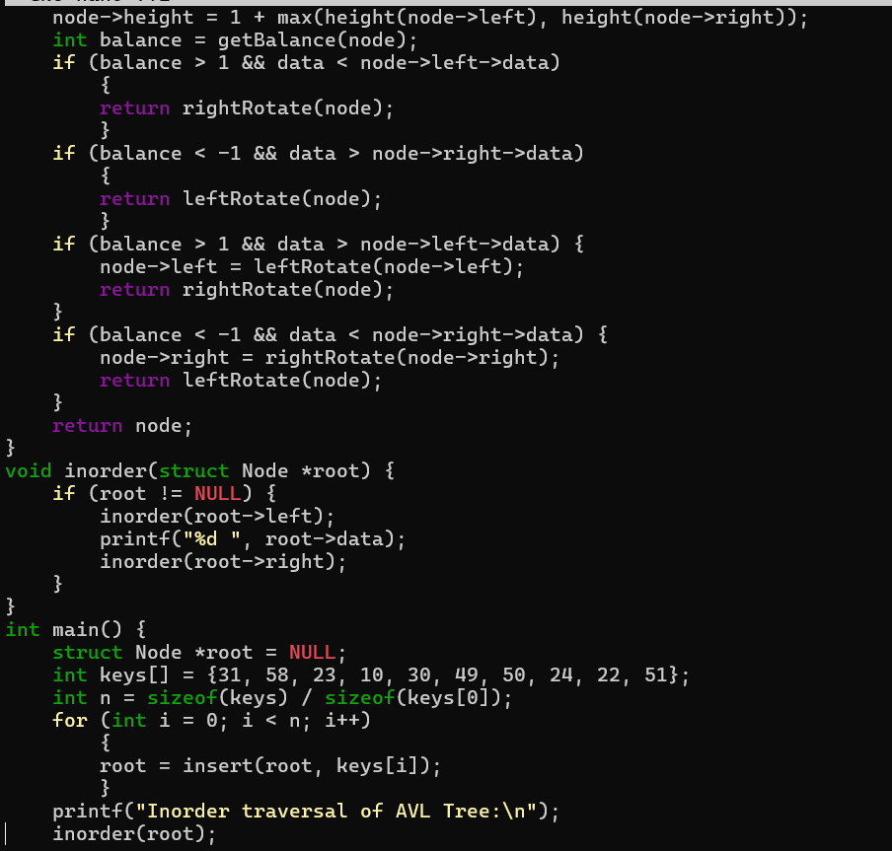
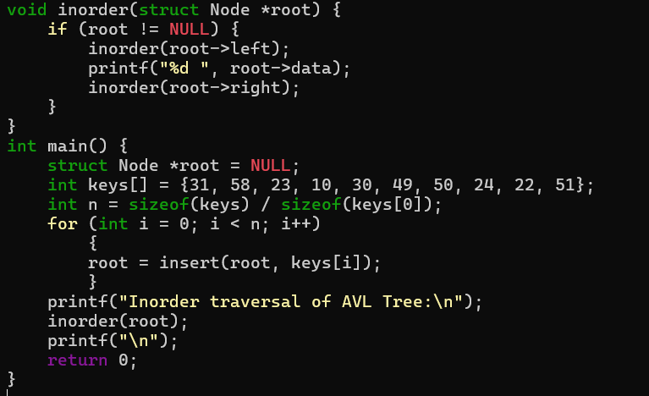
Output:
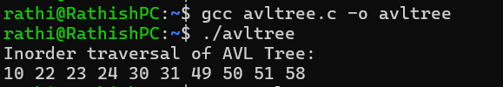
When elements are inserted, the tree checks if it becomes unbalanced by looking at the balance factor (difference between the heights of the left and right subtrees). If the tree becomes unbalanced, it performs rotations to restore balance. This helps keep the tree height small and ensures that operations like searching, inserting, and deleting can be done efficiently in O(log n) time.

