CH.SC.U4CSE24205  BHUVAN VIKRAM S B | BREADTH FIRST SEARCH AND DEPTH FIRST SEARCH ALGORITHMS | DAA EXP-3

BREADTH FIRST SEARCH:

- It is a graph traversal algorithm.
- Starts from the source node and explores the graph level by level.
- First visits all nodes adjacent to the source node and then continues to visit adjacent nodes of those nodes.
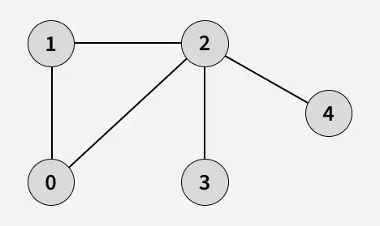

- Start from 0
- Visit 1 Neighbour of 0
- Visit 2 Neighbour of 0
- Visit 3 Neighbour of 2
- Visit 4 Neighbour of 2

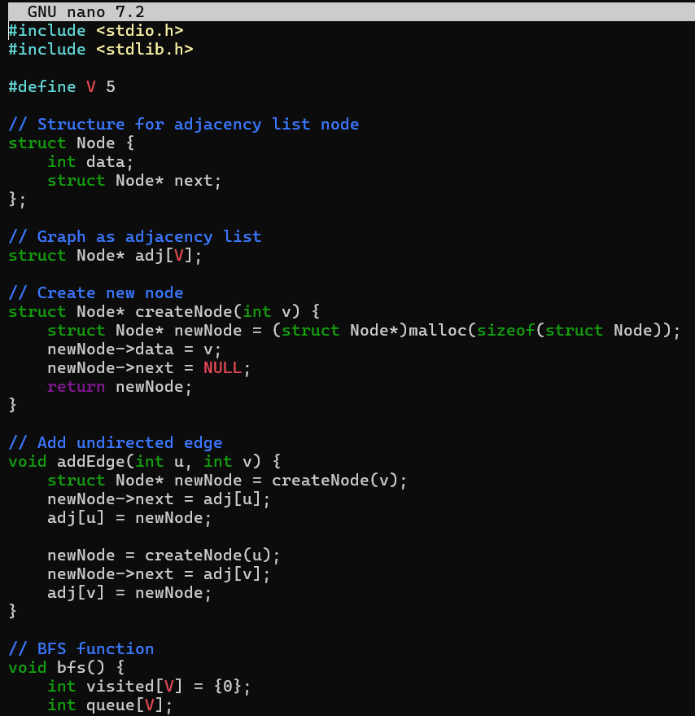
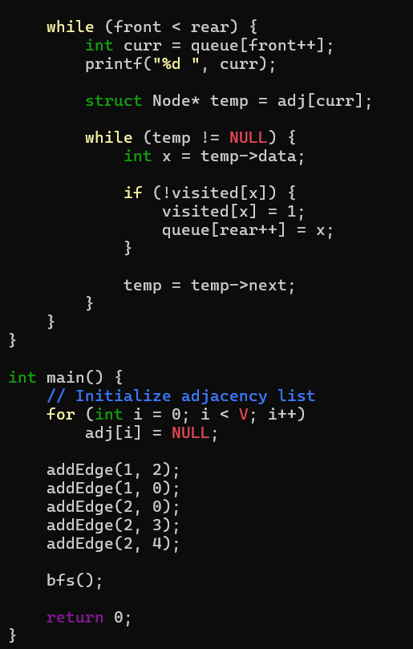
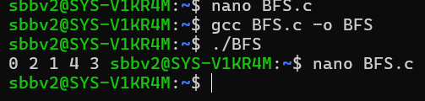

DEPTH FIRST SEARCH:

- DFS is a graph traversal algorithm
- Starts from source vertex and explores each path completely before backtracking and exploring other paths.
- To avoid revisiting nodes in graphs with cycles, a visited array is used to track visited vertices.


- Start at 0: Mark as visited.
- Visit to 1
- Visit 2
- Visit 3 then backtrack to 2
- Visit 4 Backtrack to 2 then 1 then 0
