CH.SC.U4CSE24205 | Prim’s and Kruskal’s Algorithms | DAA EXP-4

Minimum Spanning Tree (MST)

Both Prim’s and Kruskal’s algorithms are used to find a Minimum Spanning Tree of a connected, undirected, weighted graph.

Minimum Spanning Tree (MST) = A tree that:

Connects all vertices

Has no cycles

Has minimum total edge weight

Prim’s Algorithm:

Algorithm:
- Choose any vertex as the starting vertex.
- Mark it as visited.
- Repeat until all vertices are included in MST:
  - Among all edges that connect a visited vertex to an unvisited vertex,
  - Select the edge with minimum weight.
  - Add this edge to MST.
  - Mark the new vertex as visited.
- Stop when the MST contains (V − 1) edges.

Graph:
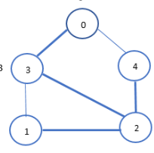
Steps:
1.

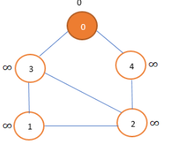

2.
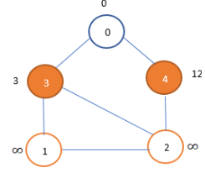
3.
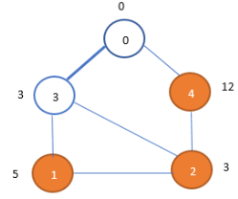
4.
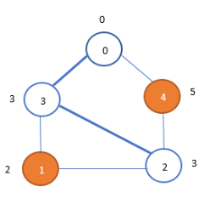
5.
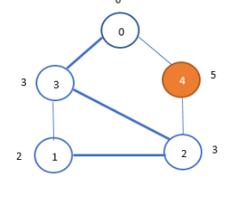
6.
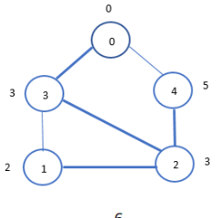
7.
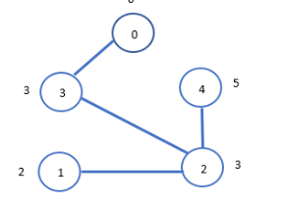
Code:
#include <stdio.h>
#include <limits.h>

#define V 5

int minKey(int key[], int mstSet[]) {
int min = INT_MAX, min_index;

for (int v = 0; v < V; v++)
if (mstSet[v] == 0 && key[v] < min)
min = key[v], min_index = v;

return min_index;
}

void printMST(int parent[], int graph[V][V]) {
int totalWeight = 0;
printf("Edge \tWeight\n");

for (int i = 1; i < V; i++) {
printf("%d - %d \t%d\n", parent[i], i, graph[i][parent[i]]);
totalWeight += graph[i][parent[i]];
}

printf("Total Weight = %d\n", totalWeight);
}

void primMST(int graph[V][V]) {
int parent[V];
int key[V];
int mstSet[V];

for (int i = 0; i < V; i++) {
key[i] = INT_MAX;
mstSet[i] = 0;
}

key[0] = 0;
parent[0] = -1;

for (int count = 0; count < V - 1; count++) {
int u = minKey(key, mstSet);
mstSet[u] = 1;

for (int v = 0; v < V; v++) {
if (graph[u][v] && mstSet[v] == 0 && graph[u][v] < key[v]) {
parent[v] = u;
key[v] = graph[u][v];
}
}
}

printMST(parent, graph);
}

int main() {
int graph[V][V] = {
{0, 2, 3, 0, 0},
{2, 0, 1, 4, 0},
{3, 1, 0, 5, 6},
{0, 4, 5, 0, 7},
{0, 0, 6, 7, 0}
};

primMST(graph);

return 0;
}
Output:

Kruskal’s Algorithm:
Algorithm:
- Sort all edges in non-decreasing order of weight.
- Initialize each vertex as a separate set.
- For each edge (u, v) in sorted order:
- If u and v belong to different sets:
  - Add edge to MST.
  - Union the two sets.
- Stop when MST contains (V − 1) edges.
Graph:
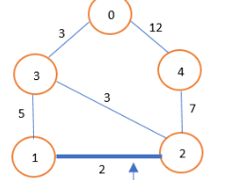
Steps:
1.
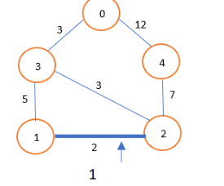
2.
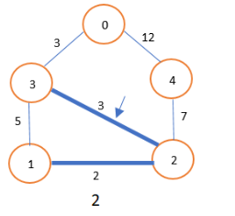
3.
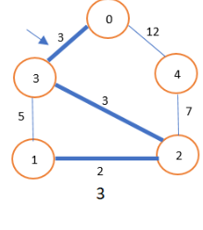
4.
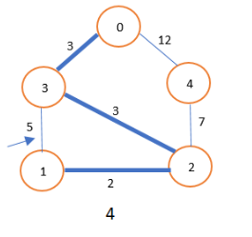
5.
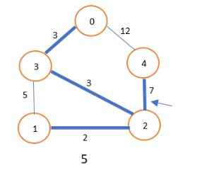
6.
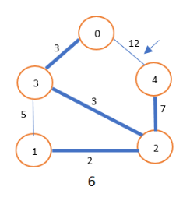
7.
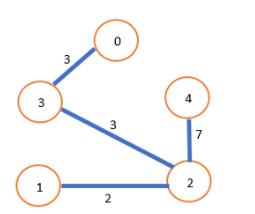
Code:
#include <stdio.h>
#include <stdlib.h>

#define V 5
#define E 7

struct Edge {
int src, dest, weight;
};

struct Graph {
struct Edge edge[E];
};

int parent[V];

int find(int i) {
while (parent[i] != i)
i = parent[i];
return i;
}

void unionSet(int x, int y) {
int xset = find(x);
int yset = find(y);
parent[xset] = yset;
}

int compare(const void* a, const void* b) {
struct Edge* e1 = (struct Edge*)a;
struct Edge* e2 = (struct Edge*)b;
return e1->weight - e2->weight;
}

void kruskal(struct Graph* graph) {
struct Edge result[V];
int e = 0;
int i = 0;

for (int v = 0; v < V; v++)
parent[v] = v;

qsort(graph->edge, E, sizeof(graph->edge[0]), compare);

while (e < V - 1 && i < E) {
struct Edge next = graph->edge[i++];
int x = find(next.src);
int y = find(next.dest);

if (x != y) {
result[e++] = next;
unionSet(x, y);
}
}

int totalWeight = 0;
printf("Edge \tWeight\n");
for (i = 0; i < e; i++) {
printf("%d - %d \t%d\n", result[i].src, result[i].dest, result[i].weight);
totalWeight += result[i].weight;
}
printf("Total Weight = %d\n", totalWeight);
}

int main() {
struct Graph graph = {
{
{0, 1, 2},
{0, 2, 3},
{1, 2, 1},
{1, 3, 4},
{2, 3, 5},
{2, 4, 6},
{3, 4, 7}
}
};

kruskal(&graph);
return 0;
}

