BHUVAN VIKRAM SB  CH.SC.U4CSE24205 | JOB SEQUENCING | EXP 7

CODE:
#include <stdio.h>

struct Job
{
char id;
int deadline;
int profit;
};

void jobSequencing(struct Job jobs[], int n)
{
int i, j;

// Sort jobs by profit (descending)
for(i = 0; i < n - 1; i++)
{
for(j = i + 1; j < n; j++)
{
if(jobs[i].profit < jobs[j].profit)
{
struct Job temp = jobs[i];
jobs[i] = jobs[j];
jobs[j] = temp;
}
}
}

int slot[n];
char result[n];

for(i = 0; i < n; i++)
slot[i] = -1;

for(i = 0; i < n; i++)
{
for(j = jobs[i].deadline - 1; j >= 0; j--)
{
if(slot[j] == -1)
{
slot[j] = 1;
result[j] = jobs[i].id;
break;
}
}
}

printf("Selected job sequence: ");
for(i = 0; i < n; i++)
{
if(slot[i] == 1)
printf("%c ", result[i]);
}
}

int main()
{
struct Job jobs[] = {
{'A', 5, 36},
{'B', 8, 21},
{'C', 3, 28},
{'D', 4, 19},
{'E', 4, 21},
{'F',9,13},
{'G',12,28},
{'H',14,25},
{'I',2,18},
{'J',7,20},
{'K',5,27},
{'L',1,22},
{'M',6,14},
{'N',3,26}
};

int n = sizeof(jobs) / sizeof(jobs[0]);

jobSequencing(jobs, n);

return 0;
}

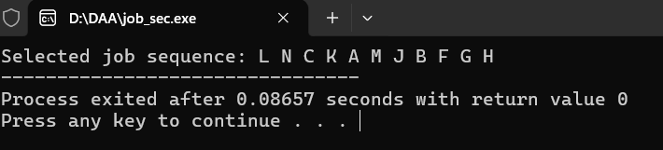

In this program, the Job Sequencing with Deadlines problem is solved using a greedy approach. Each job has a deadline and a profit, and the aim is to choose jobs that give the maximum profit. The jobs are first arranged in order of highest profit to lowest profit. Then, each job is scheduled in the latest available time slot before its deadline. By doing this, the program selects the most profitable jobs that can be completed within the given deadlines and avoids scheduling multiple jobs at the same time.

