BHUVAN VIKRAM S B  CH.SC.U4CSE24205 | MERGE AND QUICK SORT | EXP - 5

MERGE SORT :

31, 58, 10, 23, 30, 49, 50, 24, 22, 51
CODE:
#include <stdio.h>

void merge(int arr[], int left, int mid, int right)
{
int i, j, k;
int n1 = mid - left + 1;
int n2 = right - mid;

int L[n1], R[n2];

for(i = 0; i < n1; i++)
L[i] = arr[left + i];

for(j = 0; j < n2; j++)
R[j] = arr[mid + 1 + j];
i = 0;
j = 0;
k = left;

while(i < n1 && j < n2)
{
if(L[i] <= R[j])
{
arr[k] = L[i];
i++;
}
else
{
arr[k] = R[j];
j++;
}
k++;
}

while(i < n1)
{
arr[k] = L[i];
i++;
k++;
}

while(j < n2)
{
arr[k] = R[j];
j++;
k++;
}
}

void mergeSort(int arr[], int left, int right)
{
if(left < right)
{
int mid = (left + right) / 2;

mergeSort(arr, left, mid);
mergeSort(arr, mid + 1, right);

merge(arr, left, mid, right);
}
}

int main()
{
int arr[] = {31,58,10,23,30,49,50,24,22,51};
int n = 10;

mergeSort(arr, 0, n-1);

printf("Sorted array:\n");

for(int i = 0; i < n; i++)
printf("%d ", arr[i]);

return 0;
}

THE SORTED LIST IS :
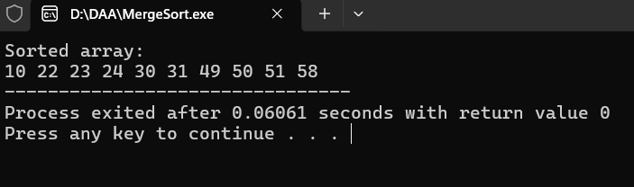

In Merge Sort, the list of numbers is first split into smaller parts again and again until each part has only one number. Then these small parts are combined back together in the correct order by comparing the numbers. This process continues until the entire list becomes sorted.

QUICK SORT:
#include <stdio.h>

void swap(int *a, int *b)
{
int temp = *a;
*a = *b;
*b = temp;
}

int partition(int arr[], int low, int high)
{
int pivot = arr[high]; // choose last element as pivot
int i = low - 1;

for(int j = low; j < high; j++)
{
if(arr[j] <= pivot)
{
i++;
swap(&arr[i], &arr[j]);
}
}

swap(&arr[i + 1], &arr[high]);
return i + 1;
}

void quickSort(int arr[], int low, int high)
{
if(low < high)
{
int pi = partition(arr, low, high);

quickSort(arr, low, pi - 1);
quickSort(arr, pi + 1, high);
}
}

int main()
{
int arr[] = {31,58,10,23,30,49,50,24,22,51};
int n = 10;

quickSort(arr, 0, n - 1);

printf("Sorted array:\n");

for(int i = 0; i < n; i++)
printf("%d ", arr[i]);

return 0;
}
\


In Quick Sort, one number is chosen as a pivot element. All numbers smaller than the pivot are placed on the left side and larger numbers are placed on the right side. This process is repeated for each smaller section of the list until all numbers are arranged in order.

