CH.SC.U4CSE24205  BHUVAN VIKRAM S B | DAA - EXP 1 | DATE : 30/11/2025

Q1. Write a program to find the sum of first n natural numbers using a user defined function.

CODE:
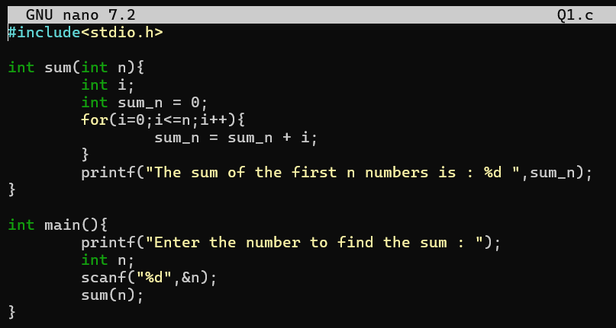
OUTPUT:
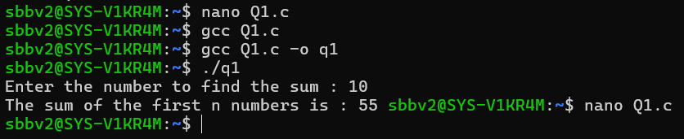
Interpretation:
I created a user-defined function named sum() that receives the number n as its parameter. Inside the function, I used a for loop that runs from 0 to n, and in each iteration, the loop adds the current value of i to the variable sum_n. This helps to store the total sum step by step.
The main() function gets user input. It first asks the user to enter a number. Then it reads the value of n using scanf() and passes that value to the sum() function. Finally, the function prints the total sum of the first n numbers.

Q2. Write a program to find the sum of squares of first n natural numbers using a user defined function.
CODE:
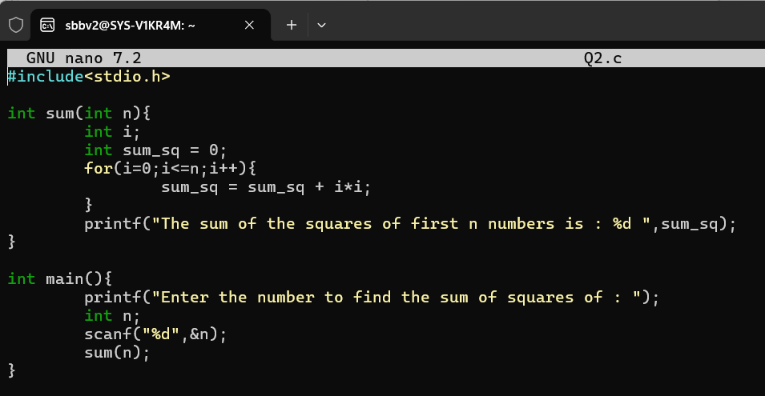

OUTPUT:
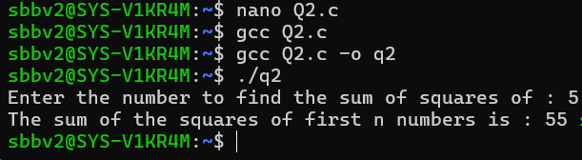
Interpretation:
I created a user-defined function named sum() that takes the input value n as its parameter. Inside this function, I used a for loop that starts from 0 and goes up to n. During each iteration, the square of the current number (i*i) is added to the variable sum_sq, which gradually accumulates the total sum of squares.
In the main() function, the program first asks the user to enter a number. The input is read using scanf() and stored in the variable n. This value is then passed to the sum() function, which will do the calculation and prints the final result.

Q3. Write a program to find the sum of cubes of first n natural numbers using a user defined function.
CODE:
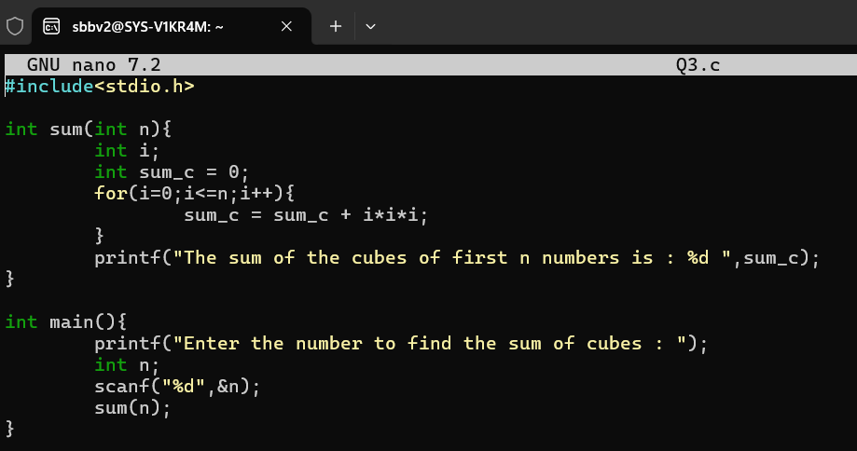
OUTPUT:
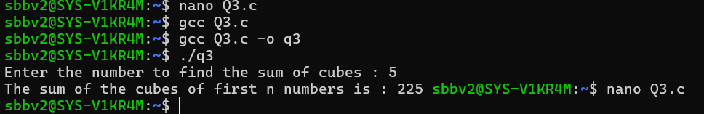
Interpretation:
I created a user-defined function named sum() that takes the input number n as its parameter. Inside the function, I used a for loop that runs from 0 up to n, and in each iteration, the cube of the current value (i*i*i) is added to the variable sum_c. This allows the total sum of cubes to get stored in each step.
The main() function is responsible for interacting with the user. It first displays a message asking the user to enter a number. After reading this value using scanf(), it passes the number to the sum() function, which performs the calculation and prints the final sum.

Q4. Write a program to find factorial for n natural numbers using recursive function.
CODE:
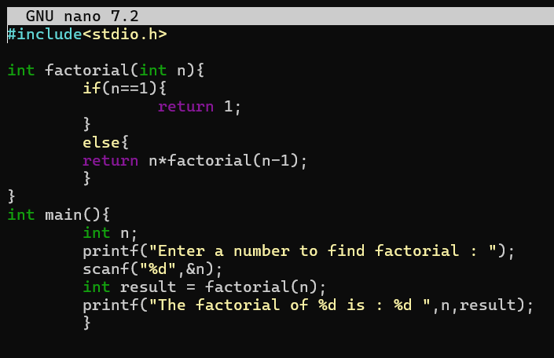
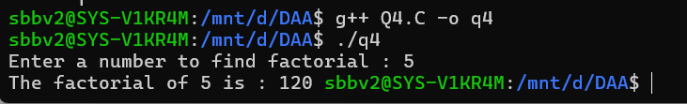
Interpretation:
I created a user-defined function named factorial() that repeatedly calls itself to calculate the product of all numbers from n down to 1. The function includes a base condition if(n == 1) to stop the recursion and return 1, which forms the foundation for building the final answer.
If the number is not 1, the function returns n * factorial(n - 1), which means each call multiplies the current value of n by the factorial of the previous number. This recursive process continues until the base case is reached.
In the main() function, I asks the user to enter a number, read the input using scanf(), and then pass it to the factorial() function. The returned result is stored in the result variable and printed.

Q5. Write a program to transpose a 3x3 matrix
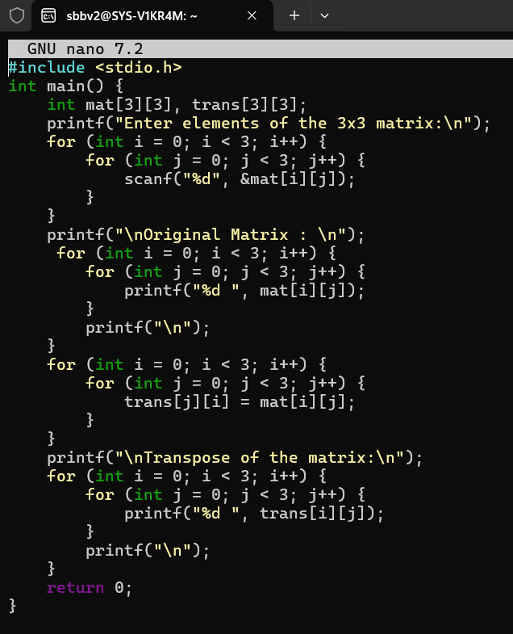

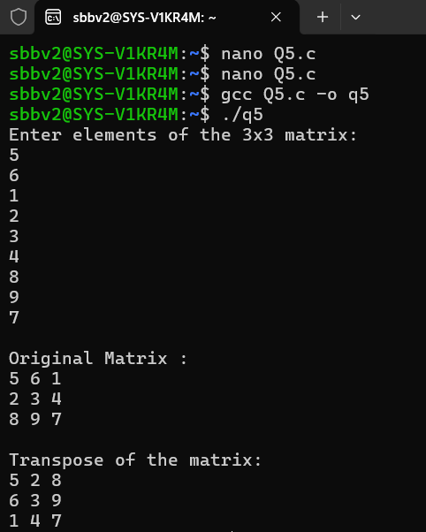
Interpretation:
first created two 3×3 arrays: mat to store the original matrix and trans to store the transposed matrix. Using nested for loops, I took input for all nine elements of the matrix from the user.
After storing the values, I printed the original matrix to show the user what they entered as the input. To generate the transpose, I used another pair of nested loops, where I simply swapped the row and column positions by assigning trans[j][i] = mat[i][j]. This operation will flip the matrix over its diagonal that gives the transpose.

Q6. Write a program to print the fibonacci numbers upto a given number n.
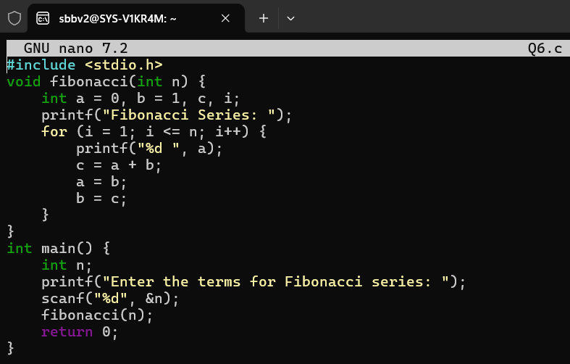
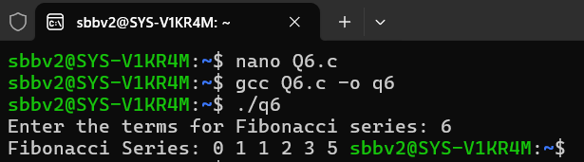
Interpretation:
I created a function named fibonacci() that accepts the number of terms n as its parameter. Inside the function, I initialized the first two Fibonacci numbers, a = 0 and b = 1, since the sequence always begins with these numbers.
Using a for loop, I printed each term one by one. In every iteration, I displayed the current value of a, and then calculated the next term by adding a and b. After that, I updated the variables so the sequence will continue in which a becomes b and b becomes the newly calculated value.
The main() function asks the user to enter how many terms they want. It reads the input using scanf() and passes the value to the fibonacci() function, which prints the complete series.

