Azure Architecture and Cost Estimate Report

Requirement

Set up Azure networking with private and public subnets, then create an Azure Container Instances (ACI) to deploy applications using Docker containers. Configure two Docker containers: one for a Node.js application and another for a MongoDB database. Use an Azure Load Balancer or Application Gateway to access the Node.js application, while the MongoDB container communicates securely within the private subnet. Create deployment diagram and the estimated cost as well.

Architecture
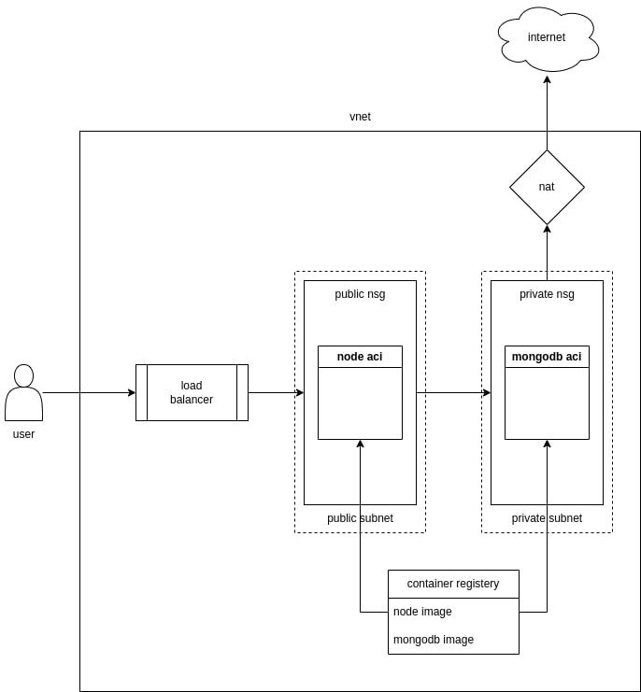

Cost Estimate

Resource Type | Resource Name | Number of Deployed Resources | Cost per Day (INR) | Cost per Month (INR)
Resource Group | rg-crudify-app | 1 | 0 | 0
Virtual Network | vnet-crudify-app | 1 | 0 | 0
Network Security Group | nsg-private-crudify-app | 1 | 0 | 0
Network Security Group | nsg-public-crudify-app | 1 | 0 | 0
NAT Gateway | natgw-crudify-app | 1 | 8.3 | 249
Public IP Address | pip-natgw-crudify-app | 1 | 4.15 | 124.5
Public IP Address | pip-lb-crudify-app | 1 | 4.15 | 124.5
Load Balancer | lb-crudify-app | 1 | 5.81 | 174.3
Container Registry | acrcrudifyapp | 1 | 29.05 | 871.5
Container Instance | aci-mongodb-crudify-app | 1 | 83.5 | 2490
Container Instance | aci-app-crudify-app | 1 | 83.5 | 2490
Total |  | 11 | 219.76 | 6523.8

