# 

**MiniProject-1**

DEPARTMENT OF COMPUTER APPLICATION

BCA-2024

SEMESTER-3

FRONT END WEB DEVELOPMENT

Mentor Name : Veera Raghav K

Done by: Bhuvan B Krishna

Reg No: 2411021240030

Faculty Signature:_______

Report on Facebook Login Page (HTML File)

# 1. File Overview

Purpose: This HTML file is a simple, styled Facebook login page replica created for practice or demonstration purposes.

# 2. Page Structure

The file contains the following key components:

1. Header Section (<head>)

- Title: Facebook Login Page

- Favicon: Facebook.png

- CSS Styling: Inline <style> section defines layout, colors, and effects.

2. Body Section (<body>)

- Heading (<h1>): Displays “facebook” in blue (#1877F2).

- Login Container (<div>):

- Contains a login title (Login to Facebook).

- A form with:

- Input field for email/phone number.

- Input field for password.

- A login button linking directly to the official Facebook login page.

- Additional links for forgotten account and sign-up.

# 3. Styling & Design

- Color Theme: Matches Facebook’s branding (#1877F2 for blue, neutral grays for text and borders).

- Box Design: Rounded corners, drop shadow effect.

- Inputs: Wide, padded, with placeholder text.

- Button: Blue background with white text and hover effect.

- Links: Styled in blue for emphasis.

# 4. Functionality

- Form Action: Currently empty (action=""), meaning login credentials are not submitted anywhere.

- Login Button: Redirects users to official Facebook instead of processing inputs.

- Navigation Links:

- Password recovery → Facebook’s recovery page.

- Sign-up → Facebook’s sign-up campaign page.

# 5. Strengths

- Clean and simple design.

- Close resemblance to the official Facebook login UI.

- Responsive hover effect on the button.

- External links correctly point to official Facebook resources.

# 6. Limitations

- Non-functional form: No backend integration to handle login data.

- Hardcoded Links: 'Log In' button redirects to Facebook instead of authenticating input.

- Fixed Layout: Centering uses fixed margin, making it non-responsive.

- Accessibility: Missing ARIA labels and semantic HTML.

# 7. Recommendations

- Add form action and backend script to handle login securely.

- Use responsive CSS (Flexbox/Grid) instead of fixed margins.

- Implement form validation (e.g., check for valid email format).

- Add labels for input fields to improve accessibility.

- Replace <button><a></a></button> with a proper submit button.

## Output Code & Screenshots

The output is a simple Facebook login page replica with input fields for email/phone and password, along with login, forgotten account, and sign-up options. Below is a screenshot of the output:

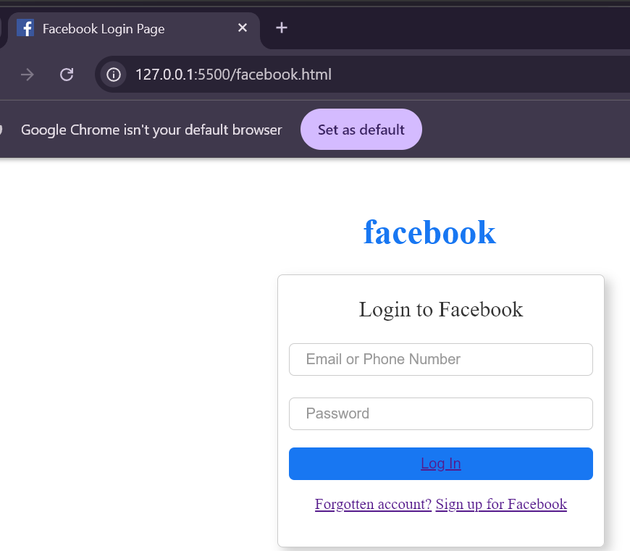

# Conclusion

This page serves as a basic HTML/CSS practice project, imitating the Facebook login interface.

It is visually effective but functionally incomplete without backend integration.