# 

**MiniProject-1**

DEPARTMENT OF COMPUTER APPLICATION

BCA-2024

SEMESTER-3

FRONT END WEB DEVELOPMENT

Mentor Name : Veera Raghav K

Done by: Bhuvan B Krishna

Reg No: 2411021240030

Faculty Signature:_______

# Report on Student Details Webpage

## Introduction

The Student Details webpage is a simple HTML and CSS-based page created to display student-related information in a structured and styled manner. The design incorporates a clean layout with visually appealing formatting for easy readability.

## Webpage Structure

The webpage consists of the following main components:

1. A centered container (div) with background color, borders, and shadow effects.

2. A page title and styled headings to display student details clearly.

3. A button with a hyperlink redirecting to Alliance University’s official website.

## Displayed Student Information

The webpage presents the following student details:

- Registration ID: 123456

- Student Name: Bhuvan B Krishna

- Course: BCA in Game Development

- College Name: Alliance University

- Location: Bangalore, India

- Year of Study: 2nd Year

- Contact Information: 8217347439

## Styling (CSS)

The webpage uses inline CSS to style various elements, including headers, the container, and the button. The major styling features are:

- The main heading (h1) is centered, underlined, and styled with a serif font in dark blue.

- Student details (h3 elements) are aligned with a left margin for readability.

- The container (div) has a chartreuse background, rounded corners, and box shadows for emphasis.

- The button is centered with rounded corners, padding, and shadow effects. It changes color when hovered over.

## Output Code & Screenshots

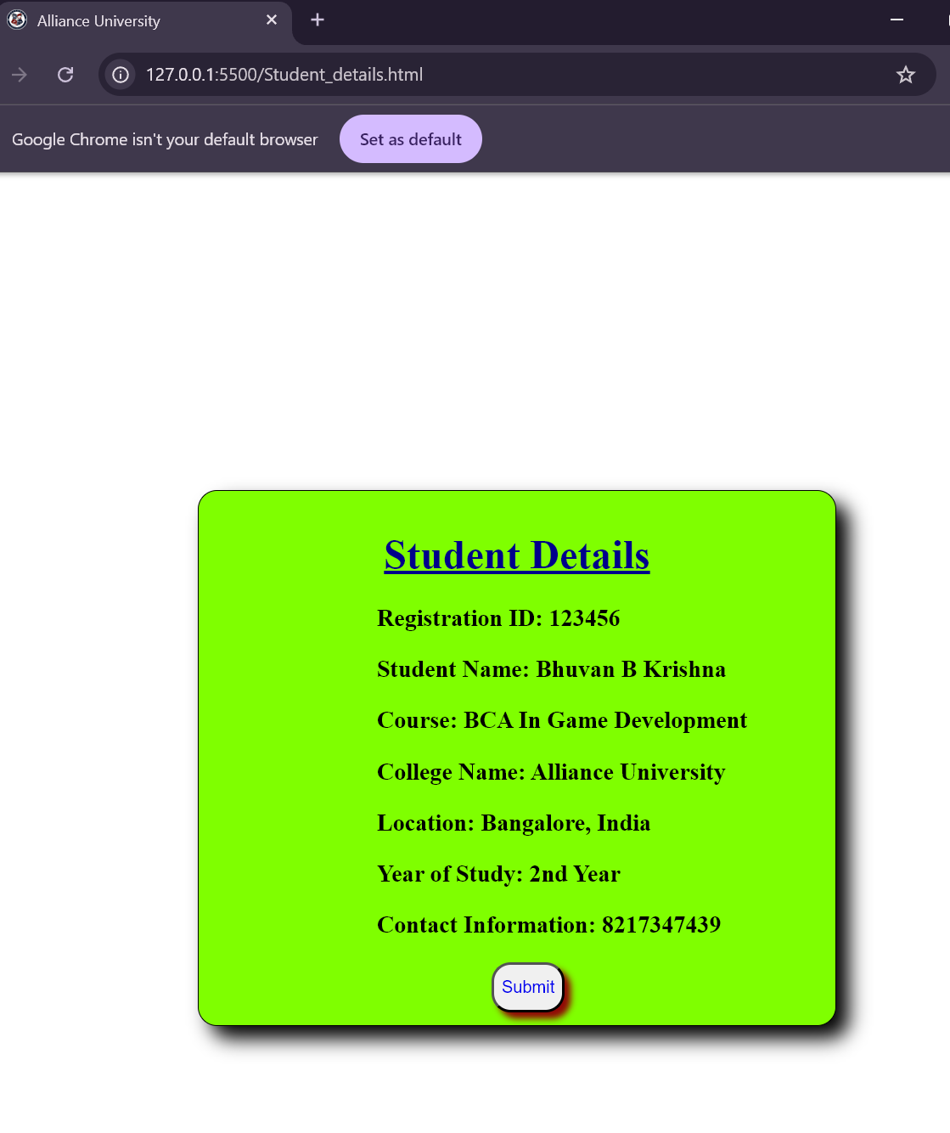

## Functionality

The webpage includes a 'Submit' button that redirects the user to Alliance University’s official website (https://www.alliance.edu.in/). This demonstrates basic use of HTML hyperlinks within styled buttons.

## Conclusion

The Student Details webpage is a well-structured static page that effectively displays essential student information in a visually appealing way. It highlights fundamental usage of HTML for structure, CSS for styling, and hyperlinks for navigation. For enhanced functionality, future improvements could include dynamic data handling, form submissions, or database connectivity.