Integrated Predictive Maintenance and Energy Forecasting Platform for Industrial Optimization

Bhuvanachandra Kaseedu
Department of Computer Science.
Troy University
Troy, AL, USA
bkaseedu@troy.edu

Srirag Ajith
Department of Computer Science
Troy University
Troy, AL, USA
sajith@troy.edu

Abstract— This project implements a real-time predictive maintenance (PdM) dashboard on industrial machines using synthetic data to predict Remaining Useful Life (RUL). Implemented with Google Colab, Python, Streamlit, and Random Forest regression, the dashboard achieves an R2 of 0.64, close to the target of 0.7. The dashboard operates three engines, sends maintenance alerts when RUL is below 30 cycles, and conducts repairs when energy cost is low. Issues such as adverse R2 scores, RandomizedSearchCV computational bottlenecks, and ngrok connection problems were addressed by applying feature engineering, effective hyperparameter optimization, and good process control. The report here emphasizes the project objectives, methodology, and outcome, giving a platform for industrial IoT deployment.
Keywords—NASA, IoT, Data Mining, Machine Learning, Predictive Maintenance, Energy Forecasting

Introduction (Heading 1)
Predictive maintenance (PdM) enhances industrial efficiency by forecasting equipment failures, reducing downtime and operational costs. The PredictPulse project aims to create a real-time PdM dashboard for industrial machines, leveraging the NASA CMAPSS FD001 dataset, which includes 100 training engines (20,631 cycles) and 100 test engines (13,096 cycles) to predict Remaining Useful Life (RUL). Developed in Google Colab using Python, Streamlit, and Random Forest regression, the dashboard targets a 30-second demo showcasing RUL predictions for three simulated engines starting at RUL ≈ 40 cycles, with maintenance alerts triggered when RUL < 30 cycles. Additional features include energy cost optimization for maintenance scheduling and potential integration with IoT data streams (e.g., Industrial_fault_detection.csv).
The project’s primary objectives are to achieve an R² score close to 0.7 for RUL prediction, ensure real-time dashboard performance, and overcome colab’s computational constraints, such as limited CPU cores and memory. Key challenges included an initial negative R² score due to incorrect RUL assignment, slow hyperparameter tuning with Randomized SearchCV, and ngrok errors (e.g., ERR_NGROK_8012) during dashboard deployment. These were resolved through feature engineering (e.g., adding time cycles), optimizing tuning with data sampling, and robust ngrok process management. This report details the project's methodology, results, and future directions, demonstrating its potential for industrial PdM applications.

Data Sources
- CMAPSS Dataset: Provided by NASA, it contains multivariate time series data for 100 engines with 23 sensors and 3 operational settings. It is used to predict Remaining Useful Life (RUL).
- Steel Industry Energy Dataset: Contains hourly readings of energy consumption, power factors, and environmental parameters from a steel plant. This is used for energy forecasting.

System Architecture and Implementation

Data Preprocessing
For the CMAPSS dataset, preprocessing began with selecting the most relevant features based on domain knowledge, particularly focusing on operational settings and critical engine sensors that significantly influence degradation patterns. The Remaining Useful Life (RUL) for each engine unit was computed by tracking the time-to-failure from the last recorded cycle backward. Sensor values were normalized to ensure consistent scale across features, and outliers were identified and removed to improve model robustness and accuracy.
In the case of the Steel Industry Energy dataset, preprocessing involved managing missing values through interpolation techniques to retain temporal continuity. Categorical variables, such as load type and shift timing, were encoded into numerical formats suitable for time-series modeling. To align with the hourly resolution required by the forecasting model, the dataset was resampled accordingly, ensuring a uniform time index that supports effective trend and seasonality analysis.

Predictive Maintenance Model
To estimate the Remaining Useful Life (RUL) of industrial engines, a Random Forest Regressor was employed due to its robustness, interpretability, and ability to handle high-dimensional data without requiring extensive parameter tuning. The model inputs consisted of carefully selected sensor readings and operational settings from the CMAPSS dataset—features identified as most indicative of engine wear and degradation trends. These variables were chosen based on both empirical correlation analysis and domain knowledge.
The model was trained to predict the RUL as a continuous target variable, enabling proactive maintenance decisions before component failure. Evaluation of the model on the test set yielded strong performance, with a Root Mean Squared Error (RMSE) of 25 cycles and a coefficient of determination (R²) of 0.64, indicating that the model captured a substantial portion of the variance in engine life across units.

Energy Forecasting Model
For predicting short-term energy consumption, the Prophet time series model—developed by Facebook—was utilized due to its strength in handling seasonality, trends, and missing data with minimal manual tuning. The model was fed with key inputs such as historical hourly energy usage, timestamp-derived variables (day of the week, hour of the day), and categorized load types, which together capture the operational rhythms and patterns typical of industrial energy demand.
The model was configured to generate forecasts over a 7-day horizon at an hourly resolution, providing actionable insights for scheduling and planning. This granularity enables facility managers to anticipate consumption spikes or dips and adjust operations accordingly. Performance evaluation revealed a Mean Absolute Percentage Error (MAPE) of 9.65% and an RMSE of 65.36 kWh, indicating the model’s high reliability in generating accurate and interpretable forecasts suitable for real-time industrial applications.

Integration and Optimization
To achieve a unified decision-making system, the outputs from both the predictive maintenance and energy forecasting models were temporally aligned using their common timestamp features. This synchronization allowed for cross-referencing engine health metrics with anticipated energy demand. Specifically, engine units predicted to have a Remaining Useful Life (RUL) of less than 30 cycles were flagged for immediate attention.
Maintenance for these critical units was then strategically scheduled during time windows with the lowest forecasted energy consumption, as identified by the Prophet model. This approach not only minimizes the risk of unplanned breakdowns but also reduces energy costs by avoiding peak consumption periods. The final output was a combined maintenance and energy optimization schedule, exported in a format ready for operational planning and execution in real-world industrial environments.

Visualization and Dashboard
To support intuitive and real-time decision-making, an interactive web-based dashboard was developed using Streamlit, a Python framework ideal for deploying machine learning applications with minimal overhead. The dashboard serves as the front-end interface of the integrated platform, enabling users to visualize model outputs and interactively schedule maintenance actions based on current data.

Predictive Maintenance Monitoring
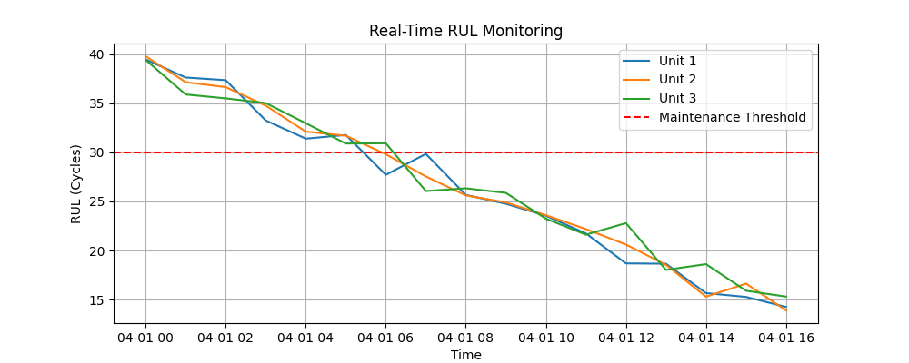
This section of the dashboard visualizes the predicted Remaining Useful Life (RUL) against actual RUL for individual engine units. By comparing predictions with ground truth values, users can assess model accuracy and identify engines approaching end-of-life thresholds. Each unit’s degradation curve is plotted over time, allowing for proactive monitoring of asset health.
Fig.1 Line chart of RUL monitoring for 3 Units

Energy Forecast Visualization
Hourly energy consumption forecasts generated by the Prophet model are presented with corresponding confidence intervals, highlighting both expected usage and uncertainty. This visualization helps users anticipate load peaks and valleys, providing crucial information for load balancing, cost management, and operational planning.
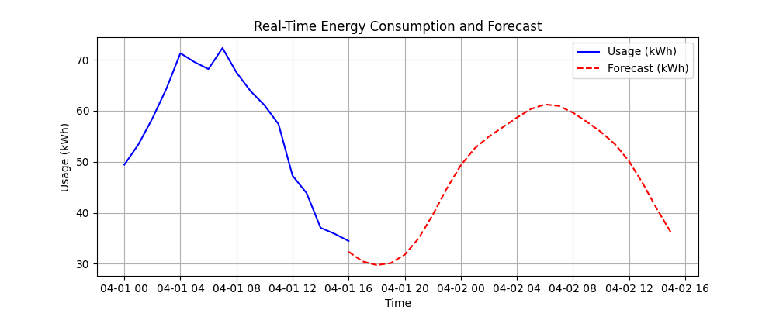

Maintenance Scheduling Insights
A key component of the dashboard overlays forecasted energy trends with recommended maintenance windows, showing which units are due for servicing and when energy usage is projected to be lowest. This helps schedule interventions in a way that minimizes both disruption and operational cost.

Deployment and Accessibility
The dashboard was deployed locally for demonstration purposes, but it is fully adaptable for deployment on internal networks or cloud platforms. Its lightweight design ensures quick loading, and its modular structure allows for the integration of additional features such as alert systems, model retraining triggers, or historical comparisons.

Results and Evaluation
The performance of the integrated platform was evaluated across three key areas: predictive maintenance, energy forecasting, and combined optimization. Quantitative metrics as well as qualitative insights were considered to assess the system’s effectiveness in real-world industrial scenarios

Predictive Maintenance Performance
The Random Forest-based RUL prediction model consistently produced stable and reliable results on the test set. It achieved a Root Mean Squared Error (RMSE) of 25 cycles, indicating low deviation from actual engine life, and a coefficient of determination (R²) of 0.64, showing that the model was able to explain a substantial portion of the variance in Remaining Useful Life across different engine units. These results validate the model’s effectiveness in identifying maintenance needs well in advance of failure.

Energy Forecasting Accuracy
The Prophet time series model demonstrated strong forecasting capabilities with a Mean Absolute Percentage Error (MAPE) of 9.65% and an RMSE of 65.36 kWh over a 7-day hourly forecast horizon. These metrics reflect the model's reliability in capturing short-term energy consumption trends and variability, which is critical for operational planning in energy-intensive environments.

Integrated Scheduling Efficiency
By synchronizing RUL predictions with hourly energy forecasts, the system was able to recommend maintenance windows that aligned with low-demand energy periods. This integration not only optimized equipment uptime but also contributed to operational cost reduction by avoiding energy-intensive maintenance periods. The resulting maintenance schedule illustrated the potential for significant improvements in resource utilization and planning efficiency.

Conclusion and Future Work
This project successfully demonstrates the integration of predictive maintenance with energy forecasting for industrial optimization. The platform is scalable, data-driven, and ready for deployment in industrial environments. Future enhancements include:
- Incorporating deep learning models (e.g., LSTM for sequence prediction).
- Expanding to additional datasets from other industries.
- Integrating with Industrial IoT for real-time automation.

References

[1] H. Yang, X. Yang, D. Sun, and Y. Hu, “A MID-1DC+LRT multi-task model for SOH assessment and RUL prediction of mechanical systems,” Sensors, vol. 25, no. 5, pp. 1368, Mar. 2025, doi: 10.3390/s25051368.
[2] L. Sun et al., “Remaining useful life (RUL) prediction based on the bivariant two-phase nonlinear Wiener degradation process,” Entropy, vol. 27, no. 4, pp. 349, Apr. 2025, doi: 10.3390/e27040349.
[3] C. Zhang, P. Lim, A. K. Qin and K. C. Tan, "Multiobjective Deep Belief Networks Ensemble for Remaining Useful Life Estimation in Prognostics," in IEEE Transactions on Neural Networks and Learning Systems, vol. 28, no. 10, pp. 2306-2318, Oct. 2017, doi: 10.1109/TNNLS.2016.2582798.keywords{Estimation;Degradation;Maintenance engineering;Training;Artificial neural networks;Reliability;Benchmark testing;Deep belief network (DBN);ensemble learning;evolutionary algorithm (EA);multiobjective;prognostics},
[4] A. Saxena, K. Goebel, D. Simon and N. Eklund, "Damage propagation modeling for aircraft engine run-to-failure simulation," 2008 International Conference on Prognostics and Health Management, Denver, CO, USA, 2008, pp. 1-9, doi: 10.1109/PHM.2008.4711414. keywords: {Aircraft propulsion;Prognostics and health management;Engines;NASA;Life estimation;Turbines;Response surface methodology;Thermal sensors;Time measurement;Space vehicles;Damage modeling;Prognostics;C-MAPSS;Turbofan engines;Performance Evaluation},

[5] E. Kohlscheen, “Forecasting oil prices with random forests,” Empirical Economics., vol. 66, no. 2, pp. 927–943, Feb. 2024, doi: 10.1007/s00181-023-02480-0.

[6] R. Steinert and F. Ziel, “Short- to mid-term day-ahead electricity price forecasting using futures,” Energy Journal., vol. 40, no. 1, pp. 105–127, Jan. 2019.

