**A Project on**

# LIBRARY MANAGEMENT SYSTEM

**TABLE OF CONTENTS:**

|  |  |  |
| --- | --- | --- |
| **S.NO** | **CONTENTS** | **PAGE NO.** |
| 01. | Problem Statement | 3 |
| 02. | Entities and attributes | 3 |
| 03. | Functional Dependencies | 3 |
| 04 | Novelty | 4 |
| 05. | Relationships identified | 16 |
| 06. | Relations Diagram | 17 |
| 07. | Entities Relationship  Diagram | 18 |
| 08. | E-R to Relational Diagram | 19 |
| 09. | Schema Diagram | 18 |
| 10 | Normalisation | 17 |
| 11 | DBMS concepts used | 28 |
| 12 | Sample Demo | 35 |

**PROBLEM STATEMENT:**

The Library Management System optimizes resource handling by efficiently cataloging, tracking, and managing books and other materials. It streamlines processes like borrowing, returning, and reservation through a user-friendly interface, enhancing user accessibility. The project's objective is to develop an efficient backend system using Oracle SQL for the library management application.

**INITIAL ASSUMPTIONS:**

1. We have assumed that we have 7 relations in total for the given problem.
2. Books relation: This relation describes the attributes of each books in the library
3. Books_orders relation: This relation contains the details about the orders placed for the books needed by the library.

Here we have assumed that one order can be placed from a single supplier only but may contain many books.

1. Member_login relation: It contains the authentication details of the members
2. Members relation: It consists of the details about the members
3. Issues relation: This relation consists of the details about the books borrowed by the members
4. Renewals relation: This relation consists of the renewals taking place with respect to an IssueID
5. Reservation relation: This relation consists of the requests made by the users for the books that are not currently available to lend

**NOVELTY**

**(i) Separate user and admin interfaces:**

This application has distinct user and admin interfaces to cater to the different needs of the user and the admin.

The user interface provides the user with the following functionalities:

* Search for a particular book
* View current borrowed books and reserved books.
* Borrow/Reserve a book
* Renew a borrowed book
* Update user profile

The admin interface provides the admin with the following functionalities:

* View all current issues/reservations
* View details about a particular user
* View details of all procurements
* View details about a particular supplier

**(ii) Single page to borrow, renew, reserve and return:**

A single page shows book information on a particular book along with consideration of the member id. This page is used to borrow, renew, reserve, and return a book. Using a single page reduces confusion and increases ease of use thereby improving user experience.

**(iii) Reservation system:**

We have introduced a reservation system that is not so prevalent in many library management apps. This feature enables the user to reserve a book for a particular date which he/she will borrow on the day.

**(iv) Easy renewal system:**

Our application has an easy renewal system in which the user can renew the book with a single click. The app allows the user to renew the book up to 10 times and each renewal pushes the due date by a week. This reduces the hassle of returning and reborrowing the same book again and again every week.

**ENTITIES AND ATTRIBUTES:**

* Books_registry (ISBN, Title, Author_ID, Authorname, Genre,

Publisher, Year, Copies)

* Book_Orders(Procurement_ID,Supplier_ID,ISBN,Suppliername,Supp lier_mob,Order_date,Recived_date,Qty)
* Members(Mem_ID, Name, Role, Dept, Email,Mem_mobno)
* Member_login(Mem_id,Pwd)
* Issues (Issue_ID, Mem_ID, ISBN, Duedate, Issuedate, ReturnStatus, FineStatus)
* Renewals(RenewaID,Issue_ID,NewDueDate,RenewedDate)
* Reservation( Reserve_ID, Mem_ID, ISBN, Reservedate,

ReservationStatus)

**FUNCTIONAL DEPENDENCIES:**

### 01) Books_registry (ISBN, Title, Author_ID, Authorname, Genre, Publisher, Year, Copies)

Books relation contains information about the books available in the library and the number of copies.

F= { ISBN→ Title, Authorname, Genre, Publisher, Year, Copies, Author_Id→Authorname}

### STEP 1: Check if the singleton property is satisfied

{ISBN} →{Title}

{ISBN}→{AuthorID}

{ISBN} →{Authorname}

{ISBN} →{Publisher}

{ISBN} →{Genre}

{ISBN} →{Copies}

{ISBN} →{Year}

Therefore F1={

ISBN →Title,

ISBN→Author_ID

ISBN→Authorname,

ISBN →Publisher,

ISBN→Genre,

ISBN →Copies,

ISBN →Year,

Author_Id→Authorname

}

**STEP 2: Check for the existence of extraneous attributes in an FD**

//No extraneous attribute

### STEP 3: Check for the existence of redundant FDs

There is a transitive dependency among the FDS as follows:

ISBN→Author_ID,

Author_Id→Authorname

Thus ISBN→Authorname is redundant.

Therefore THE MINIMAL SET OF DEPENDENCIES,

F3={

ISBN →Title,

ISBN→Author_ID,

ISBN →Publisher,

ISBN→Genre,

ISBN →Copies,

ISBN →Year,

Author_Id→Authorname}

**CLOSURE:**

{ISBN+}={ISBN,Title,Author_ID,Authorname,Year,Copies,Genre,Publisher} ● It is a super key and also a minimal super key.

● Hence, it is the primary key.

### 02) Book_Orders (Procurement_ID,Supplier_ID,ISBN,Suppliername, Supplier_mob,Order_date,Recived_date,Qty)

F= { Supplier_ID→Suppliername,Supplier_mob;

Procurement_ID→Supplier_ID,ISBN,Order_date,Recived_date,Suppliername,Supplier mobno;

Procurement_ID,ISBN→Qty}

### STEP 1: Check if the singleton property is satisfied

{Procurement_ID} →{SupplierID}

{Procurement_ID}→{ISBN}

{Procurement_ID} →{Order_date}

{Procurement_ID} →{Recived_date}

{Supplier_ID} →{Suppliername}

{Supplier_ID} →{ Suppliermobno}

Therefore F1={

Procurement_ID →SupplierID,

Procurement_ID→ISBN,

Procurement_ID →Order_date,

Procurement_ID →Recived_date,

Procurement_ID →Suppliername,

Procurement_ID →Suppliermobno,

Procurement_ID,ISBN →Quantity,

Supplier_ID →Suppliername,

Supplier_ID→Suppliermobno}

### STEP 2: Check for the existence of extraneous attributes in an FD

**Procurement_ID,ISBN →Quantity**

* Let's consider the FD by removing procurement_ID,

ISBN→Quantity

Implication is not satisfied hence this is not an extraneous attribute.

* Now let us consider the fd by removing ISBN,

Procurement_ID→Quantity

This also doesn't satisfy hence this is not an extraneous attribute.

### STEP 3: Check for the existence of redundant FDs

There is a transitive dependency among the FDS as follows:

* Procurement_ID→SupplierID, Supplier_ID→Suppliername,

Thus, Procurement_ID→Suppliername is redundant.

* Procurement_ID→SupplierID, Supplier_ID→Suppliermobno

Thus, Procurement_ID→Suppliermobno is redundant.

Therefore THE MINIMAL SET OF DEPENDENCIES,

F3={

Procurement_ID →SupplierID,

Procurement_ID→ISBN,

Procurement_ID →Order_date,

Procurement_ID →Recived_date,

Procurement_ID,ISBN →Quantity,

Supplier_ID →Suppliername, Supplier_ID→Suppliermobno}

**CLOSURE:**

{Procurement_ID+}={SupplierID, Suppliername, Suppliermobno, ISBN, Order_date, Received_date,Quantity}

* It is a super key and also a minimal super key.
* Hence, it is the primary key.

**03) Members(Mem_ID, Name, Role, Dept, Email,Mem_mobno)**

F= {Memid→Name, Role, Dept, Email, Mem_mobno}

### STEP 1: Check if the singleton property is satisfied

{Mem_ID} →{Name}

{Mem_ID}→{Role}

{Mem_ID} →{Dept}

{Mem_ID} →{Email}

{Mem_ID} →{Mem_mobno}

Therefore F1={

Mem_ID→Name

Mem_ID→Role

Mem_ID →Dept

Mem_ID →Email

Mem_ID→Mem_mobno

}

### STEP 2: Check for the existence of extraneous attributes in an FD

//No extraneous attribute

**STEP 3: Check for the existence of redundant FDs** There are no redundant FDs.

**CLOSURE:**

{Memid+}=Name, Role, Dept, Email, Mem_mobno

* It is a super key and also a minimal super key.
* Hence, it is the primary key.

### 04) Member_login(Mem_id,Pwd)

F= {Memid→Pwd}

**STEP 1: Singleton property satisfied**

### STEP 2: Check for the existence of extraneous attributes in an FD

//No extraneous attribute

**STEP 3: Check for the existence of redundant FDs** There are no redundant FDs.

**CLOSURE:**

{Memid+}= Memid→Pwd

* It is a super key and also a minimal super key.
* Hence, it is the primary key.

**05) Issues (Issue_ID, Mem_ID, ISBN, Duedate, Issuedate, ReturnStatus, FineStatus)**

F= Issue_ID → {Mem_ID, ISBN, Duedate, Issuedate, ReturnStatus, FineStatus}

### STEP 1: Check if the singleton property is satisfied

{Issue_ID } →{Mem_ID} {Issue_ID } →{ISBN}

{Issue_ID } →{Duedate}

{Issue_ID } →{Issuedate}

{Issue_ID } →{ReturnStatus}

{Issue_ID } →{FineStatus}

**STEP 2: Check for the existence of extraneous attributes in an FD**

//No extraneous attribute

### STEP 3: Check for the existence of redundant FDs

F3={Issue_ID → Mem_ID,

Issue_ID → ISBN,

Issue_ID → Duedate,

Issue_ID → Issuedate,

Issue_ID → ReturnStatus,

Issue_ID → FineStatus}

* {Issue_ID+}={Issue_ID,ISBN, Duedate,Issuedate, ReturnStatus, FineStatus}
* {Issue_ID+}={Issue_ID,Mem_ID,Duedate,Issuedate,ReturnStatus,FineStatus}
* {Issue_ID+}={Issue_ID,Mem_ID,ISBN,Issuedate,ReturnStatus,FineStatus}
* {Issue_ID+}={Issue_ID,Mem_ID,ISBN,Duedate,ReturnStatus,FineStatus} ● {Issue_ID+}={Issue_ID,Mem_ID,ISBN,Duedate,Issuedate ,ReturnStatus}

//No redundant

Minimal set of dependencies=

{Issue_ID → Mem_ID,

Issue_ID → ISBN,

Issue_ID → Duedate,

Issue_ID → Issuedate,

Issue_ID → ReturnStatus,

Issue_ID → FineStatus}

**CLOSURE:**

{Issue_ID+}→ {Issue_ID,Mem_ID,ISBN,Duedate,Issuedate,ReturnStatus,FineStatus} ● It is a super key and also a minimal super key.

● Hence, it is the primary key.

**06) Renewals(RenewaID,Issue_ID,NewDueDate,RenewedDate)**

F= {Renewal_ID→ Issue_ID, NewDueDate, RenewedDate}

### STEP 1: Check if the singleton property is satisfied

{Renewal_ID} →{Issue_ID}

{Renewal_ID} →{NewDueDate}

{Renewal_ID} →{RenewedDate}

**STEP 2: Check for the existence of extraneous attributes in an FD**

//No extraneous attribute

### STEP 3: Check for the existence of redundant FDs

F3={Renewal_ID → Issue_ID,Renewal_ID → NewDueDate,Renewal_ID →

RenewedDate}

{Renewal_ID+}={Renewal_ID,NewDueDate,RenewedDate}

{Renewal_ID+}={Renewal_ID,Issue_ID,RenewedDate}

{Renewal_ID+}={Renewal_ID,Issue_ID,NewDueDate}

//No redundant

Minimal set of dependencies=

{Renewal_ID → Issue_ID,Renewal_ID → NewDueDate,Renewal_ID → RenewedDate}

**CLOSURE:**

{Renewal_ID+}→ {IRenewal_ID,Issue_ID, NewDueDate, Reservedate}

* It is a super key and also a minimal super key. ● Hence, it is the primary key.
* Reservation( Reserve_ID, Mem_ID, ISBN, Reservedate,ReservationStatus)

**07) Reservation( Reserve_ID, Mem_ID, ISBN, Reservedate, ReservationStatus)**

F= {Reserve_ID→ Mem_ID, ISBN, Reservedate,ReservationStatus}

### STEP 1: Check if the singleton property is satisfied

{Reserve_ID} →{Mem_ID}

{Reserve_ID} →{ISBN}

{Reserve_ID} →{Reservedate}

{Reserve_ID} →{ReservationStatus}

**STEP 2: Check for the existence of extraneous attributes in an FD**

//No extraneous attribute

### STEP 3: Check for the existence of redundant FDs

F3={Reserve_ID →Mem_ID,

Reserve_ID →ISBN,

Reserve_ID →Reservedate,

Reserve_ID →ReservationStatus}

{Reserve_ID+}={Reserve_ID,ISBN,Reservedate,ReservationStatus}

{Reserve_ID+}={Reserve_ID,Mem_ID,Reservedate,ReservationStatus}

{Reserve_ID+}={Reserve_ID,Mem_ID,ISBN,ReservationStatus}

{Reserve_ID+}={Reserve_ID,Mem_ID,ISBN,Reservedate}

//No redundant

Minimal set of dependencies=

{Reserve_ID →Mem_ID,

Reserve_ID →ISBN,

Reserve_ID →Reservedate, Reserve_ID →ReservationStatus}

**CLOSURE:**

{Reserve_ID+}→ {Reserve_ID,Mem_ID, ISBN, Reservedate,ReservationStatus} ● It is a super key and also a minimal super key.

● Hence, it is the primary key.

**ENTITIES AND ATTRIBUTES DIAGRAMS:**

### 01)

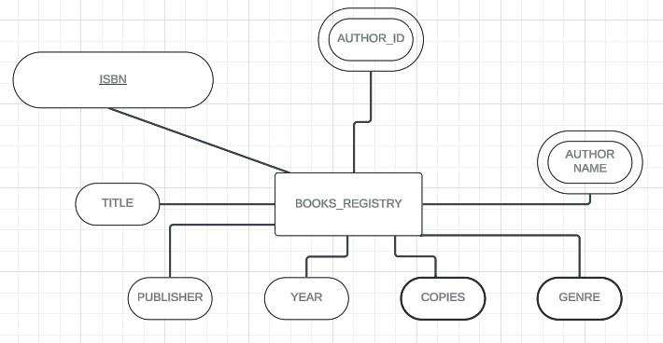

### 02)

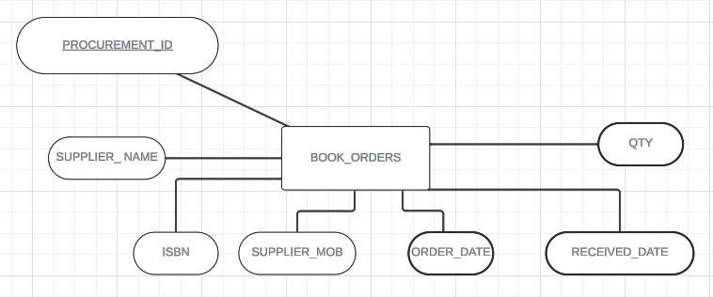

### 03)

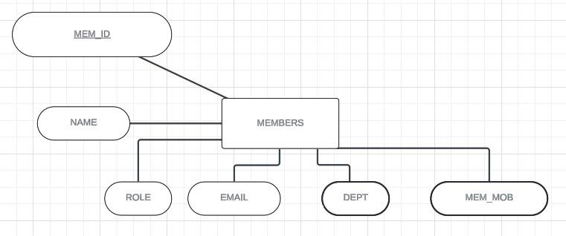

### 04)

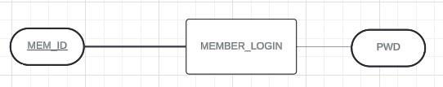

### 05)

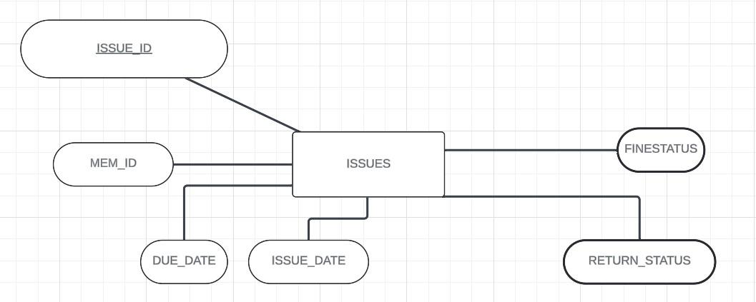

### 06)

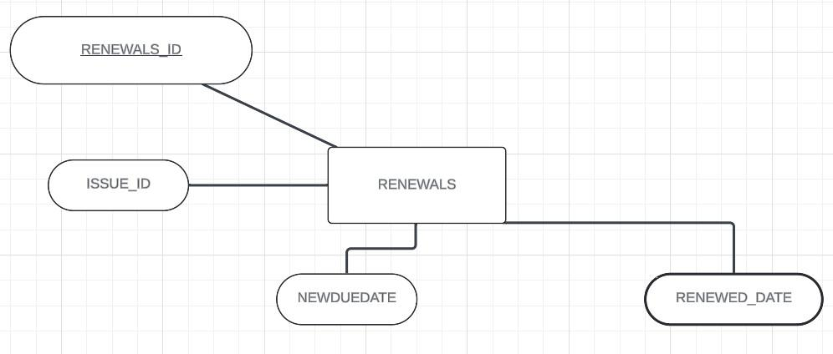

### 07)

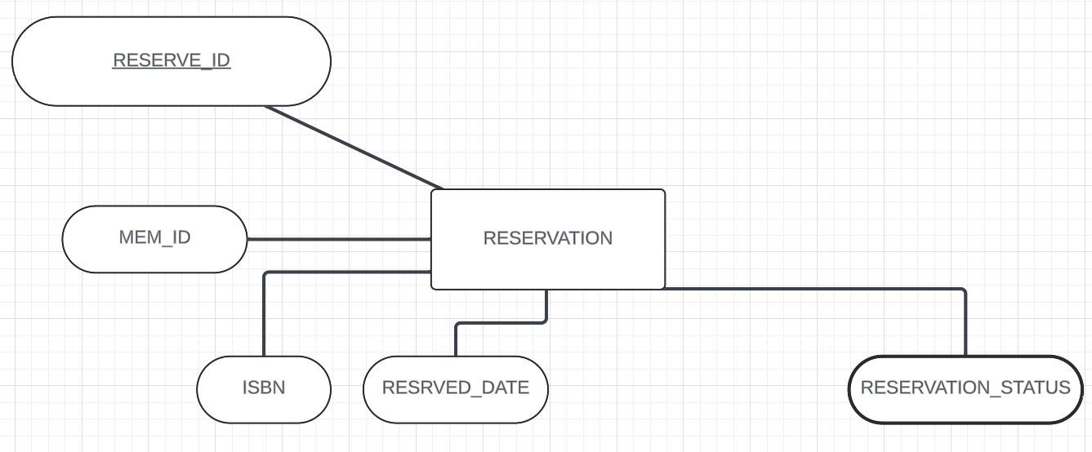

**RELATIONSHIPS:**

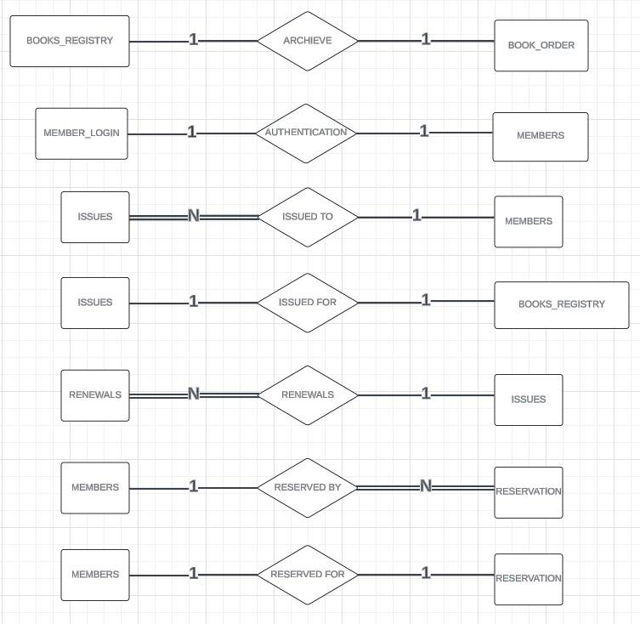

**E-R**

**DIAGRAM:**

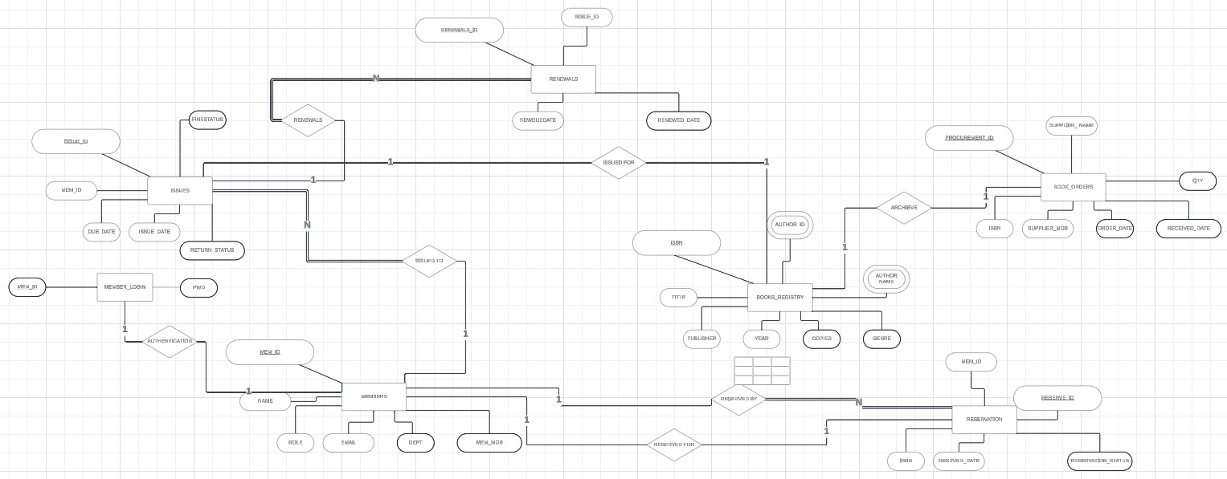

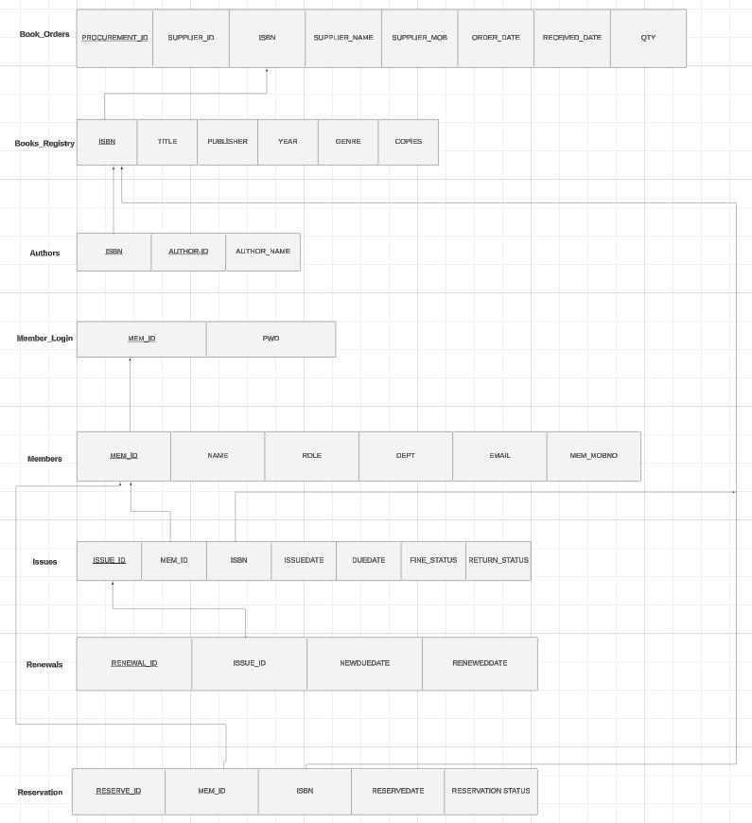**SCHEMA DIAGRAM:**

### NORMALIZATION

**1) Books_registry**

**Canonical cover:**

**ISBN→Title**

**ISBN→Publisher**

**ISBN→Year**

**ISBN→Copies**

**ISBN→Genre**

**Primary Key:** ISBN **FDS:**

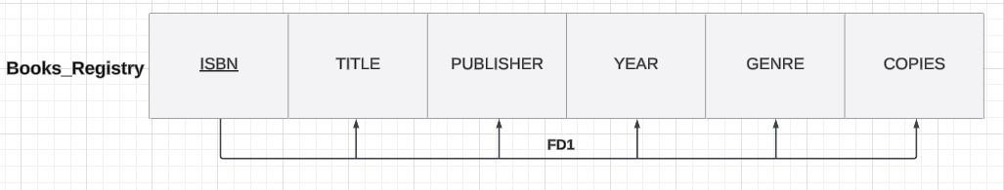

**FD1:ISBN→Title, Publisher, Year, Copies, Genre**

**1NF: Already in 1NF since there are no multivalue attributes**

**2NF: Already in 2NF since there are no partial functional dependencies**

**3NF: Already in 3NF since there are no transitive dependencies**

**2)Entity:Member_login Canonical cover: Mem_ID→Pwd**

**Primary Key: Mem_ID FDS:**

**FD1:Mem_ID→Pwd**

**1NF: Already in 1NF since there is no multivalue attributes**

**2NF: Already in 2NF since there is no partial functional dependencies**

**3NF: Already in 3NF since there is no transitive dependencies**

**3)Entity:Members Canonical cover:**

**Mem_ID→Name**

**Mem_ID→Role**

**Mem_ID→Dept**

**Mem_ID→Email**

**Mem_ID→Mem_mobno**

**Primary Key: Mem_ID FDS:**

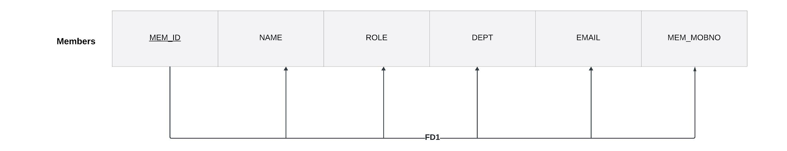

**FD1:Mem_ID→Name,Role,Dept,Email,Mem_mobno**

**1NF: Already in 1NF since there is no multivalue attributes**

**2NF: Already in 2NF since there is no partial functional dependencies**

**3NF: Already in 3NF since there is no transitive dependencies**

**4)Entity:Issues Canonical cover:**

**Issue_ID→Mem_ID**

**Issue_ID→ISBN**

**Issue_ID→Issuedate**

**Issue_ID→Duedate**

**Issue_ID→Returnstatus**

**Issue_ID→Duestatus**

**Primary Key: Issue_ID FDS:**

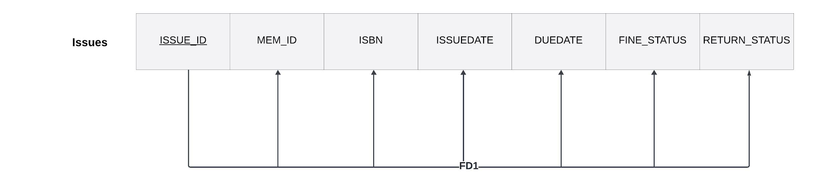

**FD1:Issue_ID→Mem_ID,ISBN,Issuedate,Duedate,Returnstatus,Duestatus**

**1NF: Already in 1NF since there is no multivalue attributes**

**2NF: Already in 2NF since there is no partial functional dependencies**

**3NF: Already in 3NF since there is no transitive dependencies**

**5)Entity:Renewals Canonical cover:**

**Renewal_ID→Issue_ID**

**Renewal_ID→Newduedate**

**Renewal_ID→Reneweddate**

**Primary Key: Renewal_ID FDS:**

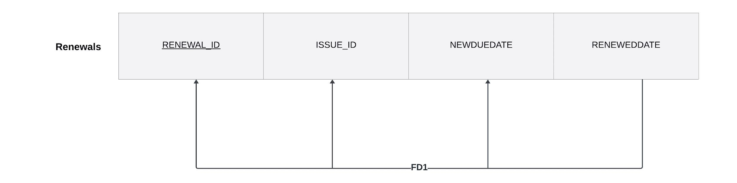

**FD1:Renewal_ID→Issue_ID,Newduedate,Reneweddate**

**1NF: Already in 1NF since there is no multivalue attributes**

**2NF: Already in 2NF since there is no partial functional dependencies**

**3NF: Already in 3NF since there is no transitive dependencies**

**6)Entity:Reservations Canonical cover:**

**Reservation_ID→Mem_ID**

**Reservation_ID→ISBN**

**Reservation_ID→Reservedate**

**Reservation_ID→Reservationstatus**

**Primary Key:Reservation_ID FDS:**

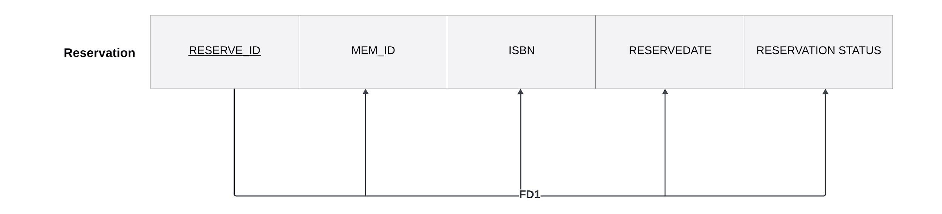

**FD1:Reservation_ID→Mem_ID,ISBN,Reserveddate,Reservationstatus**

**1NF: Already in 1NF since there is no multivalue attributes**

**2NF: Already in 2NF since there is no partial functional dependencies**

**3NF: Already in 3NF since there is no transitive dependencies 7)Entity:Authors Canonical cover:**

**Auth_ID→Authname**

**Primary Key: Issue_ID,Auth_ID FDS:**

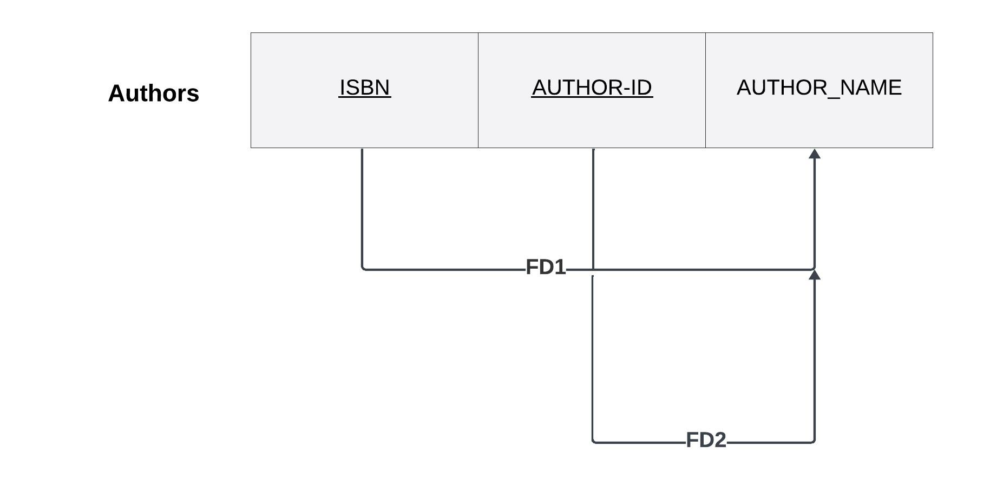

**FD1:Auth_ID→Authname**

**1NF: Already in 1NF since there is no multivalue attributes**

**2NF: It is violating 2NF since there is a partial functional dependency**

**Auth_ID→Authname**

**Thus we have to split the table into twos Authors2a and Authors2b as follows,**

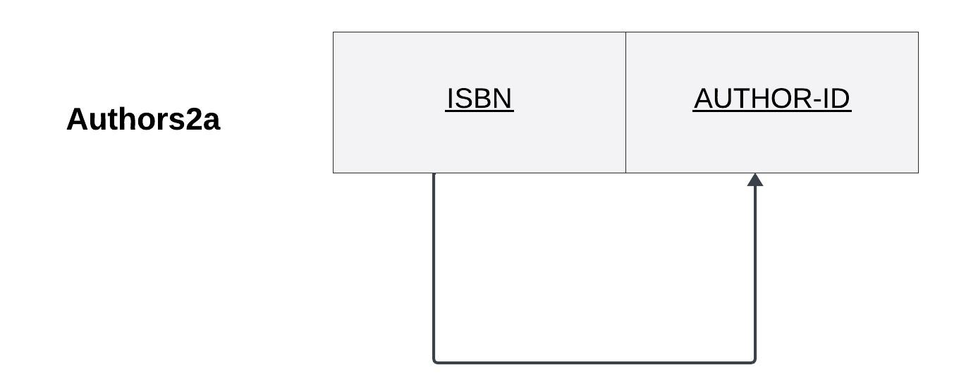

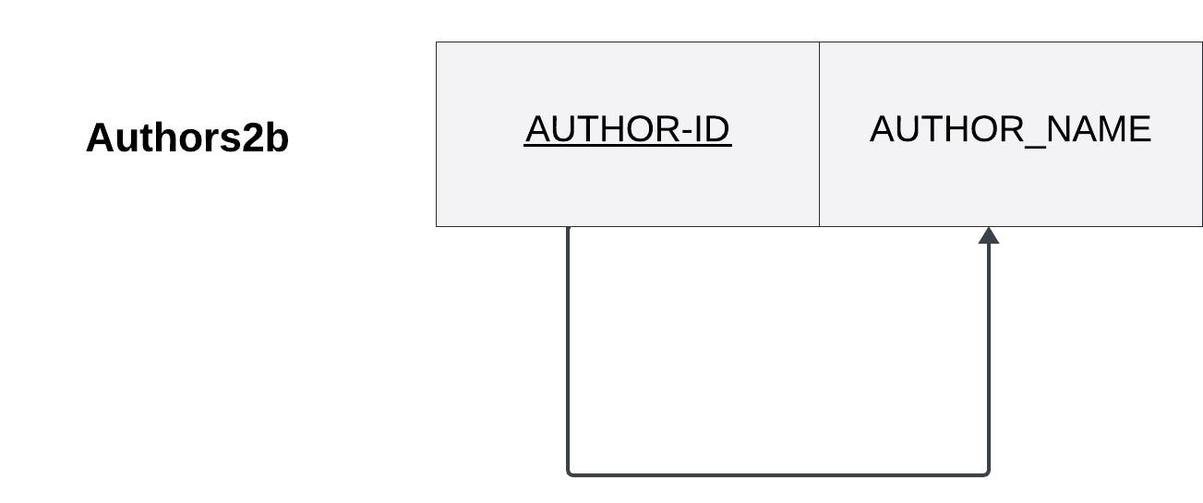

**3NF: Already in 3NF since there is no transitive dependencies**

**8)Entity:Book_orders Canonical cover:**

**Procurement_ID→Supplier_ID**

**Procurement_ID→ISBN**

**Procurement_ID→Order_date**

**Procurement_ID→Recived_date**

**Procurement_ID,ISBN→Quantity**

**Supplier_ID→Suppliername**

**Supplier_ID→Suppliermobno**

**Primary Key: Procurement_ID FDS:**

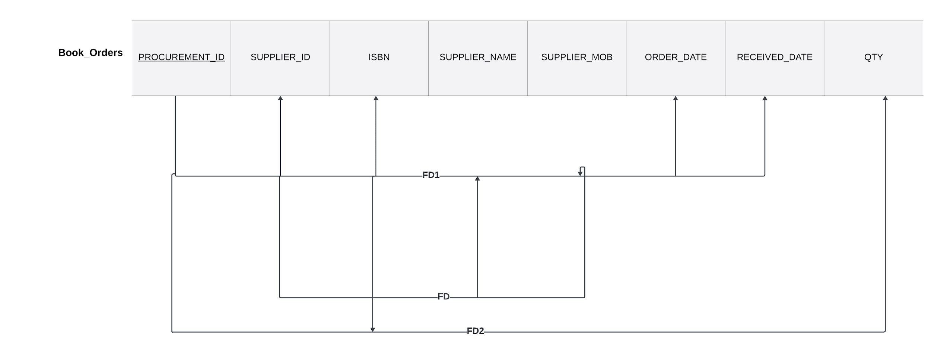

**FD1:Procurement_ID→Supplier_ID,ISBN,Order_date,Recived_date**

**FD2:Procurement_ID,ISBN→Quantity**

**FD3:Supplier_ID→Suppliername,Suppliermobno**

**1NF:ISBN is a multivalued attribute hence there is a 1NF violation but it is also a partial key so we can divide it as follows into Book_orders1a, Book_orders1b**

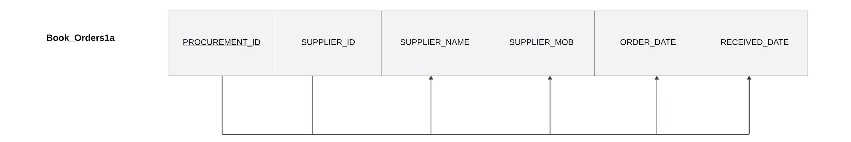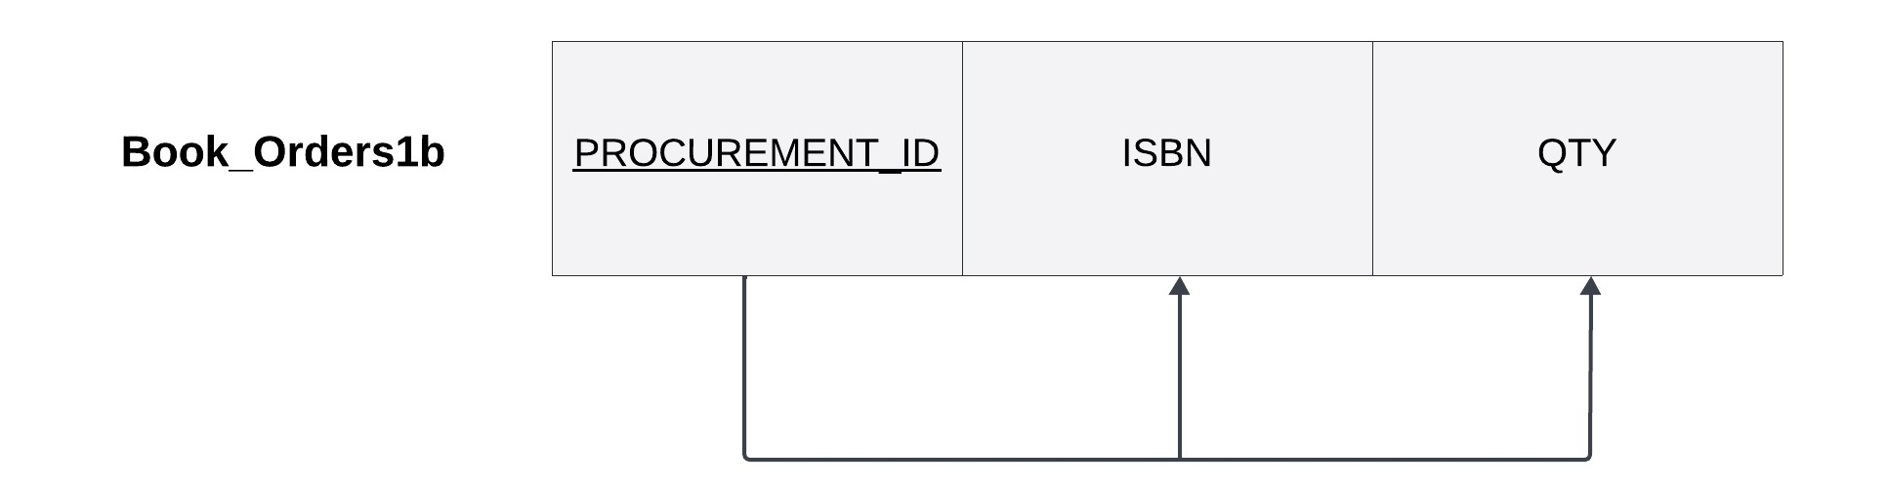

**2NF: Both the tables are in 2NF since there is no partial functional dependencies**

**3NF: Book_orders1a is in 3NF violation since there is a transitive dependency with respect to the Supplier_ID so we divide it into two tables as follows Book_orders2a and**

**Book_orders2b**

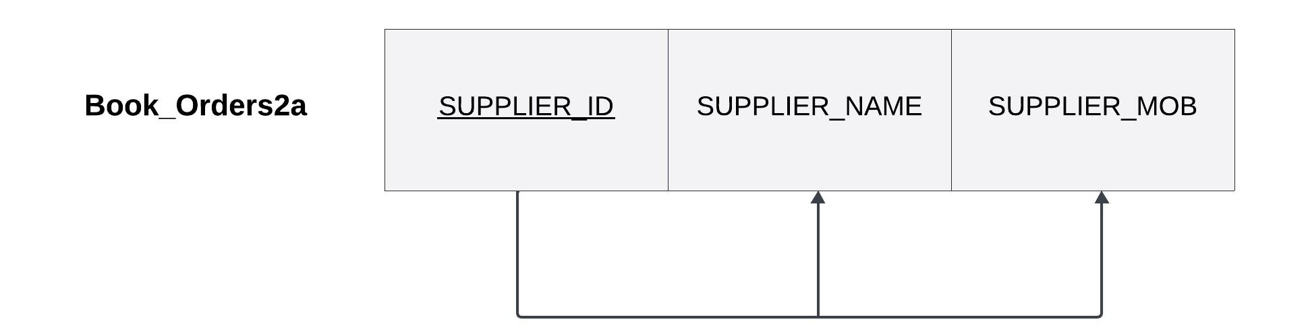

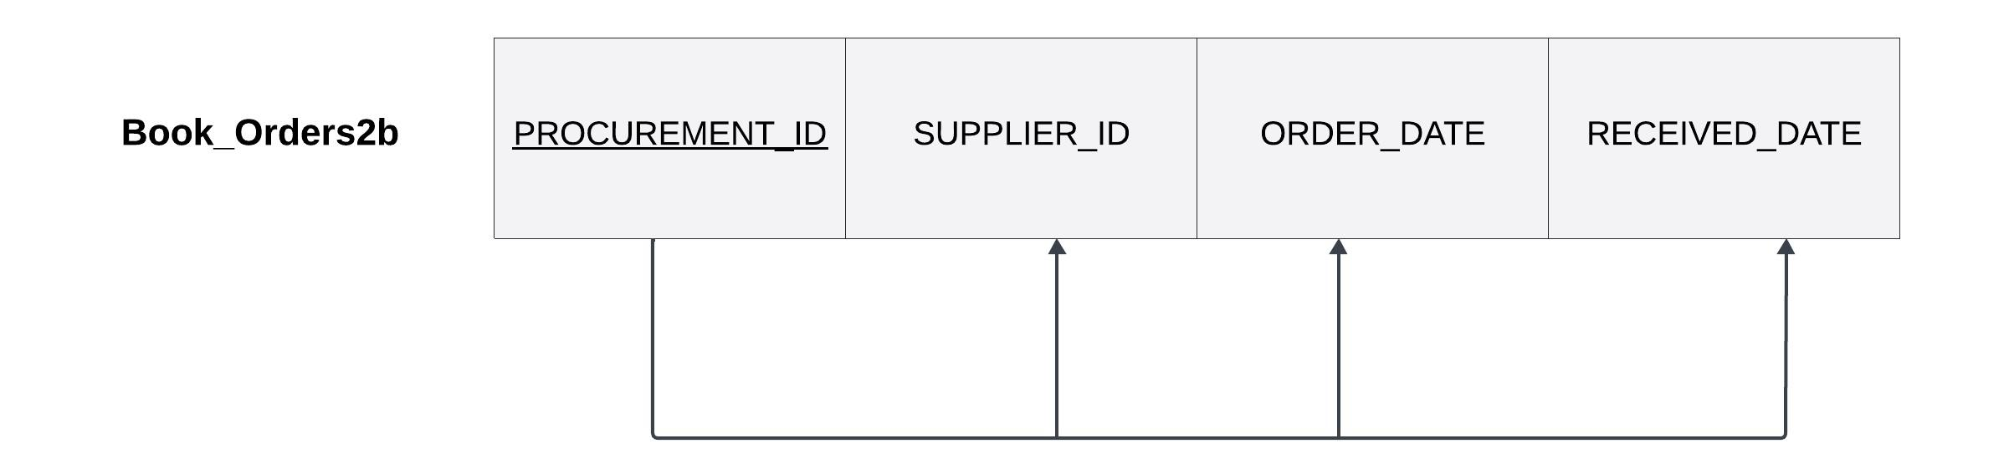

DBMS CONCEPTS USED

**1) TRIGGERS:**

**(i)Trigger_Insert_Reservation:**

CREATE OR REPLACE TRIGGER Trigger_Insert_Reservation

BEFORE INSERT ON Reservation

FOR EACH ROW

BEGIN

    IF :NEW.Reservation_ID IS NOT NULL THEN

        :NEW.reserve_status := 'PENDING';

    END IF;

END;

/

**Functionality:** Whenever a new reserve request is raised, the reserve status will default to ‘Pending’ and the reserve_status will be changed to ‘Issued’ later. This trigger **Trigger_Insert_Reservation** sets **reserve_status to pending for every new insertion** in the Reservation table.

**(ii) Trigger_Insert_Renewal:**

CREATE OR REPLACE TRIGGER Trigger_Insert_Renewal

BEFORE INSERT ON Renewals

FOR EACH ROW

BEGIN

    IF :NEW.Renew_ID IS NOT NULL THEN

        :NEW.Newdue_date := :NEW.Renewed_date + 7;

    END IF;

END;

/

**Functionality:** Every time a user renews his /her borrowed book (that is reflected as a new entry in the renewals table), this trigger **Trigger_Insert_Renewal** updates the newdue_date to Renewed_date+7 (i.e., **upon renewal add a week to the due date**)

**(iii)Trigger_Insert_issues_due_date:**

rem: 'trigger insert before issue due_date= issue_date+7'

CREATE OR REPLACE TRIGGER Trigger_Insert_issues_due_date

BEFORE INSERT ON Issues

FOR EACH ROW

BEGIN

IF :NEW.Issue_ID IS NOT NULL THEN

:NEW.Due_Date := :NEW.Issue_Date + 7;

:NEW.due_status := 'No due';

:NEW.return_status := 'Not Returned';

END IF;

END;

/

**Functionality:** Whenever a new user borrows a book, a new issue is made. This trigger **Trigger_Insert_issues_due_date** sets

* Due_Date as 7 days more than the issued date (which will be the system date-SYSDATE at the time of issue creation, SYSDATE is used in the Netbeans frontend)
* Due_status to ‘**No due**’ (default status)
* Return_status to ‘**Not Returned**’

**2)FUNCTIONS:**

**(i) Book_Stock:**

**CREATE OR REPLACE FUNCTION BOOK_STOCK (**

**ISBN1 IN NUMBER**

**)**

**RETURN NUMBER**

**IS**

**issue_count NUMBER;**

**book_copies NUMBER;**

**BEGIN**

**-- Get the count of issued books**

**SELECT COUNT(Issue_ID) INTO issue_count**

**FROM ISSUES**

**WHERE ISBN = ISBN1;**

**-- Get the total number of book copies**

**SELECT COPIES INTO book_copies**

**FROM Book_Registry**

**WHERE ISBN = ISBN1;**

**-- Return the number of available copies**

**RETURN book_copies - issue_count;**

**END;**

**/**

**Functionality:** The function **Book_Stock** is used to **return the number of copies in stock** of a particular book (identified by unique ISBN). This returns integer output by subtracting the number of issues done to a particular ISBN (from the Issues table) from the ‘copies’ value (total number of books of the given ISBN in the library’s possession) from the Book_Registry table for the corresponding ISBN.

**3) PROCEDURES/FUNCTIONS:**

**(i)Check_login**

CREATE OR REPLACE PROCEDURE check_login(

    p_mem_id IN Mem_login.mem_id%type,

    p_pwd IN Mem_login.mem_id%type,

    p_result OUT VARCHAR2

) AS

    v_count NUMBER;

BEGIN

    SELECT COUNT(*)

    INTO v_count

    FROM Mem_login

    WHERE mem_id = p_mem_id;

    IF v_count = 0 THEN

        p_result := 'not_found';

    ELSE

        SELECT COUNT(*)

        INTO v_count

        FROM Mem_login

        WHERE mem_id = p_mem_id AND pwd = p_pwd;

        IF v_count = 0 THEN

            p_result := 'wrong_password';

        ELSE

            p_result := 'login_successful';

        END IF;

    END IF;

END;/

**Functionality:** This procedure checks the validity of the user trying to login to the system. **It verifies that the corresponding username and password** matched in the backend relation ‘Mem_login’ which contains all the usernames and passwords of registered users.

**(ii)Book_Status**

CREATE OR REPLACE PROCEDURE BOOK_STATUS(

ISBN1 IN INT,

MEM_ID1 IN VARCHAR2,

STATUS OUT VARCHAR2

) IS

stock NUMBER;

issues_check VARCHAR2(1);

reserve_check VARCHAR2(1);

BEGIN

stock := 0;

-- Handling for issues_check

BEGIN

SELECT 'Y' INTO issues_check

FROM Issues

WHERE ISBN = ISBN1 AND MEM_ID = MEM_ID1;

EXCEPTION

WHEN NO_DATA_FOUND THEN

issues_check := NULL;

END;

-- Handling for reserve_check

BEGIN

SELECT 'Y' INTO reserve_check

FROM Reservation

WHERE ISBN = ISBN1 AND MEM_ID = MEM_ID1;

EXCEPTION

WHEN NO_DATA_FOUND THEN

reserve_check := NULL;

END;

-- Calculate stock using the BOOK_STOCK function

stock := BOOK_STOCK(ISBN1);

-- Determine status based on checks

IF reserve_check IS NOT NULL AND issues_check IS NULL THEN

STATUS := 'RESERVED';

ELSIF issues_check IS NOT NULL AND reserve_check IS NULL THEN

STATUS := 'BORROWED';

ELSE

IF stock = 0 THEN

STATUS := 'UNAVAILABLE';

ELSE

STATUS := 'AVAILABLE';

END IF;

END IF;

END;

/

**Functionality:** The procedure Book_Status is used to **classify each book** (also taking into consideration the member ID to one of the following categories

* Reserved
* Borrowed
* Available
* Unavailable

First, the procedure uses the member ID and the ISBN searched, and checks for records in the Reservation and Issues table for the particular member ID and ISBN pair to find if that book is either borrowed (record available in the issues table) or reserved ( record available in the reservation table) by the user already and the set the status accordingly to ‘**BORROWED**’ or ‘**RESERVED**’.

If the book is neither reserved nor borrowed, it calculates the number of books currently available with the library using the BOOK_STOCK function and sets the status to ‘**AVAILABLE**’ or ‘**UNAVAILABLE**’.

**(iii) Random_Check_Issues:**

CREATE OR REPLACE PROCEDURE RANDOM_CHECK_ISSUES (

random_value IN VARCHAR2,

value_exists OUT INT

)

IS

BEGIN

SELECT COUNT(*)

INTO value_exists

FROM ISSUES

WHERE issue_id= random_value;

EXCEPTION

WHEN NO_DATA_FOUND THEN

value_exists := 0;https://docs.google.com/document/d/1Dr9b5ydoWg6bQW2fpSu-vOABD76ILpum/edit?usp=sharing&ouid=103133928149497977141&rtpof=true&sd=true

WHEN OTHERS THEN

value_exists := -1;

RAISE;

END RANDOM_CHECK_ISSUES;

/

**Functionality:** The procedure ‘Random_check_issues’ checks if the random Issue_ID generated (in Netbeans Frontend) during the insertion of a new issue into the ‘Issues’ table is already present in the Issues table or not. This allows us to ensure unique Issue_ID is generated **to avoid Entity Integrity Constraint** since Issue_ID is a primary key.

**(ivi) Random_Check_Renewals:**

CREATE OR REPLACE PROCEDURE RANDOM_CHECK_RENEWALS (

random_value IN VARCHAR2,

value_exists OUT INT)

IS

BEGIN

SELECT COUNT(*)

INTO value_exists

FROM RENEWALS

WHERE renew_id= random_value;

EXCEPTION

WHEN NO_DATA_FOUND THEN

value_exists := 0;

WHEN OTHERS THEN

value_exists := -1;

RAISE;

END RANDOM_CHECK_RENEWALS;

/

**Functionality:** The procedure ‘Random_check_renewals’ checks if the random Renew_ID generated (in Netbeans Frontend) during the insertion of a new renewal into the ‘Renewals’ table is already present in the Renewals table or not. This allows us to ensure unique Renew_ID is generated **to avoid Entity Integrity Constraint** since Renew_ID is a primary key.

**Sample Demo:**

**Login page of the user:**

It permits the user to login based on their preventially saved credentials when they signedup for the first time .In our app we have two kinds of login one is the members of the library (the users) and then the librarian(admin).

Lets go through the member’s login first

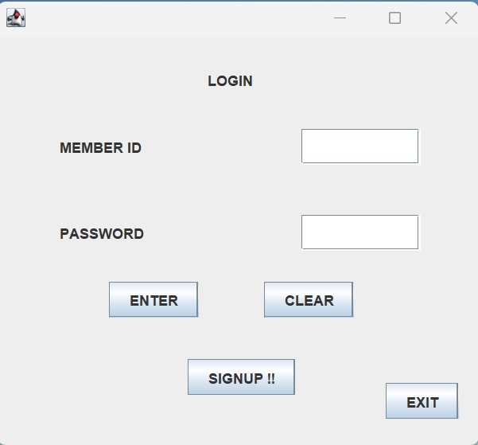

**This is the homepage**

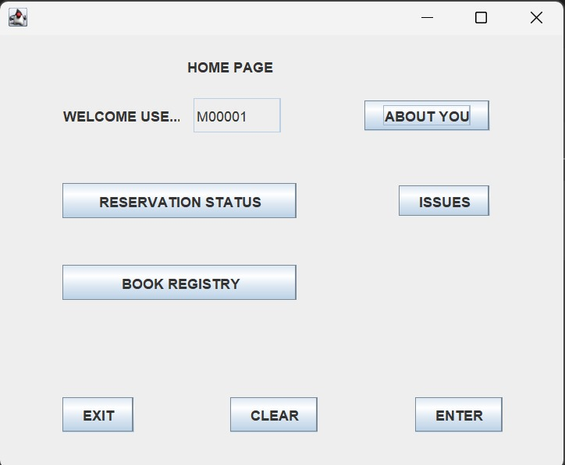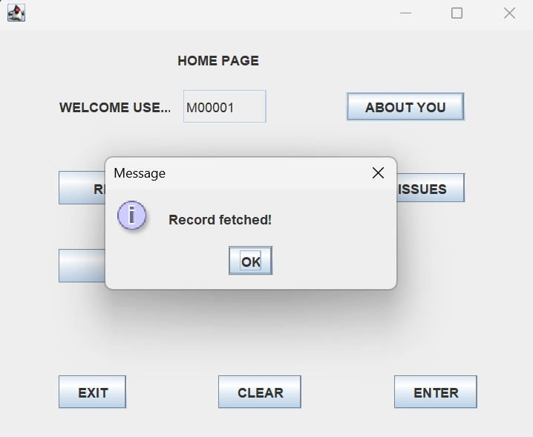**This is the about you page: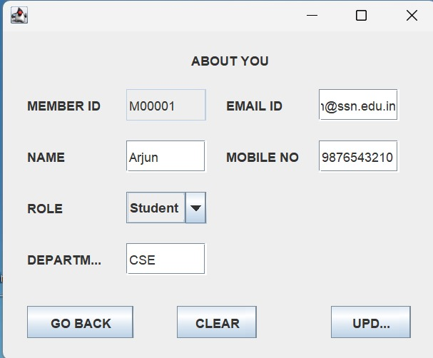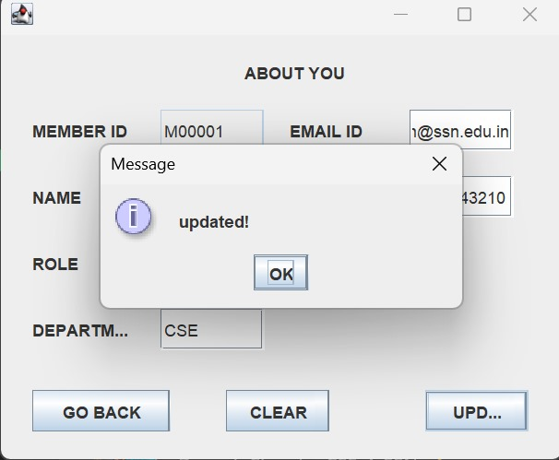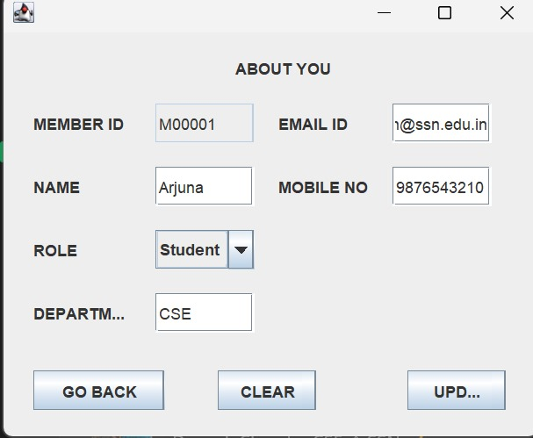This is the reservation page: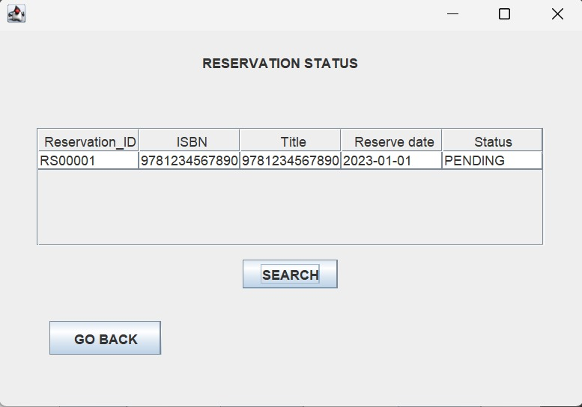This is the issues page: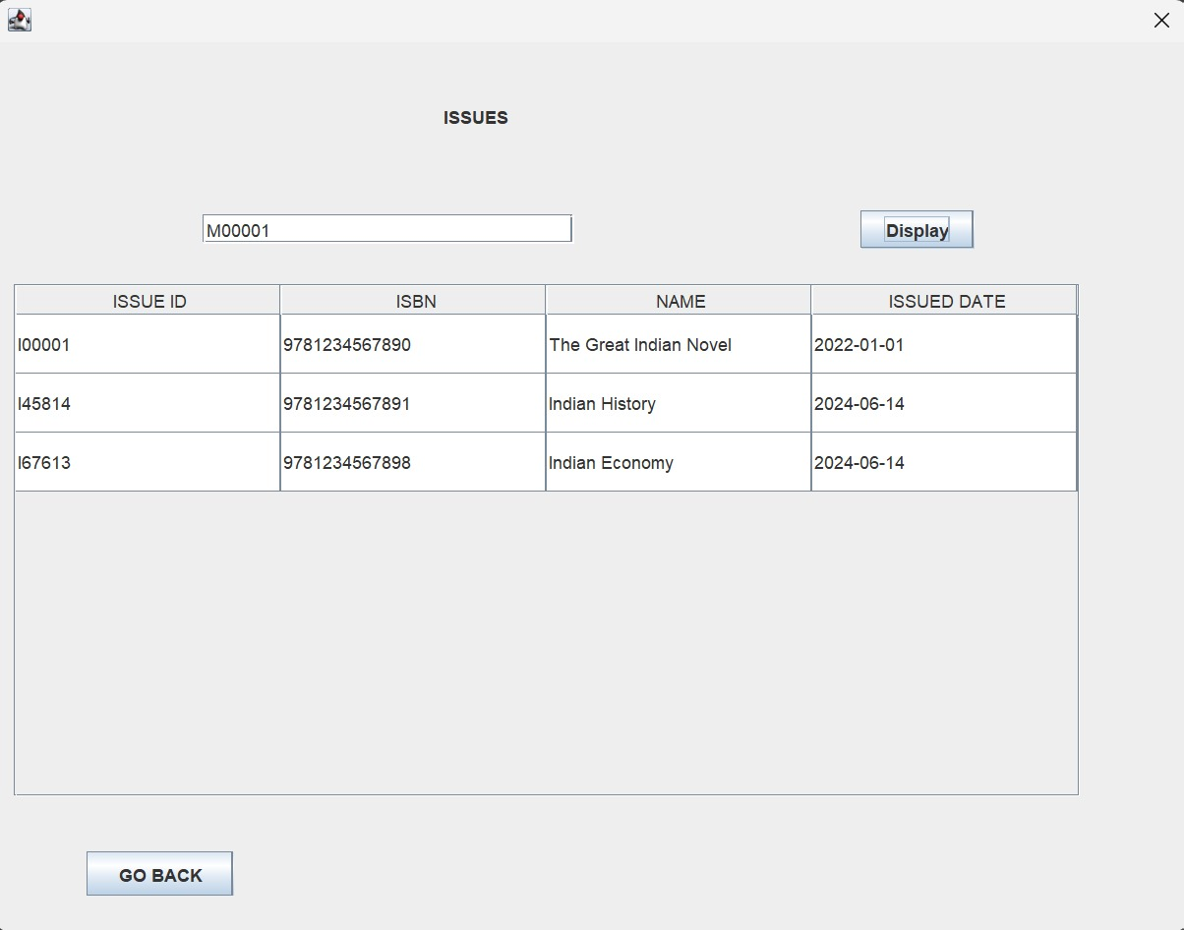This is the books registry page to search for a book 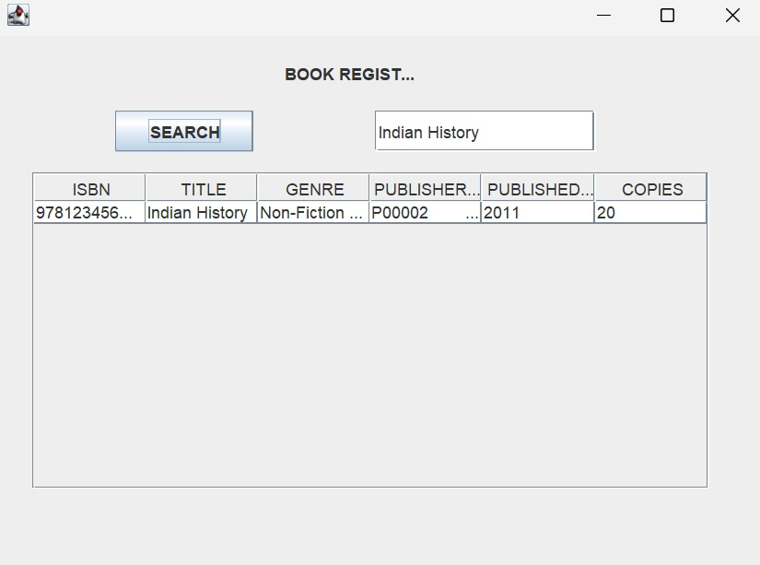This is the searched and selected book information page 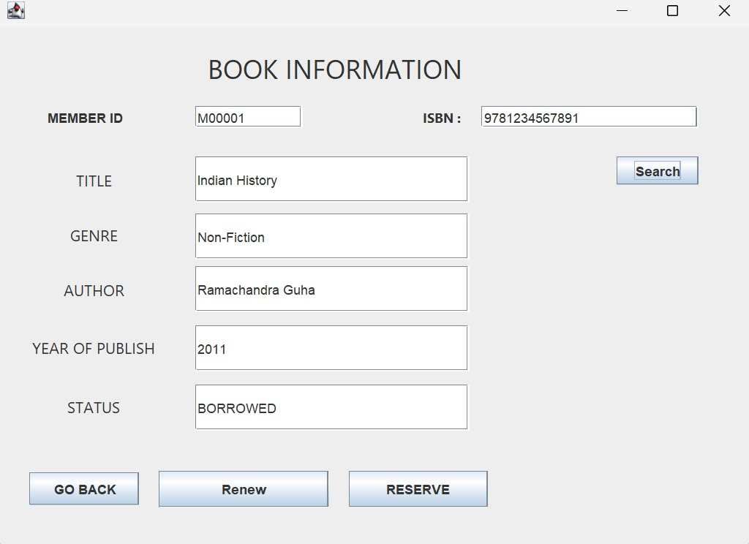This is the admin login page 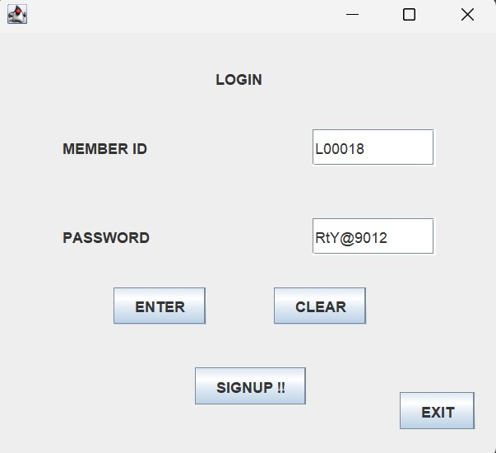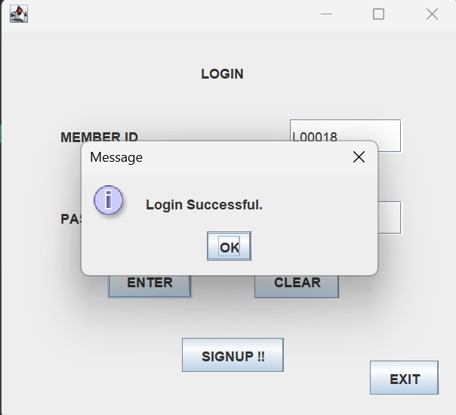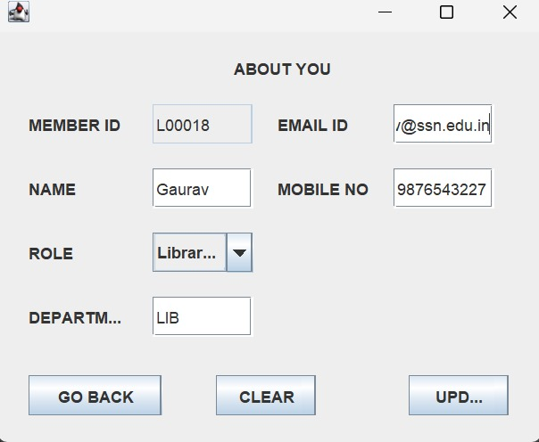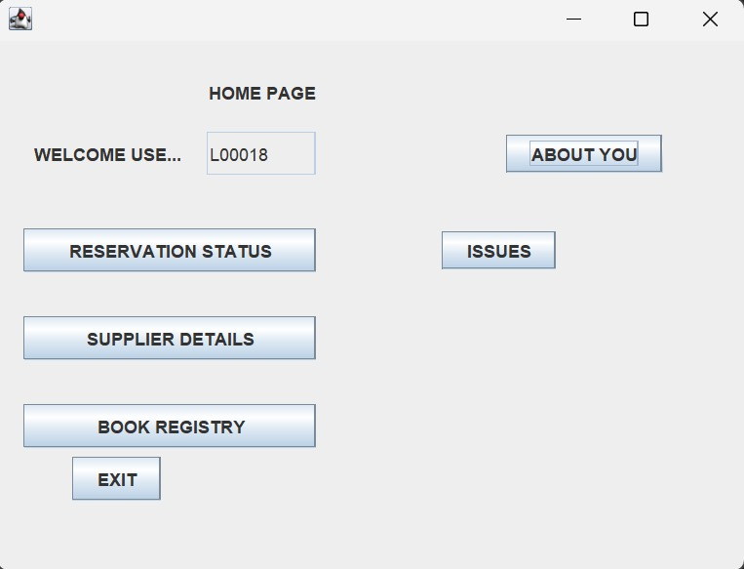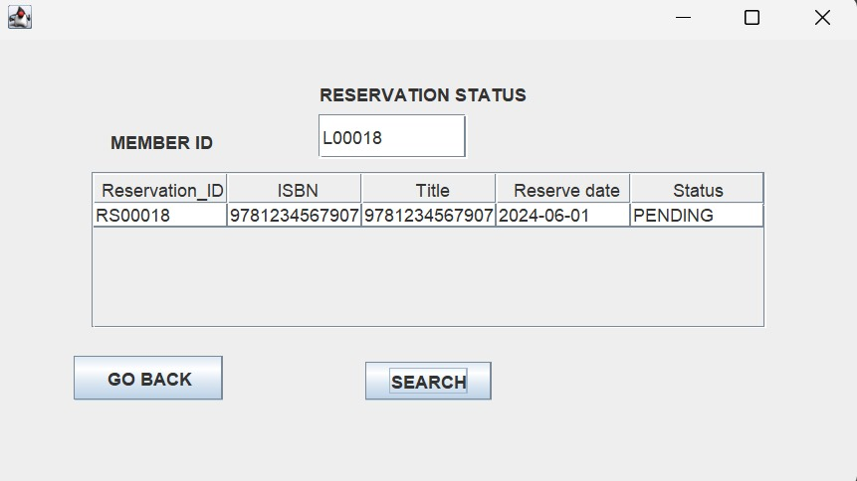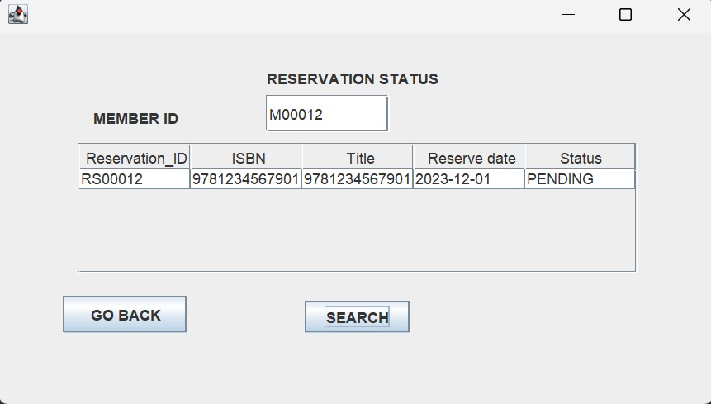This is the supplier details page: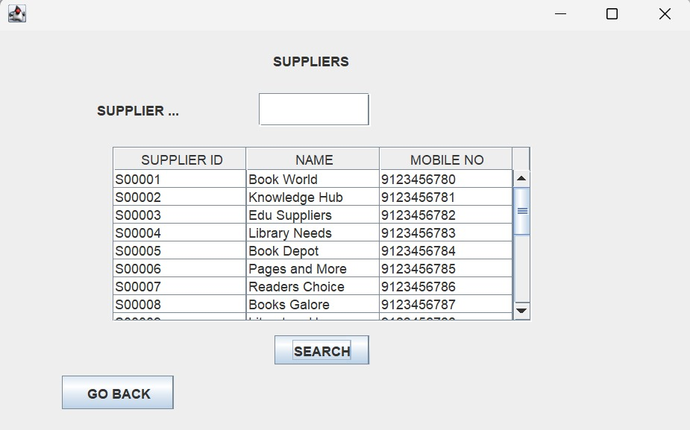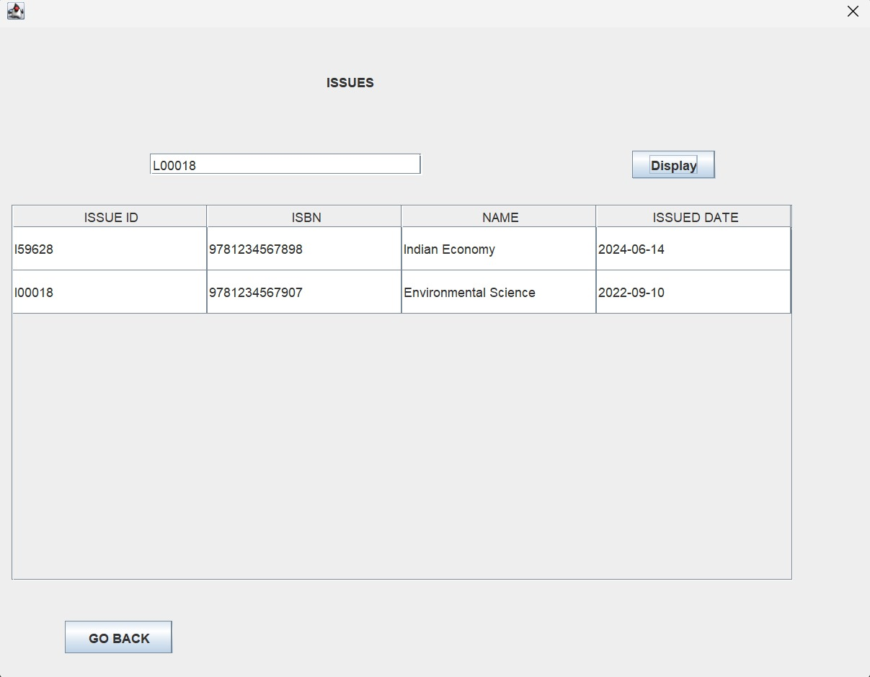This is the page where the admin can search for the issues given to the users**