Deep Learning based Object Detection and Recognition Framework for the Visually-Impaired
In this project we are combining SSD300 (single shot detector) with inception model to detect and recognized CURRENCY NOTES. SSD is capable of recognizing 21 classes but will not recognized currency notes so we have added extra layer with extra class to detect currency notes but its accuracy is not good so we extracted features from SSD and then retrained with INCEPTIONV3 which is able to get accuracy more than 98%.
For currency detection we have used INDIAN OLD NOTES dataset as new currency notes dataset not available so we trained SSD and inception with OLD currency notes and then this new model can detect total 21 classes with 1 more class as currency so now SSD can detect and recognized total 22 classes.
Below is the currency dataset use for inception training
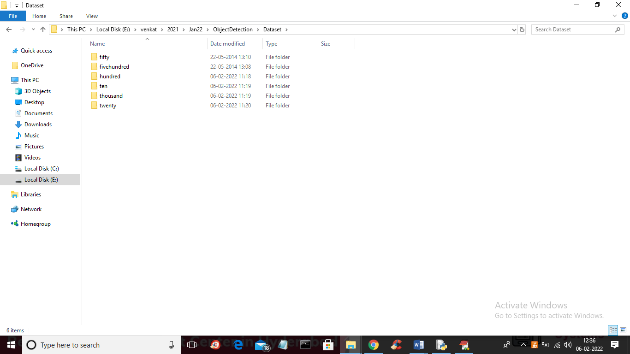
In above screen we have folders for different currency notes and you just go inside any folder to view images of that currency notes like below screen
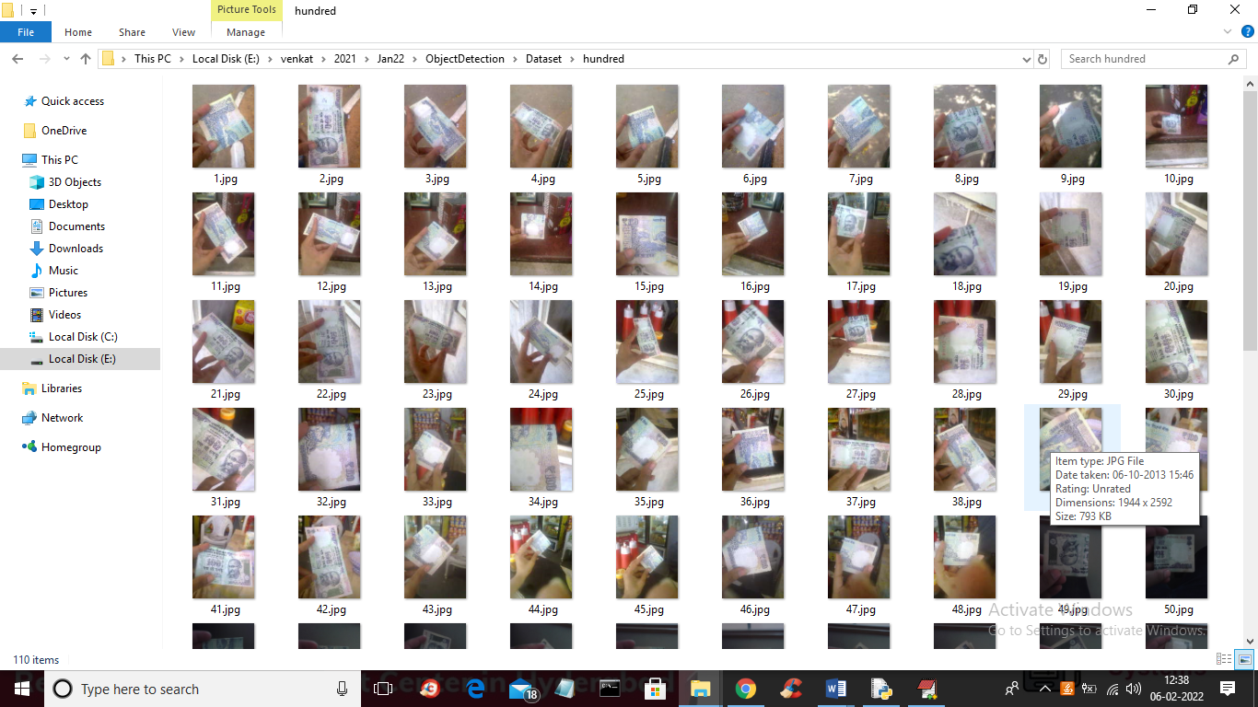
We will used above images to train both SSD and INCEPTION models
To implement this project we have designed following module
- Generate SSD-Inception Model: using this module we will generate and load SSD300 and inception model
- Run SSD300 Object Detection & Classification: using this model we will detect and classify object (21 classes with currency) using SSD and Inception model
- Inception Accuracy & Loss Graph: using this module we will plot Inception training accuracy and loss graph
SCREEN SHOTS
To run project double click on ‘run.bat’ file to get below screen
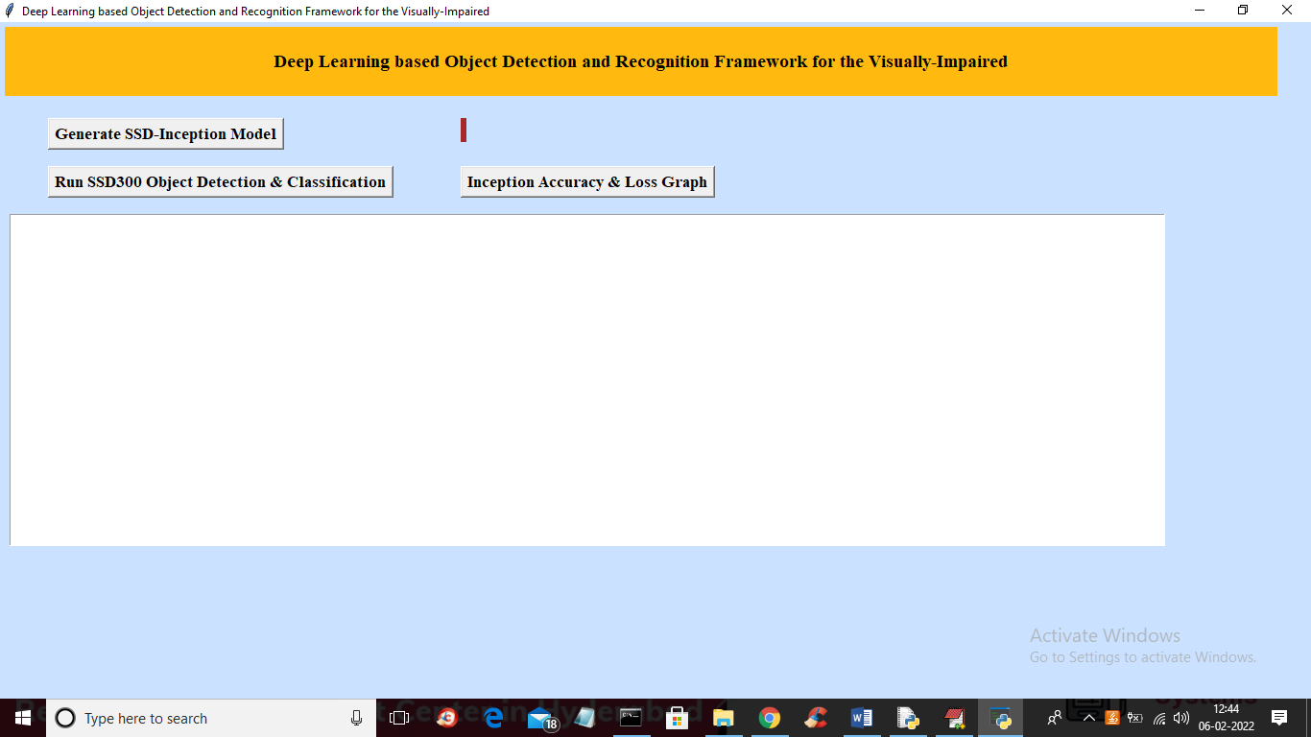
In above screen click on ‘Generate SSD-Inception Model’ button to load models and to get below screen
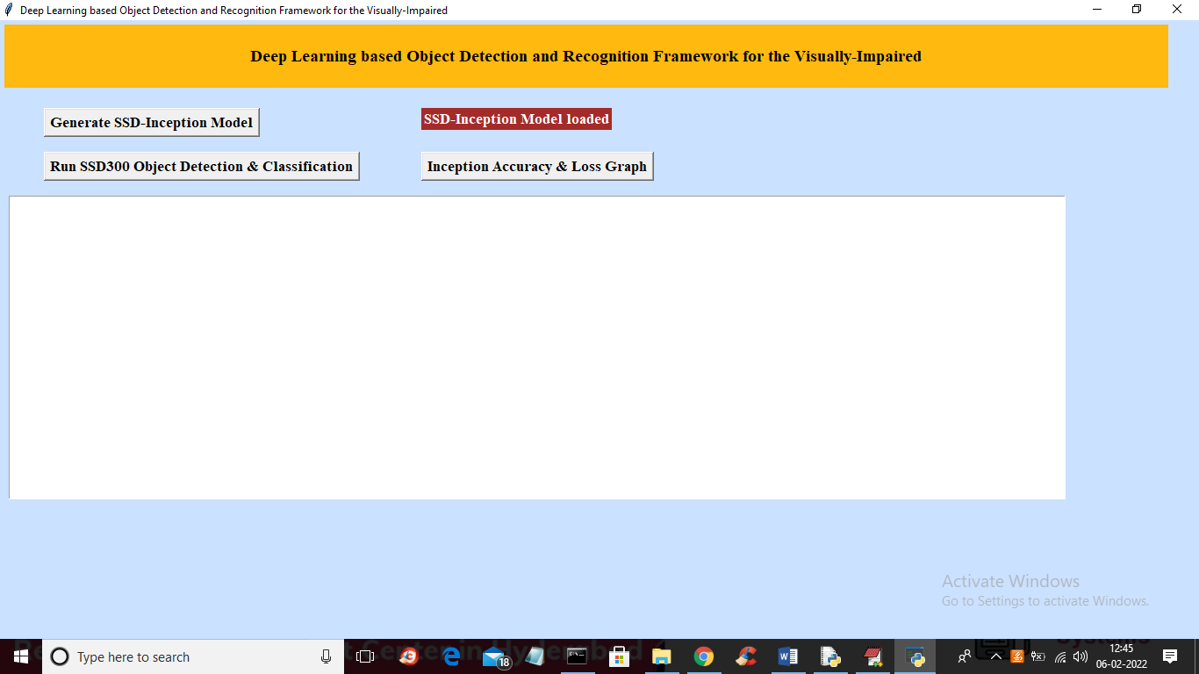
In above screen in red colour text we can see models loaded and now click on ‘Run SSD300 Object Detection & Classification’ button to upload image and then classify object
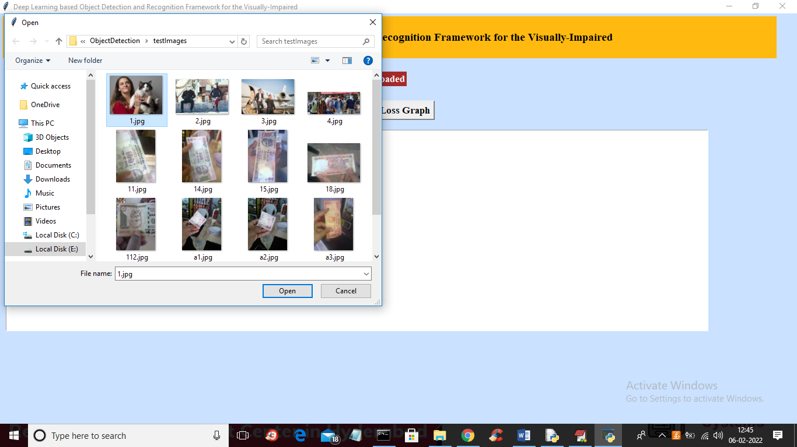
In above screen selecting and uploading 1.jpg file and then click on ‘Open’ button to get below output
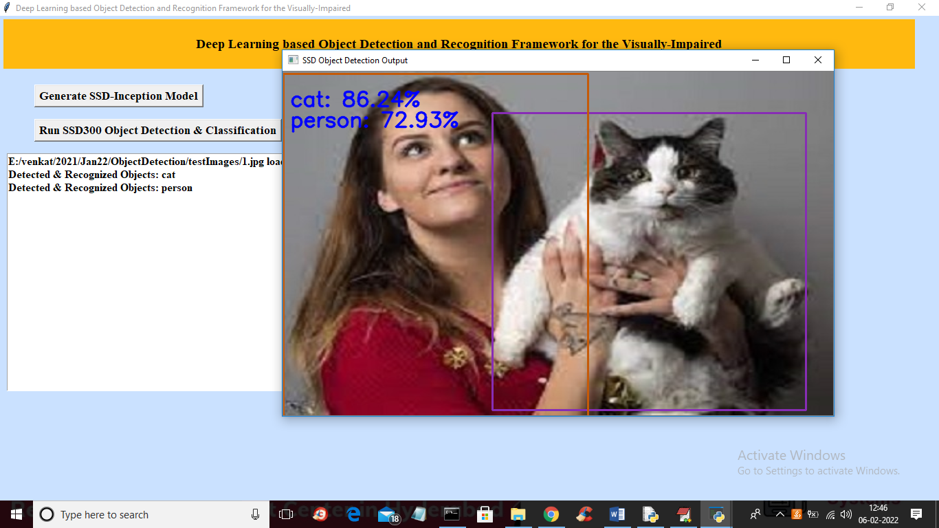
In above screen objects detected and classified as person and cat and now try other images
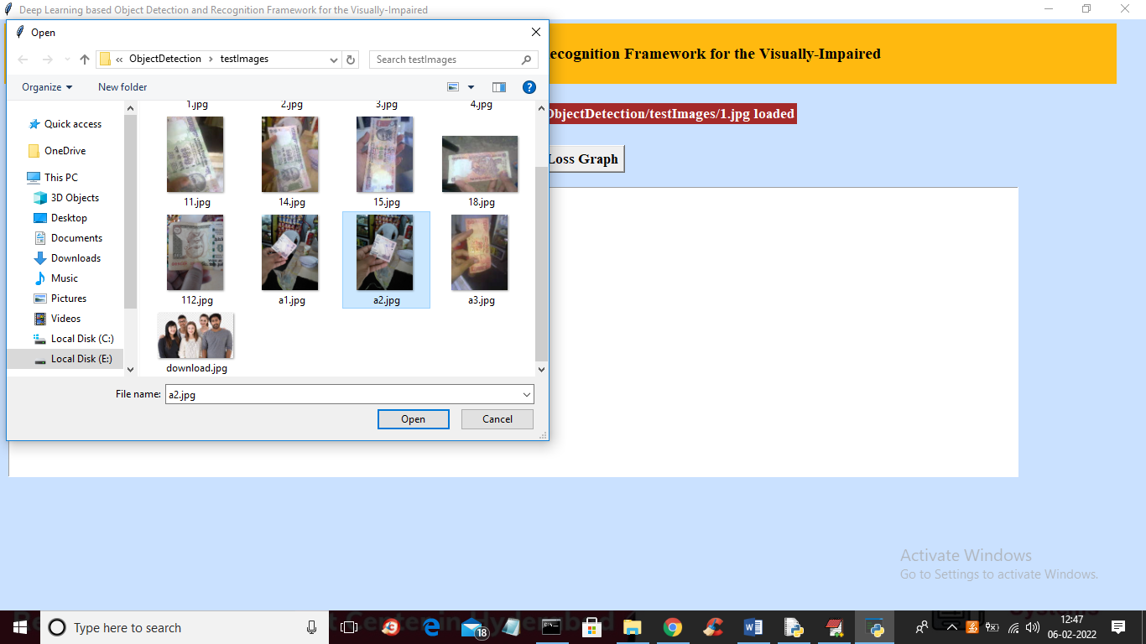
For above a2.jpg selection below is the output
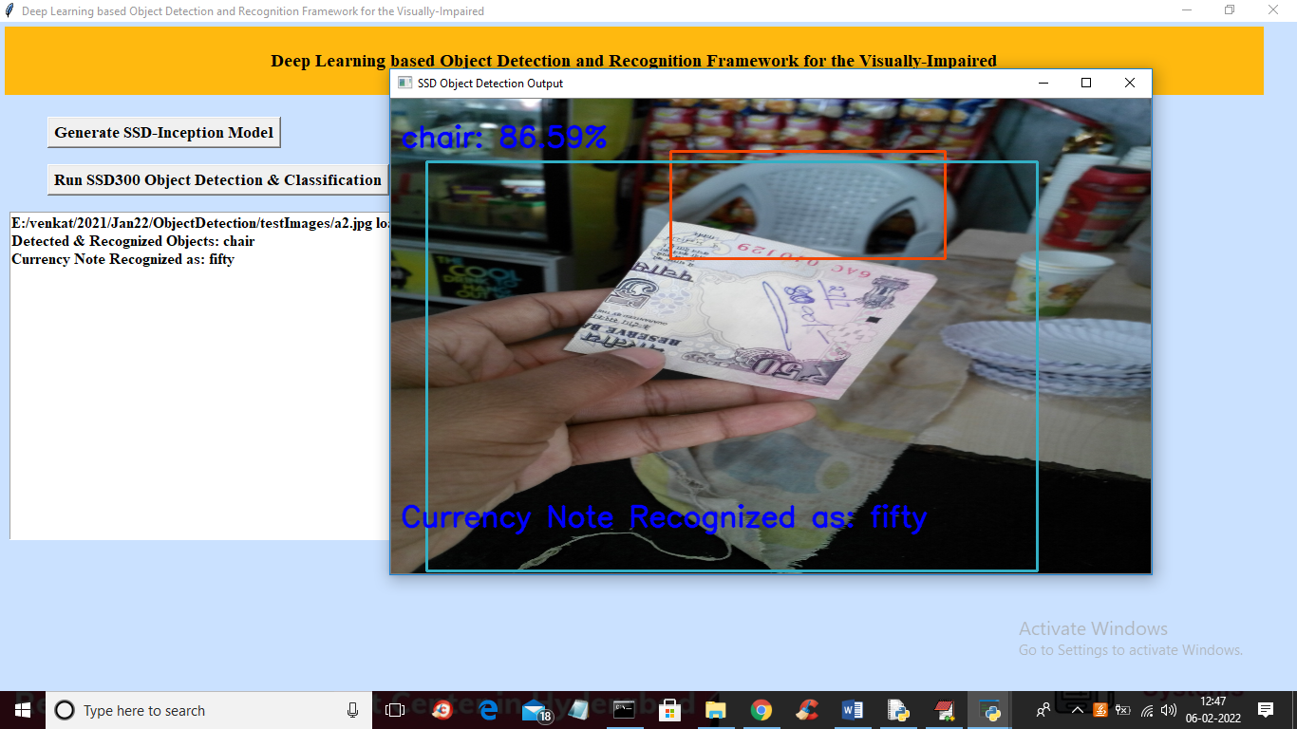
In above screen application displaying chair and currency note fifty detected and no test other images
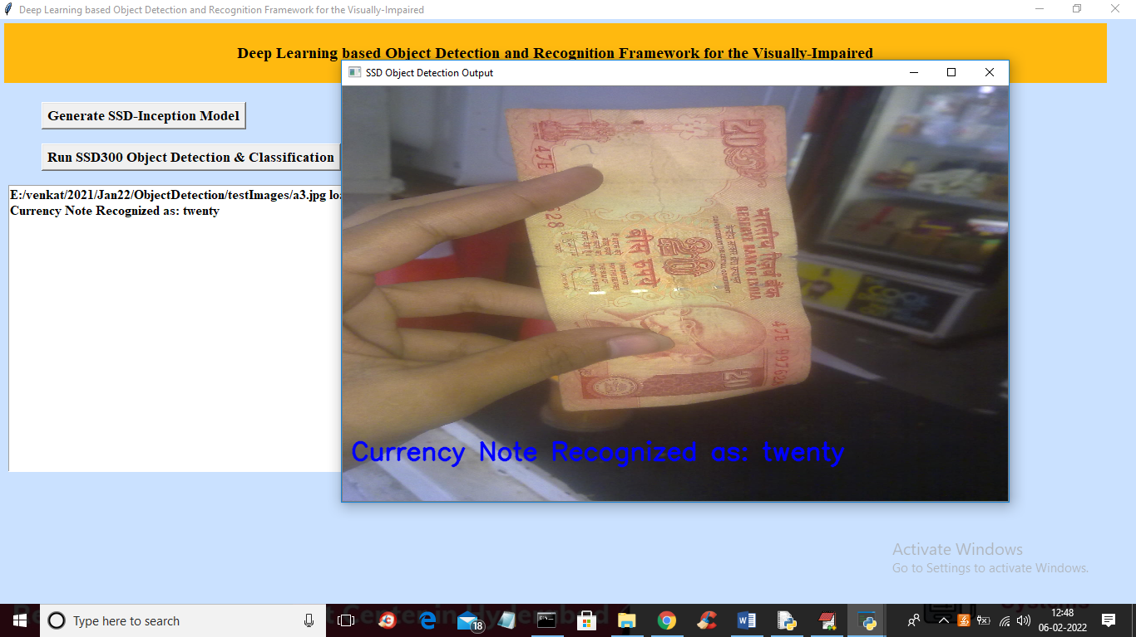
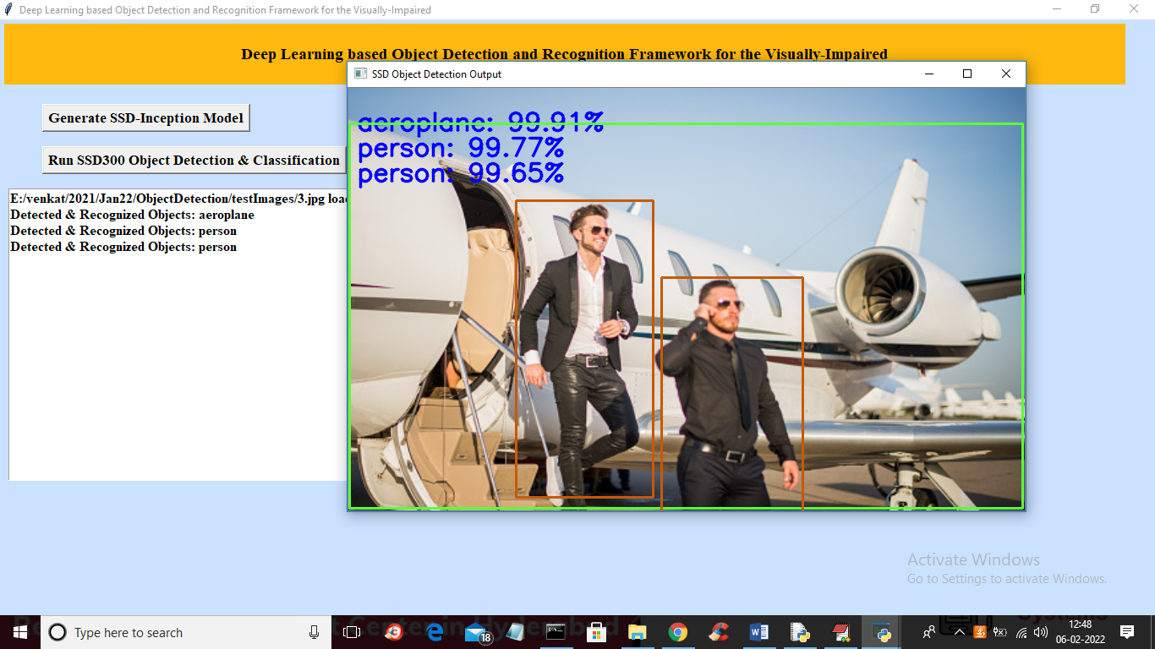
In above screen in text area as well as images you can see printing of detected objects and similarly you can upload and test other images
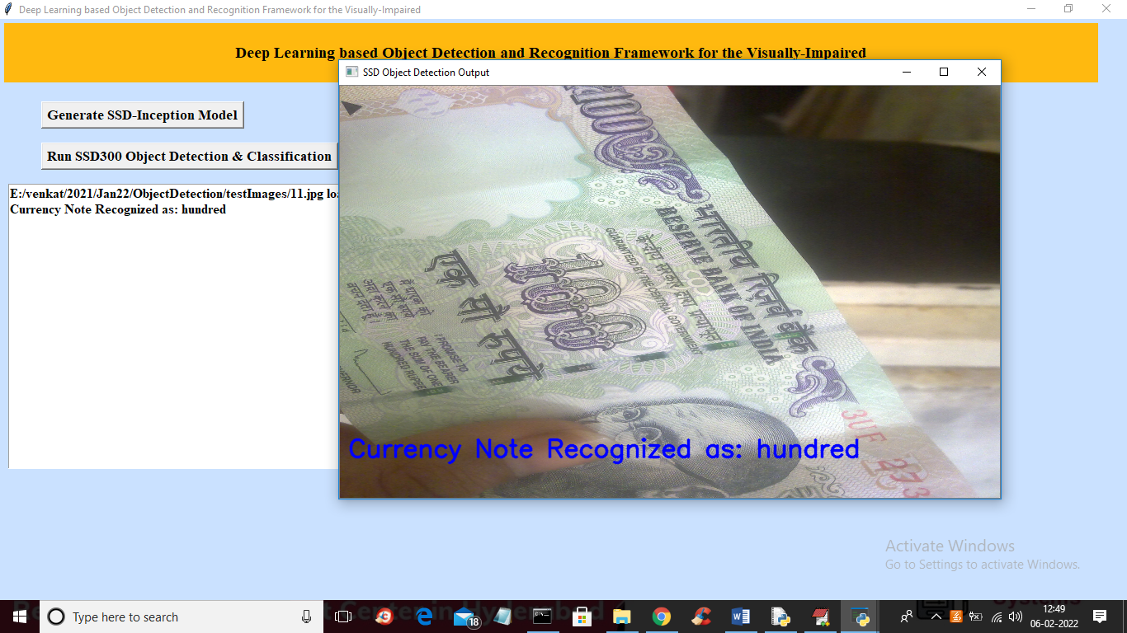
Now click on ‘Inception Accuracy & Loss Graph’ button to get below graph
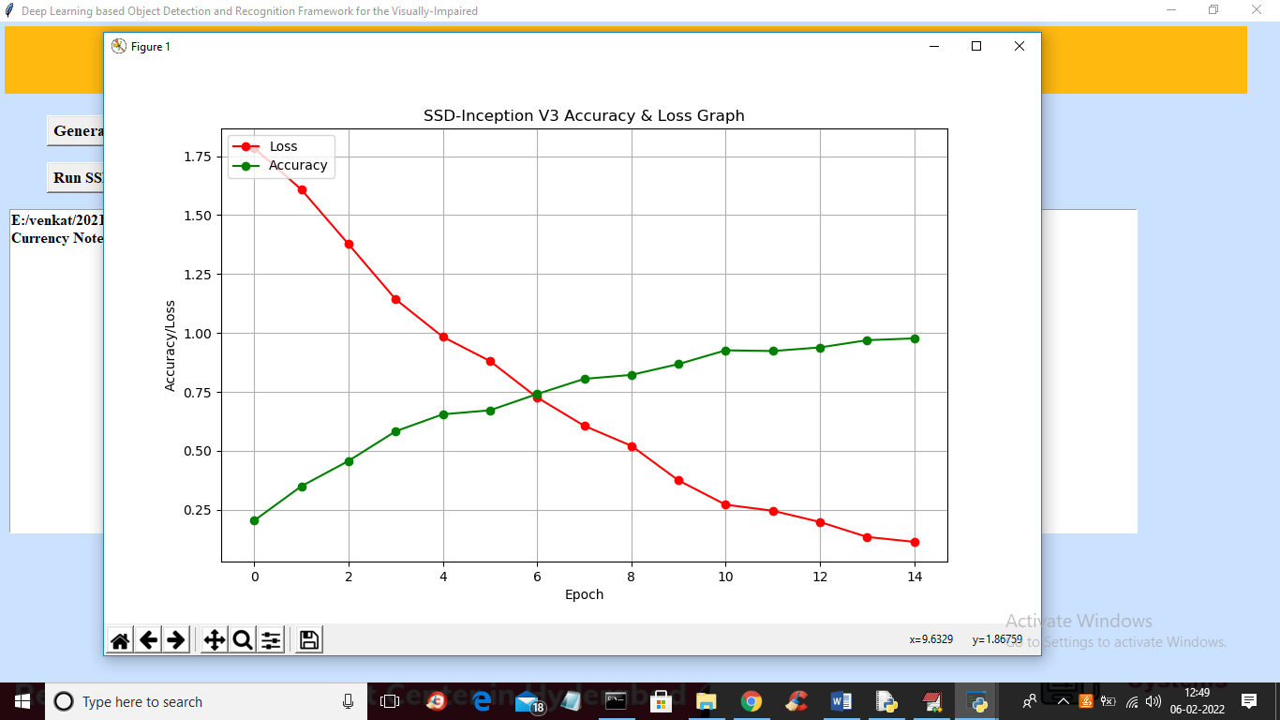
To train Inception we took 15 epoch so in above graph x-axis represents epoch and y-axis represents accuracy and loss values and in above graph green line represents accuracy and red line represents loss and we can see with each increasing epoch accuracy get increase and loss get decrease and at final epoch accuracy reached to 100% and loss reached to 0. So this proves that inception is train efficiently to detect all classes

