Mantid

Script Repository Detailed Design Document

# Introduction

## Purpose of this Document

This document describes the detailed design of the Script Repositoy toolbox for Mantid framework.

It will form the basis of the development of this aspect of the framework and act as a guide for maintaining the system.

## Scope of this Document

todo

## Context of this issue

Provide a version control support for the *MantidScripts* and Reduction/Analysis algorithms being developed and used in the context of Mantid from the users and instrument scientists. Give the Mantid Development Team, the opportunity to help to improve the quality and the usage of the Mantid framework by getting in touch with the *MantidScripts* being used. Allow the Development Team to switch off the old python api.

## Definition of the Terms

# *MantidScripts*: Used to define the python scripts supposed to run using the Mantid API to reduce or analyse data.

# ScriptRepository Toolbox

## Context

The goals presented here has been analysed by the Development Team, and in order to allow the users and scientist to share their *MantidScripts* a git repository was created at: [mantidproject/scripts](https://github.com/mantidproject/scripts). Unfortunately, this strategy has never launched off, we suppose mainly because the users and scientist:

* were not aware of its existence, or did not see any benefit of it;
* could not understand the technical issues related to downloading and uploading files at github.
* would get confused trying to figure out which files/directories could interest them.
* need a github account and special permission to be able to publish their files.

In order to cope with these limitations, the Development Team, will create a User Interface that wraps the issues related to the github, including it to the MantidPlot.

Following there is a list of requirements for this new module.

ScriptSharingGUI; and

* ScriptSharingService

The first one, is that will allow the user to deal with the files inside the script folder. While the second, will be responsible for background services as updating the git repository, checking updates, etc.

## Requirements

* MantiPlot GUI interaction.
* Connection to the git repository : [mantidproject/scripts](https://github.com/mantidproject/scripts)
* Allow the user to choose the files and directories that he want to download. He won’t be interested having all the files locally if he wants just one *MantidScripts*
* List all the files available at the repository
* Provide description of the files/scripts.
* Show history of the changes of the file.
* User should not be concern that git is being used as support technology.
* Allow the user to publish his own *MantidScripts*.
* Allow three kind of *MantidScripts* updates:
  + Update the script when a new remote version is available
  + Alert the user when a new remote version is available
  + Check for update for the scpecific file/folder only on user request
* Protect local changes -> do not override local changes. Give the user this responsibility
* Provide user clear messages on misbehaviour of the system (for example, no internet connection)
* Do not consume much system resources (specially in background process)
* Expose the functionalities to the python API.

## ScriptRepositoryGUI

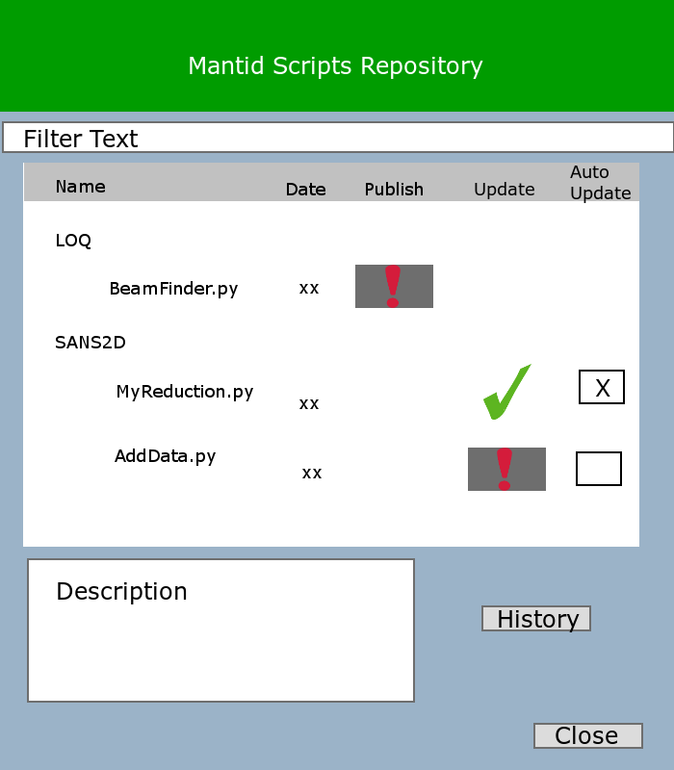

Figure 1 ScriptRepositoryGUI

### UML

#### Diagram For ScriptRepository User interface

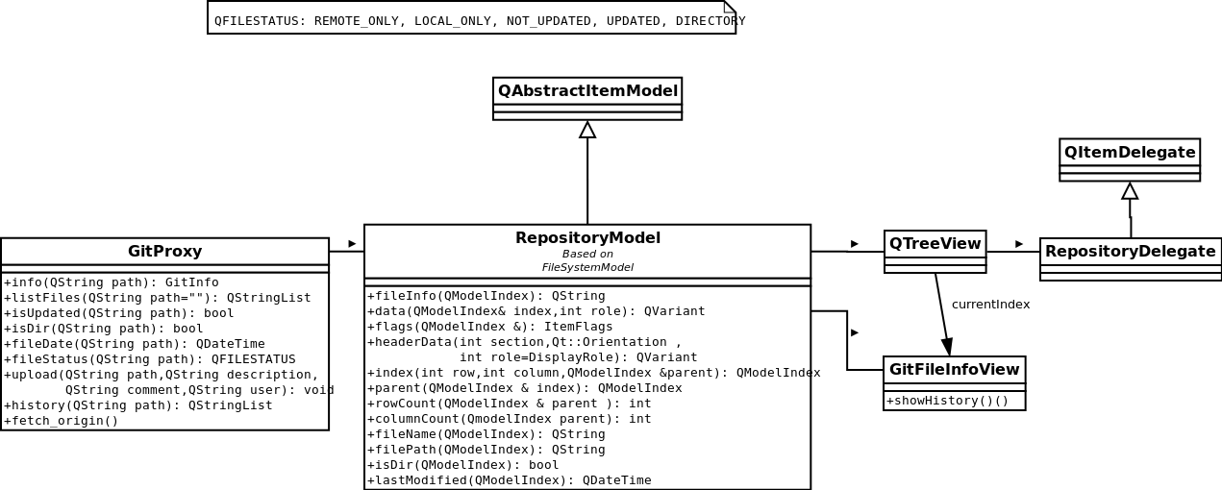

Figure 2ScriptRepositoryGUI UML

#### Diagram For Script Repository Implementation

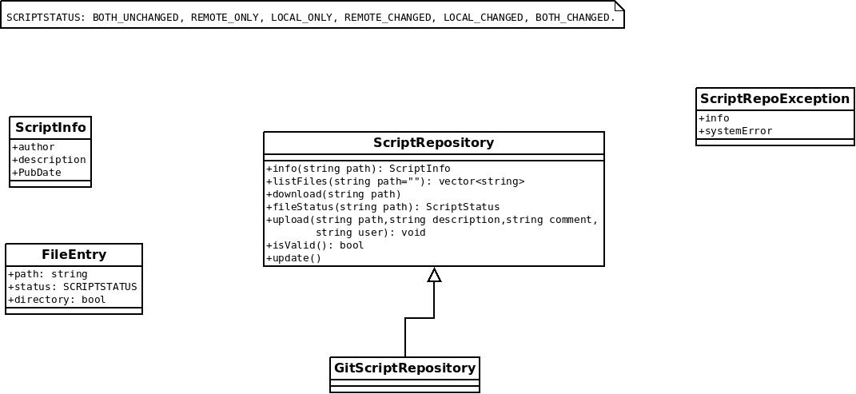

Figure 2ScriptRepository Implmentation UML

### Detailed Design

#### Description of the Implementation

GitScriptRepository implements the interface of ScriptRepository. In what follows, a description of the goal of each method is given, and how to obtain it though the git command line.

##### Update:

Connects to the remote repository, and check for updates. If necessary, it may create the local repository (clone), specially, when first called.

*This operation requires internet connection.*

So, the update method may be separated in two main functionalities:

* Installation

When installing the git repository, the user do not want to have all the files downloaded in his folder, so it is necessary to do a clone of the git repository without checkout:

###### git clone –n [url] [local_path]

Besides, when using the repository, the user should not see .pyc files created automatically from the python, so, a .ignore file must be present as well.

**OBS: After doing this, git will create an “empty” folder (everything will be inside the .git folder). And a git status will say that you have deleted all the files.**

* Checking up updates

It is necessary to check the remote repository for updates. Git allows to check remotes changes through:

###### git fetch origin

The problem here is that **we can not merge the updates**. The reason is that we do not want to create new files, nor we want to change files of the users if they have not requested to do so. One possibility is to use the command:

###### git reset –soft FETCH_HEAD

This command, change the master to point to the origin, but it does not change the current index. By doing this,

###### git status

will be able to see that new files are being added from remote, and will be able to see if the file has being remotely changed or locally changed.

##### ListFiles:

List all files that are available at the repository and the local files, marking the information about the current state of the file. The files support the following states:

* BOTH_UNCHANGED: The local file and the remote file are the same.
* REMOTE_ONLY: The user has not downloaded this file.
* LOCAL_ONLY: The user has created this file, but not publish it.
* REMOTE_CHANGED: The user downloaded the file, but a new version of this file is available.
* LOCAL_CHANGED: The user downloaded the file and edited it.
* BOTH_CHANGED: Both Remote and local changes are valid.

The answer here is equivalent to the output of:

###### git status

## ScriptSharingService

The ScriptSharingService is responsible for doing things in the background. Its main purpose are:

* cloning the repository at the installation of Mantid (if necessary)
* Periodically fetching the origin repository
* Update the files automatically, and/or notify users about new versions available.

For the second option, it would be possible to add this service to the Operate System chron table, so to, force the execution of the service in a periodic base.

This service will need to interact with the Mantid user properties, in order to keep information about the list of files that the user wants to be notified about its changes, the list of files that the user wants to download automatically, etc.

# The Upload web service

The uploads of user files and scripts will be done indirectly through a dedicated upload web service. It will be set up a web service that receive a file, and the git path, and some information that are necessary to insert the file inside the git repository.

TODO: WHY THIS IS NECESSARY?

# For future

* Add folder special icons to show up-to-date, not in repository
* Add right-click menu to upload.

# READERS: DO NOT READ AFTER THIS POINT (NOTES FOR THE AUTHOR)

Notes for me: From a Top-Botton approach.

Using a Model-View-Control scheme provided by Qt framework.

http://doc.qt.digia.com/qt/model-view-programming.html

tips:

QStandardItemModel

QTreeView

QStyledItemDelegate <-QAbstractItemDelegate, [QItemDelegate](http://doc.qt.digia.com/qt/qitemdelegate.html)

http://doc.qt.digia.com/qt/itemviews-spinboxdelegate.html

QTreeView -> will show the remote/local files, and custom delegates will be created to handle the information of Not Updated, Not published, and to provide the following actions:

upload, download, update.

Model:

RepositoryModel:

File, Download, Date, published, update status, history, description

http://doc.qt.digia.com/qt/itemviews-simpletreemodel.html

Delegate:

RepositoryDelegate:

column: 0-> Download -> Button or empty widget

column: 1-> File/Folder name -> Default ->line edit

column: 2-> Date of last modified ->QDateTimeEdit

column: 3-> published -> button or emtpy widget

column: 4 -> update status -> button or checked widget

View:

QTreeView