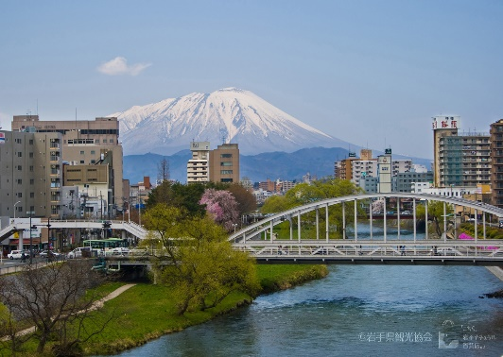

The 10th $IEEE$ International Conference on Awareness Science and Technology

***iCAST 2019***

October 23 - 25, 2019, Morioka, Japan

***Webpage:*** [***http://www.chishiki.soft.iwate-pu.ac.jp/icast2019/***](http://www.chishiki.soft.iwate-pu.ac.jp/icast2019/)

**Objective:** The 10th. IEEE International Conference on Awareness Science and Technology (iCAST 2019) is a major international conference to bring together researchers, engineers, and scientists from academia and industry working in awareness science and its applications, for discussion, exchanging ideas, opinions, and most importantly to present their works and latest results.

Special sessions on various subjects related to awareness, such as artificial intelligence, soft-computing, intelligent systems, perception, cognitive science, psychology, data analysis, IoT, are welcome. Individual submissions in the following area are invited.

**Topics include but not limited to the following:**

Awareness Science:

Awareness mechanism and modeling, Machine learning/deep learning, Pattern recognition and image understanding, Agent computing/ontology/semantics, Neuro-computing/perception/cognition, Fuzzy logic/granular computing/rough set

Awareness Technology:

Context/situation/background/semantics awareness, Chance/opportunity awareness, Intention/Emotion/Preference awareness, Location/position/goal awareness, Power/energy/capability/resource awareness, Weakness/risk/danger awareness, Safety/security/privacy/trust awareness, Knowledge/tacit knowledge engineering

Awareness Related Applications:

Social network, Data/Web/Text Mining, Perception/Processing of Image/video/speech signal, Virtual and Augmented Reality, Intelligent Transportation System, Patient Aware Health care system, Internet of Things, E-business/e-government/e-learning, Smart city/grid, Intelligent control, Intelligent robot

**Call for Special Sessions:** Proposals to organize Special Sessions are welcome. For details, please visit conference web-site special session page at:   
<http://www.chishiki.soft.iwate-pu.ac.jp/icast2019/cfss.html>

**Venue:** AIINA7th. & 8th. Fl., Morioka, Iwate, Japan. <http://www.aiina.jp/en/>

(4mins. Walk from Morioka station, 8mins drive from Tohoku Expressway)

**Paper Submission Procedure:**

Electronic version of full paper (IEEE format, A4 six-page standard including figures and tables) complete with authors’ affiliations should be submitted through official site.

All accepted papers will be sent to IEEE Xplore Digital Library. Selected papers will be recommended for post-conference publication in some Science Citation Index Expanded, EI, or Scopus journals.

**Important Dates:**

* June 3, 2019: Deadline of Special Session (SS) proposal
* June 28, 2019: Notification of Acceptance of SS proposal
* July 26, 2019: Deadline of paper submission (both general session and SS)
* August 30, 2019: Notification of paper acceptance
* September 17, 2019: Submission of final camera-ready papers
* September 10, 2019: Deadline for registration

***S $ponsor$*:** Japan Chapter of IEEE Systems, Man and Cybernetics Society (SMCS).

$Supporters$**:** Iwate Prefectural University, Japan,

IEEE SMCS Technical Committee on Awareness Computing,  
 IEEE CIS Task Force on Awareness Computing.

**Honorary Chair**

Atsuto Suzuki, *Iwate Prefectural   
 University, Japan*

**General Chairs**

Goutam Chakraborty, *Iwate   
 Prefectural University, Japan*

Rung-Ching Chen, *Chaoyang   
 University of Technology, Taiwan*

**PC Chairs**

Masafumi Matsuhara, *Iwate   
 Prefectural* *University, Japan*

Yusuke Manabe*, Chiba* *Institute of   
 Technology, Japan*

**PC Co-chairs**

Yan Pei*, University of Aizu, Japan*

Yo-Ping Huang, *National Taipei   
 University of Technology*

**Special Session Chair**

Cheng-Hsuing Hsieh, *Chaoyang   
 University of Technology, Taiwan.*

**Publicity Chairs**

Takako Hashimoto, *Chiba University   
 of Commerce, Japan*   
Shih-Cheng Horng, *Chaoyang   
 University of Technology, Taiwan*

Hui Yu, *University of Portsmounth,   
 UK*

**Publication Chair**

Basabi Chakraborty, *Iwate   
 Prefectural University, Japan*

**Local Organizing & Finance Chairs**

Jun Sasaki, *Iwate Prefectural   
 University, Japan*

Hisayoshi Ito*, Iwate Prefectural   
 University, Japan*

**Advisory Committee**

Hideyuki Takagi, *Kyushu University,   
 Japan*

Ruo-Wei Hung*, Chaoyang University   
 of Technology, Taiwan*

Kei Ohnishi*, Kyushu Institute of   
 Technology, Japan*

**Registration Chairs**

Prima Oky Dicky Ardiansyah, *Iwate   
 Prefectural University, Japan*

Hiroshi Mabuchi, *Iwate Prefectural   
 University, Japan*

**Steering Committee**

Goutam Chakraborty, *Iwate   
 Prefectural University, Japan*  
Qiangfu Zhao, *University of Aizu,   
 Japan*  
Robert Kozma, *University of   
 Memphis, USA*  
Tadahiko Murata, *Kansai University,   
 Japan*

Keun Ho Ryu*, Chungbuk National   
 University, Korea*