iPod

This is an audio player made using html,css along with javascript

libraries like jQuery and React.



How to use?

1. Open the ipod(.html) file.
2. Click the circular button at bottom to open the ipod.
3. Desired option can be hovered upon by rotating the wheel.
4. The same option can then be selected by clicking the centralized button inside the wheel.
5. Songs can be played by clicking their respective cover pictures.
6. Play, Pause, Rewind and Fast-Forward buttons are also present.
7. Previous page can be loaded by clicking on the back buttons present in the screen.
8. The ipod closes and returns to its idle state by clicking on the HOME button.

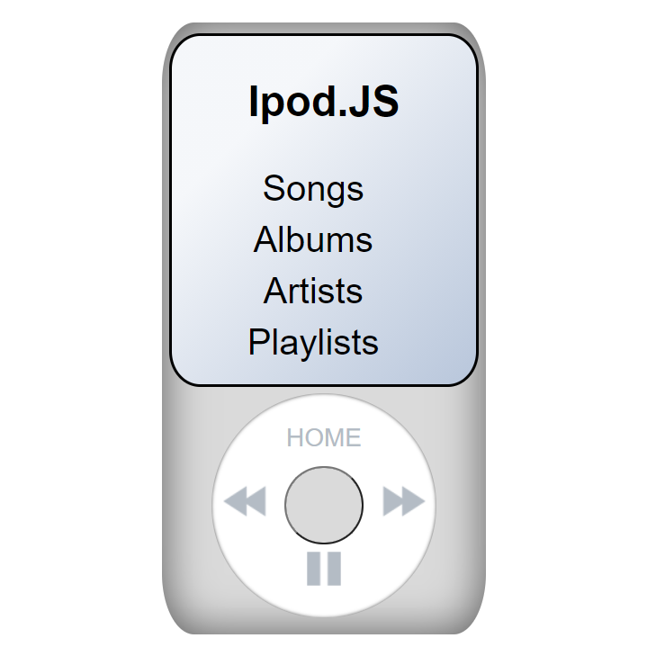

Some sample shots -

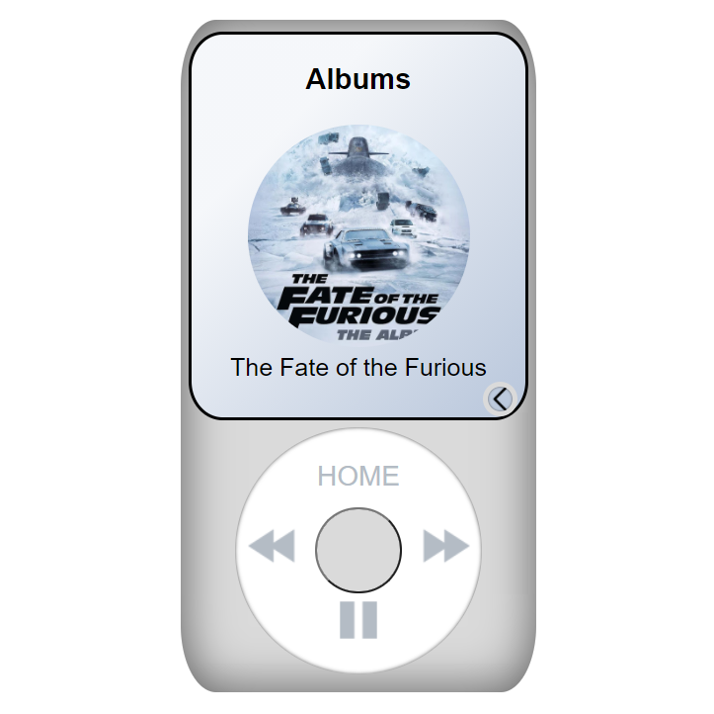

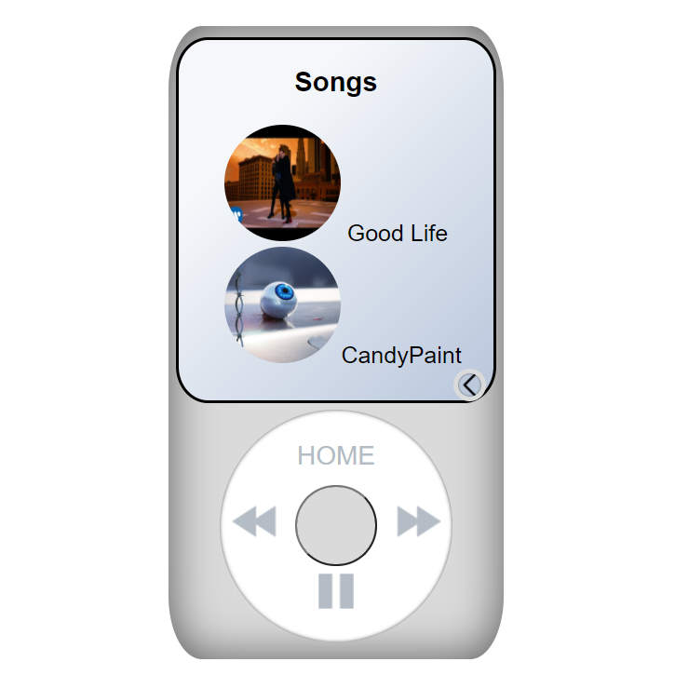

Made by –

Bhuvan Kohli

[bhuvankohli16@gmail.com](mailto:bhuvankohli16@gmail.com)

[www.linkedin.com/in/bhuvan-kohli-4916911b7](http://www.linkedin.com/in/bhuvan-kohli-4916911b7)

<https://github.com/BhuvanK18>