1. BUSINESS TASK AND NARROWED ANALYTICAL FOCUS

The business objective is to analyse patterns in the 2024 Business Analyst job market using LinkedIn job advertisements. This analysis will help a US consulting company to understand the demand for roles related to business analysis, the requirements of employers, the geographic distribution of these roles, and the associated skills.

Due to the size of the available datasets and the time and resource constraints of the initial project, the analysis has been narrowed down to three areas:
(1) job characteristics and demand
(2) geographic distribution
(3) the skills associated with business analyst roles.

It will focus on advertisements for Business Analyst roles identified by job title, using job characteristics, location, skills, and job summary information to identify patterns and relationships.

The purpose of this initial stage is to identify meaningful patterns and develop an analytical plan based on evidence, rather than to provide a definitive solution to the business problem.

2. CRISP-DM APPROACH

CRISP-DM provides a structured approach to the initial stage of this business analyst job market analysis. It ensures that the business problem is defined before any data is prepared or analysed, while allowing the analytical approach to be refined based on findings from data exploration and quality assessment.

Business understanding: The objective is to identify patterns in Business Analyst-related job opportunities that can provide the consulting company with useful labour-market insights. The analysis focuses on job characteristics, geographic distribution, and associated skills because the full dataset is too large to investigate every aspect within the available time and resources.

Data Understanding: Available LinkedIn job-posting, job-skill and job-summary data are examined to understand their structure, variables, coverage, relationships and quality. Business Analyst-related advertisements are identified from the job title information.

Data preparation: Relevant business analyst records are extracted, and the three datasets are linked using 'job_link'. Skill information is transformed from comma-separated values into individual skills, while job summary information is retained to identify additional requirements, such as education and experience.

Modelling/analysis: Descriptive and comparative analyses are used to examine job demand, geographic patterns, and skill requirements. Cross-analysis will be used where appropriate to identify relationships between job level, location, job characteristics, and skills.

Evaluation: The results will be assessed against the original business questions and data quality findings. Any unexpected patterns, such as the extremely high proportion of onsite roles, will be investigated before conclusions are drawn.

Deployment/communication: The first iteration will communicate the identified patterns, limitations, and recommended next steps in order to support a more detailed future analysis. The project does not aim to provide a final business solution.

3.BIBLIOGRAPHY

CRAAP Test – Source 1

Source
Organisation: U.S. Department of Labor, Employment and Training Administration
Source: O*NET OnLine
Title: Business Intelligence Analysts – 15-2051.01
URL: [O*NET Business Intelligence Analysts](https://www.onetonline.org/link/details/15-2051.01)
Accessed: 26 August 2026

Currency
ONET is continuously updated and provides current information about business intelligence analysts, including their tasks, required skills, educational background and the software they use. However, as our project analyses LinkedIn advertisements from 2024, ONET will mainly be used as a current occupational benchmark rather than as a direct representation of the job market in 2024.

Relevance
The source is highly relevant because it provides a detailed description of the role of a Business Intelligence Analyst, identifying related tasks, skills and software. It provides useful categories for comparing the requirements identified in our 2024 LinkedIn dataset.

Authority
Sponsored by the U.S. Department of Labor's Employment and Training Administration, O*NET is a highly authoritative government source. It provides structured occupational information based on established data and research methods.

Accuracy
O*NET provides detailed information on occupational tasks, required skills and knowledge, educational requirements, and necessary software. It also identifies the sources used to compile this information, thereby improving transparency. However, as it represents occupation-level information rather than individual LinkedIn advertisements, our dataset must be analysed independently.

Purpose
The purpose of O*NET is to provide reliable occupational information about jobs and the skills required to perform them. As a government resource, it is designed to inform users rather than promote commercial products or services.

Overall CRAAP Assessment
O*NET is a high-quality, suitable source because it is authoritative, relevant, structured and transparent. The main limitation is that some of the information may be based on data that is more recent than our 2024 LinkedIn dataset. It will therefore be used as a benchmark and supporting source.

Relevance to the Analysis Plan
We will use O*NET to identify the relevant skills, tasks and software categories for our analysis. These will then be compared with the 2024 LinkedIn data to highlight the similarities and differences between established occupational requirements and employer job advertisements.

CRAAP Test - Source 2

Source
Organisation: U.S. Bureau of Labor Statistics, U.S. Department of Labor
Source: Occupational Outlook Handbook
Title: Management Analysts
URL: [BLS Management Analysts - Occupational Outlook Handbook](https://www.bls.gov/ooh/business-and-financial/management-analysts.htm)
Accessed: 26 August 2026

Currency
The BLS Occupational Outlook Handbook provides up-to-date information on employment, wages and the labour market, including data for 2024 and employment projections up to 2034. This makes it a valuable source of labour-market context for our 2024 LinkedIn dataset.

Relevance
The source is relevant because it provides information about management analysts, including details on employment, wages, education, and job characteristics. However, 'Management Analysts' is a broader occupational category than the 'Business Analyst' roles in our dataset, so the former will mainly be used for context and benchmarking purposes.

Authority
The source is highly authoritative as it is published by the U.S. Bureau of Labor Statistics, a U.S. government agency responsible for collecting and reporting labour market statistics. The Occupational Outlook Handbook is a well-established source of occupational information.

Accuracy
The BLS provides clear, quantitative employment, wage and job outlook statistics with defined years and measurement periods. However, as its occupational classification does not exactly match all business analyst positions, the statistics should not be treated as a direct measure of our LinkedIn dataset.

Purpose
The Occupational Outlook Handbook aims to provide impartial information about different occupations, including their duties, required qualifications, wages, and job prospects. It is a government information resource, rather than a commercial or promotional one.

Overall CRAAP Assessment
The BLS is a highly credible and suitable source because it is current and authoritative, and its information is supported by statistical data. The main limitation is that the term 'Management Analyst' is broader than the 'Business Analyst' roles in our LinkedIn dataset.

Relevance to the Analysis Plan
The BLS will provide a broader context of the U.S. labour market for interpreting our LinkedIn findings. Information on employment outlooks, educational requirements and occupational characteristics can be compared with patterns found in 2024 job advertisements, while the LinkedIn dataset will remain our primary source of evidence.

2.MIND MAP

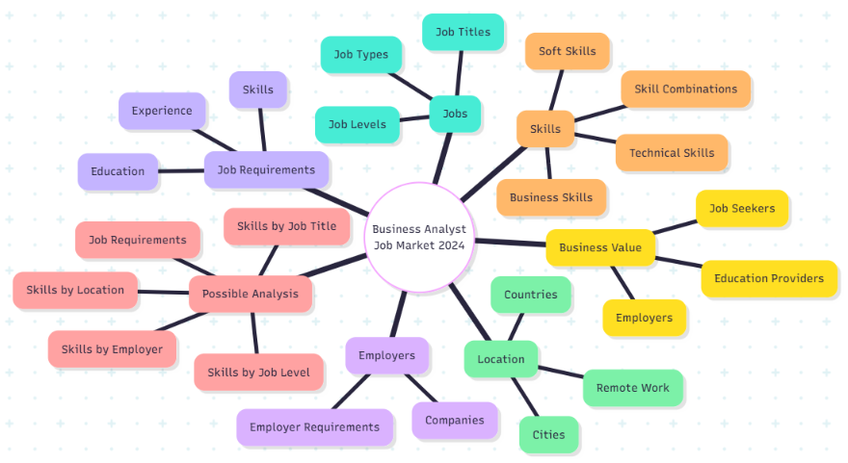
Fig. Mind Map done before narrowing done research

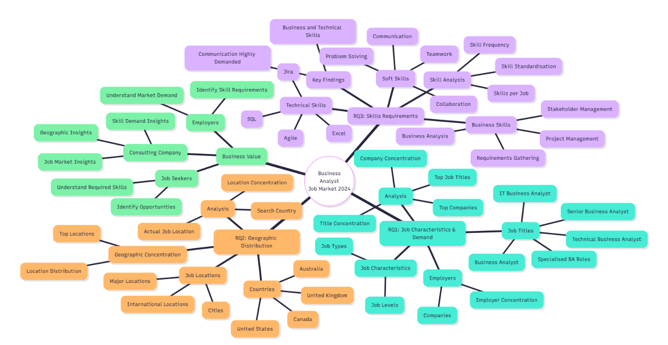
Fig. Mind Map on narrowed research questions

3.DATA DICTIONARY

The project uses three related datasets: LinkedIn Job Postings, Job Skills and Job Summary. The LinkedIn_Job_Postings dataset contains structured information about job advertisements, including job title, employer, location, job level and job type. The 'job_skills' dataset contains the skills associated with each advertisement, while the 'job_summary' dataset contains unstructured textual information about job responsibilities and requirements. The datasets can be linked using job_link. The data dictionary explains the meaning, type, source, constraints and analytical purpose of each variable, as well as how derived variables are constructed for analysis.

1. linkedin_job_postings

Variable | Description | Data Type | Purpose in Analysis
job_link | Unique LinkedIn URL identifying the job advertisement. | String | Used as the primary identifier and to link the three datasets.
last_processed_time | Date and time when the job record was last processed. | Date/Time | Provides information about data processing and timeliness.
got_summary | Indicates whether a job summary was obtained. | Boolean | Used to assess availability of job-summary information.
got_ner | Indicates whether named-entity recognition processing was completed. | Boolean | Provides information about the processing of job data.
is_being_worked | Indicates whether the record was being processed. | Boolean | Provides information about dataset processing status.
job_title | Title of the advertised job position. | Text/Categorical | Used to identify and categorise Business Analyst-related roles.
company | Name of the organisation advertising the job. | Text/Categorical | Used to analyse employers and employer-specific requirements.
job_location | Location associated with the advertised position. | Text/Categorical | Used for geographic analysis.
first_seen | Date when the job advertisement was first observed. | Date | Used to examine the temporal coverage of job advertisements.
search_city | City associated with the search that retrieved the job. | Text/Categorical | Provides additional geographic information.
search_country | Country associated with the search that retrieved the job. | Categorical | Used for country-level comparisons.
search_position | Position used in the search process that retrieved the job. | Text/Categorical | Provides context about how the job was collected.
job_level | Seniority level of the advertised position. | Categorical | Used to compare requirements and skills across career levels.
job_type | Working arrangement of the advertised position. | Categorical | Used to compare onsite, hybrid and remote opportunities.

2. job_skills

Variable | Description | Data Type | Purpose in Analysis
job_link | LinkedIn URL identifying the associated job advertisement. | String | Used to link skills with job-posting information.
job_skills | List of skills associated with the job advertisement. Multiple skills are stored in one field. | Multi-valued Text | Core variable for analysing skill demand and skill combinations.

3. job_summary

Variable | Description | Data Type | Purpose in Analysis
job_link | LinkedIn URL identifying the associated job advertisement. | String | Used to link job summaries with job-posting information and skills.
job_summary | Free-text description of the job, which may contain responsibilities, qualifications, experience and other requirements. | Unstructured Text | Used to investigate job requirements and identify information not captured in the structured fields.

4. Constructed Variables

Derived Variable | How It Will Be Constructed | Data Type | Purpose
BA_related | Flags a job as Business Analyst-related when the job title contains the defined Business Analyst keyword criteria. | Binary | Separates relevant BA advertisements from the wider job dataset.
skill | Split the comma-separated job_skills field into individual skill records. | Categorical/Text | Makes skill-level frequency and relationship analysis possible.
skill_count | Count the number of individual skills associated with each job after skill decomposition. | Numeric | Allows comparison of the breadth of skill requirements between jobs.
skill_category | Classify skills into categories such as technical, business and soft skills using a defined classification approach. | Categorical | Allows comparison of different types of skills.
location_group | Standardise job locations into consistent geographic groups such as country/region. | Categorical | Supports geographic comparison.
remote_category | Derive working arrangement from job_type into categories such as Remote, Hybrid and Onsite. | Categorical | Supports comparison of skill/job patterns by working arrangement.
education_requirement | Extract education requirements from job_summary where identifiable. | Categorical/Text | Examines educational expectations for BA-related roles.
experience_requirement | Extract stated experience requirements from job_summary where identifiable. | Text/Numeric/Categorical | Examines experience requirements and their relationship with job level.

DATA CONSTRUCTION

The three source datasets will be integrated using 'job_link', the common identifier for individual job advertisements. The 'job_skills' variable contains multiple, comma-separated skills within a single field. Therefore, the skills will be separated into individual records to enable frequency analysis, comparison, and analysis of skill co-occurrence. Additional derived variables may be created to identify business analyst-related positions, categorise different business analyst job types, count the number of skills associated with each advertisement, classify skills into broader categories and standardise geographical information. Where appropriate, information such as educational and experience requirements may also be extracted from the unstructured 'job_summary' field. The construction rules for all derived variables will be documented to maintain transparency and reproducibility.

4. INDIVIDUAL PROOF OF WORK

4.1 Initial Data Understanding

I started the individual analysis by looking at the structure and content of the available LinkedIn job postings before choosing the Business Analyst records. I then loaded the main linkedin_job_postings.csv dataset into Python using Pandas in Google Colab. To make the initial investigation more manageable, I selected the relevant variables for the planned analysis: job_link, job_title, company, job_location, first_seen, search_city, search_country, job_level and job_type.

The loaded dataset contained 1,048,575 job-posting records and the nine selected variables. I inspected the data types, column structure, and sample records to understand how the information was represented. Most of the variables were stored as categorical/text fields; however, first_seen was initially stored as text and therefore required conversion to a date format for later analysis.

Examining the first_seen variable revealed that the available records covered 12–17 January 2024 with no missing dates. This revealed an important limitation of the dataset, as the available observations did not cover the entire 2024 calendar year.

I also examined the diversity of job titles. The dataset contained 476,817 unique job titles, demonstrating that the original dataset covered a broad range of occupations. As the project focuses specifically on Business Analyst-related employment, I used the job_title field to identify relevant records.

4.2 Initial Identification of Business Analyst Jobs

Next, I investigated how Business Analyst-related jobs could be identified within the wider LinkedIn job-posting dataset. I started by examining the 'job_title' field and testing different analyst-related keywords, in order to determine how many records could potentially be relevant to the project.

Having compared the results of different keyword searches, I selected the exact phrase 'business analyst' in the job title as the initial criterion. This produced 3,813 business analyst job postings from the original dataset.

I created a separate ba_df dataframe containing these records, enabling the Business Analyst jobs to be investigated independently of the full dataset. I then examined these records using variables such as job title, company, job location, search city, search country, job level, job type and first seen.

This initial extraction provided a focused dataset for the first stage of analysis. However, when I later compared this selection with another business analyst dataset provided by a teammate, I identified additional relevant records. Consequently, the dataset of 3,813 records was treated as an initial extraction rather than the final Business Analyst population. The comparison and refinement process is documented in Section 4.7.

4.3 Initial Data Quality Investigation

After creating the initial Business Analyst dataset, I conducted a preliminary investigation into the quality of the job-posting and skills data. I checked the dimensions of the dataset, as well as the number of missing values and duplicate records and job_link values, in order to determine whether the records could be used reliably for further processing.

I also examined the completeness and consistency of important categorical variables, including job level, job type and search country. I examined the 'first_seen' field to determine whether the dates could be interpreted correctly, and to identify the temporal coverage of the available data.

For the skills dataset, I checked the number of records associated with job postings and investigated missing skill information. I also examined the number of skills recorded for individual jobs, in order to understand the structure of the multi-valued 'job_skills' field.

These checks enabled me to identify the strengths and limitations of the initial data before attempting to integrate the job, skills, and summary datasets. The findings also helped to determine which issues needed to be investigated further during the construction of the final integrated dataset.

4.4 Job Summary Extraction

What I did:
I extracted the job summaries from the Business Analyst postings. This meant that the final analysis could use not only the structured job attributes and skills, but also the textual information contained in each job advertisement.

How I did it:
The original job_summary.csv file was approximately 49 GB in size, so it was not practical to load the entire file into memory. Instead, I used a chunk-based extraction approach, reading the file in smaller chunks of 100,000 rows at a time. First, I created a list of the required job_link values from the Business Analyst jobs with available skills, and then I used these links to extract only the relevant summaries.

During the initial analysis, I extracted summaries for the original 3,813 business analyst postings and obtained 3,725 matching summaries. This identified 88 postings without an available summary.

After refining the Business Analyst dataset to match the dataset provided by the teammate [Sarvesh], which contained 4,576 postings, I repeated the extraction process using the required job links. This produced 4,440 matching job summaries, which I saved separately and later used for integration.

I also checked the extracted summary dataset for missing values and duplicate job_link values, ensuring that each summary could be reliably matched to its corresponding job posting.

What I found:
The final extraction contained:

- 4,440 job summaries
- 4,440 unique job_link values
- 0 duplicate rows
- 0 duplicate job_link values
- 0 missing job_link values
- 0 missing job_summary values

The summary lengths ranged from 99 to 17,393 characters, with a median of approximately 3,510 characters. This indicates that the summaries contain a substantial amount of textual information that can be used for further analysis.

What I learned/why it matters:
Due to the large size of the summary dataset, the data had to be processed selectively rather than being loaded entirely into memory. Using 'job_link' as the matching key enabled me to extract only the required summaries for the Business Analyst analysis. It also provided a reliable way of connecting the unstructured job-summary information with the structured job and skills data at a later integration stage.

4.5 Relationship Between Jobs, Skills and Summaries

What I did:
I examined how the different datasets could be connected to enable analysis of information about each Business Analyst job. In particular, I needed to link job-posting information, skills information, and job summaries.

How I did it:
I used 'job_link' as the common identifier across the datasets because it provides a consistent way to match information belonging to the same job posting.

The skills dataset contains multiple skill records for a job, while the job-posting and summary datasets contain one record per job. I therefore treated 'job_link' as the linking key and preserved the multi-valued 'job_skills' information within the job-level dataset.

The relationship can be represented as follows:

Job Posting → Job_link → Skills → Job Summary.

First, I used the skills data to identify the Business Analyst job links for which skill information was available. These links were then used to retrieve the corresponding job summaries from the large job_summary.csv file.

What I found:
Following the refinement of the Business Analyst population, 4,440 job links were found to have available skills. These 4,440 job links were then successfully matched with job summaries.

This meant that job, skill and summary information could be brought together at the level of the individual job posting.

What I learned/why it matters:
This step demonstrated that 'job_link' was suitable as the primary integration key, enabling the connection of the three types of information without relying on job titles or company names, which could potentially result in incorrect matches.

It also established the basis for the final integrated dataset, in which each record represents a Business Analyst job, containing its characteristics, location, skills, and job summary.

4.6 Initial Integration Attempt

What I did:
I initially integrated the Business Analyst job, skills and summary data to determine whether the datasets could successfully be combined using job_link.

How I did it:
I performed an inner join on job_link between the job posting, skills, and summary datasets. I used an inner join because I wanted the final analytical dataset to contain only jobs for which all the required information was available.

This initial integration was based on my original Business Analyst dataset comprising 3,813 job postings. The results showed that not all identified Business Analyst postings could be matched with the required supporting information.

I then investigated the unmatched records to determine whether the issue was caused by incorrect matching, missing skills or unavailable job summaries.

What I found:
The initial integration showed that some Business Analyst postings did not have a corresponding job summary or list of required skills. This demonstrated that simply identifying business analyst jobs was not sufficient to create a complete analytical dataset.

Therefore, the unmatched records needed to be investigated before proceeding with the final analysis.

What I learned/why it matters:
This step highlighted the importance of verifying relationships between datasets, rather than assuming that all identified jobs would have comprehensive supporting information. It also prompted me to review the Business Analyst dataset and compare it with an alternative available extraction prior to constructing the final dataset.

This was an important part of the iterative data preparation process, as it helped to identify limitations in the initial dataset, which motivated the refinement carried out in the next step.

4.7 Comparison with Teammate Dataset and Refinement

What I did:
After resolving the initial integration issues, I compared my original Business Analyst dataset with the one provided by my teammate, in order to establish whether the discrepancy was due to the filtering approach or the underlying data extract.

How I did it:
I compared the 'job_link' values in both datasets and identified the postings that were present in my teammate's dataset but missing from my original dataset. I then examined the job titles of these additional postings to determine their relevance to the Business Analyst analysis.

What I found:

My original dataset contained 3,813 Business Analyst postings.
The Teammate dataset contained 4,576 Business Analyst postings.
The Teammate dataset contained an additional 763 job links that were not present in my original dataset.
All of the additional postings had titles containing either 'Business Analyst' or 'Analyst'.
These postings contained 430 unique job titles.

This showed that the difference was not simply caused by a different interpretation of the 'Business Analyst' title. It appeared that the datasets had been produced from different underlying extracts or versions of the data.

What I learned/why it matters:
The comparison showed that my original dataset of 3,813 records did not represent all the relevant business analyst postings in the alternative extract. I therefore used the 4,576-record dataset as the revised starting point for the final analysis.

This refinement was important because it increased the available Business Analyst job population and provided a stronger basis for constructing the final integrated dataset.

4.8 Final Dataset Construction

What I did:
After refining the Business Analyst dataset, I created the final integrated dataset to be used for the rest of the analysis.

How I did it:
I started with the 4,576 business analyst job postings from the refined dataset. I then identified the 4,440 postings that had skill information available and used their job_link values to retrieve the corresponding job summaries from the large job_summary.csv file.

The datasets were then integrated using 'job_link' as the common identifier.

4,576 BA jobs → 4,440 jobs with skills → 4,440 required job links → 4,440 job summaries → final inner join.

This final integration was performed using an inner join, ensuring that each record in the analytical dataset contained the necessary job, skill and summary information.

What I found:

The final dataset contained:

- 4,440 job postings
- 11 variables
- 0 missing values
- 0 duplicate rows
- 0 duplicate job_link values

The 11 variables were:

job_link, job_title, company, job_location, search_city, search_country, job_level, job_type, first_seen, job_skills and job_summary.

Compared with the original 4,576 business analyst postings, 136 were excluded, giving an integration coverage of 97.03%.

Importantly, investigation showed that all 136 of the excluded postings were missing both skills and job summary information rather than being partially matched records.

What I learned / why it matters:
The final dataset provides a consistent job-level structure, enabling analysis of each record across job characteristics, location, skills, and job summary information. The high integration coverage also means that the majority of the refined Business Analyst population was retained for analysis.

This dataset was used for the subsequent data-quality analysis and preliminary exploration.

4.9 Final Dataset Validation

What I did:
After creating the final integrated dataset, I ran validation checks to confirm its structural suitability for the subsequent analysis stages.

How I did it:
I checked the dimensions of the final dataset, its column structure, missing values, duplicate records, and the uniqueness of the job_link identifier. I also examined the data types and key categorical and date variables to identify obvious inconsistencies before beginning the final data quality analysis.

What I found:

The final dataset contained:

- 4,440 records
- 11 variables
- 0 missing values
- 0 duplicate rows
- 0 duplicate job_link values
- 100% unique job links

The final dataset included the required information from the three sources:

- Job characteristics
- Geographic information
- Skills
- Job summaries

The 'first_seen' field was also checked as a date variable and was successfully interpreted, with values ranging from 12 to 17 January 2024.

What I learned/why it matters:
The validation confirmed that the final integrated dataset was structurally consistent and could be used for a detailed assessment of data quality and preliminary analysis.

It also established a clear distinction between dataset-level completeness and the earlier loss of 136 records during integration. While the final dataset of 4,440 records has no missing values, the excluded records remain an important limitation to consider when evaluating the data's overall quality and representativeness.

4.10 Final Data Quality Analysis

What I did:

I performed a detailed assessment of the quality of the final integrated dataset. I evaluated the completeness, uniqueness, validity, consistency and timeliness of the data, as well as the quality of the multi-valued skills field.

I also investigated the 136 records excluded during integration to consider the quality of the final dataset in the context of the original 4,576 business analyst postings.

4.10.1 Integration coverage

The final integrated dataset contained 4,440 postings, while the refined Business Analyst dataset contained 4,576.

Therefore:

Retained: 4,440 (97.03%)
Excluded: 136 (2.97%).
All 136 of the excluded postings were missing both skills and job summary information.
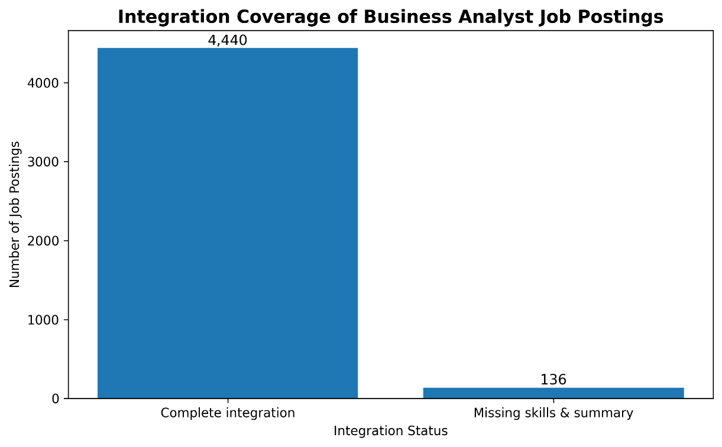

What I learned:
Although the final dataset has high integration coverage, the exclusion of 2.97% of postings should still be acknowledged as a limitation, as these postings may contain information that differs from the retained records.

4.10.2 Completeness

The percentage of non-missing values was calculated for each variable in the final dataset.

All 11 variables were 100% complete across the 4,440 retained records.

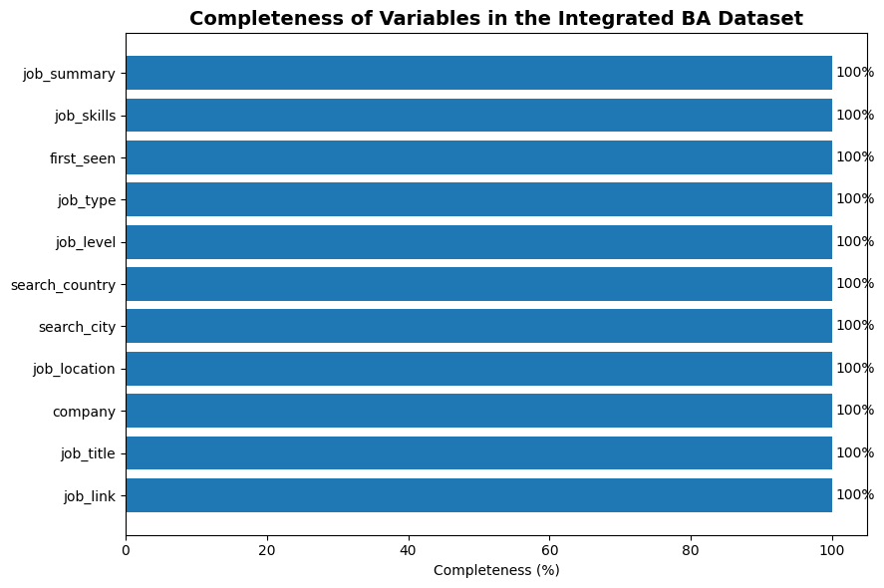

What I learned:
There are no missing values in the final analytical dataset. However, this does not mean that the entire original population was available, as the 136 excluded postings were removed prior to final integration.

4.10.3 Uniqueness

I checked for complete duplicate rows and for the uniqueness of the 'job_link' field.

Total records: 4,440
Unique 'job_link' values: 4,440
Duplicate rows: 0
Duplicate job_link values: 0
Job_link uniqueness: 100%

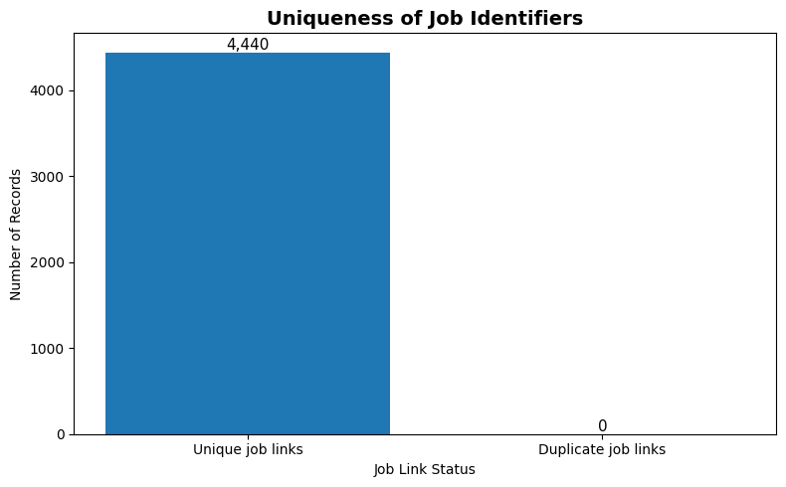
Key learning: job_link provides a strong unique identifier for the final dataset, reducing the risk of duplicate job postings affecting the analysis.

4.10.4 Validity and consistency

I examined the permitted values and distributions of significant categorical variables.

Job level:
Mid senior: 3,926 (88.4%)
Associate: 514 (11.6%)

Job type:
Onsite: 4,438 (99.95%)
Remote: 1
Hybrid: 1

Search country:
United States: 3,638 (82%)
United Kingdom: 335 (7.5%)
Canada: 246 (5.5%)
Australia: 221 (5%)
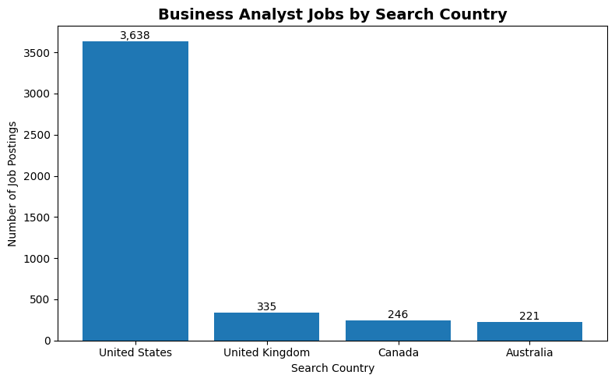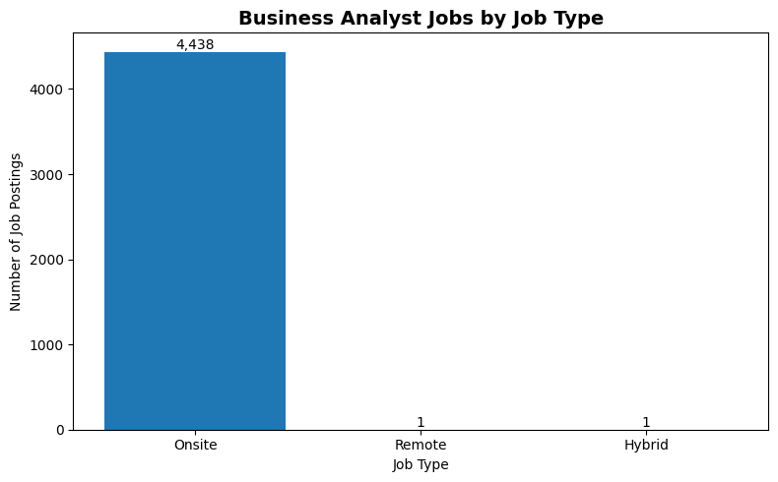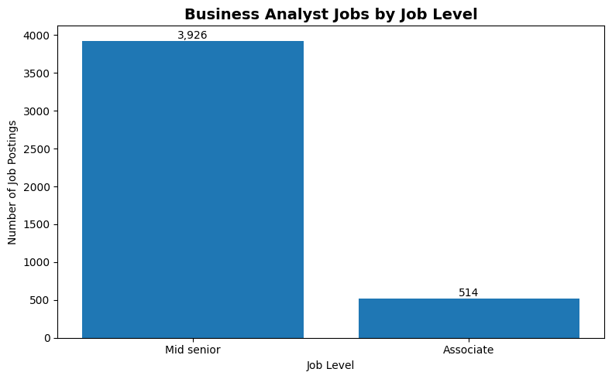
What I learned:
The categorical fields contain a small number of consistent values, making them suitable for grouping and comparison. However, the extremely high proportion of 'Onsite' values should be treated with caution and investigated further, rather than being automatically interpreted as a complete representation of the business analyst employment market.

4.10.5 Timeliness

I examined the 'first_seen' variable to determine the temporal coverage of the dataset.

The earliest date is 12 January 2024 and the latest date is 17 January 2024.
Invalid dates were not identified. 0

The available records therefore cover only a six-day period.

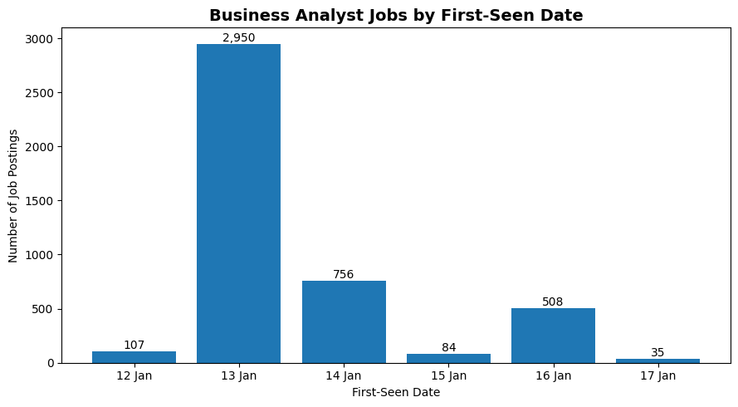
What I learned:
The dates are valid, but the dataset does not provide temporal coverage for the whole year. Therefore, I should not use this dataset to draw conclusions about changes in demand for business analysts throughout 2024.

4.10.6 Quality of skills data

I also assessed the multi-valued 'job_skills' field.

For the 4,440 integrated jobs:

Mean number of skills per job: 25.01
Median: 22
Minimum: 1
Maximum: 163
- Jobs with zero recorded skills: 0
Jobs containing duplicate skill entries: 435 (9.8%)
Total duplicate skill entries: 779

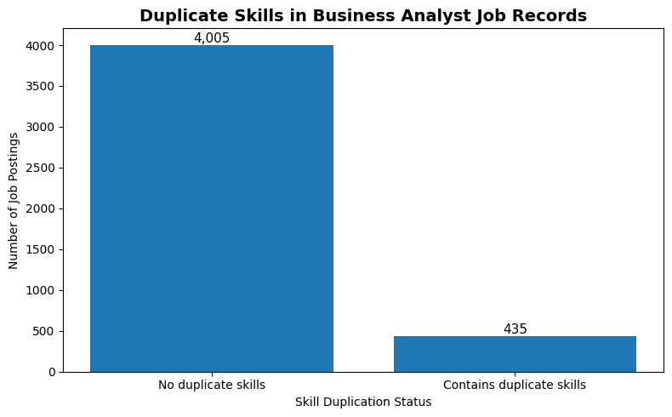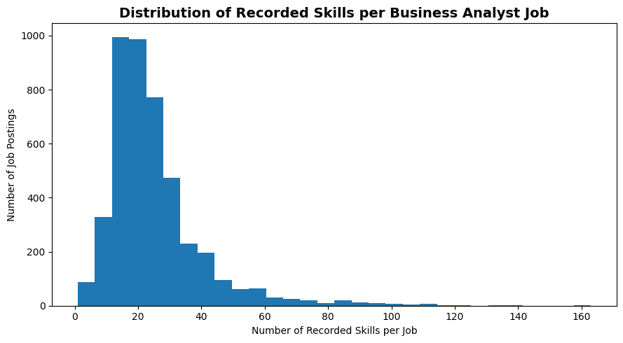
What I learned:
Every retained job has at least one recorded skill, but approximately 9.8% of jobs contain duplicate skill entries within their skill lists. These duplicates should be handled when calculating skill frequencies, to ensure that the same skill is not counted multiple times for a single job.

The maximum of 163 skills is unusually high and should be investigated as a potential outlier rather than being treated as invalid automatically.

4.10.7 Overall Data Quality Assessment

Overall, the final analytical dataset is of high structural quality. It is 100% complete and contains no duplicate records or invalid date values. Additionally, all job links are unique.

The main limitations identified are:

- 2.97% of the refined BA population was excluded due to the unavailability of both skills and summaries.
- Skill duplicates occur in 9.80% of jobs;
- first_seen covers only 12–17 January 2024, which limits temporal analysis.
- The extreme concentration of job type values requires cautious interpretation.
- The geographic search fields need to be interpreted carefully as they describe the search context rather than necessarily representing the actual job location.

5. Final Preliminary Exploration

5.1 Job Characteristics and Demand

A preliminary analysis of the job titles and companies represented in the final Business Analyst dataset was conducted to identify patterns in the demand for Business Analyst-related roles.

Job titles:
The most common title was 'Business Analyst', with 988 postings, followed by 'Senior Business Analyst' with 205 postings. Other frequently occurring titles included JDE Business Analyst (Supply Chain), JD Edwards Business Analyst, IT Business Analyst, and Technical Business Analyst. The top five job titles accounted for 1,554 (35.0%) of the final dataset postings, while the top 20 accounted for 1,938 (43.6%) postings.
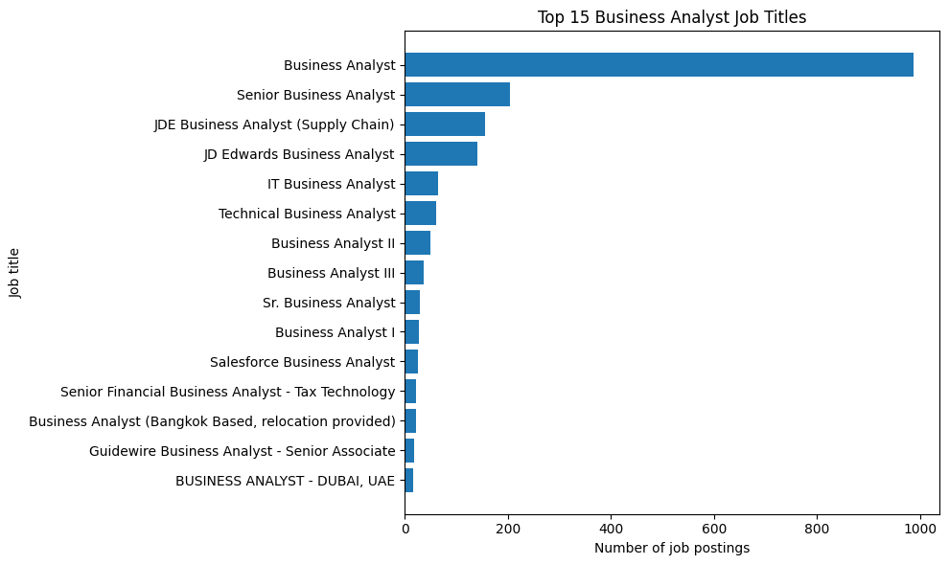

Companies:
The largest number of postings was associated with LATICRETE International (296), followed by Dice (155) and Tata Consultancy Services (69). The top five companies accounted for 635 postings (14.3%), while the top 20 accounted for 1,052 postings (23.7%).
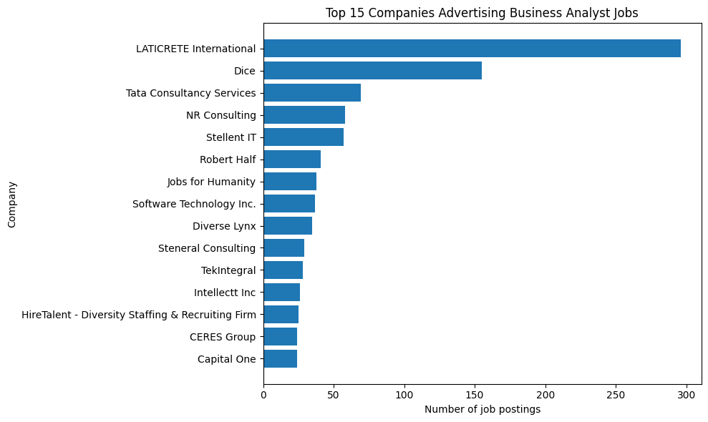
Interpretation:
These results suggest that demand for business analysts is distributed across a wide range of job titles and employers, rather than being concentrated in a small number of categories. The relatively low concentration of postings among the largest companies also suggests that opportunities are spread across multiple employers. The variety of job titles suggests that business analyst work can occur in different business and technical contexts.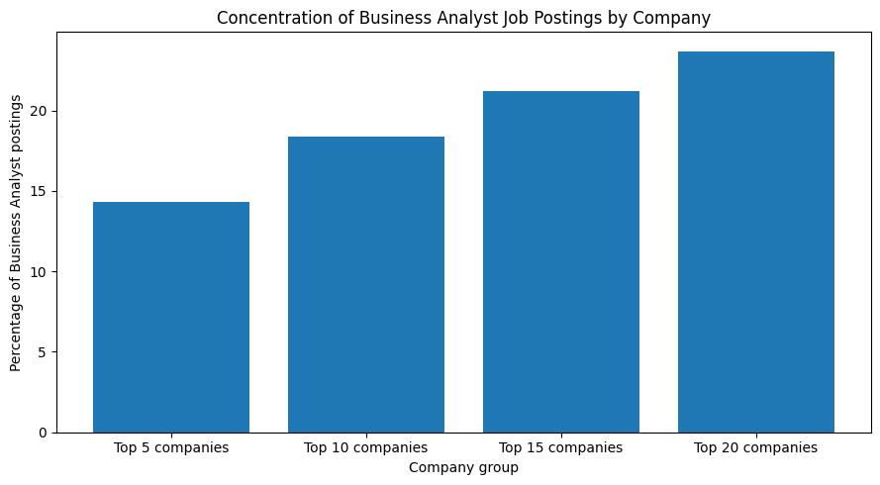
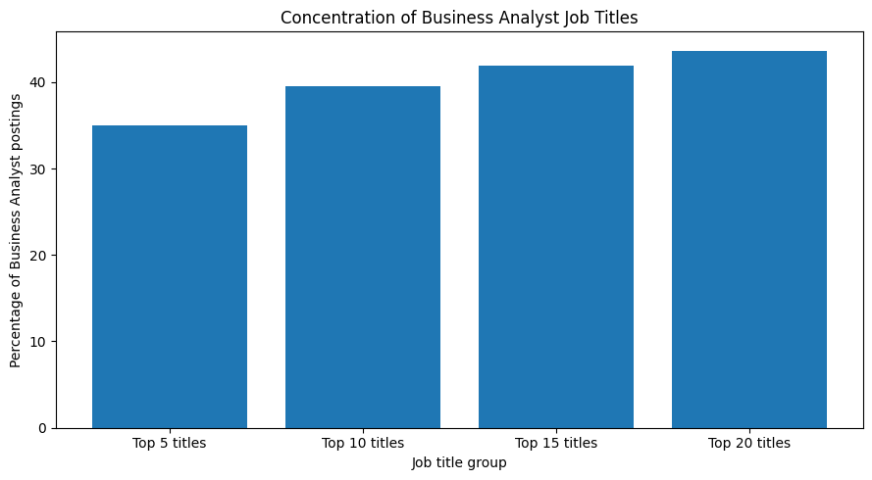

5.2 Geographic Distribution

The preliminary analysis examined the geographic distribution of business analyst job postings, considering both the 'search_country' and 'job_location' variables. These variables were considered separately, as search_country represents the country associated with the search, whereas job_location provides the location associated with the job posting.

Search country distribution:
The majority of analysed postings were associated with the United States (3,638 postings, or 82.0%). The United Kingdom accounted for 335 postings (7.5%), followed by Canada with 246 postings (5.5%) and Australia with 221 postings (5.0%).
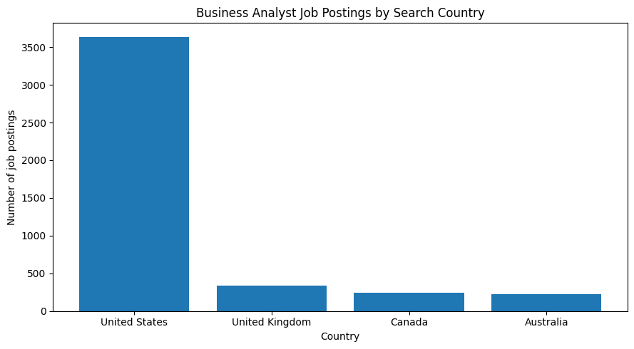

Actual job locations:
The most frequently occurring locations were New York, NY (104 postings), Atlanta, GA (81), Boston, MA (78), London (66), and Chicago, IL (64). The top five locations represented approximately 8.9% of all postings, while the top 20 represented around a quarter (24.1%).
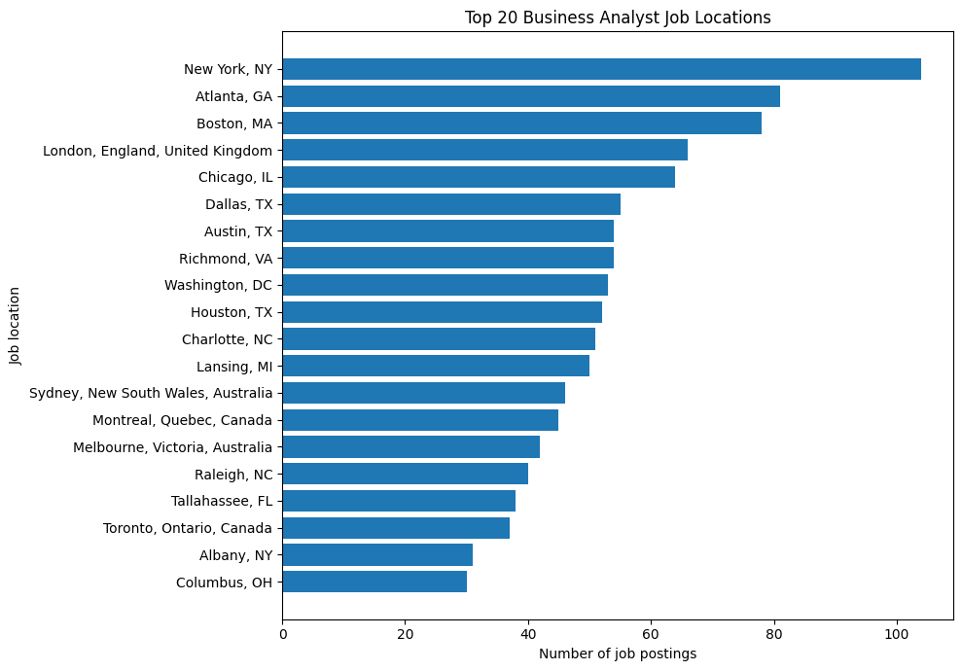

Interpretation:
The results suggest that business analyst opportunities are distributed across a wide geographical area rather than being concentrated in a small number of locations. While the United States dominates the distribution of searches, the results also show job opportunities in multiple US cities, as well as in international locations such as London, Sydney, Melbourne, Montreal and Toronto. This suggests that geographic location may be an important factor in further analysing Business Analyst employment opportunities.

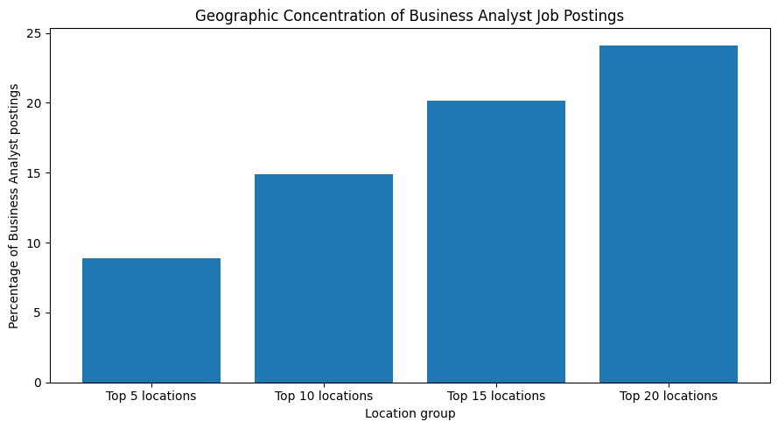

5.3 Skills Associated with Business Analyst Roles

The preliminary skills analysis examined the frequency with which skills were recorded in the 4,440 job postings for Business Analysts. The 'job_skills' field was split into individual skills and standardised to account for obvious naming variations. Duplicate skills within the same job posting were then removed before calculating the frequency of each skill.

The most frequently required skills were:
Communication appeared in 2,069 postings (46.6%) and was followed by business analysis with 1,943 postings (43.8%). Problem solving appeared in 1,511 postings (34.0%), project management in 1,507 postings (33.9%) and data analysis in 1,452 postings (32.7%). SQL also appeared frequently, in 1,044 postings (23.5%).

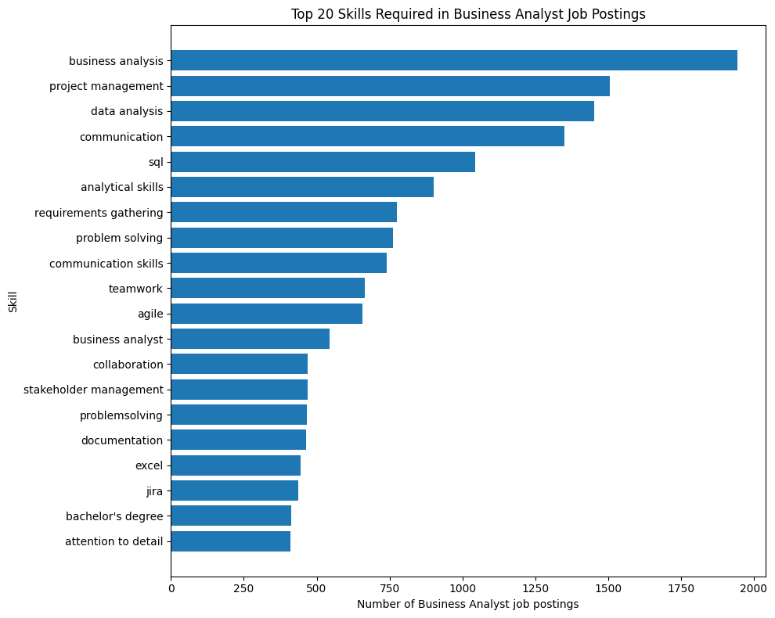
The results show that the most common skills include both business/interpersonal and analytical/technical skills. Other frequently appearing skills include requirements gathering, teamwork, agile, stakeholder management, Excel and Jira.

Interpretation:
These findings suggest that business analyst roles require a combination of communication, business analysis, problem-solving, project-related, and data-oriented capabilities, rather than a specific technical skill. This indicates that employers may value business analysts who can connect business requirements with analytical and technical activities.
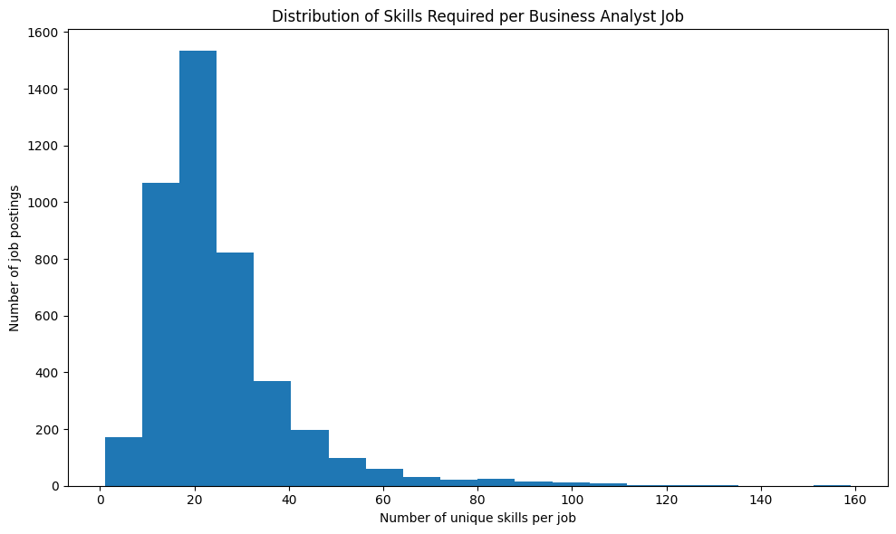

Why this matters:
For the consulting company, these findings provide an initial insight into the most commonly requested capabilities in business analyst job advertisements. Further analysis could examine whether skill requirements differ by job title, employer, location, or job level.

5.4 Overall Preliminary Findings

The preliminary exploration revealed several patterns relating to job characteristics, geographic distribution, and skill requirements. These findings provide an initial understanding of the business analyst job market and help to define areas for more detailed analysis.

Job demand: Business Analyst opportunities are distributed across a wide range of job titles and employers. The top five job titles accounted for 35.0% of postings, whereas the top five companies accounted for just 14.3%, suggesting that demand from employers is relatively dispersed.

Geographic distribution: While the United States accounted for 82.0% of searches, the actual job locations showed opportunities spread across many cities. The top 20 job locations accounted for around 24.1% of postings, suggesting that opportunities are not concentrated in a few locations.

Skills: The most frequently recorded skills combined communication and business capabilities with analytical and technical skills. Communication appeared in 46.6% of postings, while business analysis, problem solving, project management, and data analysis were also highly represented.

Overall, the preliminary analysis suggests that the business analyst job market is diverse in terms of employers, locations, and skill requirements. These findings provide a basis for further analysis of the relationships between job titles, employers, locations and skills, rather than treating business analyst roles as a single, homogeneous category.

However, the analysis is preliminary and should not be interpreted as representing the entire 2024 job market. In particular, as the available first_seen dates only cover 12–17 January 2024, the dataset cannot be used to establish trends across the whole year.

6. Action Plan

The preliminary exploration revealed patterns relating to business analyst job titles, employers, geographical distribution and skill requirements. These findings will form the basis of a more detailed analysis. The next stage will examine the relationships between these factors to establish which are associated with different types of business analyst opportunity.

The analysis will focus on comparing job characteristics and skill requirements across locations, employers, and levels of seniority. This will facilitate the transition from descriptive findings to insights that are more useful for the consulting company's understanding of the business analyst job market.

7. REFERENCES:

U.S. Bureau of Labor Statistics. (2025). Management Analysts: Occupational Outlook Handbook. U.S. Department of Labor.
https://www.bls.gov/ooh/business-and-financial/management-analysts.htm?

U.S. Department of Labor, Employment and Training Administration. (2026). Business Intelligence Analysts – 15-2051.01. O*NET OnLine.
https://www.onetonline.org/link/details/15-2051.01?

