**Automated Vehicle Damage Detection and Cost Analysis Using Computer Vision**

**Abstract**

This research introduces an advanced system for automated vehicle damage assessment leveraging computer vision and deep learning technologies. The proposed solution addresses the challenges of manual vehicle inspection by implementing a three-stage approach: damage detection, precise segmentation, and automated cost estimation. The system employs state-of-the-art deep learning models for initial damage detection and localization through bounding boxes, followed by detailed damage segmentation at the pixel level. These models work in conjunction to identify various types of vehicle damage including dents, scratches, and structural deformations. The final stage employs a sophisticated cost analysis algorithm that considers damage type, severity, and affected area to generate accurate repair cost estimates. The system's performance was evaluated on a diverse dataset of vehicle damage images, demonstrating high detection accuracy and reliable cost estimations comparable to expert assessments. This automated approach significantly reduces the time and subjectivity associated with traditional damage assessment methods, making it particularly valuable for insurance companies, automotive service centers, and vehicle inspection facilities. The research contributes to the growing field of automated vehicle inspection systems and presents a practical solution for streamlining damage assessment processes.

Methodology

The proposed system for automated vehicle damage assessment follows a structured pipeline comprising data preparation, model training, damage detection, and cost estimation. The workflow consists of the following steps:

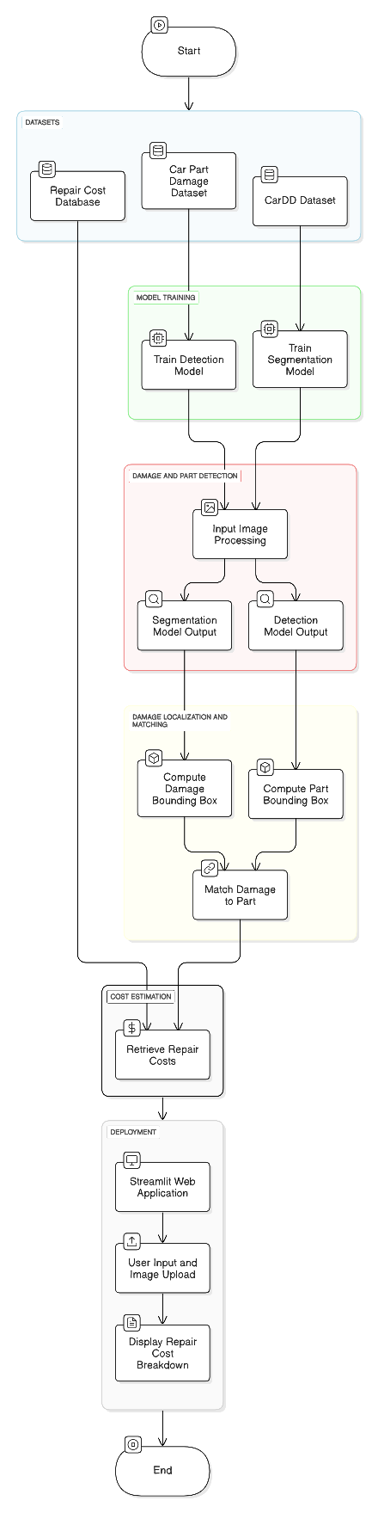

1. Dataset Preparation

- The CarDD Dataset was preprocessed using Roboflow for training a YOLOv11 segmentation model to detect six types of damages: scratch, dent, crack, glass shatter, lamp broken, and tire flat.

- A separate Car Part Damage Detection Dataset was created using Roboflow for training a YOLOv11 detection model to identify seven car parts: bonnet, dickey, bumper, door, fender, light, and windshield.

2. Model Training

- A YOLOv11 segmentation model was trained on the CarDD Dataset for precise damage localization at the pixel level.

- A YOLOv11 detection model was trained on the Car Part Dataset to identify and classify damaged car parts.

3. Damage and Part Detection

- The input image is passed through the segmentation model, producing a mask that highlights the damaged areas.

- The image is then processed by the detection model, which identifies the car part containing the damage.

4. Damage Localization and Matching

- The bounding box centers of detected damage types are computed from the segmentation mask.

- The bounding box centers of car parts are extracted from the detection model output.

- Euclidean Distance is used to match each damage type to its closest car part:

\[

d = \sqrt{(x_2 - x_1)^2 + (y_2 - y_1)^2}

\]

where \((x_1, y_1)\) and \((x_2, y_2)\) are the center coordinates of the damage and car part, respectively.

5. Cost Estimation

- The damage type and affected part are used to retrieve repair costs from a CSV file based on the user-provided car brand and model.

- The total repair cost is computed as:

\[

\text{Total Cost} = \sum_{i=1}^{n} C_{i}

\]

where \(C_{i}\) is the repair cost for each detected damage.

6. Deployment

- A Streamlit-based web application was developed to allow users to input car details, upload an image, and receive a detailed repair cost breakdown.

This methodology ensures an automated, accurate, and scalable approach to vehicle damage assessment.