KMeans & Agnes Clustering

Bhuvan Kapoor [23MDT1003]

2024-03-19

# Experiment: Clustering  
  
# KMeans Clustering  
library(ggplot2)  
library(cluster)  
library(tidyverse)

## ── Attaching core tidyverse packages ──────────────────────── tidyverse 2.0.0 ──  
## ✔ dplyr 1.1.4 ✔ readr 2.1.5  
## ✔ forcats 1.0.0 ✔ stringr 1.5.1  
## ✔ lubridate 1.9.3 ✔ tibble 3.2.1  
## ✔ purrr 1.0.2 ✔ tidyr 1.3.1  
## ── Conflicts ────────────────────────────────────────── tidyverse_conflicts() ──  
## ✖ dplyr::filter() masks stats::filter()  
## ✖ dplyr::lag() masks stats::lag()  
## ℹ Use the conflicted package (<http://conflicted.r-lib.org/>) to force all conflicts to become errors

library(factoextra)

## Welcome! Want to learn more? See two factoextra-related books at https://goo.gl/ve3WBa

library(gridExtra)

##   
## Attaching package: 'gridExtra'  
##   
## The following object is masked from 'package:dplyr':  
##   
## combine

df <- USArrests  
df <- na.omit(df)  
df <- scale(df)  
  
head(df)

## Murder Assault UrbanPop Rape  
## Alabama 1.24256408 0.7828393 -0.5209066 -0.003416473  
## Alaska 0.50786248 1.1068225 -1.2117642 2.484202941  
## Arizona 0.07163341 1.4788032 0.9989801 1.042878388  
## Arkansas 0.23234938 0.2308680 -1.0735927 -0.184916602  
## California 0.27826823 1.2628144 1.7589234 2.067820292  
## Colorado 0.02571456 0.3988593 0.8608085 1.864967207

k2 <- kmeans(df, centers = 2, nstart = 25)  
str(k2)

## List of 9  
## $ cluster : Named int [1:50] 2 2 2 1 2 2 1 1 2 2 ...  
## ..- attr(*, "names")= chr [1:50] "Alabama" "Alaska" "Arizona" "Arkansas" ...  
## $ centers : num [1:2, 1:4] -0.67 1.005 -0.676 1.014 -0.132 ...  
## ..- attr(*, "dimnames")=List of 2  
## .. ..$ : chr [1:2] "1" "2"  
## .. ..$ : chr [1:4] "Murder" "Assault" "UrbanPop" "Rape"  
## $ totss : num 196  
## $ withinss : num [1:2] 56.1 46.7  
## $ tot.withinss: num 103  
## $ betweenss : num 93.1  
## $ size : int [1:2] 30 20  
## $ iter : int 1  
## $ ifault : int 0  
## - attr(*, "class")= chr "kmeans"

k2

## K-means clustering with 2 clusters of sizes 30, 20  
##   
## Cluster means:  
## Murder Assault UrbanPop Rape  
## 1 -0.669956 -0.6758849 -0.1317235 -0.5646433  
## 2 1.004934 1.0138274 0.1975853 0.8469650  
##   
## Clustering vector:  
## Alabama Alaska Arizona Arkansas California   
## 2 2 2 1 2   
## Colorado Connecticut Delaware Florida Georgia   
## 2 1 1 2 2   
## Hawaii Idaho Illinois Indiana Iowa   
## 1 1 2 1 1   
## Kansas Kentucky Louisiana Maine Maryland   
## 1 1 2 1 2   
## Massachusetts Michigan Minnesota Mississippi Missouri   
## 1 2 1 2 2   
## Montana Nebraska Nevada New Hampshire New Jersey   
## 1 1 2 1 1   
## New Mexico New York North Carolina North Dakota Ohio   
## 2 2 2 1 1   
## Oklahoma Oregon Pennsylvania Rhode Island South Carolina   
## 1 1 1 1 2   
## South Dakota Tennessee Texas Utah Vermont   
## 1 2 2 1 1   
## Virginia Washington West Virginia Wisconsin Wyoming   
## 1 1 1 1 1   
##   
## Within cluster sum of squares by cluster:  
## [1] 56.11445 46.74796  
## (between_SS / total_SS = 47.5 %)  
##   
## Available components:  
##   
## [1] "cluster" "centers" "totss" "withinss" "tot.withinss"  
## [6] "betweenss" "size" "iter" "ifault"

fviz_cluster(k2, df)

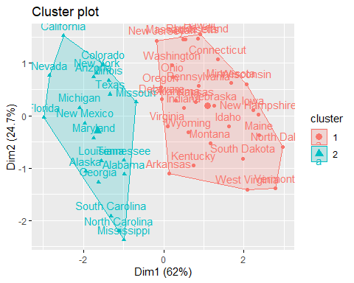

k3 <- kmeans(df, centers = 3, nstart = 25)  
k4 <- kmeans(df, centers = 4, nstart = 25)  
k5 <- kmeans(df, centers = 5, nstart = 25)  
  
p1 <- fviz_cluster(k2, geom = 'point', data = df) + ggtitle("K=2")  
p2 <- fviz_cluster(k3, geom = 'point', data = df) + ggtitle("K=3")  
p3 <- fviz_cluster(k4, geom = 'point', data = df) + ggtitle("K=4")  
p4 <- fviz_cluster(k5, geom = 'point', data = df) + ggtitle("K=5")  
  
grid.arrange(p1, p2, p3, p4, nrow = 2)

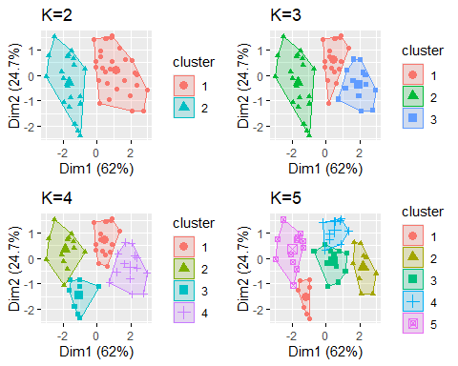

# selecting optimum number of clusters  
set.seed(123)  
fviz_nbclust(df, kmeans, method = 'wss')

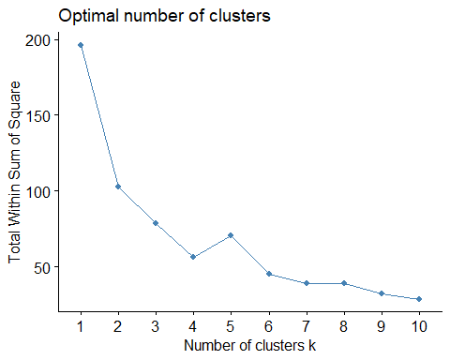

set.seed(123)  
fviz_nbclust(df, kmeans, method = 'silhouette')

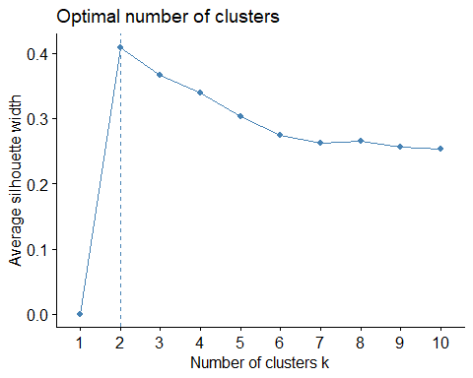

set.seed(123)  
gap_stat <- clusGap(df, FUN = kmeans, nstart = 25, K.max = 10, B = 50)  
fviz_gap_stat(gap_stat)

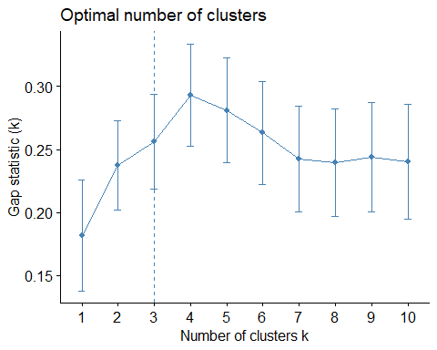

set.seed(123)  
final <- kmeans(df, 2, nstart = 25)  
print(final)

## K-means clustering with 2 clusters of sizes 20, 30  
##   
## Cluster means:  
## Murder Assault UrbanPop Rape  
## 1 1.004934 1.0138274 0.1975853 0.8469650  
## 2 -0.669956 -0.6758849 -0.1317235 -0.5646433  
##   
## Clustering vector:  
## Alabama Alaska Arizona Arkansas California   
## 1 1 1 2 1   
## Colorado Connecticut Delaware Florida Georgia   
## 1 2 2 1 1   
## Hawaii Idaho Illinois Indiana Iowa   
## 2 2 1 2 2   
## Kansas Kentucky Louisiana Maine Maryland   
## 2 2 1 2 1   
## Massachusetts Michigan Minnesota Mississippi Missouri   
## 2 1 2 1 1   
## Montana Nebraska Nevada New Hampshire New Jersey   
## 2 2 1 2 2   
## New Mexico New York North Carolina North Dakota Ohio   
## 1 1 1 2 2   
## Oklahoma Oregon Pennsylvania Rhode Island South Carolina   
## 2 2 2 2 1   
## South Dakota Tennessee Texas Utah Vermont   
## 2 1 1 2 2   
## Virginia Washington West Virginia Wisconsin Wyoming   
## 2 2 2 2 2   
##   
## Within cluster sum of squares by cluster:  
## [1] 46.74796 56.11445  
## (between_SS / total_SS = 47.5 %)  
##   
## Available components:  
##   
## [1] "cluster" "centers" "totss" "withinss" "tot.withinss"  
## [6] "betweenss" "size" "iter" "ifault"

fviz_cluster(final, geom = 'point', data = df)

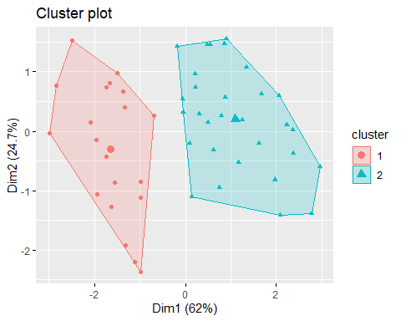

# Agglomeritive (AGNES)  
data <- iris  
hca1 <- agnes(data, method = "complete")  
pltree(hca1, cex = 0.6, hand = -1, main = 'Dendrogram')

## Warning in graphics:::plotHclust(n1, merge, height, order(x$order), hang, :  
## "hand" is not a graphical parameter  
  
## Warning in graphics:::plotHclust(n1, merge, height, order(x$order), hang, :  
## "hand" is not a graphical parameter

## Warning in axis(2, at = pretty(range(height)), ...): "hand" is not a graphical  
## parameter

## Warning in title(main = main, sub = sub, xlab = xlab, ylab = ylab, ...): "hand"  
## is not a graphical parameter

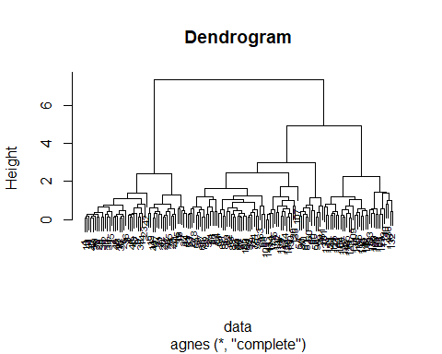

dvcut <- cutree(as.hclust(hca1),k=3)  
table(dvcut)

## dvcut  
## 1 2 3   
## 50 66 34

hca2 <- agnes(data, method = "single")  
pltree(hca2, cex = 0.6, hand = -1, main = 'Dendrogram')

## Warning in graphics:::plotHclust(n1, merge, height, order(x$order), hang, :  
## "hand" is not a graphical parameter

## Warning in graphics:::plotHclust(n1, merge, height, order(x$order), hang, :  
## "hand" is not a graphical parameter

## Warning in axis(2, at = pretty(range(height)), ...): "hand" is not a graphical  
## parameter

## Warning in title(main = main, sub = sub, xlab = xlab, ylab = ylab, ...): "hand"  
## is not a graphical parameter

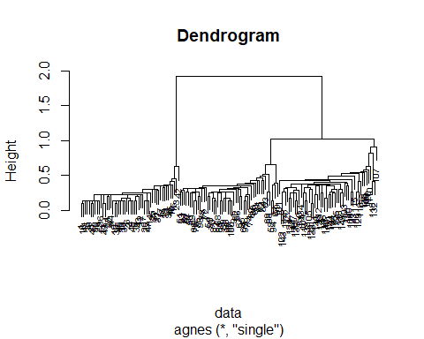

dvcut <- cutree(as.hclust(hca2),k=3)  
table(dvcut)

## dvcut  
## 1 2 3   
## 50 50 50

hca3 <- agnes(data, method = "average")  
pltree(hca3, cex = 0.6, hand = -1, main = 'Dendrogram')

## Warning in graphics:::plotHclust(n1, merge, height, order(x$order), hang, :  
## "hand" is not a graphical parameter

## Warning in graphics:::plotHclust(n1, merge, height, order(x$order), hang, :  
## "hand" is not a graphical parameter

## Warning in axis(2, at = pretty(range(height)), ...): "hand" is not a graphical  
## parameter

## Warning in title(main = main, sub = sub, xlab = xlab, ylab = ylab, ...): "hand"  
## is not a graphical parameter

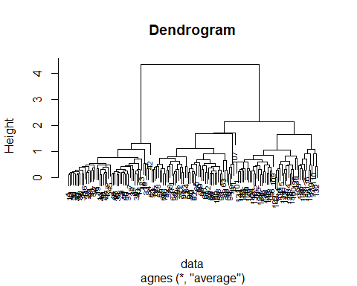

dvcut <- cutree(as.hclust(hca3),k=3)  
table(dvcut)

## dvcut  
## 1 2 3   
## 50 51 49