Maximum Likelihood Estimation

Bhuvan Kapoor [23MDT1003]

2024-04-23

## Experiment 10 : MLE  
library(tidyverse)

## ── Attaching core tidyverse packages ──────────────────────── tidyverse 2.0.0 ──  
## ✔ dplyr 1.1.4 ✔ readr 2.1.5  
## ✔ forcats 1.0.0 ✔ stringr 1.5.1  
## ✔ ggplot2 3.5.0 ✔ tibble 3.2.1  
## ✔ lubridate 1.9.3 ✔ tidyr 1.3.1  
## ✔ purrr 1.0.2   
## ── Conflicts ────────────────────────────────────────── tidyverse_conflicts() ──  
## ✖ dplyr::filter() masks stats::filter()  
## ✖ dplyr::lag() masks stats::lag()  
## ℹ Use the conflicted package (<http://conflicted.r-lib.org/>) to force all conflicts to become errors

library(EnvStats)

##   
## Attaching package: 'EnvStats'  
##   
## The following objects are masked from 'package:stats':  
##   
## predict, predict.lm

library(dplyr)  
  
# Binomial Distribution  
set.seed(33)  
heads <- rbinom(1,100,0.5)  
heads

## [1] 55

ebinom(heads, size = 100, method = 'mle')

##   
## Results of Distribution Parameter Estimation  
## --------------------------------------------  
##   
## Assumed Distribution: Binomial  
##   
## Estimated Parameter(s): size = 100.00  
## prob = 0.55  
##   
## Estimation Method: mle/mme/mvue for 'prob'  
##   
## Data: heads  
##   
## Sample Size: 100

# Poisson Distribution  
set.seed(33)  
data_pois <- rpois(100, lambda = 5)  
  
df_pois <- data.frame(data_pois)  
  
df_pois %>%  
 ggplot(aes(x = data_pois)) +  
 geom_histogram(bins = 20) +   
 labs(title = "Poisson Distribution",  
 subtitle = 'lambda = 5',  
 x = 'data',  
 y = 'count') +  
 theme_bw()

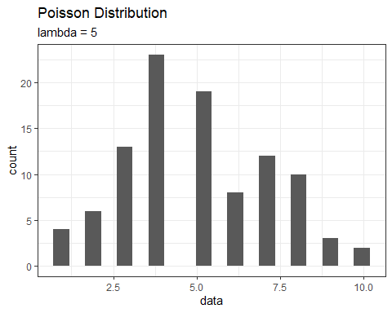

epois(data_pois, method = 'mle')

##   
## Results of Distribution Parameter Estimation  
## --------------------------------------------  
##   
## Assumed Distribution: Poisson  
##   
## Estimated Parameter(s): lambda = 5.01  
##   
## Estimation Method: mle/mme/mvue  
##   
## Data: data_pois  
##   
## Sample Size: 100

# Normal Distribution  
set.seed(33)  
x <- rnorm(100, mean = 3, sd = 2)  
mean(x)

## [1] 3.118982

sd(x)

## [1] 2.015735

data.frame(x=x) %>%  
 ggplot(aes(x=x)) +  
 geom_histogram(bins = 20, color = 'blue', fill = 'lightblue') +  
 theme_bw(base_size = 16) +  
 xlab("Data")

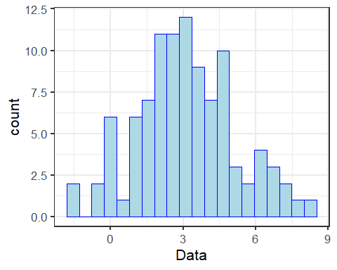

enorm(x, method = 'mle')

##   
## Results of Distribution Parameter Estimation  
## --------------------------------------------  
##   
## Assumed Distribution: Normal  
##   
## Estimated Parameter(s): mean = 3.118982  
## sd = 2.005631  
##   
## Estimation Method: mle/mme  
##   
## Data: x  
##   
## Sample Size: 100