Experiment 9 : SVM

Bhuvan Kapoor [23MDT1003]

2024-04-16

## Experiment 9 : SVM  
  
library(tidyverse) # Data Manipulation

## ── Attaching core tidyverse packages ──────────────────────── tidyverse 2.0.0 ──  
## ✔ dplyr 1.1.4 ✔ readr 2.1.5  
## ✔ forcats 1.0.0 ✔ stringr 1.5.1  
## ✔ ggplot2 3.5.0 ✔ tibble 3.2.1  
## ✔ lubridate 1.9.3 ✔ tidyr 1.3.1  
## ✔ purrr 1.0.2   
## ── Conflicts ────────────────────────────────────────── tidyverse_conflicts() ──  
## ✖ dplyr::filter() masks stats::filter()  
## ✖ dplyr::lag() masks stats::lag()  
## ℹ Use the conflicted package (<http://conflicted.r-lib.org/>) to force all conflicts to become errors

library(kernlab) # SVM Methodology

##   
## Attaching package: 'kernlab'  
##   
## The following object is masked from 'package:purrr':  
##   
## cross  
##   
## The following object is masked from 'package:ggplot2':  
##   
## alpha

library(e1071) # SVM Methodology  
library(ISLR) # Sample Data  
library(RColorBrewer) # Customize Color  
  
## Example 1  
# Construct sample data set - completely separable  
set.seed(10)  
x <- matrix(rnorm(25*2), ncol = 2)  
y <- c(rep(0,13), rep(1,12))  
x[y==1,] = x[y==1,] + 3  
data <- data.frame(x=x, y=as.factor(y))  
data

## x.1 x.2 y  
## 1 0.01874617 -0.37366156 0  
## 2 -0.18425254 -0.68755543 0  
## 3 -1.37133055 -0.87215883 0  
## 4 -0.59916772 -0.10176101 0  
## 5 0.29454513 -0.25378053 0  
## 6 0.38979430 -1.85374045 0  
## 7 -1.20807618 -0.07794607 0  
## 8 -0.36367602 0.96856634 0  
## 9 -1.62667268 0.18492596 0  
## 10 -0.25647839 -1.37994358 0  
## 11 1.10177950 -1.43551436 0  
## 12 0.75578151 0.36208723 0  
## 13 -0.23823356 -1.75908675 0  
## 14 3.98744470 2.67545599 1  
## 15 3.74139013 2.34843701 1  
## 16 3.08934727 4.08655140 1  
## 17 2.04505614 2.23745512 1  
## 18 2.80484962 2.17133746 1  
## 19 3.92552126 3.83447390 1  
## 20 3.48297852 2.03234801 1  
## 21 2.40368936 2.97118466 1  
## 22 0.81471316 3.23252515 1  
## 23 2.32513406 2.69879132 1  
## 24 0.88093881 2.32238542 1  
## 25 1.73480198 3.65522764 1

# Plot Data  
plot(data$x.2,data$x.1, xlab = "x2", ylab = "x1", col = data$y, pch = 4)

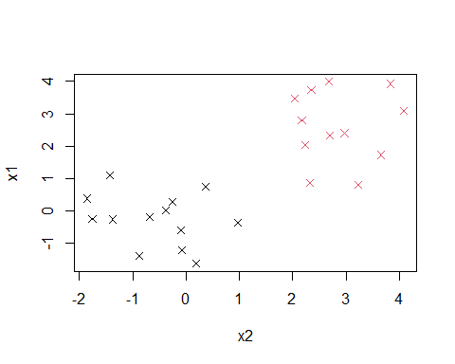

# Fit SVM  
svmfit <- svm(y~., data = data, kernel = 'linear', scale = F)  
  
# Plot Results  
plot(svmfit, data)

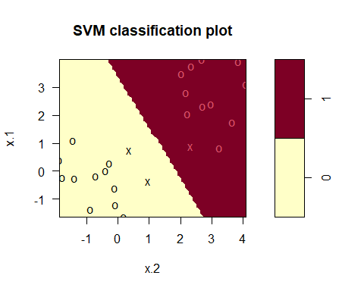

svmfit$SV

## x.1 x.2  
## 8 -0.3636760 0.9685663  
## 12 0.7557815 0.3620872  
## 24 0.8809388 2.3223854

## Example 2  
# Construct sample data set - not completely separable  
set.seed(10)  
x <- matrix(rnorm(20*2), ncol = 2)  
y <- c(rep(-1,10), rep(1,10))  
x[y==1,] = x[y==1,] + 1  
data <- data.frame(x=x, y=as.factor(y))  
data

## x.1 x.2 y  
## 1 0.01874617 -0.5963106 -1  
## 2 -0.18425254 -2.1852868 -1  
## 3 -1.37133055 -0.6748659 -1  
## 4 -0.59916772 -2.1190612 -1  
## 5 0.29454513 -1.2651980 -1  
## 6 0.38979430 -0.3736616 -1  
## 7 -1.20807618 -0.6875554 -1  
## 8 -0.36367602 -0.8721588 -1  
## 9 -1.62667268 -0.1017610 -1  
## 10 -0.25647839 -0.2537805 -1  
## 11 2.10177950 -0.8537405 1  
## 12 1.75578151 0.9220539 1  
## 13 0.76176644 1.9685663 1  
## 14 1.98744470 1.1849260 1  
## 15 1.74139013 -0.3799436 1  
## 16 1.08934727 -0.4355144 1  
## 17 0.04505614 1.3620872 1  
## 18 0.80484962 -0.7590868 1  
## 19 1.92552126 0.6754560 1  
## 20 1.48297852 0.3484370 1

# Plot Data  
plot(data$x.2,data$x.1, xlab = "x2", ylab = "x1", col = data$y, pch = 4)

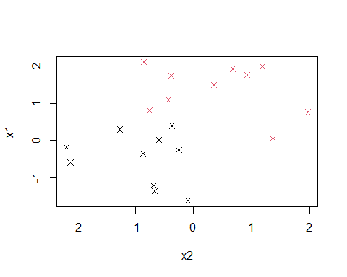

# Fit SVM  
svmfit_1 <- svm(y~., data = data, kernel = 'linear', scale = F, cost = 5)  
svmfit_2 <- svm(y~., data = data, kernel = 'linear', scale = F, cost = 10)  
  
# Plot Results  
plot(svmfit_1, data)

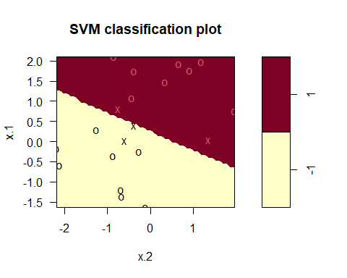

plot(svmfit_2, data)

