

Last-Mile Delivery Optimization: Challenges and Innovations
Student 1: Bhuvan Singh, Student 2: Amit Bhardwaj
MBA (BE) Programme, Department of Finance and Business Economics, University of Delhi, South Campus
Roll Number of Student 1: 23023, Roll Number of Student 2: 23012

Abstract
The rapid growth of e-commerce and on-demand services has intensified the need for efficient and consumer-centric last-mile delivery solutions. This study, titled "Last-Mile Delivery Optimization: Challenges and Innovations," investigates the evolving dynamics of last-mile logistics with a focus on consumer satisfaction, preferences for innovative delivery options, and openness to sustainable practices. The primary objectives were: (1) to assess the level of consumer satisfaction in last-mile delivery services; (2) to examine whether scheduled delivery options impact satisfaction; and (3) to analyze if a consumer’s concern for sustainability influences their willingness to pay extra for green delivery alternatives.
A quantitative approach was adopted, with primary data collected through a structured questionnaire administered to 52 respondents. The data was analyzed using non-parametric statistical tests such as Wilcoxon Signed Rank Test, Mann-Whitney U Test, and Kruskal-Wallis H Test, ensuring robustness despite the limited sample size. The results revealed that consumers are generally satisfied with current delivery services, particularly in terms of speed, updates, and convenience (M = 4.058, p < 0.001). While scheduled delivery preference showed slightly higher satisfaction, the statistical test could not confirm significance due to limited group variance. Most notably, a significant association was found between the importance placed on sustainability and the willingness to pay more for green delivery methods (p = 0.008), indicating a rising trend in eco-conscious consumer behavior.
The study contributes both theoretically and practically. Theoretically, it reinforces consumer behavior models by integrating sustainability as a key variable. Practically, it highlights opportunities for delivery firms to enhance satisfaction through scheduling flexibility and sustainable alternatives. However, the study is limited by sample size and demographic scope. Future research with broader representation can help generalize and extend these findings.
Keywords: Last-Mile Delivery, Consumer Satisfaction, Scheduled Delivery, Green Logistics, Sustainability, E-Commerce, Delivery Optimization, Consumer Behavior

Table of Contents
S No. | Particulars | Page No.
- | Abstract | 1
1. | Introduction | 3
2. | Literature review | 4
3. | Research Gap | 4
4. | Objectives | 5
5. | Research Methodology | 6
6. | Discussion of results | 8
6.1 | Descriptive results | 8
6.2 | Statistical model: Results and Interpretation | 11
6.3 | Comparison of results | 23
7. | Discussion and Conclusion | 24
8. | Implications | 25
8.1 | Theoretical Implication | 25
8.2 | Practical Implication | 25
9. | Limitations and future directions for research | 26
10. | References | 27

- Introduction
The last-mile delivery segment—the final leg of a product’s journey from a warehouse or fulfillment center to the end customer—has emerged as a crucial battleground for e-commerce and logistics providers in an era of instant gratification. With the exponential rise in online shopping and doorstep services, especially after the COVID-19 pandemic, consumer expectations have shifted from standard delivery to faster, more transparent, and sustainable alternatives. This transformation is not only driven by convenience but also by a rising awareness of environmental impact, leading companies to innovate in last-mile logistics through technologies like electric vehicles, smart lockers, and drone deliveries.
Despite its importance, the last-mile segment remains the most time-consuming and cost-intensive part of the supply chain, often accounting for over 50% of total delivery costs. While companies have introduced various optimization strategies, including real-time tracking, route planning, and crowd-sourced delivery, the actual perceptions and preferences of consumers toward these innovations remain under-researched—particularly in the Indian context.
This study explores the intersection of consumer satisfaction, delivery innovation, and sustainability preferences within the framework of last-mile logistics. The central objective is to evaluate how satisfied consumers are with their delivery experiences and whether preferences for modern delivery options—such as scheduled slots or eco-friendly alternatives—correlate with satisfaction and future adoption intent. The study is grounded in three core hypotheses:
- H1: Consumers report a satisfaction level significantly above neutral regarding their last-mile delivery experience.
- H2: Consumers who prefer scheduled deliveries report higher satisfaction levels.
- H3: Consumers placing a higher importance on sustainability are more likely to pay extra for green delivery services.
A structured survey was administered to 52 participants, and the results were analyzed using robust non-parametric tests. While general satisfaction was high (M = 4.058), the influence of scheduling preference could not be statistically confirmed due to group size limitations. However, a statistically significant correlation was found between eco-consciousness and the willingness to pay extra for sustainable delivery options—highlighting a key insight for the logistics industry.
This introduction sets the stage for a deeper examination of the findings and their theoretical and practical implications in the following sections of the report.

- Literature Review
Customer satisfaction in last-mile delivery has become a vital area of focus as e-commerce continues to reshape logistics. Studies have shown that satisfaction is driven by multiple factors beyond mere delivery speed. Li et al. (2006) conducted a comparative analysis of UPS and FedEx and identified that delivery accuracy, timely communication, parcel condition, and problem resolution are key to a positive delivery experience. Similarly, Boysen et al. (2021) noted that while optimization models prioritize operational efficiency, customer-centric metrics such as flexibility and responsiveness are often overlooked. Molin et al. (2022) further highlighted that consumer satisfaction is strongly influenced by the quality of last-mile interactions — such as real-time tracking, ability to customize delivery times, and ease of communication. As per Dablanc et al. (2017), the rise of urban congestion and consumer expectations has increased demand for personalized, predictable delivery services.
Recent innovations such as scheduled delivery slots have been proposed as solutions to improve convenience and satisfaction. Deutsch and Golany (2018) emphasized that offering time slots for deliveries not only enhances the customer experience but also reduces operational inefficiencies like redelivery. Molin et al. (2022) found that many consumers, particularly urban working professionals, value the flexibility of choosing when and where to receive parcels, suggesting a shift in preferences toward scheduled and self-service deliveries. McKinnon and Tallam (2003) explored unattended delivery models and found that consumer satisfaction was significantly higher when delivery timing matched the consumer’s availability, even without human interaction. These findings indicate a strong link between time flexibility and consumer satisfaction, especially in dense urban areas.
Sustainability in last-mile delivery has also drawn increasing attention, especially among environmentally aware consumers. Studies like those by Schnieder et al. (2021) and Kreier (2022) observed that carbon-conscious consumers often favor green delivery options, such as electric vehicle-based logistics, consolidated shipments, or carbon-neutral services. However, the willingness to support such services financially varies. According to Molin et al. (2022), some consumers are ready to pay extra for greener options if properly informed about the environmental impact. Deutsch and Golany (2018) found that green logistics can also enhance brand image and loyalty when aligned with consumer values. These studies underscore the emerging link between sustainability awareness and consumer delivery preferences.
- Research Gaps
Although customer satisfaction is widely recognized as crucial in last-mile delivery, most existing research focuses on operational metrics and provider performance, with relatively less emphasis on direct consumer feedback across multiple satisfaction dimensions such as communication, tracking, packaging, and timeliness. Moreover, there is a lack of segmented analysis based on different consumer groups (e.g., students, salaried professionals), which could uncover distinct satisfaction drivers across demographics.
While scheduled deliveries are acknowledged as a valuable innovation, limited empirical research exists on how consumer preference for scheduled time slots quantitatively correlates with their overall satisfaction. Most studies have focused on operational benefits for firms, overlooking the behavioral side of consumers who actively choose such services. There is also a gap in assessing whether scheduled delivery acts as a service differentiator in the eyes of the end-user.
In the context of sustainable delivery options, research acknowledges that eco-conscious consumers are emerging, but there's insufficient data on how environmental concern translates into actual consumer behavior, especially regarding their willingness to pay extra for green options. Moreover, studies have not sufficiently explored how demographic factors (e.g., age, income, education) influence this willingness, particularly in developing or urbanizing economies. Understanding this behavior is essential for designing viable green logistics models that appeal to both values and wallets.
4. Objectives
Objective 1:
To evaluate the overall satisfaction level of consumers with last-mile delivery services provided by e-commerce and logistics companies.
This objective seeks to understand how end-users perceive their delivery experience in terms of efficiency, timeliness, packaging, communication, and reliability. It aims to capture whether the current operational strategies in last-mile logistics are meeting consumer expectations. By analyzing consumer satisfaction scores and identifying common satisfaction drivers, the study intends to provide actionable insights into the strengths and areas for improvement in the last stage of the supply chain, which is critical for customer retention and brand reputation.

Objective 2:
To examine whether consumers’ preference for scheduled deliveries has a significant impact on their satisfaction with last-mile delivery services.
This objective focuses on analyzing whether offering time-flexible delivery slots correlates with higher customer satisfaction. The rationale is to explore if consumers who prefer scheduled deliveries—due to convenience or availability—report a more positive experience compared to those who do not prioritize such options. The study further aims to identify if delivery time customization can be positioned as a service differentiator in competitive e-commerce markets. Insights from this analysis could help logistics providers design customer-centric delivery models that enhance service personalization.

Objective 3:
To investigate the relationship between consumers’ willingness to pay extra for eco-friendly (green) delivery options and the importance they place on sustainability in logistics operations.
This objective is designed to assess the influence of environmental consciousness on consumer behavior in the context of last-mile delivery. It explores whether individuals who value sustainability are more inclined to support green logistics initiatives, even at a higher cost. The goal is to identify if there is a viable market segment that logistics providers can target through eco-conscious service models—such as electric vehicle deliveries, carbon-neutral shipments, or recyclable packaging. This insight can assist companies in aligning their operations with ESG (Environmental, Social, and Governance) goals while catering to evolving consumer values

5. Research Methodology
This study titled “Last-Mile Delivery Optimization: Challenges and Innovations” adopts a quantitative primary research approach to examine consumer experiences, preferences, and attitudes toward last-mile delivery services, especially in the context of emerging innovations such as scheduled delivery slots, smart lockers, eco-friendly logistics, and contactless delivery.
Research Design
The research follows a descriptive and exploratory design aimed at understanding the factors affecting consumer satisfaction and their preferences regarding various modern last-mile delivery solutions. The study also investigates the impact of demographic factors (such as age, income, and occupation) on consumers’ attitudes toward innovative and sustainable delivery practices.
Data Collection Method
A structured online survey was used to collect primary data. The survey, titled “Consumer Survey: Last-Mile Delivery Challenges and Innovations”, was designed using Google Forms and was disseminated through digital channels. The questionnaire comprised both close-ended Likert scale items and multiple-choice questions, ensuring consistency and facilitating statistical analysis.
The survey consisted of three sections:
- Demographic Information: Including age, gender, occupation, and household income.
- Perception & Preferences: Measuring satisfaction with delivery services, usage and trust in modern delivery methods (e.g., scheduled delivery, contactless, smart lockers, drone delivery), and general convenience.
- Sustainability Orientation: Assessing the importance of environmental factors in delivery choices and willingness to pay extra for eco-friendly alternatives.
A total of 52 valid responses were collected, providing a sufficient base for non-parametric statistical testing due to the modest sample size and ordinal nature of several variables.
Sampling Technique
The study used convenience sampling, targeting individuals familiar with e-commerce and online delivery services. While this technique limits the generalizability of the findings, it was deemed appropriate given the study's exploratory nature and time constraints.
Analytical Tools and Software
Data analysis was conducted using JASP statistical software, an open-source alternative known for its user-friendly interface and robust non-parametric testing capabilities. Given the ordinal and categorical nature of the data, and the small sample size, non-parametric tests were chosen over parametric alternatives.
The following statistical tests were applied:
- Mann-Whitney U Test: To assess differences between two independent groups (e.g., consumers who prefer scheduled deliveries vs. those who do not).
- Kruskal-Wallis H Test: To compare satisfaction and green preferences across more than two demographic categories (e.g., income groups, age ranges).
- Wilcoxon Signed-Rank Test: To compare paired or related samples where applicable, such as perceived importance of sustainability vs. likelihood of choosing green delivery.
Ethical Considerations
Participation was voluntary and anonymous, and respondents were informed that the data would be used strictly for academic purposes. No personal identifiers were collected, and all responses were kept confidential.

6. Discussion of Results
6.1 Descriptive Statistics

Age
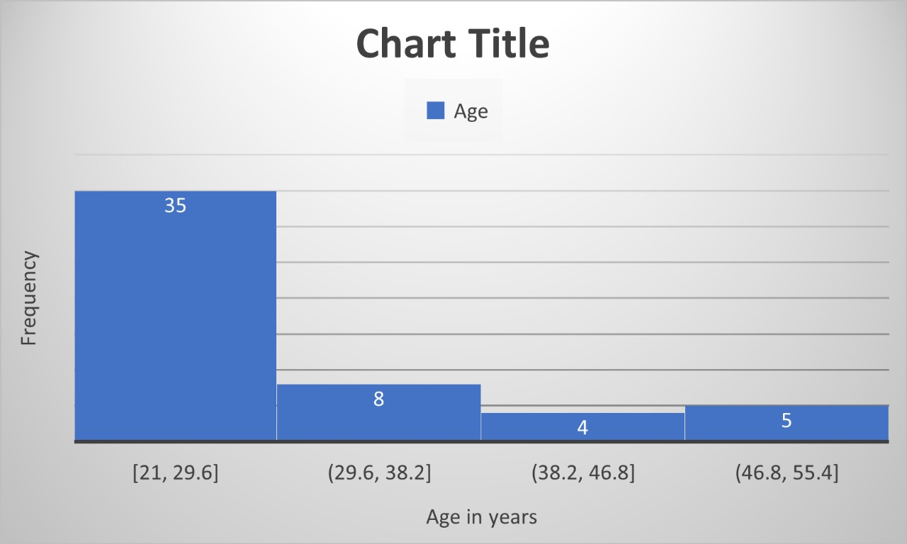
The histogram shows that the majority of respondents (35 out of 52, approx. 67%) fall within the 21–29.6 years age group, indicating a younger-skewed sample. The 29.6–38.2 age group includes 8 respondents (15%), while the 38.2–46.8 and 46.8–55.4 age groups account for 4 (8%) and 5 (10%) respondents, respectively. This right-skewed distribution suggests that younger individuals were more engaged in the survey, which may influence the overall findings and preferences reflected in the data.

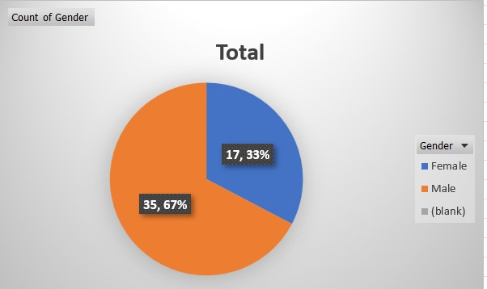
Gender
The gender distribution among the 52 respondents indicates a male-dominated sample. Out of the total, 67% (35 respondents) identified as male, while 33% (17 respondents) identified as female. There were no missing or unspecified entries in this category, which indicates complete and reliable data collection. The considerable difference between the number of male and female respondents may reflect the demographic skew of the survey audience.

Occupation
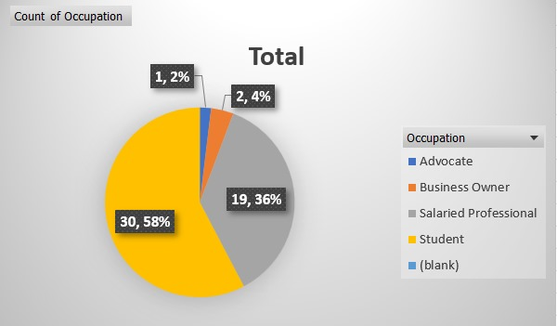
Occupation-wise, the sample is significantly skewed towards students, who constitute 57.7% (30 respondents) of the total. Salaried professionals make up 36.5% (19 respondents), while business owners (3.8%, 2 respondents) and advocates (1.9%, 1 respondent) form a much smaller part of the population. The high proportion of students likely reflects the context or target audience of the survey. This category also had no missing values, contributing to the reliability of the analysis.

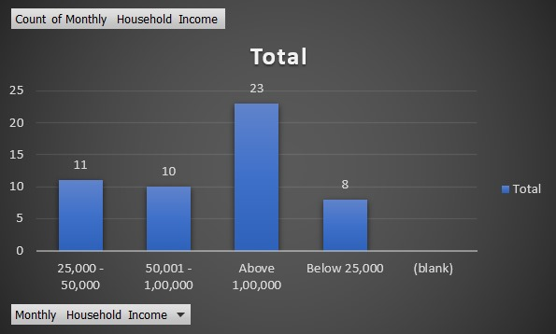
Monthly household Income
In terms of monthly household income, the majority of respondents (44.2%, or 23 individuals) reported earning above ₹1,00,000. This is followed by 21.2% (11 respondents) in the ₹25,000–50,000 range, 19.2% (10 respondents) in the ₹50,001–1,00,000 bracket, and 15.4% (8 respondents) earning below ₹25,000. The data suggests a relatively well-off respondent base, with nearly two-thirds (63.4%) earning more than ₹50,000 per month. No income data was left blank, ensuring completeness in this category.

Would you prefer scheduled deliveries if you could choose your delivery time slot?
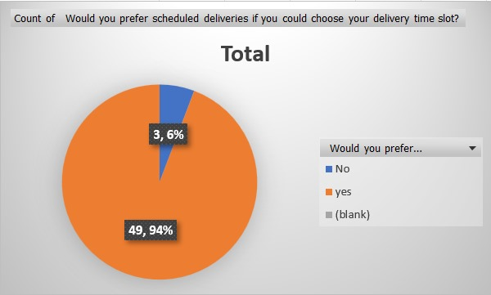
The chart illustrates consumer preference for scheduled deliveries with customizable time slots. An overwhelming 94% (49 respondents) answered “Yes,” showing strong interest in time-specific deliveries. Only 6% (3 respondents) said “No,” reflecting minimal opposition. This suggests that offering scheduled delivery options could significantly enhance customer satisfaction and improve last-mile delivery efficiency. Businesses can use this insight to optimize logistics and reduce failed delivery attempts.

Would you be willing to pay a slightly higher delivery fee for eco-friendly options like delivery through electric vehicles, sustainable packaging ?
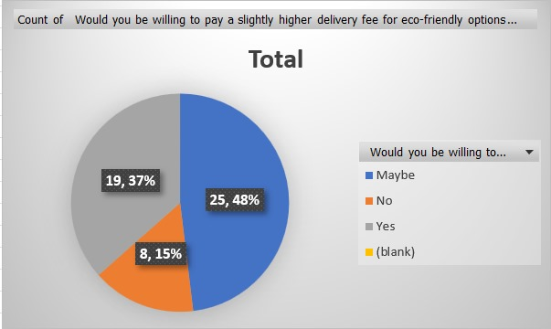
The pie chart illustrates respondents' willingness to pay a slightly higher delivery fee for eco-friendly options like electric vehicle delivery and sustainable packaging. A significant portion, 48% (25 respondents), indicated "Maybe," suggesting conditional openness. 37% (19 respondents) responded "Yes," showing a clear willingness to support sustainability efforts. Meanwhile, 15% (8 respondents) said "No," indicating price sensitivity. Overall, the majority lean toward eco-conscious choices, albeit with some reservations.

6.2 Statistical Model Results and Evaluation
Hypothesis 1: Consumers are generally satisfied with the last-mile delivery experience.
Null Hypothesis (H₀):
Consumers are not generally satisfied with the last-mile delivery experience; the median satisfaction score is equal to or less than 3 (neutral).
Alternate Hypothesis (H₁):
Consumers are generally satisfied with the last-mile delivery experience; the median satisfaction score is significantly greater than 3.
- Dependent Variable:
  - Consumer Satisfaction Score
    - Measured on a 5-point Likert scale (1 = Very Dissatisfied, 5 = Very Satisfied).
    - This variable reflects overall satisfaction across aspects like delivery speed, tracking updates, and convenience.
- Independent Variable:
  - Hypothetical population average (Neutral point = 3 on the Likert scale)
    - Not a variable in the classic sense, but here we compare the satisfaction score against a neutral value.
The hypothesis tests whether the mean satisfaction score is significantly greater than 3, which would imply general satisfaction.
Since satisfaction ratings are ordinal and not normally distributed (as per the Shapiro-Wilk test), a Wilcoxon Signed-Rank Test (non-parametric) was applied.
Statistical Test Used:
Wilcoxon Signed-Rank Test (non-parametric alternative to one-sample t-test, used due to non-normality)

One Sample T-Test
 |  | Test |  | Statistic |  | df |  | p |  | Effect Size |  | SE Effect Size
How satisfied are you with the last-mile delivery experience of products in terms of speed, updates, and convenience? |  | Student |  | 10.516 |  | 51 |  | < .001 |  | 1.458 |  | 0.199
 |  | Wilcoxon |  | 820.000 |  |  |  | < .001 |  | 1.000 |  | 0.179
Note. For the Student t-test, effect size is given by Cohen's d . For the Wilcoxon test, effect size is given by the matched rank biserial correlation.
Note. For the Student t-test, the alternative hypothesis specifies that the mean is greater than 3. For the Wilcoxon test, the alternative hypothesis specifies that the median is greater than 3.

Assumption Checks
Test of Normality (Shapiro-Wilk)
 |  | W |  | p
How satisfied are you with the last-mile delivery experience of products in terms of speed, updates, and convenience? |  | 0.808 |  | < .001
Note. Significant results suggest a deviation from normality.

Descriptives
Descriptives
 |  | N |  | Mean |  | SD |  | SE |  | Coefficient of variation
How satisfied are you with the last-mile delivery experience of products in terms of speed, updates, and convenience? |  | 52 |  | 4.058 |  | 0.725 |  | 0.101 |  | 0.179

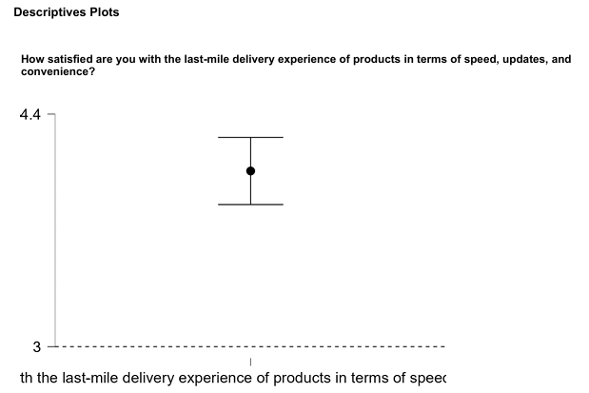

Findings:
- Mean Satisfaction Score: 4.058 (on a 5-point Likert scale)
- p-value: < .001 (statistically significant)
- Rank-Biserial Correlation: 0.179 (small to moderate effect size)
- Normality Check: Shapiro-Wilk p < .001 → Data is not normally distributed, justifying non-parametric test.
Decision & Interpretation:
Since p < 0.05, we reject the null hypothesis and accept the alternate hypothesis.
There is sufficient statistical evidence to conclude that consumers are generally satisfied with the last-mile delivery experience in terms of speed, updates, and convenience.
Although the effect size is not very large, it is positively oriented, reinforcing the direction of satisfaction.
Additional Insight:
- The high satisfaction scores might also reflect consumers' growing expectations being met in an e-commerce-driven ecosystem.
- However, there is room for improvement as it is not the maximum (5.0), implying potential gaps in areas like timeliness, product handling, or communication.

H2: There is a significant difference in satisfaction with last-mile delivery based on whether consumers prefer scheduled deliveries.
Null Hypothesis (H₀):
There is no significant difference in satisfaction with last-mile delivery between consumers who prefer scheduled deliveries and those who don’t.
Alternate Hypothesis (H₁):
There is a significant difference in satisfaction levels between the two groups.
Variables Involved:
- Independent Variable:
  - Preference for Scheduled Deliveries (Categorical)
    - Two groups:
      - “Yes” – Consumers who prefer scheduled delivery
      - “No” – Consumers who do not
- Dependent Variable:
  - Satisfaction Score
    - Again measured on a 5-point Likert scale, reflecting overall delivery satisfaction
This hypothesis compares whether satisfaction scores vary significantly across two independent groups (Yes vs. No preference). The test used was Mann-Whitney U, suitable for non-normal ordinal data.
⚠ However, due to limited sample size in the “No” group (n = 3) and zero variance, the test couldn't be reliably computed.
Statistical Test Used:
Mann-Whitney U Test (non-parametric test for comparing two independent groups)

Test of Normality (Shapiro-Wilk)
Residuals |  | W |  | p
How satisfied are you with the last-mile delivery experience of products in terms of speed, updates, and convenience? |  | 0.813 |  | < .001
Note. Significant results suggest a deviation from normality.

Descriptives
Group Descriptives
 |  | Group |  | N |  | Mean |  | SD |  | SE |  | Coefficient of variation |  | Mean Rank |  | Sum Rank
How satisfied are you with the last-mile delivery experience of products in terms of speed, updates, and convenience? |  | No |  | 3 |  | 4.000 |  | 0.000 |  | 0.000 |  | 0.000 |  | 25.000 |  | 75.000
 |  | yes |  | 49 |  | 4.061 |  | 0.747 |  | 0.107 |  | 0.184 |  | 26.592 |  | 1303.000

Descriptives Plots
How satisfied are you with the last-mile delivery experience of products in terms of speed, updates, and convenience?
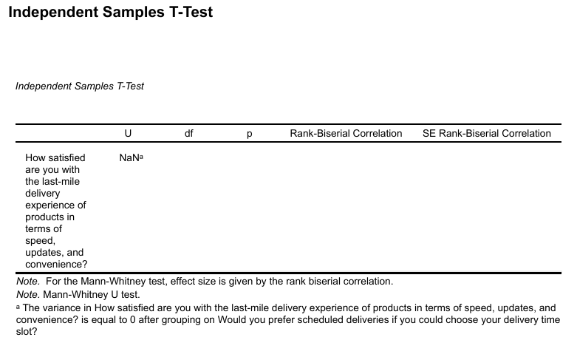
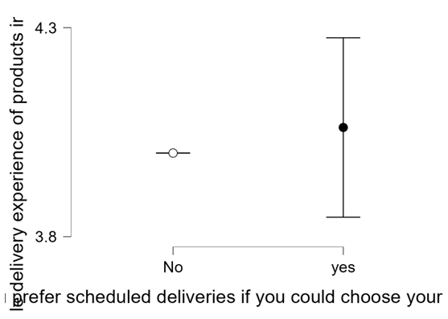

Findings:
- Mean Satisfaction Score:
• Yes (Prefer scheduled delivery): 4.061 (n = 49)
• No (Do not prefer scheduled delivery): 4.000 (n = 3)
- Result: U = NaN due to 0 variance in the “No” group — all responses were the same
- Normality: p < .001 → Data is non-normal
Decision & Interpretation:
Due to only 3 responses in the “No” group and zero variance, the statistical test could not be performed properly.
As a result, we fail to reject the null hypothesis, and no statistically significant difference can be concluded.
While descriptively those who prefer scheduled deliveries appear slightly more satisfied, the sample size and lack of variability limit any valid inference.
This highlights a data limitation in the study.
Additional Insight:
- Although not confirmed statistically, the slight satisfaction edge for those preferring scheduled deliveries could indicate a demand for time-flexibility and control over delivery windows, which companies can explore further.

Hypothesis 3: There is a significant association between consumers’ willingness to pay extra for green delivery options and the importance they assign to sustainability.
Null Hypothesis (H₀):
There is no significant difference in willingness to pay for green delivery among groups with different sustainability concerns.
Alternate Hypothesis (H₁):
There is a significant difference in willingness to pay across sustainability preference levels.
Variables Involved:
- Independent Variable:
  - Importance Assigned to Sustainability (Categorical – Ordinal scale)
    - Grouped as:
      - “No” – Does not consider sustainability important
      - “Maybe” – Neutral or somewhat important
      - “Yes” – Considers sustainability very important
- Dependent Variable:
  - Willingness to Pay Extra for Green Delivery (Ordinal)
    - Measured using consumer responses to whether they are willing to pay more for eco-friendly delivery options

Assumption Check
Test for Equality of Variances (Levene's)
F |  | df1 |  | df2 |  | p
0.051 |  | 2.000 |  | 49.000 |  |  | 0.950

Descriptives
Descriptives - How important is environmental sustainability in your delivery choices?
Would you be willing to pay a slightly higher delivery fee for eco-friendly options like delivery through electric vehicles, sustainable packaging? |  | N |  | Mean |  | SD |  | SE |  | Coefficient of variation
Maybe |  | 25 |  | 4.080 |  | 0.862 |  | 0.172 |  | 0.211
No |  | 8 |  | 2.875 |  | 0.991 |  | 0.350 |  | 0.345
Yes |  | 19 |  | 4.158 |  | 0.834 |  | 0.191 |  | 0.201

Kruskal-Wallis Test
Kruskal-Wallis Test
 |  |  |  |  |  |  |  |  |  | 95% CI for Rank ε²
Factor |  | Statistic |  | df |  | p |  | Rank ε² |  | Lower |  | Upper
Would you be willing to pay a slightly higher delivery fee for eco-friendly options like delivery through electric vehicles, sustainable packaging ? |  | 9.763 |  | 2 |  | 0.008 |  | 0.191 |  | 0.050 |  | 0.368

Dunn
Dunn's Post Hoc Comparisons - Would you be willing to pay a slightly higher delivery fee for eco-friendly options like delivery through electric vehicles, sustainable packaging ?
Comparison |  | z |  | W_{i} |  | W_{j} |  | r_{rb} |  | p |  | p_{bonf} |  | p_{holm}
Maybe - No |  | 2.839 |  | 28.540 |  | 12.000 |  | 0.635 |  | 0.005 |  | 0.014 |  | 0.009
Maybe - Yes |  | -0.316 |  | 28.540 |  | 29.921 |  | 0.053 |  | 0.752 |  | 1.000 |  | 0.752
No - Yes |  | -2.965 |  | 12.000 |  | 29.921 |  | 0.691 |  | 0.003 |  | 0.009 |  | 0.009
Note. Rank-biserial correlation based on individual Mann-Whitney tests.

Here, you’re testing whether willingness to pay varies across levels of sustainability concern. A Kruskal-Wallis H test (non-parametric ANOVA) was used due to:
- Three or more independent groups
- Ordinal data
- Non-normal distribution
Post-hoc analysis (Dunn’s Test with Bonferroni correction) revealed that:
- Consumers who do not value sustainability are significantly less willing to pay extra than those who do.
- The “Maybe” and “Yes” groups didn’t differ significantly, but both were higher than the “No” group.
Statistical Test Used:
Kruskal-Wallis Test with Dunn’s Post-Hoc Comparisons
Key Results:
- Kruskal-Wallis H Statistic: 9.763
- Degrees of Freedom: 2
- p-value: 0.008 (Statistically significant)
- Effect Size (Rank ε²): 0.191 (Moderate effect size)
- Confidence Interval for ε²: [0.050, 0.368]
Post-Hoc Dunn’s Test Comparisons:
Comparison | z-score | p-value | Bonferroni Adj. | Interpretation
Maybe – No | 2.839 | 0.005 | 0.014 | Significant difference
No –  Yes | -2.965 | 0.003 | 0.009 | Significant difference
Maybe – Yes | -0.316 | 0.752 | 1 | No significant difference

Interpretation:
- The significant Kruskal-Wallis result (p = 0.008) indicates that there are differences between at least two groups in their willingness to pay for eco-friendly delivery options.
- The effect size of 0.191 shows a moderate association, suggesting this is practically meaningful as well.
- Post-hoc tests reveal that:
  - Consumers who don’t value sustainability are significantly less willing to pay extra compared to both the “Maybe” and “Yes” groups.
  - However, the difference between “Maybe” and “Yes” is not significant, showing similar attitudes.
Additional Insights:
- There is a clear behavioral segmentation: those who reject sustainability values are notably resistant to added costs for green options, while those who are undecided or supportive of sustainability show a similar openness to paying a premium.
- This reinforces the idea that personal environmental values directly influence purchasing behavior, especially in last-mile logistics

6.3 Comparison of results
The analysis of the three hypotheses reveals important insights into consumer behavior in the context of last-mile delivery services.
For Hypothesis 1, which tested whether consumers are generally satisfied with their last-mile delivery experience, a Wilcoxon Signed-Rank Test was employed due to the non-normal distribution of the data. The results were statistically significant (p < 0.001), with a mean satisfaction score of 4.058, which is significantly above the neutral point of 3. The effect size, measured by rank-biserial correlation (0.179), suggests a small to moderate positive effect, supporting the conclusion that consumers are generally satisfied with the delivery services they receive.
For Hypothesis 2, which proposed that there would be a significant difference in satisfaction based on whether or not consumers prefer scheduled deliveries, a Mann-Whitney U Test was used. However, the test could not be successfully conducted because the group of consumers who did not prefer scheduled deliveries consisted of only three individuals, all of whom gave identical satisfaction ratings. This resulted in zero variance within that group and a U-value that could not be calculated (NaN). Consequently, the analysis failed to produce a statistically valid outcome, and no definitive conclusion could be drawn regarding this hypothesis.
Hypothesis 3 explored the association between consumers’ willingness to pay extra for environmentally friendly (green) delivery options and the importance they assign to sustainability. A Kruskal-Wallis H Test, followed by Dunn’s post-hoc test, was used to assess differences among three groups: those who value sustainability, those who are neutral (“Maybe”), and those who do not consider it important. The findings were statistically significant (p = 0.008), with a moderate effect size of 0.191 (measured using rank epsilon-squared). Post-hoc comparisons revealed that consumers who do not value sustainability were significantly less willing to pay extra for green delivery options compared to those who did value it or were neutral. These results strongly support Hypothesis 3, indicating that sustainability concern is a key driver of willingness to invest in eco-friendly logistics solutions.
In summary, the results support Hypotheses 1 and 3, highlighting general consumer satisfaction and a clear link between sustainability values and willingness to pay more. Hypothesis 2, however, could not be tested effectively due to data limitations

7. Discussion and Conclusion
This study titled "Last-Mile Delivery Optimization: Challenges and Innovations" aimed to explore consumer satisfaction, preferences, and behavioral intent regarding modern and sustainable delivery solutions. Based on the primary survey conducted with 52 respondents and statistical analyses using non-parametric tests (Wilcoxon Signed Rank, Mann-Whitney U, and Kruskal-Wallis H), several key insights emerged.
Firstly, it was found that consumers are generally satisfied with their last-mile delivery experience, particularly in terms of speed, delivery updates, and convenience. The Wilcoxon Signed Rank test confirmed that the average satisfaction score (M = 4.058) was significantly higher than the neutral value of 3, with a statistically significant result (p < 0.001), thereby supporting the first hypothesis (H1). Though the effect size was small to moderate (r = 0.179), it still indicates a positive consumer sentiment.
Secondly, an attempt was made to explore whether preference for scheduled deliveries had a significant impact on overall satisfaction levels. However, due to limited variance and small group size (only 3 respondents in the "No" group), the Mann-Whitney U test could not yield a valid result. Thus, the second hypothesis (H2) could not be statistically supported, though a slightly higher satisfaction score was observed in the group that preferred scheduled deliveries.
Lastly, the third hypothesis (H3) examined the association between consumers’ willingness to pay extra for green delivery options and the importance they place on sustainability. The Kruskal-Wallis H test revealed a statistically significant difference across groups (p = 0.008), and follow-up Dunn's post hoc test confirmed that consumers who prioritized sustainability were more likely to pay extra for eco-friendly delivery. The effect size (ε² = 0.191) indicated a moderate association.
Overall, the findings suggest that consumers are open to innovation and sustainability in last-mile logistics, especially if these align with their values and convenience. While satisfaction is generally high, logistical strategies like scheduled delivery and green alternatives hold great potential for future development—provided that practical barriers (like cost, availability, and awareness) are addressed.

8. Implications
8.1 Theoretical Implications
This study adds to the growing body of literature on last-mile delivery optimization by offering an updated understanding of consumer behavior in the Indian context, particularly post-COVID where contactless and sustainable delivery solutions have gained relevance.
- It reinforces the validity of the Technology Acceptance Model (TAM) and Consumer Perceived Value Theory, as consumer satisfaction is influenced by convenience, trust, and innovation.
- The support for H3 highlights the emergence of green consumerism, wherein environmental sustainability has started to significantly shape delivery choices.
- The non-significant result for H2 further underscores the limitations of generalizing scheduling preferences without accounting for sample representativeness.
This research encourages future theoretical models to integrate sustainability concern as a determinant of consumer logistics behavior and prioritize segmentation based on eco-consciousness.

8.2 Practical Implications
From a managerial and logistics planning perspective, the findings offer several actionable insights:
- Consumer satisfaction is strong, but still hinges on factors like timely updates, convenience, and delivery reliability. Thus, maintaining high standards in operational efficiency remains critical.
- Scheduled deliveries, though not statistically validated in this study, showed slightly higher satisfaction levels and are worth further exploration. Logistics companies can offer custom time slots or paid scheduling features for enhanced convenience.
- Given the statistically significant link between sustainability concern and willingness to pay extra, there is a clear business opportunity for logistics providers to:
  - Promote eco-friendly delivery options like electric vehicles and green packaging.
  - Offer tiered pricing models that allow consumers to voluntarily opt for sustainable delivery at a premium.
- Smart lockers and contactless delivery methods, though not analyzed deeply in hypothesis testing, were favored in the descriptive responses and can improve last-mile efficiency and customer trust.

9. Limitations and Future Directions for Research
Despite yielding meaningful insights, this study has some limitations that should be acknowledged:
- Sample size (n = 52) is relatively small, and the demographic representation was uneven (e.g., only 3 respondents in the "No" group for scheduled delivery preference). This limited the robustness of group comparisons and statistical power.
- The data was collected through self-reported questionnaires, which can introduce response bias and subjectivity.
- The study was limited to urban or semi-urban respondents, primarily educated consumers, which may not fully reflect the behavior of rural or underrepresented populations.
- The scope of the study did not allow for in-depth segmentation based on age, income, or occupation, which might affect last-mile delivery preferences.
Future Directions:
- A larger and more diverse sample size is recommended to ensure better generalizability and stronger statistical conclusions.
- Future research can explore the impact of awareness campaigns or incentive schemes on the adoption of sustainable delivery methods.
- Comparative studies between urban vs. rural consumers can provide deeper insights into infrastructure and accessibility challenges.
- Incorporating qualitative methods (e.g., interviews or focus groups) may help capture the emotional and experiential aspects of last-mile delivery.

10. References
- Boysen, N., Fedtke, S., & Schwerdfeger, S. (2021). Last-mile delivery concepts: A survey from an operational research perspective. OR Spectrum, 43(1), 1–58.
- Dablanc, L., Morganti, E., Arvidsson, N., Woxenius, J., Browne, M., & Saidi, N. (2017). The rise of on-demand ‘instant deliveries’ in European cities. Supply Chain Forum: An International Journal, 18(4), 203–217.
- Deutsch, Y., & Golany, B. (2018). A parcel locker network as a solution to the logistics last mile problem. International Journal of Production Research, 56(1–2), 251–261.
- Kreier, F. (2022). Drones bearing parcels deliver big carbon savings. Nature.
- Li, B., Riley, M. W., Lin, B., & Qi, E. (2006). A comparison study of customer satisfaction between the UPS and FedEx: An empirical study among university customers. Industrial Management & Data Systems, 106(2), 182–199.
- McKinnon, A. C., & Tallam, D. (2003). Unattended delivery to the home: An assessment of the security implications. International Journal of Retail & Distribution Management, 31(1), 30–41.
- Molin, E., Kosicki, M., & van Duin, R. (2022). Consumer preferences for parcel delivery methods: The potential of parcel locker use in the Netherlands. European Journal of Transport and Infrastructure Research, 22(2), 183–200.
- Schnieder, M., Hinde, C., & West, A. (2021). Sensitivity analysis of emission models of parcel lockers vs. home delivery based on HBEFA. International Journal of Environmental Research and Public Health, 18(12), 6325.
- Ulmer, M. W., & Streng, S. (2019). Same-day delivery with pickup stations and autonomous vehicles. Computers & Operations Research, 108, 1–19.

