./

Hostel Management System

Course Code: <CODE>



**Submitted By: Tejaswini B**

**Candidate ID: 105065**

|  |  |  |  |  |  |
| --- | --- | --- | --- | --- | --- |
| **Ver. Rel. No.** | **Release Date** | **Prepared. By** | **Reviewed By** | **Approved By** | **Remarks/Revision Details** |
|  |  |  |  |  |  |
|  |  |  |  |  |  |
|  |  |  |  |  |  |
|  |  |  |  |  |  |
|  |  |  |  |  |  |

**Document History**

**Contents:**

1. Problem Statement.

 2. Project Description.

 3. Introduction.

 4. Existing System.

 5. Proposed System.

 6. Requirements.

 7. Test Plan and Test Cases.

 8. Results.

**Hostel Management System**

**1. Problem Statement**

To develop a system which helps to record and maintain the details of the students living in different hostel premises.

**2. Project Description**

Hostel Management System is based on a concept to maintain data of the students of a college living in different hostel premises. Before stepping into the main system, a user has to pass through the login system to get access, then only a user can use the features of the system which includes adding, removing, updating and viewing student’s records of a particular hostel. While entering a student’s record, the user has to provide roll number, name, date of birth, age, city, phone number, email id, father’s name, father’s phone number, room number, and select hostel name. Under this, there are four hostels, BH-1, BH-2, GH-1, GH-2. But while updating a student's information from existing accounts, the user can only change room number and phone number. There are two methods to check a student’s account in detail, i.e by roll number or by student’s name. User can view students of a particular hostel. The other listing record displays the student’s name with roll number, address and contact detail.

**3. Introduction**

The Hostel Management System is a software developed for managing various details of hostel students. For the past few years, the number of educational institutions is increasing rapidly. Thereby the number of hostels is also increasing for the accommodation of the students studying in that institution. And hence there is a lot of strain on the person who is running the hostel. This particular project deals with the problems of managing a hostel and avoids the problems which occur when carried manually. Identification of the drawbacks of the existing system leads to the designing of a computerized system that will be compatible to the existing system with the system which is more user friendly. The traditional system is manual based and need lots of effort and consumes enough time. This project is intended to minimize human works and maintain details of the students living in different hostel premises.

**4. Existing System**

In “The existing system”, the institution maintains details of the students living in different hostel blocks manually. The existing system is time consuming and prone to human errors. This problem can be overcome by using a system which provides a simpler method to record student details.

**5. Proposed System**

The proposed system is having many advantages over the existing system. Ensures security for organization by maintaining the information about the student. User friendly and easy to manage. Timely and efficient system.

**Features:**

1. Login System.

2. Enter, delete, update data.

3. Check details of existing data.

4. View all records of a particular hostel.

5.   Exit.

**6.  Requirements**

The software used in this project is Dev-C++ and the program is written in ‘C’ language.

A functional requirements document defines the functionality of a system or one of its subsystems. It also depends upon the type of software, expected users and the type of system where the software is used.

**User:**

* User can login to the portal using valid username and password.
* User can add required details of the student.
* User can view the list details of the students.
* User can delete the information of the student.
* User can search for student and can update some information.

**Description:**

The various options which the user can select to enter details.

1. Add new student’s data - Allows the user to add new student’s data.

2. Search student data - Allows user to search particular student data.

3. Modify and update data - Allows user to modify and upload student data.

4. View all students data - Allows user to view all student’s data.

5. Removing existing account - Allows user to remove or delete the existing data.

6. Exit.

**Use case diagram of user**

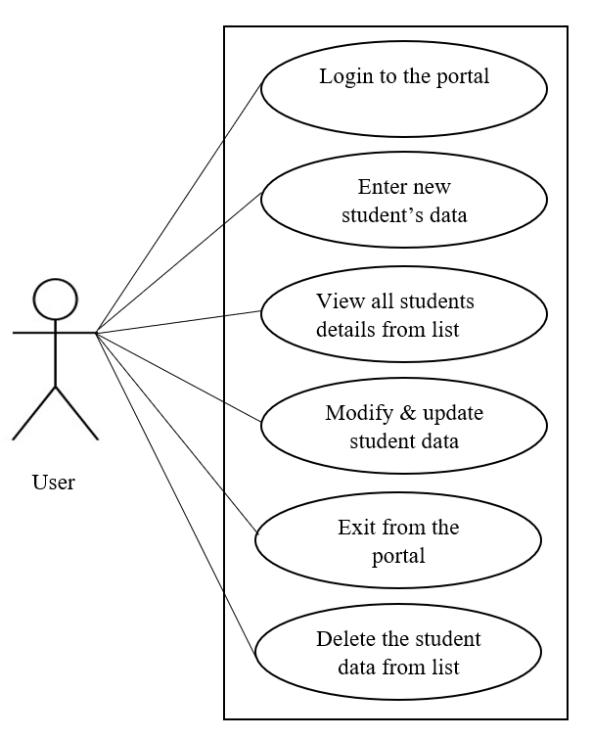

**Description of each option**

**1. Add new student’s data:** The add new student’s data option will allow the user to enter a student roll number, name, date of birth, age, place, email id, phone number, hostel block, father’s name and phone number.

**2. Update information of existing account:** The update information of existing account option needs the roll number of the student which the user wants tochange and update the details of a student.

**3. Search the details of existing account:** The search details of existing account option will allow the user to type in the roll number of the student which the user wants to view.

**4. View all students data:** The view all data option will allow the user to view all details of the students.

**5. Remove existing account:** The remove existing account option will allow the user to type in the roll number of the student which the user wants to delete.

**6. Exit:** The exit option allows the user to come out of the portal.

**7. Test Plan and Test Cases.**

|  |  |  |  |  |
| --- | --- | --- | --- | --- |
| **Test case id** | **Test case description** | **Input** | **Expected outcome** | **Status** |
| 1 | Verification of login | Username and Password | It should verify username and password. If valid input is given, it should navigate to the respective home page. If invalid then shows the message login is unsuccessful. | Pass |
| 2 | Enter new student’s data | Student roll no. Student name, date of birth, age, place, email id, Ph no, Hostel block, Father’s name and Ph no. | Popup a message “Student details added Successfully”. | Pass |
| 3 | Check and update details of the existing student | Student roll number or Student name | If the valid roll no is entered then shows the message “Student details updated”. If invalid then shows a message “Roll number does not exist”. | Pass |
| 4 | View all students list of a particular hostel block | Student roll number or Student name | If the valid roll no is entered then shows the list of all students of a particular hostel block. If invalid then shows a message “Record not found”. | Pass |
| 5 | Delete the details of existing student from the list | Student roll number or Student name | If the valid roll no is entered then the user can remove the details of the student from the list. If invalid then shows a message “Record not found”. | Pass |

**8. Expected Results:**

The expected results of the hostel management system are:

1. The user can successfully login to the portal using valid username and password. If the username and password is invalid then shows a message login is unsuccessful.

2. The user can enter a student roll number, name, date of birth, age, place, email id, phone number, hostel block, father’s name, phone number. After entering all the details popup, a message “Student details added successfully”.

3. The user can change and modify the existing account using the valid student roll number. If the roll number is not valid shows a message “Record not found”.

4. The user can view all students lists of a particular hostel and can search details of particular student using roll number.

5. The user can remove or delete data of a particular student using a valid roll number. If the student roll number is invalid shows a message “Record not found”.

6. Using exit option user can come out of the portal.

# 