THE FUTURE WORK: THE DATA ANALYSIS ON GLASSDOOR JOBS

Project website Link: [**https://bhuvana08.github.io/Glassdoor-Job-Analysis-Project/**](https://bhuvana08.github.io/Glassdoor-Job-Analysis-Project/)

**INTRODUCTION**

OVERVIEW:

Job analysis is a systematic process used to analyze the requirements and characteristics of job roles and profiles. Glassdoor is a popular website and online platform that offers extensive information about jobs, salaries, and companies. Job analysis, in this context, involves a systematic approach to defining job roles, descriptions, requirements, responsibilities, and evaluation criteria. It plays a critical role in determining the necessary education, skills, knowledge, and training required for specific job positions. Moreover, it assesses the job's worth by measuring its effectiveness and contribution to an organization, thereby aiding in the establishment of competitive compensation packages.

Neglecting the analysis of Glassdoor job data can result in limited insights into job market trends, difficulty in identifying relevant job opportunities, challenges in attracting and retaining top talent, and a lack of understanding of a company's branding and reputation.

PURPOSE:

The primary objective of this project is to conduct a comprehensive analysis of Glassdoor job listings to extract insights into prevailing and emerging job market trends, identify in-demand skills and qualifications, and provide recommendations for employers to enhance their employer branding and reputation, ultimately helping them attract and retain high-caliber talent.

LITERATURE REVIEW:

A literature review for the Data Analysis of Glassdoor Jobs entails an examination of various job roles within a specific domain offered by organizations in particular industries and sectors. Job analysis establishes job families within organizations and allows for the identification of career progression paths, which can enhance opportunities for employees to advance in their careers and increase their compensation.

**THEORETICAL ANALYSIS**

BLOCK DIAGRAM:

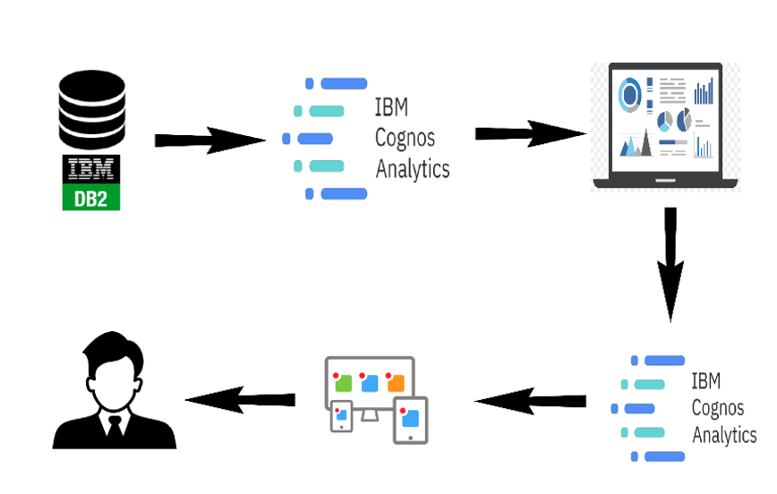

HARDWARE AND SOFTWARE UTILIZED:

**Hardware:**

- Laptop

- Mobile Phone

**Software:**

- IBM Cognos

- Anaconda

- Python

RESULTS:

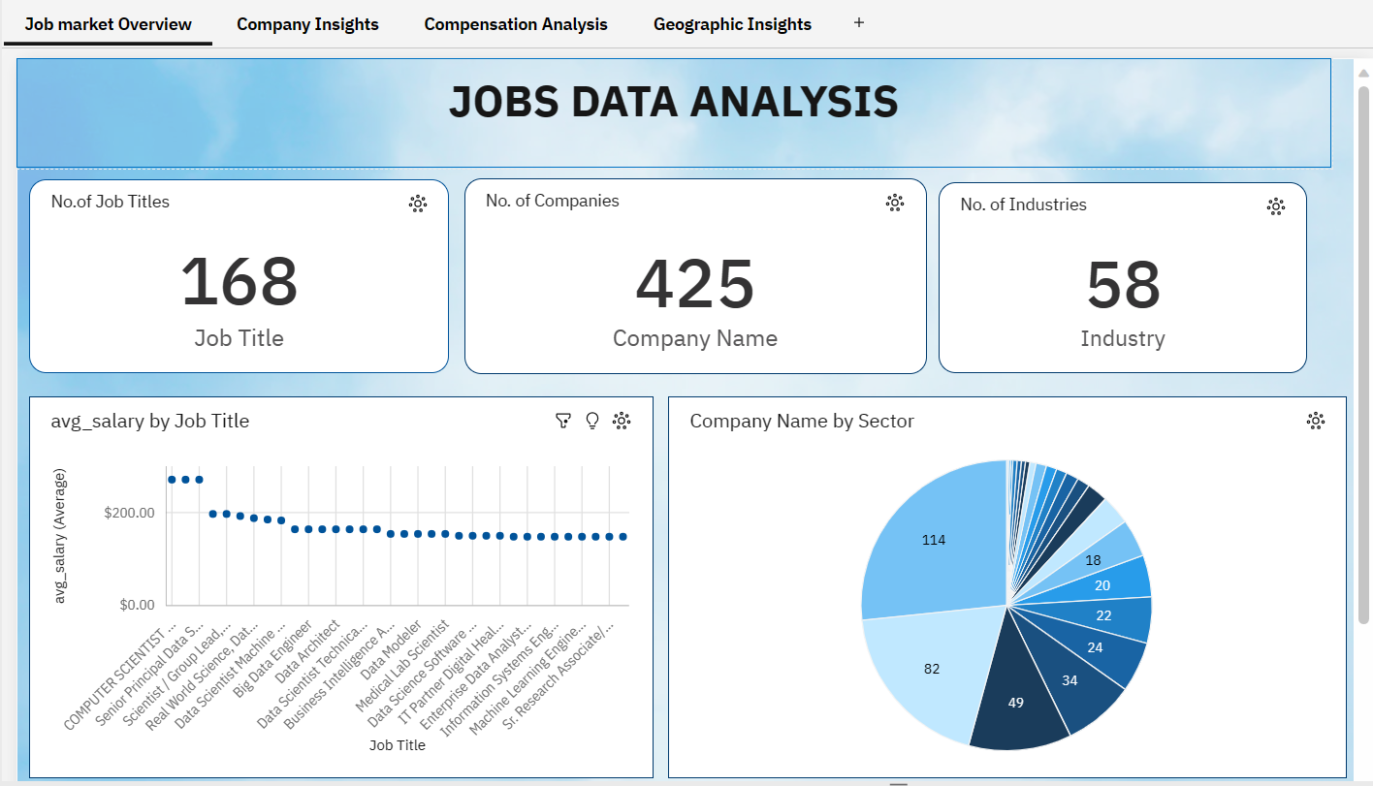

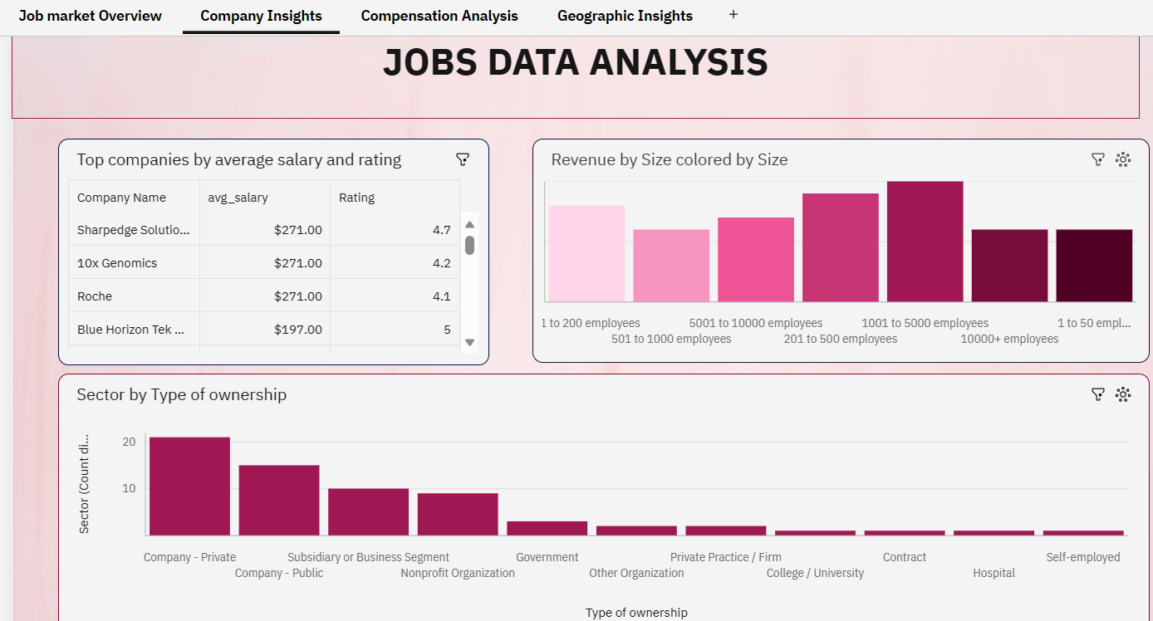

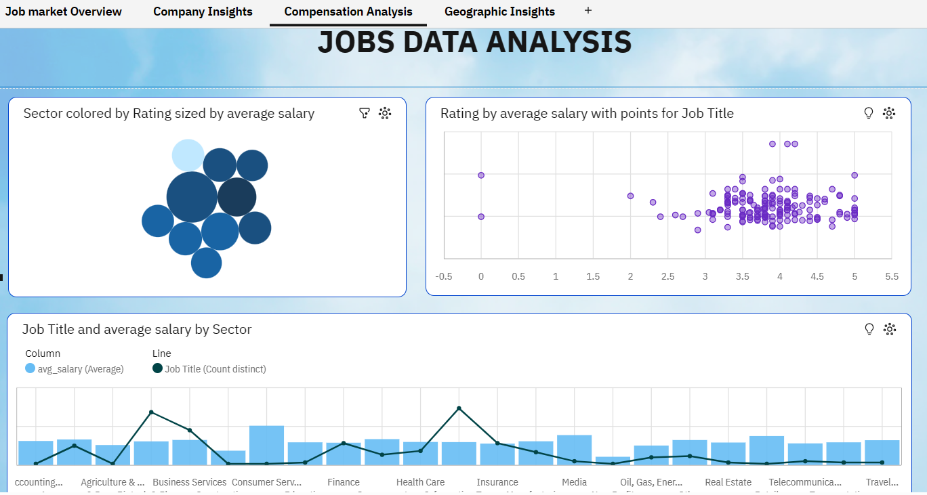

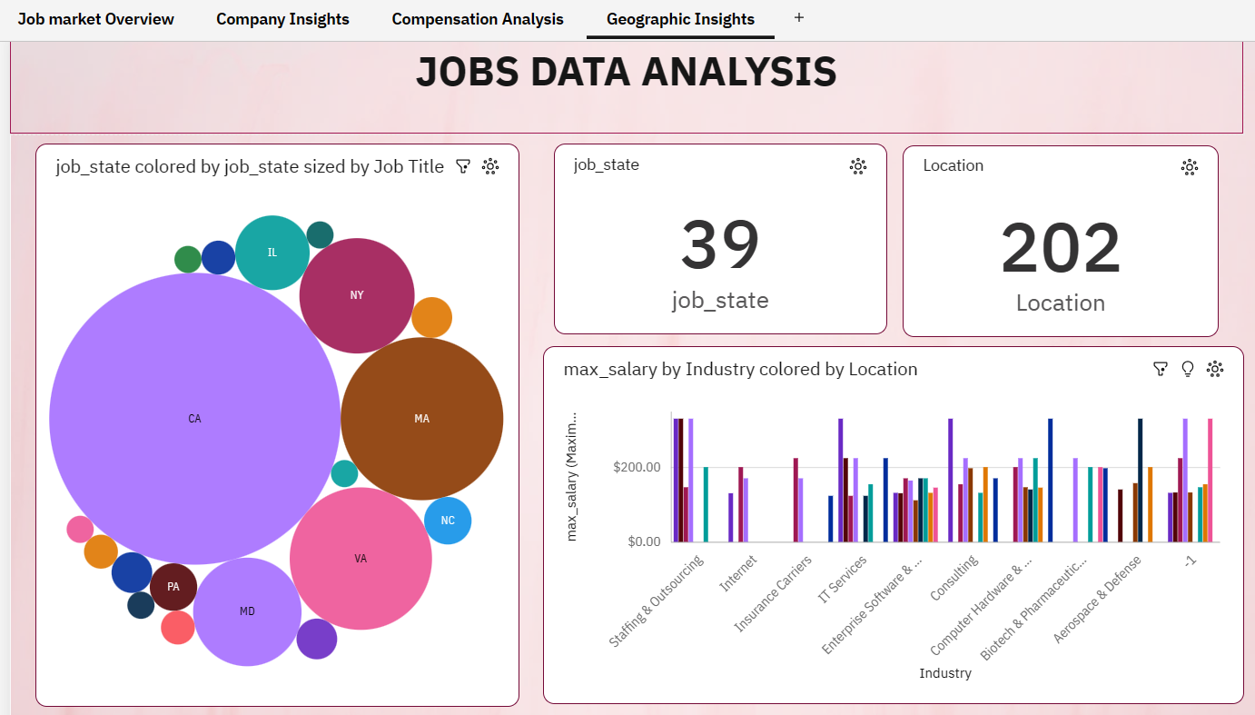

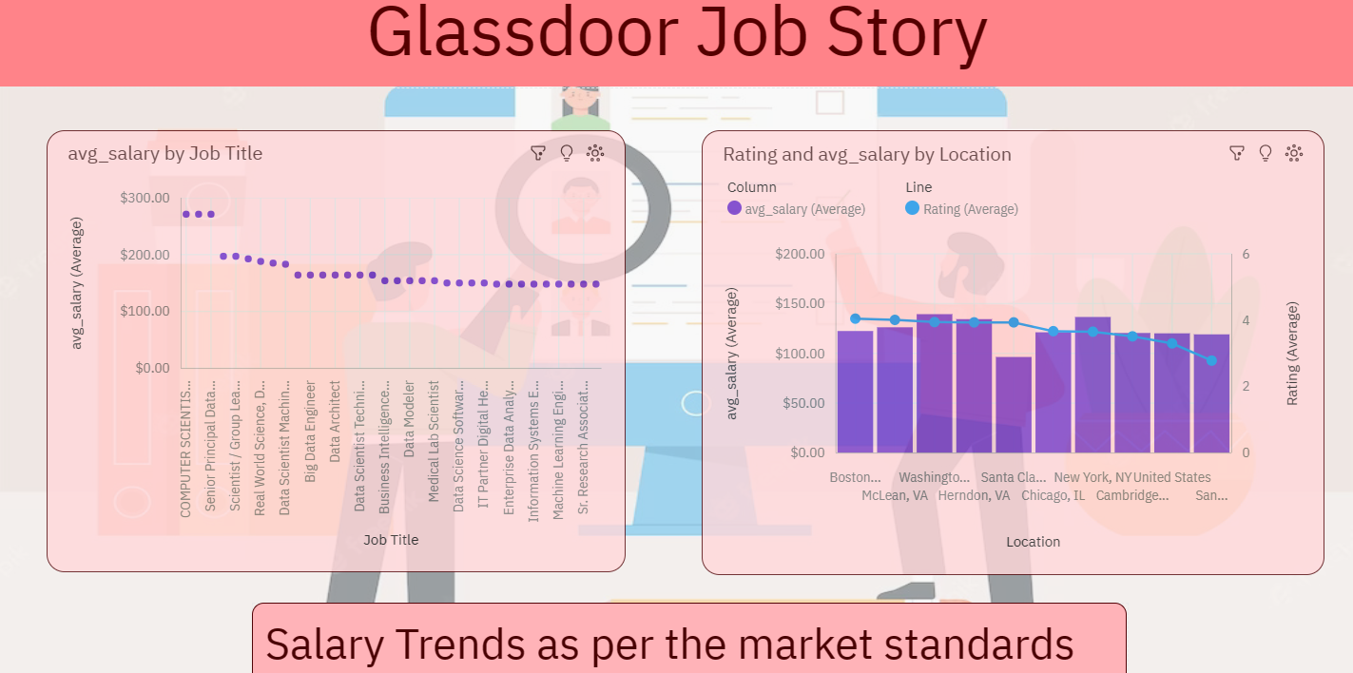

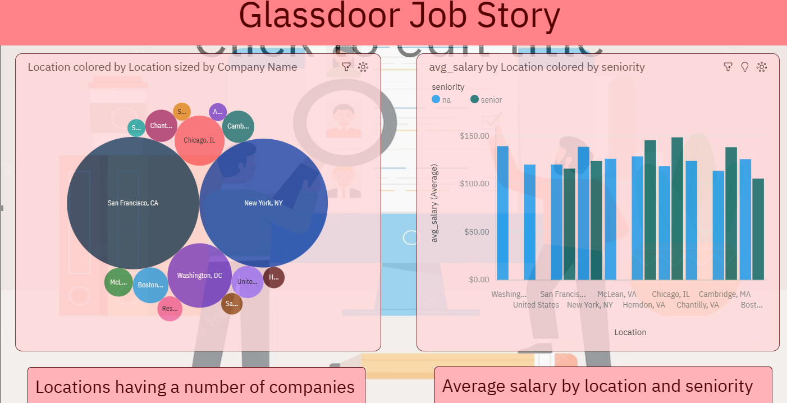

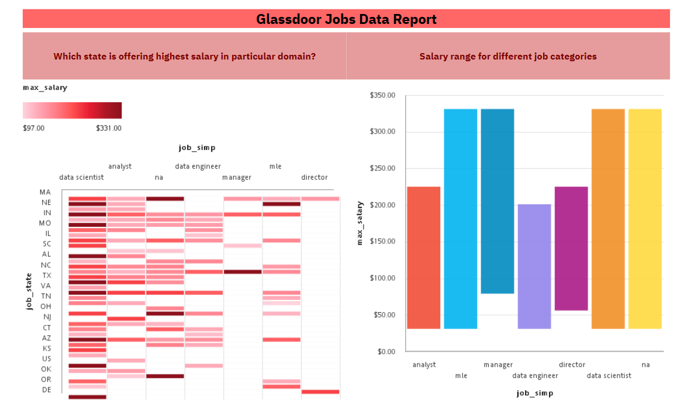

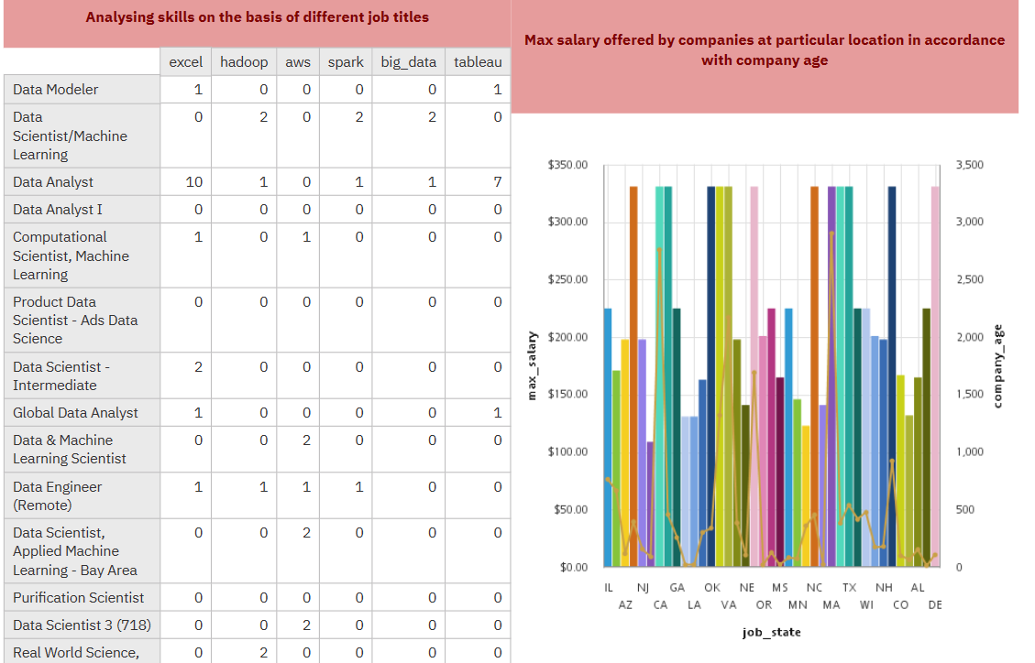

ADVANTAGES:

**Social Impact:**

This project can empower job seekers to make more informed career decisions, and negotiate better compensation and working conditions, potentially contributing to increased economic mobility and reduced income inequality.

**Business Impact:**

By improving retention rates, reducing turnover costs, and enhancing productivity, an analysis of Glassdoor job data can help employers create a more attractive work environment, attracting and retaining top talent.

DISADVANTAGES:

- Analyzing large volumes of data can be challenging.

- The process can be time-consuming.

- It may be complex for those unfamiliar with IBM, Anaconda, and Python.

APPLICATIONS:

- Business

- Student recruitment based on individual interests

- Job analysis

CONCLUSION:

The future prospects for the Data Analysis of Glassdoor Jobs project are promising, offering opportunities for further exploration and enhancement. With the vast amount of data available on the platform, several areas can be focused on to improve analysis and deliver more valuable insights.

1. **Machine Learning and Natural Language Processing:** Incorporating these techniques can extract deeper insights from job descriptions and reviews, providing a better understanding of required skills and qualifications.

2. **Expanded Scope:** Expanding the analysis beyond job postings to include factors like salaries, benefits, and company culture can offer a more comprehensive view of the job market.

3. **Comparative Analysis:** Comparing different industries, regions, or job roles can identify trends and areas for improvement.

4. **Data Visualization:** Creating meaningful and interactive visualizations can enhance data usability and accessibility.

5. **Continuous Updates:** Regularly updating and maintaining the data analysis pipeline ensures accuracy and relevance.

In summary, the project holds significant potential for uncovering valuable insights, providing actionable recommendations, and empowering job seekers and employers alike. Leveraging advanced analytical techniques and continually improving the analysis pipeline can contribute to transparency and efficiency in the job market.

FUTURE SCOPE:

The future scope of the Data Analysis of Glassdoor Jobs project offers numerous possibilities, including predictive analytics, recommender systems, sentiment analysis, diversity and inclusion analysis, skill gap analysis, geographical analysis, and social network analysis. Exploring these areas can revolutionize how individuals find and evaluate job opportunities and foster data-driven decision-making for both job seekers and employers.