Project Design Phase-II: Technology Stack Stack (Architecture & Stack)
Project: JWT-Based Product Inventory Management System
Team id: SWTID-2026-9714
Team Members :
- S Bhuvaneswari – bhuvaneswari2007b@gmail.com
- A Gayathri – gayug6904@gmail.com
- P Vaishnavi – vaishnavipandi0702@gmail.com
- B Maha – mahasuila8778@gamil.com
- R Rangeela – rangeela6122006@gmail.com

Phase-II Documentation: Architecture Overview & Technology Stack

Table of Contents

01

Introduction
Purpose and system overview
02

Architecture Overview
High-level design and data flow

03

Technology Stack
Complete technology breakdown

04

Components & Technologies
System components overview

05

Application Characteristics
Key features and capabilities

06

Implementation Snapshot
Backend architecture details



c

Introduction

Purpose
This document details the technical architecture and full technology stack used to build a JWT-secured Product Inventory Management System on the MERN stack. It provides a comprehensive overview of how React, Node.js, Express, and MongoDB work together to create a secure, scalable inventory solution with user authentication and product management capabilities.

System Overview
The system implements a three-tier architecture where a React frontend communicates with a Node.js
+ Express backend via RESTful APIs. JWT-based authentication ensures secure access control, while MongoDB stores user accounts and product inventory data. The backend enforces multi-tenant isolation by scoping all product operations to the authenticated user's ID.

Architecture Overview

High-Level Architecture

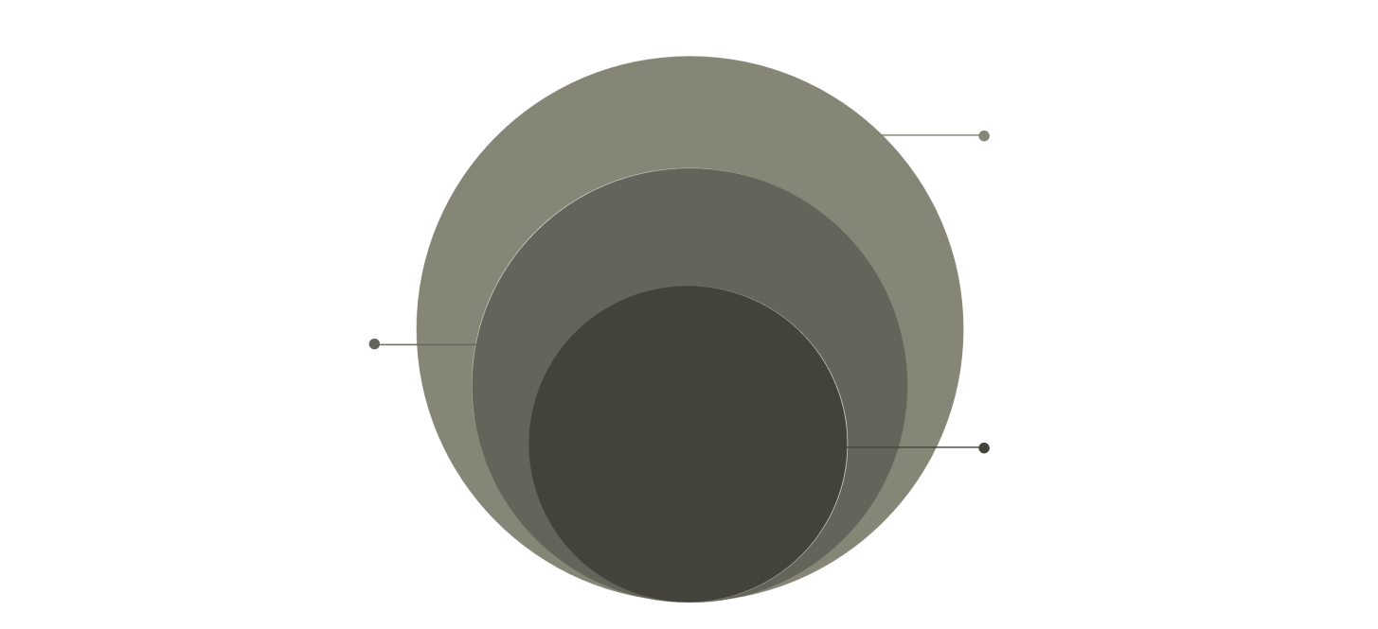
Data Store
MongoDB with Users and Products collections

API Layer
Express routes with JWT auth and controllers

Client
React + Vite frontend using Axios

Client Layer
React + Vite frontend with Axios for API communication

API Layer
Express routes, controllers, and JWT middleware

Data Layer
MongoDB with Mongoose ODM and secure queries

Data Flow Process

User Registration/Login
Credentials validated, password hashed with bcrypt, JWT token issued with 7-day expiration

Search & List Operations
Case-insensitive name search with keyword matching, results sorted by creation date, automatic user scoping


1
2
3

Protected Product CRUD
Bearer token validated via middleware, user ID attached to requests, operations scoped to user's products

Security Note: All passwords are hashed using bcrypt before storage, and JWT tokens include the user ID in the payload for automatic request scoping. Product documents include a userId field to enforce multi-tenant isolation.

Technology Stack


Frontend
•
•
•
•
React with Vite for fast development Axios for API calls
Tailwind CSS for responsive design
JWT for authentication state
Backend
•
•
•
•
•
Node.js + Express for REST APIs jsonwebtoken for JWT handling bcryptjs for password hashing CORS enabled for development
dotenv for environment config
Database
•
•
•
•
MongoDB (Atlas or local) Mongoose ODM for data modeling Users and Products collections
Indexed queries for performance
Communication
•
•
•
•
REST over HTTPS JSON payloads
Bearer JWT in Authorization header
Stateless authentication

Key Technology Versions

Node.js & Runtime

Node.js ≥ 20.x recommended for modern JavaScript features and improved performance

Database & ODM

MongoDB with Mongoose ODM for schema modeling and query building

Frontend Tools

Vite for fast dev server and build process

Components & Technologies

S.No | Component | Description | Technology
1 | User Authentication | JWT generation, validation, and secure user authentication with password hashing | Node.js, Express.js, bcryptjs, jsonwebtoken
2 | Product CRUD Operations | Create, read, update, delete, and search product inventory with user scoping | Node.js, Express.js, MongoDB, Mongoose
3 | Database Storage | Secure storage of user accounts and product inventory data with indexed queries | MongoDB (Atlas), Mongoose ODM
4 | API Communication | Secure data transfer between frontend and backend with JSON payloads | REST API, Axios, HTTPS
5 | Frontend Interface | Responsive user interface with form handling and state management | React, Vite, Tailwind CSS

Application Characteristics

S.No | Characteristic | Description | Technology
1 | Open-Source Frameworks | Backend frameworks used in the system | Node.js, Express.js, Mongoose
2 | Scalable Architecture | Modular MVC/Layered architecture supporting future features | REST API  Architecture, JWT Middleware
3 | Security | Secure authentication and protected routes | JWT Auth, bcrypt Password Hashing
4 | Performance Optimization | Fast dev/build and efficient DB queries | Vite, MongoDB Indexing
5 | Responsive Design | Works across devices and screen sizes | Tailwind CSS, Responsive Layout
Multi-Tenant Isolation
Each user's products are automatically scoped by their unique user ID, preventing cross-user data access
Stateless
Authentication
JWT tokens contain all necessary user information, eliminating server-side session storage requirements
Case-Insensitive
Search
Product name searches automatically handle mixed case queries for better user experience

Implementation Snapshot

Backend Responsibilities

 Auth Controller 
Handles user registration and login requests.
Passwords are hashed using bcrypt before storage, and JWT tokens are issued with a ~7-day expiration period. The token payload includes the user ID for automatic request scoping.

Product Controller
Manages all product CRUD operations with automatic user scoping. Implements case-insensitive name search with keyword matching, sorts results by creation date (descending), and enforces that all operations are limited to the authenticated user's products via userId field.

 Auth Middleware
Verifies Bearer tokens on protected routes, decodes
JWT to extract user information, and attaches req.user.id to the request object for use in controllers. Returns 401 Unauthorized for invalid or missing tokens.

Server & Database Configuration

Server Setup
- CORS enabled for development origin
(http://localhost:5173)
- JSON parsing middleware for request body handling
- Route mounting with consistent versioning
- Port configuration with fallback to 5000
- Error handling middleware for graceful failures

Environment Configuration

 Route Configuration
Defines API endpoints at /api/v1/auth (public register
and login) and /api/v1/products (protected CRUD operations). Routes are mounted with consistent versioning for future API evolution.

Database Connection
  - Connection via MONGODB_URI environment
variable
  - Graceful error handling for connection failures
  - Mongoose ODM for schema modeling
  - Recommended indexes on {userId, createdAt} and
{userId, name}
  - Automatic reconnection logic


Node.js Version
Recommended: Node.js ≥ 20.x for modern JavaScript features and improved performance
.env Variables
MONGODB_URI (database connection string), JWT_SECRET (random string for token signing), PORT (server port, defaults to 5000)
Development Tools
nodemon for automatic server restart during development, dotenv for environment variable loading

Development Tip: Set up a .env file in the root directory with MONGODB_URI pointing to your MongoDB instance (Atlas or local), JWT_SECRET as a random string (minimum 32 characters), and PORT as 5000 or your preferred port number.

Database Schema Overview
Users Collection

Field | Description
username | Unique user identifier (indexed for fast lookups)
password | Bcrypt-hashed password (never stored in plain text)
createdAt | Account creation timestamp with automatic indexing
Products Collection

Field | Description
name | Product name with case-insensitive search support
description | Optional product description field
userId | Reference to owner user (indexed for scoping queries)
createdAt | Document creation timestamp (indexed, default sort)

2

Core Collections
Users and Products with secure
relationships
4

Required Fields
username, password, name, userId
for data integrity

100%

Encrypted Storage
All passwords hashed before
database persistence

Summary & Key Takeaways

Secure Authentication
JWT-based authentication with bcrypt password hashing ensures secure user credentials and stateless session management across the application
Multi-Tenant Design
Automatic user scoping via userId fields prevents unauthorized cross-user data access while maintaining simple, clean queries
RESTful Architecture
Clear separation between frontend and backend with well-defined API contracts enables independent development and future scalability

Best Practices Implemented

  - Passwords never stored in plain text - always bcrypt-hashed before database persistence
  - JWT tokens include minimal user data (ID only) to reduce token size while maintaining security
  - Automatic user scoping eliminates need for manual permission checks in controllers
  - Case-insensitive product search improves user experience without complex queries
  - Indexed database fields ensure fast queries as inventory grows
  - Environment variables for configuration enable different settings per deployment environment

Future Enhancement Opportunities

Role-Based Access Control
Add admin and viewer roles for enterprise inventory management

Input Validation
Implement schema validation middleware for data integrity

Rate Limiting
Add API rate limiting to prevent abuse and DDoS
attacks

Refresh Tokens
Implement refresh token rotation for improved
security

