K8’s deployments successful for both frontend and backend, PFB, screenshots for the pods and svc showing created, up and running.  
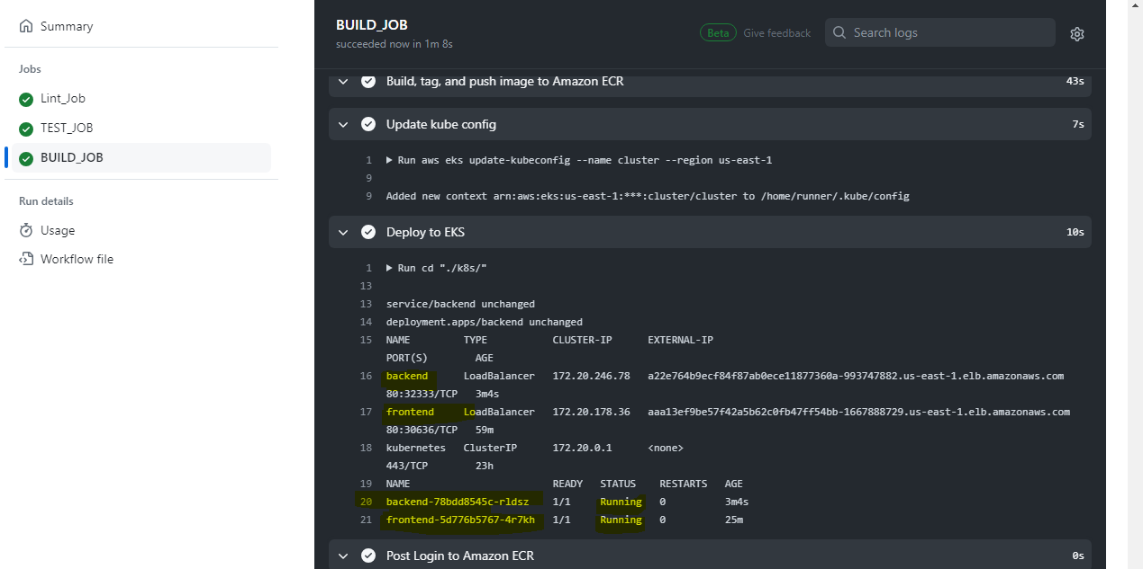

Frontend – push images to ECR:  
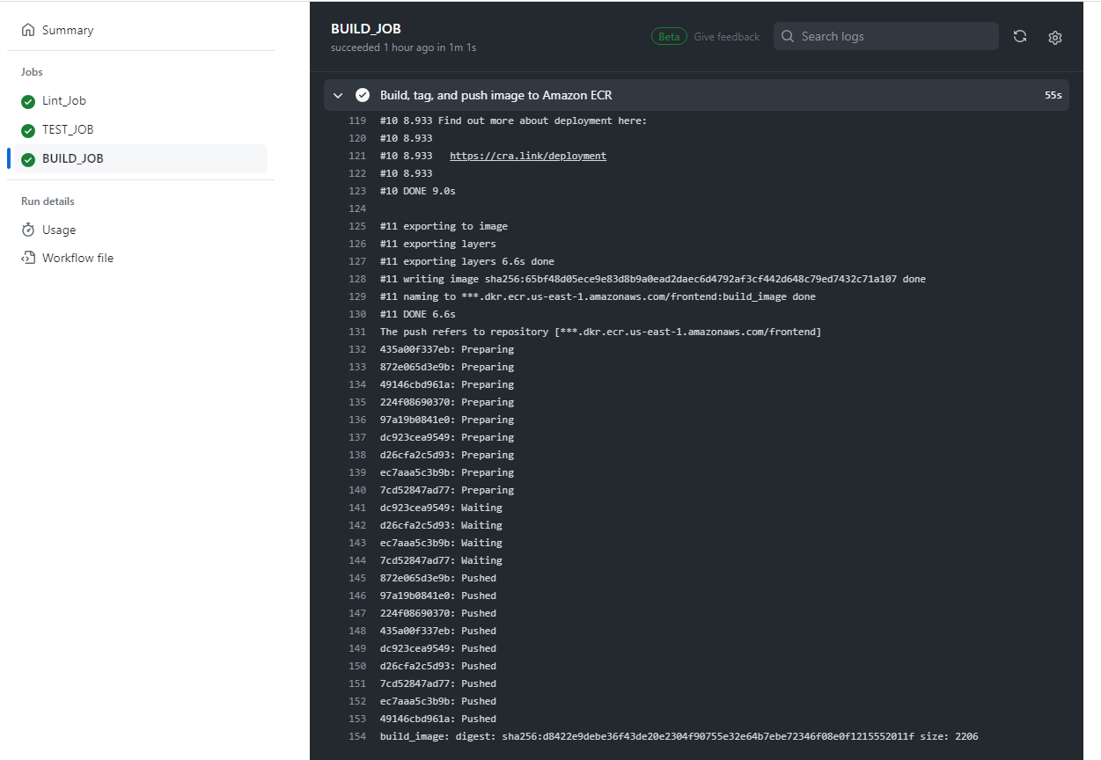

Backend – Push images to ECR:  
