**Assignment**

**Name: Bhuvana Nandhimalla**

**Student id: 700744203**

**Course id: CS5710**

**CRN: 30716**

**1) Creating random vector of size 15 having only Integers in the range 1-20.**

import numpy as np

v = np.random.randint(1,20,(15,))

# Reshaping the array to 3 by 5

arr = v.reshape(3,5)

print(arr.shape)

print(arr)

# Replacing the max in each row by 0

row_max = arr.max(axis=1).reshape(-1,1)

arr = np.where(arr == row_max, 0, arr)

print('\n',arr)

**2) Create a 2-dimensional array of size 4 x 3 (composed of 4-byte integer elements), also print the shape, type and data type of the array**

x = np.array([[1, 2, 3], [4, 5, 6], [7, 8, 9], [10, 5, 7]], np.int32)

print('Shape:', x.shape)

print('Type:', type(x))

print('Data type:', x.dtype)

**3) Computing the eigenvalues and right eigenvectors**

from numpy import linalg as LA

mat = np.array([[3, -2], [1, 0]], np.int32)

w, v = LA.eig(mat)

print('Eigenvalues:', w)

print('\nRight eigenvectors:\n', v)

**4) Computing the sum of the diagonal element**

n = np.array([[0, 1, 2], [3, 4, 5]])

res = np.trace

print('Sum of diagonal elements:', res)

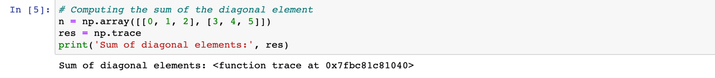

**5) Write a NumPy program to create a new shape to an array without changing its data.**

m = np.arange(1,7).reshape(3,2)

m = m.reshape(2,3)

m

**6) Write a Python programming to create a below chart of the popularity of programming Languages. 2. Sample data: Programming languages: Java, Python, PHP, JavaScript, C#, C++ Popularity: 22.2, 17.6, 8.8, 8, 7.7, 6.7**

import matplotlib.pyplot as plt

languages = ['Java', 'Python', 'PHP', 'JavaScript', 'C#', 'C++']

popularity = np.array([22.2, 17.6, 8.8, 8, 7.7, 6.7])

exp = [0.2, 0, 0, 0, 0, 0]

plt.pie(popularity, labels = languages, explode = exp, shadow = True, autopct='%1.1f%%', startangle = 135)

plt.show()

GitHub: <https://github.com/BhuvanaNandhimalla/Assignment>

Source code: <http://localhost:8888/notebooks/Desktop/Assignment.ipynb>