**FORAGE – TATA – RETAIL STORE**

* management wants to analyse what the major contributing factors are to the revenue so they can strategically plan for next year.
* guidance into areas that are performing well so they can keep a clear focus on what’s working.

CMO Questions:

* In which country is our retail going on well?
* Which product is doing its best?
* Customers are happy with which product?
* Which product along with which country has the growth potential?

CEO Questions

* Which product is the profit generator to the company?
* Are the quantities produced of products utilized well or are there any wastages?
* When is the companies profits more?
* Which product has the highest quantity of manufacturing?

Answers from FORAGE:

CEO:

* **Which region is generating the highest revenue, and which region is generating the lowest?**
* **What is the monthly trend of revenue, which months have faced the biggest increase/decrease?**
* **Which months generated the most revenue? Is there a seasonality in sales?**
* **Who are the top customers and how much do they contribute to the total revenue? Is the business dependent on these customers or is the customer base diversified?**

**CMO:**

* **What is the percentage of customers who are repeating their orders? Are they ordering the same products or different?**
* **For the repeat customers, how long does it take for them to place the next order after being delivered the previous one?**
* **What revenue is being generated from the customers who have ordered more than once?**
* **Who are the customers that have repeated the most? How much are they contributing to revenue?**

TASK

* senior management wants to understand how their business is performing and what areas are the key strengths of the company.
* focused on identifying opportunities that would lead to growth and generate more revenue in the future.
* provided multiple visualisation requests by the CEO and you would need to provide the visual which would explain the data and insights in the simplest possible manner.

RESOURCES

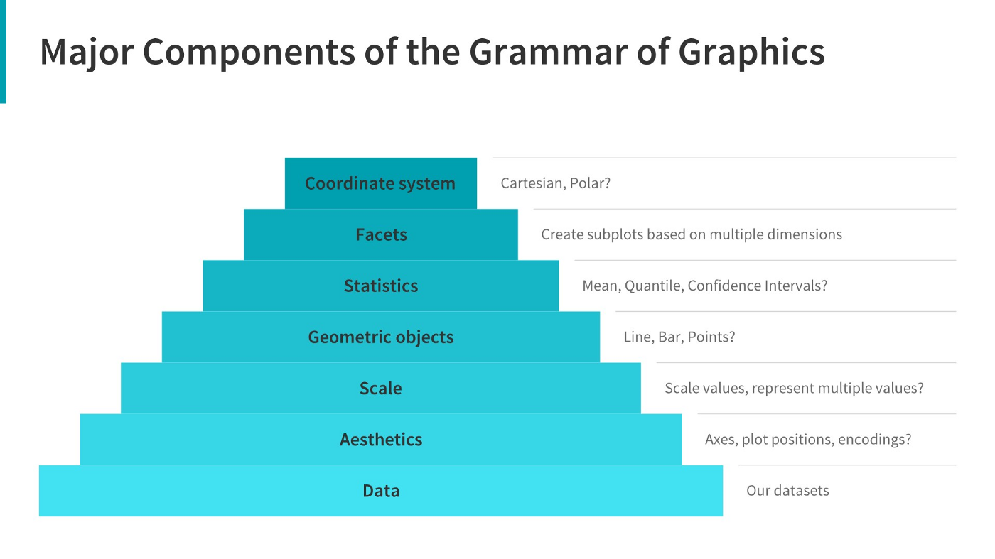

<https://www.analyticsvidhya.com/blog/2021/09/how-to-choose-the-right-chart-for-data-visualization/>

https://www.atlassian.com/data/charts/how-to-choose-data-visualization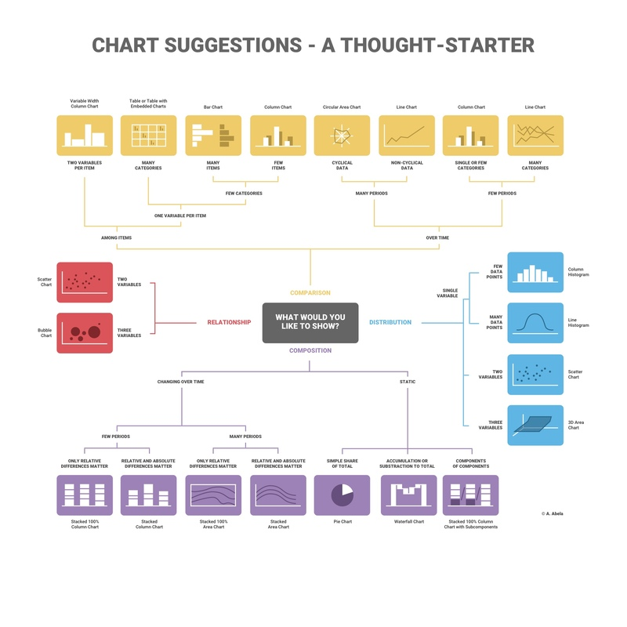

<https://www.atlassian.com/data/charts/how-to-choose-data-visualization>

<https://infogram.com/blog/choose-the-right-chart/>

TASK

* how they can use the data to make more meaningful decisions.
* provide insights which they can use to create the expansion strategy

Method:

* **Data cleanup -** Create a check that the quantity should not be below 1 unit
* Create a check that the Unit price should not be below $0

use conditional formulas where the logic would state that if the conditions are met then the tool should exclude the data from analysis. &&&&&&&& use data transformation methods to get rid of the bad data.

Q3)

Customer id in sum….not able to get top 10 customer

Soln –table view-> customer coln -> format chng to text -> summarization – don’t summarize

Didn’t check - blank spaces got included making it the top customer- rectified it by – power query – remove null.