# PYTHON BASICS

## 1. Introduction to Python

Python is a versatile and beginner-friendly programming language widely used in web development, automation, data science, and more. Its simple syntax makes it easy to learn and use.

## 2. Data Types in Python

Python provides various data types to store values:

• Integer (int): Whole numbers (e.g., 10, -5)

• Float (float): Decimal numbers (e.g., 3.14, -2.5)

• String (str): Text enclosed in quotes (e.g., 'Hello', "Python")

• Boolean (bool): True/False values (True, False)

• List: Collection of values (e.g., [1, 2, 3])

• Dictionary: Key-value pairs (e.g., {'name': 'Alice', 'age': 25})

## 3. Variables in Python

Variables store values for later use. Python allows dynamic typing, meaning you don’t need to declare variable types explicitly.

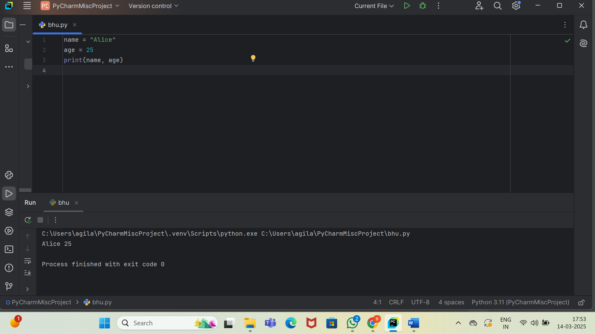

## 4. Loops in Python

### 4.1 For Loop

Used to iterate over a sequence like a list or range.

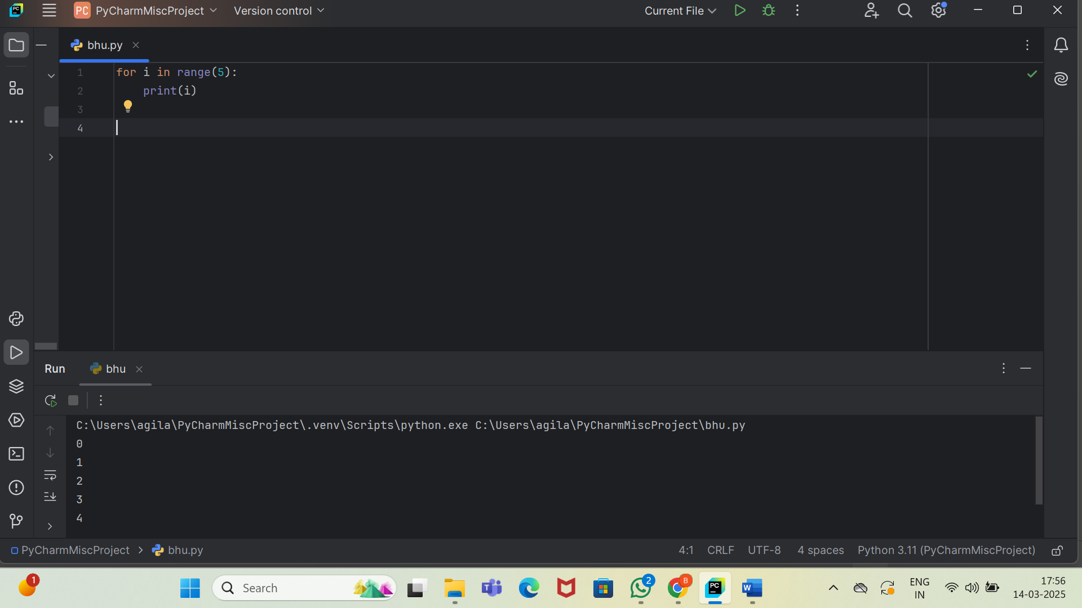

### 4.2 While Loop

Executes as long as a condition is true.

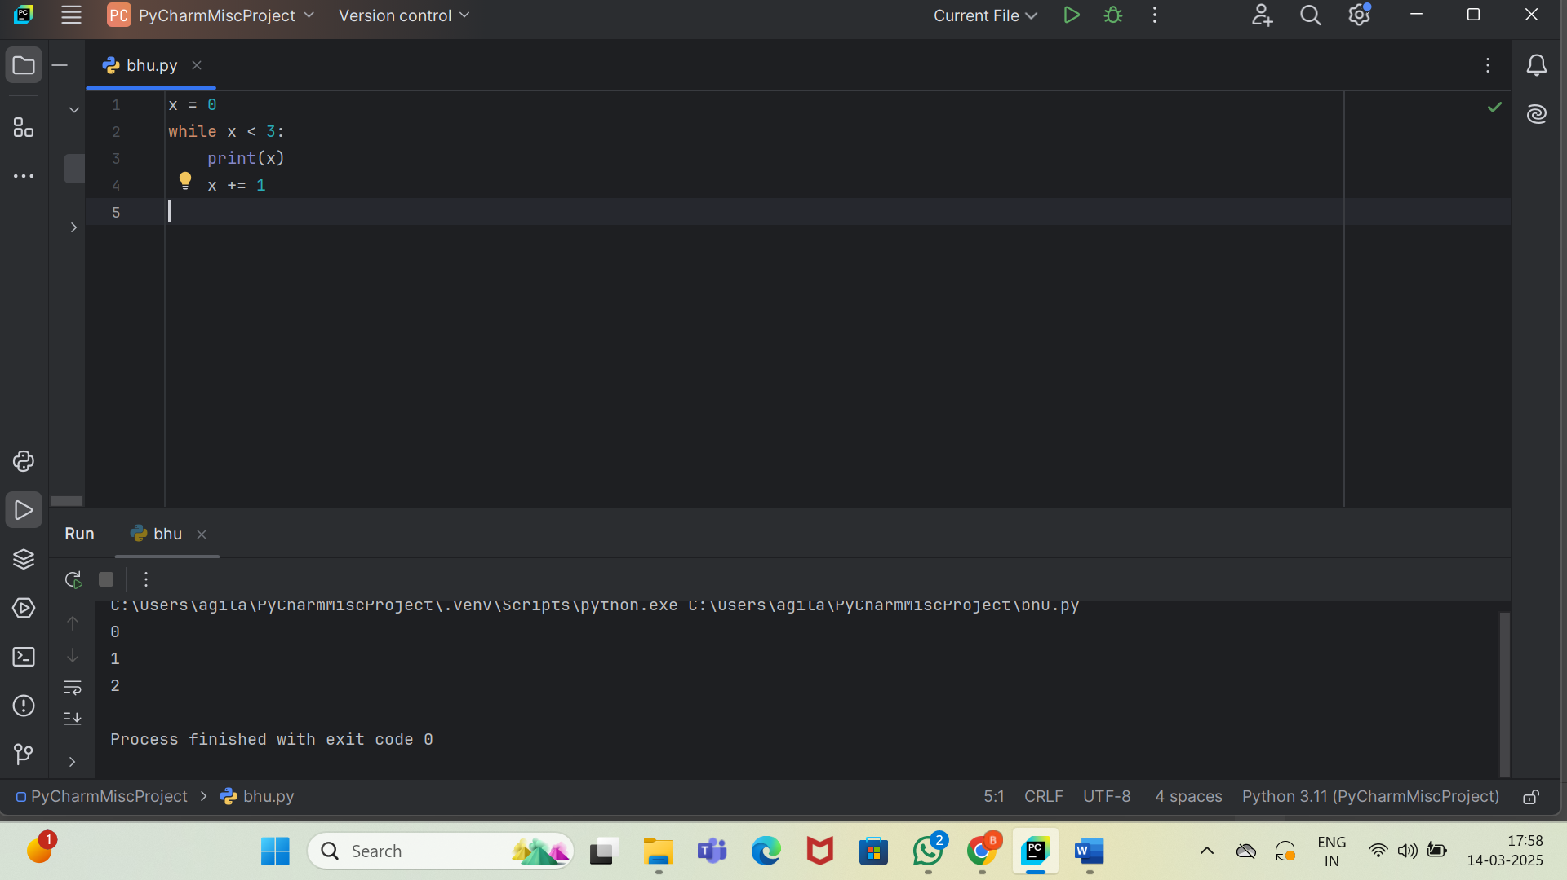

## 5. Functions in Python

### 5.1 Defining a Function

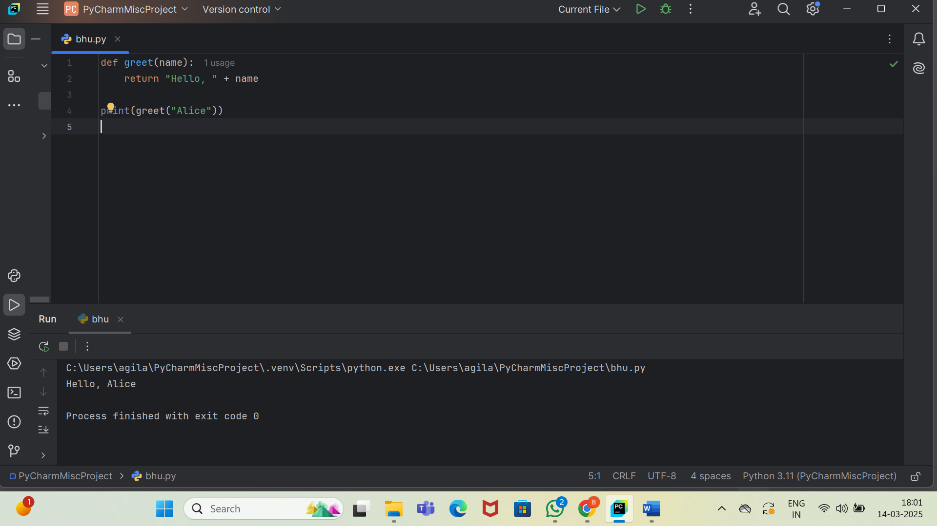

### 5.2 Function with Default Parameter

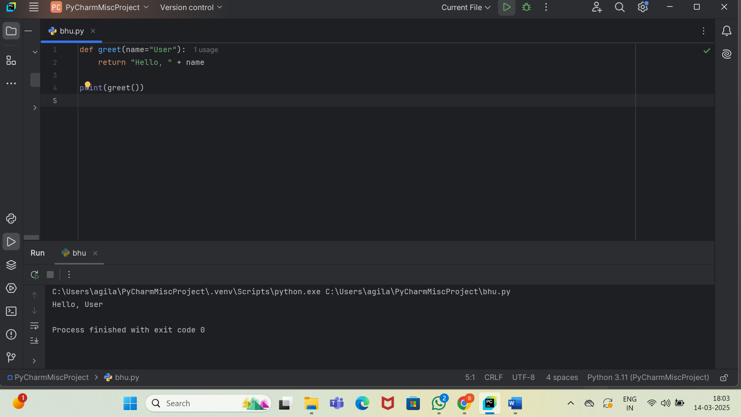

## 6. Working with Lists & Dictionaries

### 6.1 Lists

Lists store multiple values and support indexing.

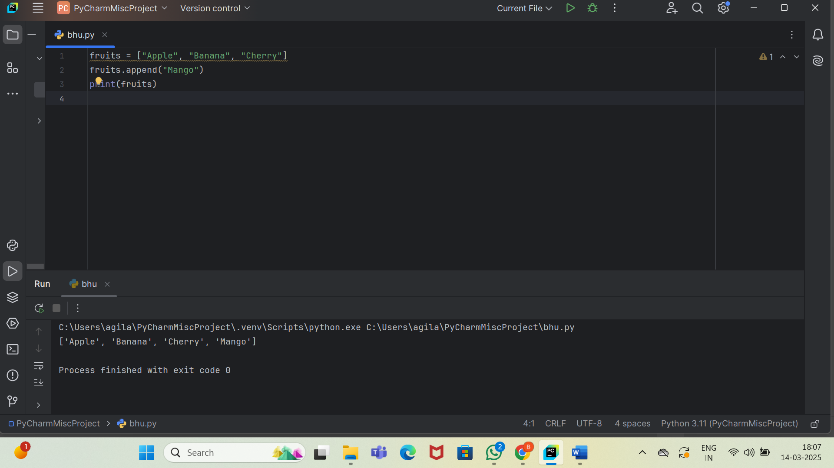

### 6.2 Dictionaries

Dictionaries store data in key-value pairs.

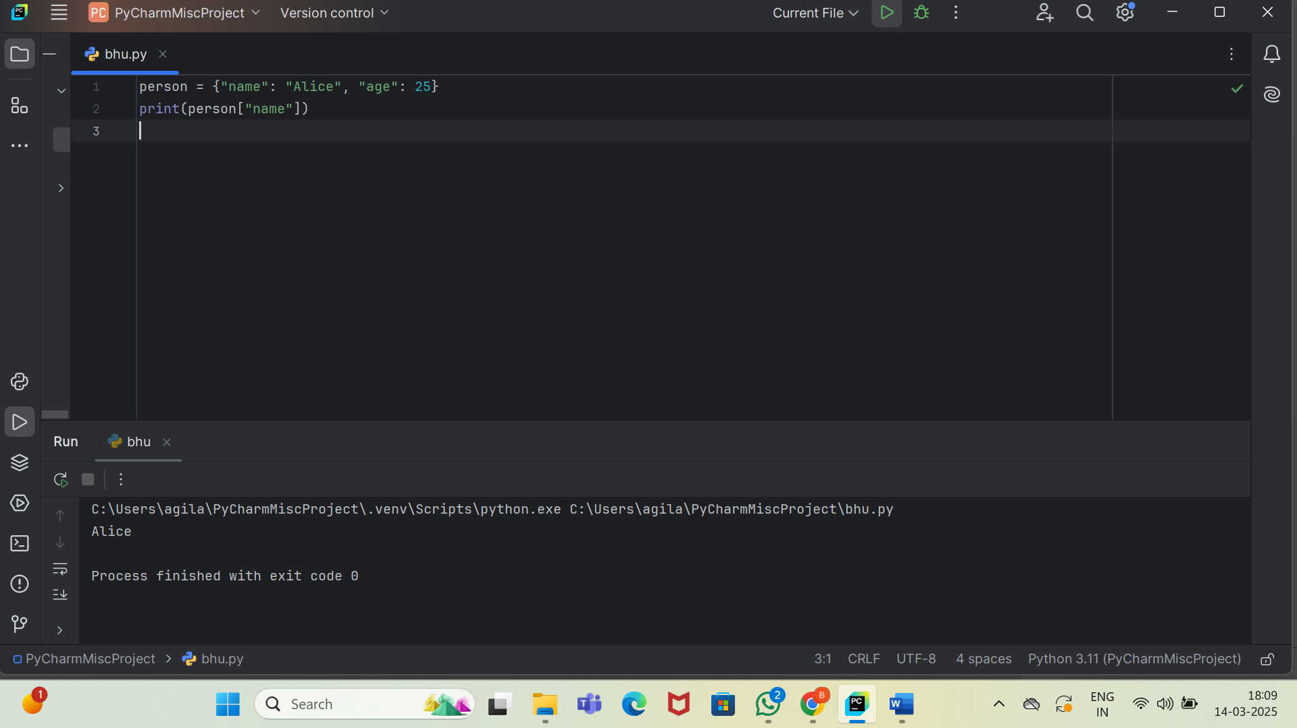 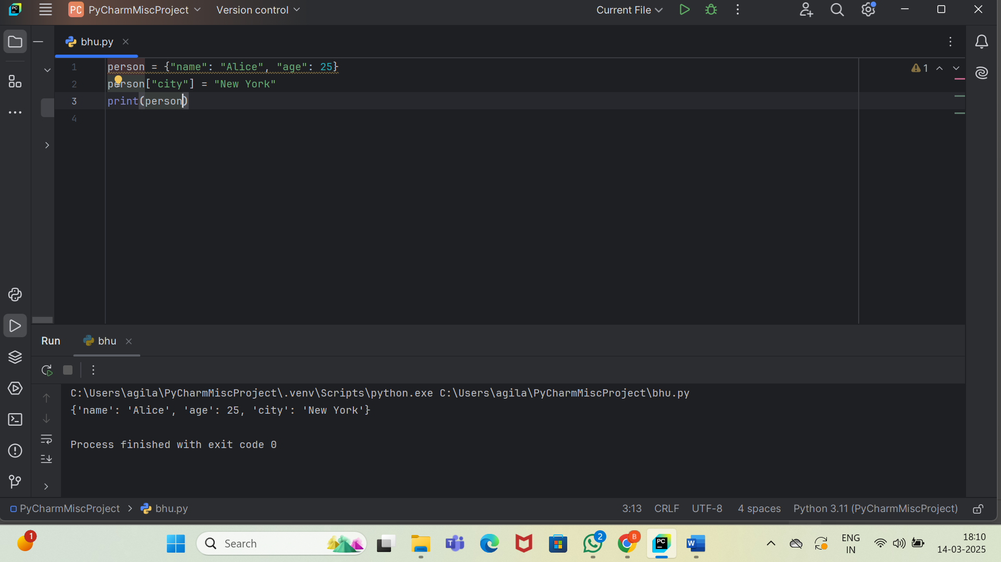

## 7. Conclusion

Python is an easy-to-learn language that provides powerful features with simple syntax. By mastering data types, variables, loops, functions, lists, and dictionaries, you build a strong foundation for advanced programming.