1 . Write a C program to add two integers.

Input : Get two values from from the user.

Process : add the number one and two.

num 1 + num2

Output : get the added numbers as a output.

Coding:

#include<stdio.h>

void main()

{  
 int a,b,sum=0;

scanf(“%d%d”,&a,&b);

sum=a+b;

printf(“%d”,sum);

}

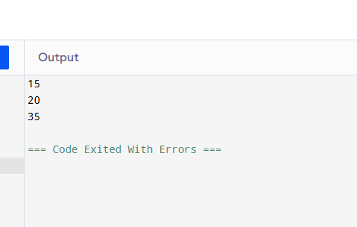

2 . Write a program to swap two numbers using a temporary variable.

Input : input for a and b.

Process : swap the numbers a and b usig swap.

Output: after swaoing the number a assined to b

#include <stdio.h>

void main()

{

int a, b, temp;

{

printf("Enter first number (a): ");

}

scanf("%d", &a);

printf("Enter second number (b): ");

scanf("%d", &b);

temp = a;

a = b;

b = temp;

{

printf("After swapping:\n");

printf("a = %d\n", a);

printf("b = %d\n", b);

}

}

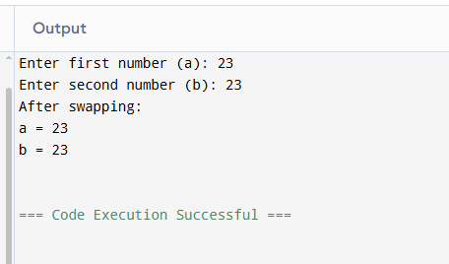

3 . Write a program to swap two numbers without using a temporary variable.

Input : input for a and b.

Process : swap the numbers a and b without using swap.

Output: after swaoing the number a assined to b.

#include <stdio.h>

void main()

{

int a, b;

printf("Enter first number (a): ");

scanf("%d", &a);

printf("Enter second number (b): ");

scanf("%d", &b);

a = a + b;

b = a - b;

a = a - b;

printf("After swapping:\n");

printf("a = %d\n", a);

printf("b = %d\n", b);

}

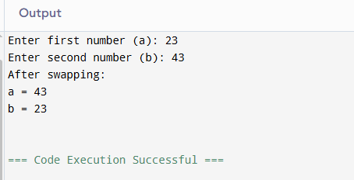

4 . Write a program to find the ASCII value of a character.

Input : get char as a input.

Process : change the given character into ASCII code.

Output : print the char into the ASCII value.

#include <stdio.h>

void main()

{

char ch;

printf("Enter a character: ");

scanf("%c", &ch);

printf("The ASCII value of '%c' is %d\n", ch, ch);

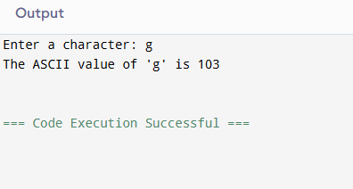

5 . Write a program to calculate the area and perimeter of a rectangle.

Input : get the value of area and perimeter of the rectangle.

Process : calculate the values given

Output : priint the calculation of the given values.

#include <stdio.h>

void main()

{

float length, width, area, perimeter;

printf("Enter the length of the rectangle: ");

scanf("%f", &length);

printf("Enter the width of the rectangle: ");

scanf("%f", &width);

area = length \* width;

perimeter = 2 \* (length + width);

{

printf("Area of rectangle = %.2f\n", area);

printf("Perimeter of rectangle = %.2f\n", perimeter);

}

}

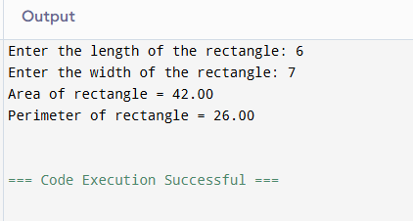

6. Write a program to compute the simple interest.

Input : get the principle and rate of intrest and time from the user

Process : make the calculation SI = p\*r\*t/100

Output : make the calculation for the given formula.

#include<stdio.h>

Void main()

{

Float principal,rate,time,simpleintrest;

Printf(“Enter principal amount: “);

Scanf(“%f”,&principal);

Printf(“Enter rate of intrest (in%%): “);

Scanf(“%f”,&rate);

Printf(“Enter time (in years): “);

Scanf(“%f”, &time);

Simpleintrest=(principal\*rate\*time)/100;

Printf(“Simpple Intrest = %.2f\n”,simpleintrest);

}

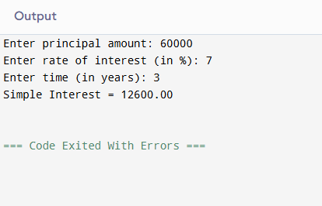

7 . Write a program to convert temperature from Celsius to Fahrenheit.

Input : get input for celsius from user.

Process : convert the given celsius into fahrenheit using formula.

Output : from the formula change the celsius into fahrenheit.

#include <stdio.h>

void main()

{

float celsius, fahrenheit;

printf("Enter temperature in Celsius: ");

scanf("%f", &celsius);

fahrenheit = (celsius \* 9 / 5) + 32;

printf("Temperature in Fahrenheit = %.2f\n", fahrenheit);

}

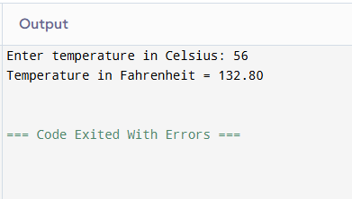

8 . Write a program to find the quotient and remainder of two integers.

Input : get the input for two integers.

Process : change the integers into quotient and the remainder.

Output : print the quotient and remainder.

#include <stdio.h>

void main()

{

int dividend, divisor, quotient, remainder;

printf("Enter dividend: ");

scanf("%d", &dividend);

printf("Enter divisor: ");

scanf("%d", &divisor);

quotient = dividend / divisor;

remainder = dividend % divisor;

printf("Quotient = %d\n", quotient);

printf("Remainder = %d\n", remainder);

}

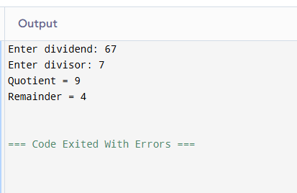

9 . Write a program to check whether a number is even or odd.

Input : get input for the number

Process : check wheather the given number is odd or even by number%2==0

Output : based on the condition print the number is odd or even

#include <stdio.h>

void main()

{

int num;

printf("Enter a number: ");

scanf("%d", &num);

if (num % 2 == 0)

printf("%d is even.\n", num);

else

printf("%d is odd.\n", num);

}

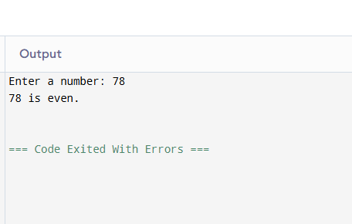

10 . Write a program to calculate the square and cube of a number.

Input : get input for a number

Process : square=number\*number, cube=number\*number\*number.

Output : square of the number and cube of the number.

#include<stdio.h>

void main()

{

int num,square,cube;

printf(“enter a number : “);

scanf(“%d”,&num);

square=num\*num;

cube = num\*num\*num;

printf(“square of %d = %d\n”,num,square);

printf(“cube of %d = %d\n”,num,cube);

}

