1. Write a program to print numbers from 1 to 100.

Input : get input for the starting and ending nuber.

Process : using for loop to print output.

Output : based on condition the numbers from 1 to 100 is printed.

#include <stdio.h>

void main()

{

for(int i = 1; i <= 100; i++)

{

printf("%d\n", i);

}

}

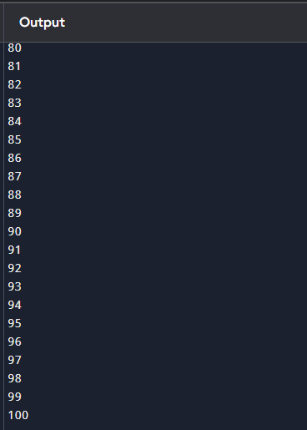

2. Write a program to print even numbers from 1 to 50.

Input : get the input for the Nth term from user.

Process : check if the condition is exactly divided by 2 .

Output : based on the condition the output is printed.

#include <stdio.h>

void main()

{

for(int i = 2; i <= 50; i += 2)

{

printf("%d\n", i);

}

}

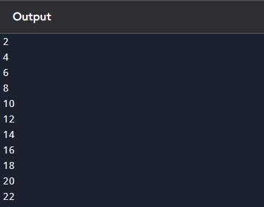

3. Write a program to find the factorial of a number.

Input : get input for the number.

Process : using fact to find the factorial.

Output : based on the condition the output is printed.

#include <stdio.h>

void main()

{

int n;

unsigned long long factorial = 1;

printf("Enter a number: ");

scanf("%d", &n);

for(int i = 1; i <= n; i++)

{

factorial \*= i;

}

printf("Factorial of %d = %llu\n", n, factorial);

}

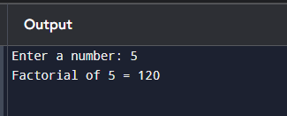

4. Write a program to calculate the sum of digits of a number.Input : get the input for number to sum.

Process : calculate the sum of given numbers.

Output : based on the condition the output is printed.

#include <stdio.h>

int main()

{

int n, sum = 0;

printf("Enter a number: ");

scanf("%d", &n);

while(n != 0)

{

sum += n % 10;

n = n / 10;

}

printf("Sum of digits = %d\n", sum);

}

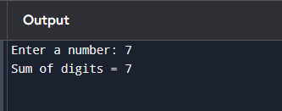

5. Write a program to reverse a number.

Input : get the for the number.

Process : using the while loop to reverse the string.

Output : based on the condition the output is printed.

#include <stdio.h>

void main()

{

int n, reverse = 0;

printf("Enter a number: ");

scanf("%d", &n);

while(n != 0)

{

reverse = reverse \* 10 + n % 10; // Add last digit to reverse

n = n / 10; // Remove last digit

}

printf("Reversed number = %d\n", reverse);

}

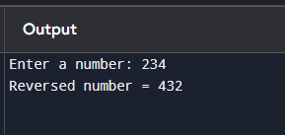

6. Write a program to check whether a number is a palindrome.

Input : get the input for the number.

Process : using if condition to check the number is pallindrome.

Output : based on the condition the output is printed.

#include <stdio.h>

int main()

{

int n, original, reverse = 0, remainder;

printf("Enter a number: ");

scanf("%d", &n);

original = n;

while(n != 0)

{

remainder = n % 10;

reverse = reverse \* 10 + remainder; // Build reverse number

n = n / 10;

}

if(original == reverse)

{

printf("%d is a palindrome.\n", original);

} else {

printf("%d is not a palindrome.\n", original);

}

}

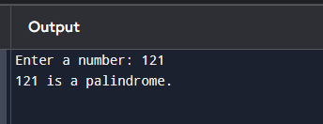

7. Write a program to print multiplication table of a number.

Input : get the input for the i.

Process : using for loop to print the multipliyer.

Output : based on the condition the output is printed.

#include <stdio.h>

void main()

{

int n;

printf("Enter a number: ");

scanf("%d", &n);

printf("Multiplication table of %d:\n", n);

for(int i = 1; i <= 10; i++)

{

printf("%d x %d = %d\n", n, i, n \* i);

}

}

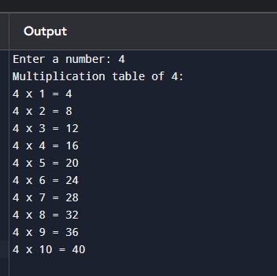

8. Write a program to count the number of digits in a number.

Input : get the input for the number .

Process : using if condition and count to count the digits of the given number.

Output : based on the condition the output is printed.

#include <stdio.h>

int main() {

int n, count = 0;

printf("Enter a number: ");

scanf("%d", &n);

if(n == 0) {

count = 1; // Special case for 0

} else {

while(n != 0) {

n = n / 10; // Remove last digit

count++;

}

}

printf("Number of digits = %d\n", count);

return 0;

}

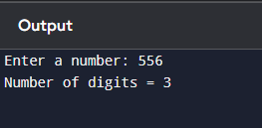

9. Write a program to print the Fibonacci series up to n terms.

Input : get the input for the starting number.

Process : using the for loop to print the series of the number.

Output : based on the condition the output is printed.

#include <stdio.h>

void main()

{

int n, first = 0, second = 1, next;

printf("Enter the number of terms: ");

scanf("%d", &n);

printf("Fibonacci Series: ");

for(int i = 1; i <= n; i++)

{

printf("%d ", first);

next = first + second;

first = second;

second = next;

}

}

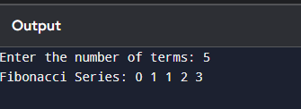

10. Write a program to calculate the sum of the first n natural numbers.

Input : get the input for the n numbers.

Process : calculate the sum of the given numbers.

Output : based on the condition the output is printed .

#include <stdio.h>

int main() {

int n, sum = 0;

printf("Enter the value of n: ");

scanf("%d", &n);

for(int i = 1; i <= n; i++) {

sum += i;

}

printf("Sum of first %d natural numbers = %d\n", n, sum);

return 0;

}

