1. Write a program to find the length of a string without using strlen().

#include <stdio.h>

void main()

{

char str[100], \*ptr;

int length = 0;

printf("Enter a string: ");

ptr = str;

while (\*ptr != '\0') {

length++;

ptr++;

}

printf("Length of the string = %d\n", length);

}

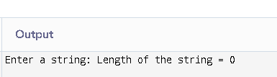

1. Write a program to copy one string to another.

#include <stdio.h>

void main()

{

char str1[100] = {'H','e','l','l','o','\0'};

char str2[100];

int i = 0;

while (str1[i] != '\0') {

str2[i] = str1[i];

i++;

}

str2[i] = '\0';

printf("Copied string: %s\n", str2);

}

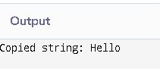

1. Write a program to concatenate two strings.

#include <stdio.h>

void main()

{

char str1[100] = "Hello ";

char str2[50] = "World!";

int i = 0, j = 0;

while (str1[i] != '\0')

{

i++;

}

while (str2[j] != '\0')

{

str1[i] = str2[j];

i++;

j++;

}

str1[i] = '\0';

printf("Concatenated string: %s\n", str1);

}

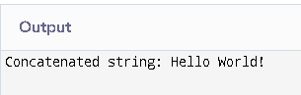

1. Write a program to compare two strings.

#include <stdio.h>

void main()

{

char str1[100] = "hello";

char str2[100] = "hello";

int i = 0, flag = 0;

while (str1[i] != '\0' || str2[i] != '\0')

{

if (str1[i] != str2[i])

{

flag = 1;

break;

}

i++;

}

if (flag == 0)

printf("Strings are equal.\n");

else

printf("Strings are not equal.\n");

}

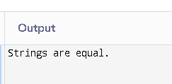

1. Write a program to count vowels and consonants in a string.

#include <stdio.h>

void main()

{

char str[100] = "Hello World";

int i = 0, vowels = 0, consonants = 0;

while (str[i] != '\0')

{

char ch = str[i];

if ((ch >= 'A' && ch <= 'Z') || (ch >= 'a' && ch <= 'z'))

{

if (ch == 'A' || ch == 'E' || ch == 'I' || ch == 'O' || ch == 'U' ||

ch == 'a' || ch == 'e' || ch == 'i' || ch == 'o' || ch == 'u')

vowels++;

else

consonants++;

}

i++;

}

printf("Vowels = %d\n", vowels);

printf("Consonants = %d\n", consonants);

}

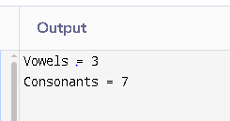

1. Write a program to convert lowercase to uppercase and vice versa.

#include <stdio.h>

void main()

{

char str[100] = "HeLLo WoRLd!";

int i = 0;

while (str[i] != '\0')

{

if (str[i] >= 'a' && str[i] <= 'z')

{

str[i] = str[i] - 32; // lowercase to uppercase

}

else if (str[i] >= 'A' && str[i] <= 'Z') {

str[i] = str[i] + 32; // uppercase to lowercase

}

i++;

}

printf("Converted string: %s\n", str);

}

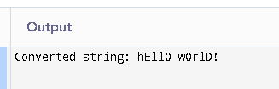

1. Write a program to check if a string is palindrome.

#include <stdio.h>

int main() {

char str[100] = "madam";

int i = 0, j = 0, flag = 0;

while (str[j] != '\0')

{

j++;

}

j--;

while (i < j) {

if (str[i] != str[j])

{

flag = 1;

break;

}

i++;

j--;

}

if (flag == 0)

printf("Palindrome\n");

else

printf("Not a palindrome\n");

}

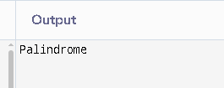

1. Write a program to reverse a string.

#include <stdio.h>

void main()

{

char str[100] = "Hello";

int i = 0, j, temp;

for (j = 0; str[j] != '\0'; j++);

j--;

while (i < j)

{

temp = str[i];

str[i] = str[j];

str[j] = temp;

i++;

j--;

}

printf("Reversed string: %s\n", str);

}

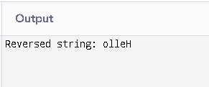

1. Write a program to count words in a string.

#include <stdio.h>

void main()

{

char str[100] = "This is a test";

int i = 0, words = 0;

while (str[i] != '\0')

{

if (str[i] != ' ' && (str[i+1] == ' ' || str[i+1] == '\0'))

{

words++;

}

i++;

}

printf("Word count = %d\n", words);

}

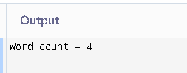

1. Write a program to find the frequency of each character in a string.

#include <stdio.h>

void main()

{

char str[100] = "hello world";

int freq[256] = {0}, i = 0;

while (str[i] != '\0')

{

freq[(int)str[i]]++;

i++;

}

for (i = 0; i < 256; i++)

{

if (freq[i] > 0)

printf("'%c' = %d\n", i, freq[i]);

}

}

