# Brainstorm

**TIP**

Add customizable tags to sticky notes to make it easier to find, browse, organize, and categorize important ideas as themes within your mural.

**TIP**

You can select a sticky note and hit the pencil [switch to sketch] icon to start drawing!

**TIP**

Participants can use their cursors to point at where sticky notes should go on the grid. The facilitator can confirm the spot by using the laser pointer holding the **H key** on the keyboard.

**Before you collaborate**

A little bit of preparation goes a long way with this session. Here’s what you need to do to get going.

**10 minutes**

**1**

**Define your problem statement**

What problem are you trying to solve? Frame your problem as a How Might We statement. This will be the focus of your brainstorm.

**5 minutes**

**2**

**Brainstorm**

Write down any ideas that come to mind that address your problem statement.

**10 minutes**

**3**

**Group ideas**

Take turns sharing your ideas while clustering similar or related notes as you go. Once all sticky notes have been grouped, give each cluster a sentence-like label. If a cluster is bigger than six sticky notes, try and see if you and break it up into smaller sub-groups.

**20 minutes**

**4**

**Prioritize**

Your team should all be on the same page about what's important moving forward. Place your ideas on this grid to determine which ideas are important and which are feasible.

**20 minutes**

**After you collaborate**

You can export the mural as an image or pdf to share with members of your company who might find it helpful.

**Quick add-ons**

# & idea prioritization

Use this template in your own brainstorming sessions so your team can unleash their imagination and start shaping concepts even if you're not sitting in the same room.

**A Team gathering**

Define who should participate in the session and send an invite. Share relevant information or pre-work ahead.

**B Set the goal**

Think about the problem you'll be focusing on solving in the brainstorming session.

**C Learn how to use the facilitation tools**

Use the Facilitation Superpowers to run a happy and

### This problem statement focuses on Creating a blog using the WordPress platform can be a complex and daunting task for individuals

**A.Bhuvaneshwar**

Create a guided setup wizard with clear steps for domain, hosting, and WordPress installation.

Provide easy-to-use, ready-made blog templates for a quick start.

Offer 24/7 live chat support for immediate assistance with technical questions.

**K.Prasanna**

Include a content calendar to plan and schedule posts effectively.

Integrate SEO tools for keyword suggestions and content optimization.

Develop a visual editor with drag-and-drop features for easy content creation.

##### Setting Up WordPress

Choose a hosting provider.

**+**

Install WordPress and select a domain name.

##### Content Creation

Write engaging blog posts with a focus on SEO.

Create a content calendar and use multimedia (images, videos).

##### SEO and Marketing

**A Share the mural**

**Share a view link** to the mural with stakeholders to keep them in the loop about the outcomes of the session.

**B Export the mural**

Export a copy of the mural as a PNG or PDF to attach to emails, include in slides, or save in your drive.

**10 minutes** to prepare

**1 hour** to collaborate

**2-8 people** recommended

productive session.

[**Open article**](https://support.mural.co/en/articles/2113740-facilitation-superpowers)

Customizing advanced design features, such as a unique theme or complex plugins.

Exploring monetization options through ads or affiliate marketing.

With limited technical skills, hindering their ability to share their ideas and content online effectively.

It provides a clear direction for your brainstorming session.

Developing a custom CMS from scratch.

**S.Chandu**

## 

Implement a user-friendly dashboard for theme and layout customization.

Simplify sharing by integrating social media platforms.

Establish an online forum for users to share experiences and get advice from the community.

**M.Mahesh**

## 

Provide comprehensive analytics tools for in-depth blog performance analysis.

Offer seamless integration with e-commerce and advertising platforms.

Prioritize security features and automated backups for blog protection and data preservation.

Optimize for search engines with keywords.

Promote your blog on social media platforms.

##### Monetization

Use Google AdSense for ad revenue.

Explore affiliate marketing opportunities.

##### Community Engagement

Respond to comments and encourage discussions Create Network with other bloggers for collaboration.

##### Technical maintenance

Regularly update WordPress and back up data.

Ensure website security and optimize for speed.

##### Conent Promotion

Create shareable content and guest post on other blogs.

Utilize email newsletters for promotion.

##### Legal and Copyright Consideration

Understand copyright laws and create a privacy policy.

Include terms of use and disclaimers on your website.

##### Feedback and Improvement

Collect user feedback and adapt based on analytics.

Continuously improve the user experience and content quality.

##### Time Management and Consistency

Set a posting schedule and use time management techniques.

Maintain consistency in content quality to avoid burnout.

**Importance**

If each of these tasks could get done without any difficulty or cost, which would have the most positive impact?

**-**

**-**

Establishing a content strategy, selecting a relevant domain name, and researching target audience.

**Feasibility**

Regardless of their importance, which tasks are more feasible than others? (Cost, time, effort, complexity, etc.)

**Keep moving forward**

**Strategy blueprint**

Define the components of a new idea or strategy.

[**Open the template**](https://app.mural.co/template/e95f612a-f72a-4772-bc48-545aaa04e0c9/984865a6-0a96-4472-a48d-47639307b3ca)

**Customer experience journey map**

Understand customer needs, motivations, and obstacles for an experience.

[**Open the template**](https://app.mural.co/template/b7114010-3a67-4d63-a51d-6f2cedc9633f/c1b465ab-57af-4624-8faf-ebb312edc0eb)

**Strengths, weaknesses, opportunities & threats**

Identify strengths, weaknesses, opportunities, and threats (SWOT) to develop a plan.

|  |  |
| --- | --- |
|  |  |
|  |  |

[**Open the template**](https://app.mural.co/template/6a062671-89ee-4b76-9409-2603d8b098be/ca270343-1d54-4952-9d8c-fbc303ffd0f2)

[**Share template feedback**](https://muralco.typeform.com/to/CiqaHVat?typeform-source=app.mural.co)

#### +

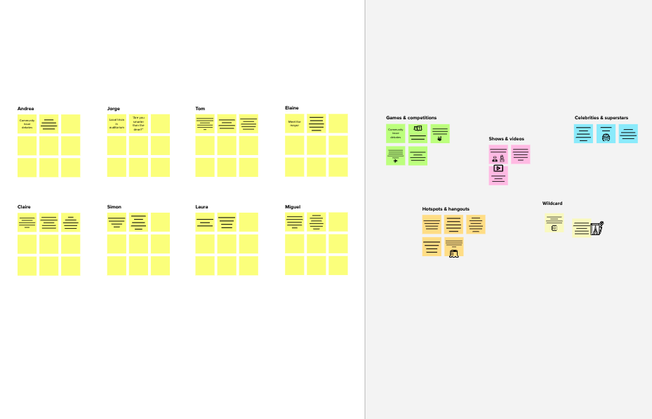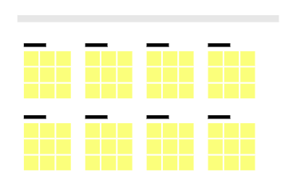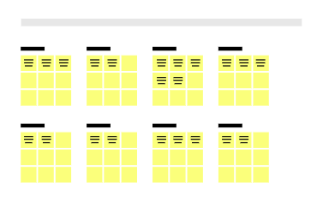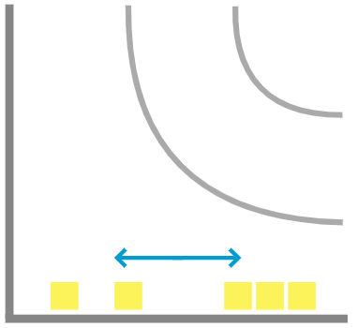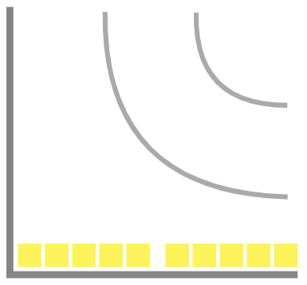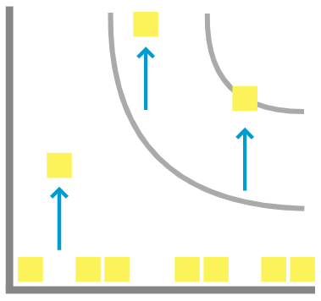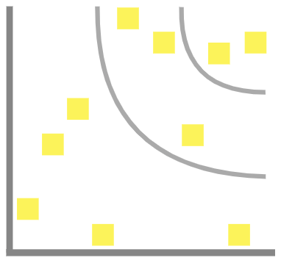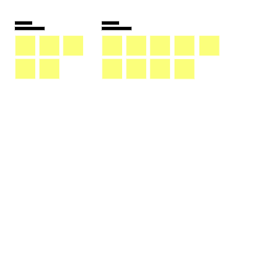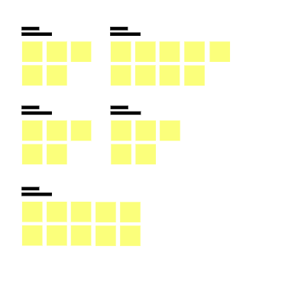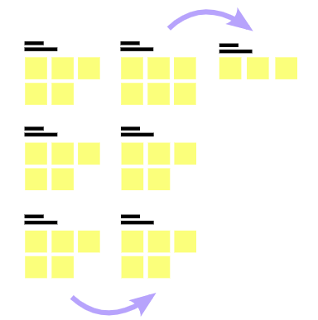

**Template**

**Need some inspiration?**

See a finished version of this template to kickstart your work.

[**Open example**](https://app.mural.co/template/e5a93b7b-49f2-48c9-afd7-a635d860eba6/93f1b98d-b2d2-4695-8e85-7e9c0d2fd9b9)