Student Name:
Bhuvaneshwar Sannappareddy

MIS_664A_Class Project 2

SQL & Data Analysis Report

Project Overview
This project focuses on using SQL to manage and analyze two real datasets collected from Washington DC:
- Moving-violation tickets, and
- Daily weather information.
This project creates a MySQL database to store and analyze two datasets: moving-violation tickets and daily weather conditions for Washington, D.C. The goal is to understand how traffic enforcement and violations relate to different weather patterns. To prepare the data, I used Python (Pandas) to clean the raw CSV files and fix formatting issues before loading them into MySQL.
After the data was organized into clear tables, I used SQL queries to explore different patterns in the dataset. The results helped me understand monthly and daily trends, agency activity levels, accident-related violations, and how rainy weather affects the number of tickets issued.

Database Creation
To store and analyze both datasets, I created a new MySQL database called sql_project. This database contains two main tables:
- moving_violations_raw
- dc_weather_raw
These tables hold the cleaned data imported through the ETL process and are structured to allow easy querying and analysis.

Table Structures
a) moving_violations_raw
This table contains all the moving-violation records for Washington, D.C. Each row represents a single ticket. The key fields include:

Column Name | Description
OBJECTID | Unique ID for each record
ISSUE_DATE | Date when the violation occurred
ISSUE_TIME | Time the ticket was issued
ISSUING_AGENCY_NAME | Name of the issuing agency
VIOLATION_PROCESS_DESC | Description of the violation
FINE_AMOUNT | Amount of the fine in dollars
ACCIDENT_INDICATOR | Indicates if the violation was accident-related
LATITUDE / LONGITUDE | Location of the violation

Purpose:
This table allows us to analyze violation trends based on date, time, agency, accident involvement, and violation type.
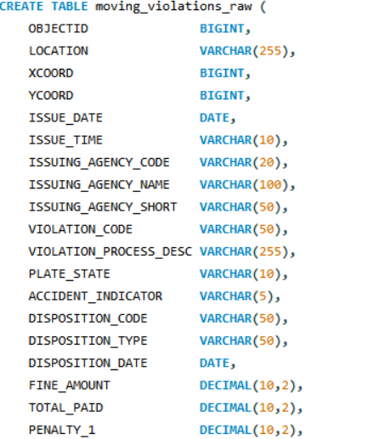 | 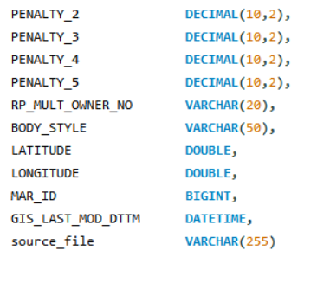

b) dc_weather_raw
This table stores daily weather information for Washington, D.C. Each row represents one day of weather observations. Key fields include:
Column Name | Description
datetime | Date of the weather record
temp, tempmax, tempmin | Temperature values
precip | Amount of precipitation
conditions | Description of the weather

Purpose:
This table helps identify rainy days, temperature variations, and monthly weather patterns, which can be linked to violation activity.
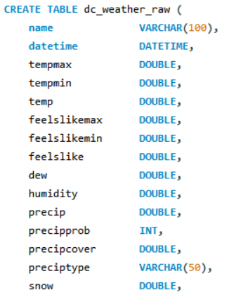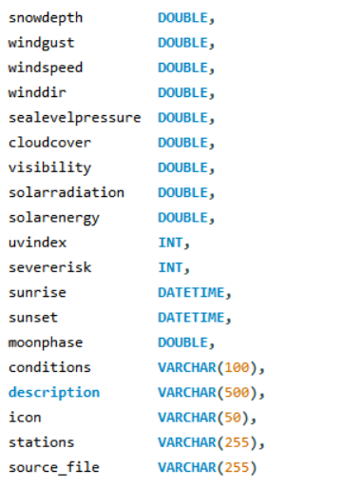

Purpose of the Database Structure
The two tables are linked through the date field:
- moving_violations_raw.ISSUE_DATE
- dc_weather_raw.datetime
This allows SQL joins to combine weather and violations data for deeper insights.
The structure supports analysis of:
- Agency behavior
- Time-of-day trends
- Weather impact (rain vs. no rain)
- Accident-related violations
- Monthly and seasonal patterns

Data Import Process
After creating the two tables in the sql_project database, I imported the cleaned versions of both datasets into MySQL using the Table Data Import Wizard in MySQL Workbench. This tool makes it easy to upload CSV files directly into a table without writing manual INSERT statements.
To import each dataset, I followed these steps:
- Selected the target table (moving_violations_raw or dc_weather_raw) in the schema.
- Chose the cleaned CSV file that was prepared during the ETL process.
- Mapped each column from the CSV file to the corresponding table column.
- Completed the import process and confirmed that all rows were loaded successfully.
- Verified the imported data by running:

SELECT * FROM moving_violations_raw LIMIT 10;
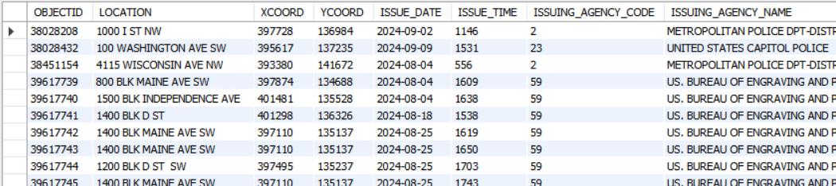

SELECT * FROM dc_weather_raw LIMIT 10;
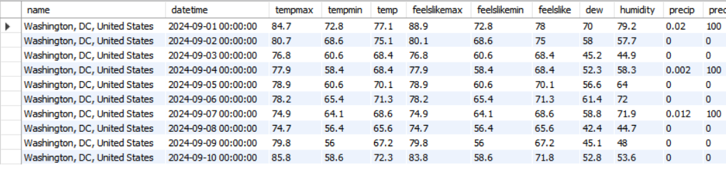

SQL Queries and Analysis
This section includes the eight SQL queries required for the project. Each query was written using simple SQL commands such as SELECT, GROUP BY, , and ORDER BY, in line with the style used in previous assignments. The purpose of each query is explained below.

Query A – List every agency that has issued moving violations tickets for each month.
This query shows which agencies issued tickets in each month and how many tickets they wrote. It helps compare agency activity over time and identify which agencies are most active in enforcing moving violations.

SELECT DATE_FORMAT(ISSUE_DATE, '%Y-%m') AS YearMonth,
ISSUING_AGENCY_NAME,
COUNT(OBJECTID) AS violations_total_tickets
FROM moving_violations_raw
GROUP BY YearMonth, ISSUING_AGENCY_NAME
ORDER BY YearMonth, violations_total_tickets DESC;
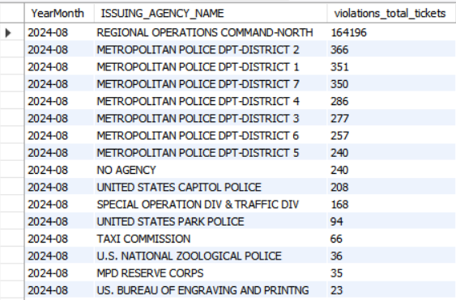

Query B – How many tickets have been issued by agencies since October 1, 2024?
Purpose:
This query shows how many different agencies issued tickets. It identifies the level of involvement from different enforcement bodies in Washington, D.C
SELECT ISSUING_AGENCY_NAME, COUNT(OBJECTID) AS Total_Tickets_Since_Oct_1st
FROM moving_violations_raw
WHERE ISSUE_DATE >= '2024-10-01'
GROUP BY ISSUING_AGENCY_NAME; .

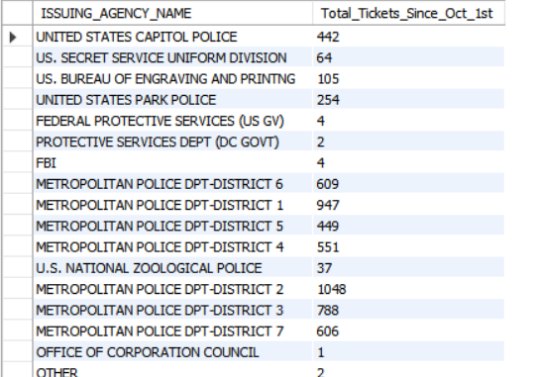

Query C – Average Number of Tickets by Day of the Week
Purpose:
This query calculates the average number of tickets issued on each weekday. It helps identify weekly patterns and shows which days tend to have more traffic violations.

SELECT DAYNAME(ISSUE_DATE) AS DayOfWeek,
COUNT(OBJECTID) / COUNT(DISTINCT ISSUE_DATE) AS Avg_Tickets_Per_Day
FROM moving_violations_raw
GROUP BY DayOfWeek
ORDER BY FIELD(DayOfWeek, 'Monday', 'Tuesday', 'Wednesday', 'Thursday', 'Friday', 'Saturday', 'Sunday');

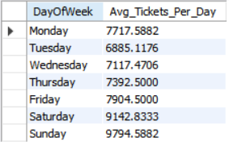

Query D – Tickets Issued During Rain
Purpose:
This query identifies how many tickets were issued on rainy days. It joins the violations data with the weather data using the date field and filters for days where precipitation is greater than zero. This helps analyze the impact of rainfall on traffic enforcement and driver behavior.

SELECT COUNT(OBJECTID) AS Tickets_During_Rain
FROM moving_violations_raw
WHERE ISSUE_DATE IN (
SELECT DATE(datetime) -- Get the list of rainy dates
FROM dc_weather_raw
WHERE precip > 0
);

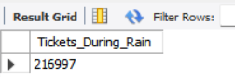

Query E – Total Monthly Precipitation
Purpose:
This query calculates the total amount of precipitation for each month in the dataset. By grouping the weather data by month and summing the precip values, it provides a clear view of how rainfall varies across different months. This helps identify trends in weather patterns and supports later analysis that compares ticket activity with monthly precipitation levels.

SELECT DATE_FORMAT(datetime, '%Y-%m') AS YearMonth,
SUM(precip) AS Total_Precipitation_In_Inches
FROM dc_weather_raw
GROUP BY YearMonth
ORDER BY YearMonth;

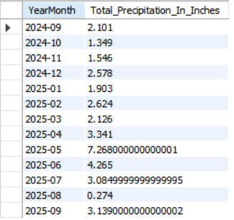

Query F – Total Speeding Fines for Violations Above 10 mph
Purpose:
This query identifies the total amount of fines collected each month from speeding violations where the driver exceeded the speed limit by more than 10 mph. The filtering conditions ensure that only major speeding offenses are included. Grouping the results by month allows us to see how these fines vary over time and whether certain months show higher levels of serious speeding.

SELECT DATE_FORMAT(ISSUE_DATE, '%Y-%m') AS YearMonth,
SUM(FINE_AMOUNT) AS Total_Speeding_Fines_Revenue
FROM moving_violations_raw
WHERE VIOLATION_PROCESS_DESC LIKE '%SPEED%'
AND VIOLATION_PROCESS_DESC NOT LIKE '%UP TO TEN MPH%'
GROUP BY YearMonth
ORDER BY YearMonth;

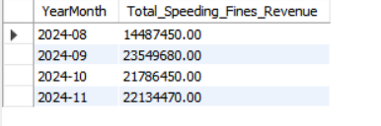

Query G – Average Tickets Per Hour of the Day
Purpose:
This query computes the average number of tickets issued during each hour of a standard day. By grouping the violations by hour and dividing by the number of distinct days, it shows which hours have the most traffic violations. This helps identify peak enforcement times, such as morning or evening rush hours.

SELECT LPAD(FLOOR(ISSUE_TIME / 100), 2, '0') AS Hour_Of_Day,
COUNT(OBJECTID) / COUNT(DISTINCT ISSUE_DATE) AS Avg_Tickets
FROM moving_violations_raw
GROUP BY Hour_Of_Day
ORDER BY Hour_Of_Day;

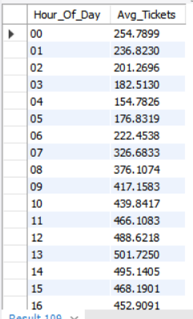

Query H – Compare tickets associated with accidents on rainy days vs non-rainy days.
Purpose:
This query compares accident-related tickets on rainy days versus non-rainy days. It joins the violations table with the weather table using the date and groups the results by the precipitation value. For each precipitation level, the query counts the total number of tickets and the number of tickets that were marked as accident-related. This helps show whether rainy conditions are linked to more accidents compared to dry conditions.

SELECT
CASE
WHEN (
SELECT w.precip
FROM dc_weather_raw w
WHERE DATE(w.datetime) = v.ISSUE_DATE
LIMIT 1
) > 0 THEN 'Rainy'
ELSE 'Non-Rainy'
END AS Weather_Condition,
COUNT(v.OBJECTID) AS Accident_Tickets
FROM moving_violations_raw v
WHERE v.ACCIDENT_INDICATOR = 'Y'
GROUP BY Weather_Condition;
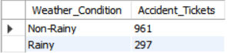

Results and Interpretation (Clear Version)
The SQL queries provide several useful insights about ticket activity and weather conditions in Washington, D.C. The results help show when violations happen most often, which agencies are most active, and how weather affects accidents and enforcement.

Ticket Activity Across Agencies and Dates
The results show that different agencies issue different numbers of tickets, and some agencies are much more active than others. Ticket counts also change by month, which helps show how violation activity varies over time.

Weekly and Hourly Violation Patterns
From the weekday and hourly queries, it is clear that ticket activity is not evenly spread throughout the week or day.
- Some weekdays consistently show higher average tickets.
- Certain hours, especially during busy traffic periods, have more violations than others.
These patterns can help understand when traffic enforcement is busiest.

Weather Impact on Violations
By connecting the violations dataset with the weather dataset, we can see how rain affects ticket counts.
- The query for rainy days shows how many tickets are issued when there is precipitation.
- Monthly precipitation totals allow comparison between wet and dry months.
- Accident-related violations grouped by rainfall levels help show whether rainy days lead to more accidents.

Speeding Fines
The results from the speeding fines query show the total monthly fines for drivers who were more than 10 mph above the speed limit. This helps identify:
- Months with higher speeding activity
- How much these serious violations contribute to overall fines

Conclusion
This project used SQL to organize and analyze two related datasets: Washington D.C. moving-violation records and daily weather data. By creating a structured database and loading cleaned CSV files into MySQL, I was able to explore patterns across agencies, dates, times, and weather conditions.
The SQL queries demonstrated that traffic violations are influenced by several factors, including time of day, day of the week, and weather. The results showed clear trends in when tickets are most common, which agencies are most active, and how rainy conditions relate to both violations and accident-related tickets. Speeding fines above 10 mph were also examined to understand monthly patterns in serious speeding behavior.
Overall, this project strengthened my ability to design tables, load cleaned datasets, and write SQL queries that answer real analytical questions. It also showed how connecting two datasets—violations and weather—can provide deeper insights into traffic patterns and conditions that affect road safety. SQL proved to be an effective tool for summarizing, comparing, and understanding these real-world data points.

