1.Host a Ubuntu Virtual Machine using Oracle VM Virtual Box. (5 marks)

2.Set up Visual Studio code on Ubuntu VM. (5 marks)

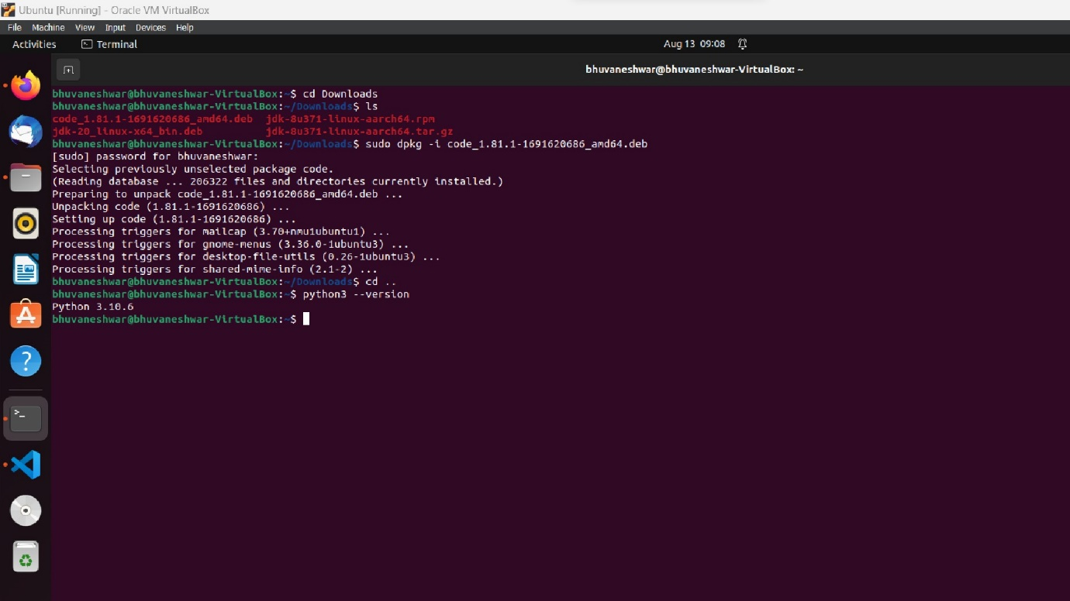

3.Set up Python. (5 marks)



4.Clone this Github repositoryhttps://github.com/Vikas098766/Microservices.git(1 mark) 5.Create a Virtual Environment. (1 mark)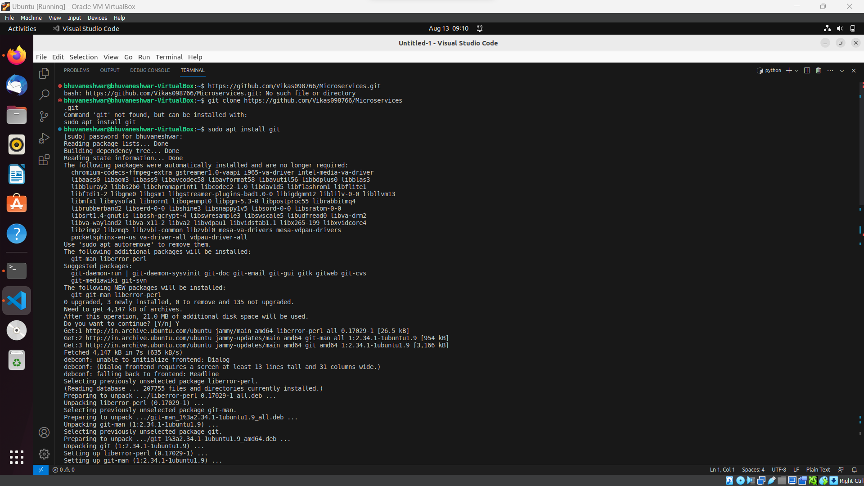

6.Install the dependencies from requirements.txt file. ( 1 mark)

7.Train and save the model. (2 marks)

8.Test the Flask web application. (5 marks)

9.Test the application and make predictions using the example calls available in the folder/tests.(5 marks)

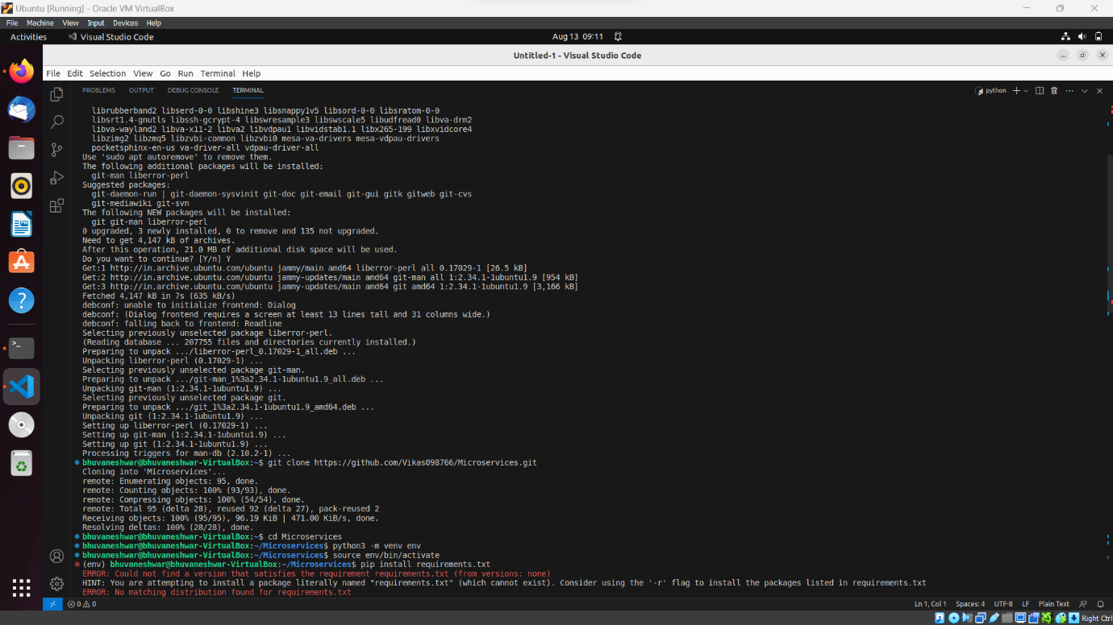

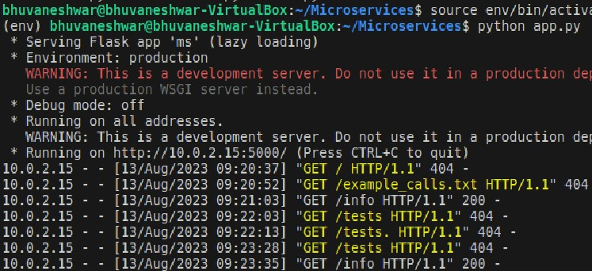

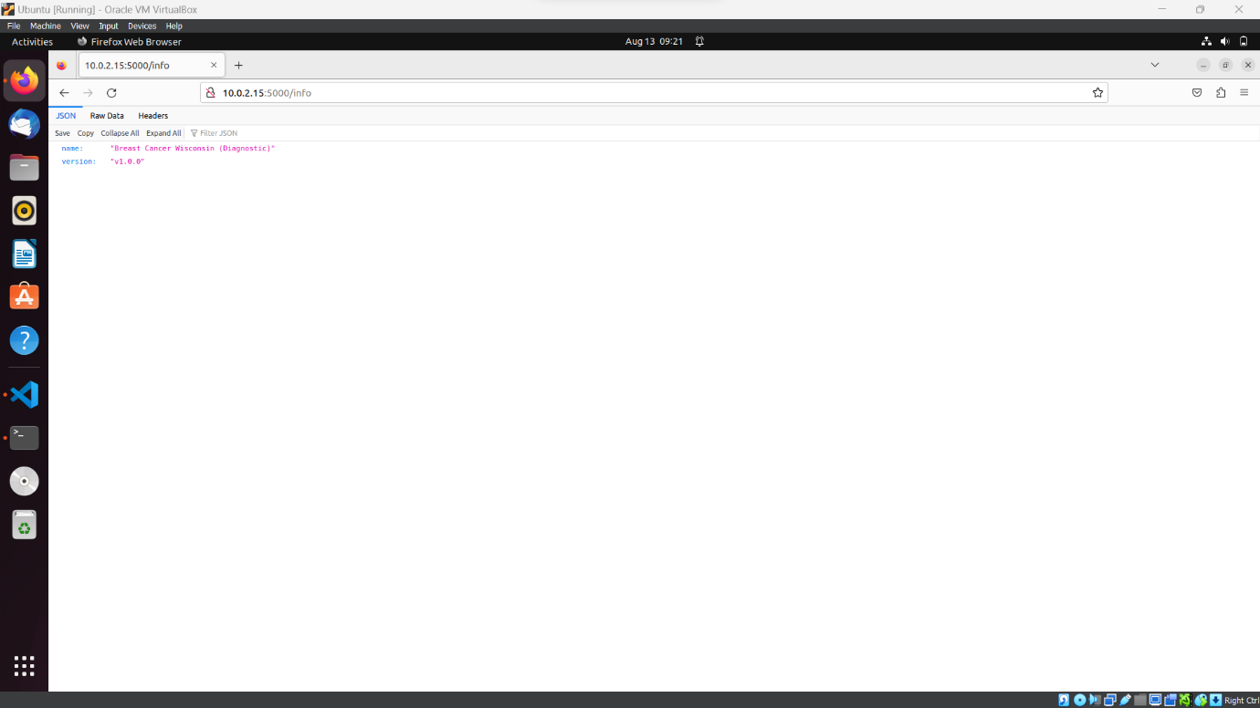

10.Create a docker image containing everything needed to run the application.(10 marks)

11.Run the containerized application as a prediction service and test it locally by passingsome example calls and get the prediction. (10 marks)

