SIMATS ENGINEERING

ASSESSMENT TOOL 3 -Application Based Question
NAME: Bhuvaneshwari B A
REG NO: 192421195

COURSE NAME: R PROGRAMMING COURSE CODE: ITA04

COURSE OUTCOME COVERED

CO1: Apply R programming fundamentals including data structures, vectors, matrices, arrays, and class types to perform mathematical operations and manage data effectively.
(Bloom Level -BL2- BL4) Assessment Tool Weightage: 20%

QUESTIONS: Total Marks: 100

Weather Data Analysis Using Arrays
Daily temperature data for three cities is collected for 7 days. Write an R program to:
  - Store the data in a 3-dimensional array.
  - Find the average temperature for each city.
  - Identify the hottest day.
  - Compare city-wise temperature variations.

Student Performance Analysis

A college stores the marks of 10 students in Mathematics, Physics, and Chemistry. Write an R program to:
- ◻ Store the marks in a matrix.
- ◻ Calculate subject-wise averages.
- ◻ Find the highest and lowest scorer in each subject.
- ◻ Display students scoring above the overall average.

Weather Data Analysis Using Arrays CODE:
# Weather Data Analysis Using Arrays

# Create a 3D array (3 Cities × 7 Days × 1 Week) temperature <- array(
c(

30,31,32,33,34,35,36, # City 1

28,29,30,31,32,33,34, # City 2

27,28,29,30,31,32,33 # City 3

),

dim = c(3,7,1), dimnames = list(
City = c("Chennai","Coimbatore","Madurai"), Day = paste("Day",1:7),
Week = "Week1"

)

)

# Display temperature data print(temperature)
# Average temperature of each city avgTemp <- apply(temperature,1,mean) cat("\nAverage Temperature:\n") print(avgTemp)
# Hottest day

maxTemp <- max(temperature) cat("\nHighest Temperature:", maxTemp,"\n")

# City-wise temperature variation cat("\nTemperature Variation:\n") variation <- apply(temperature,1,range) print(variation)
OUTPUT:
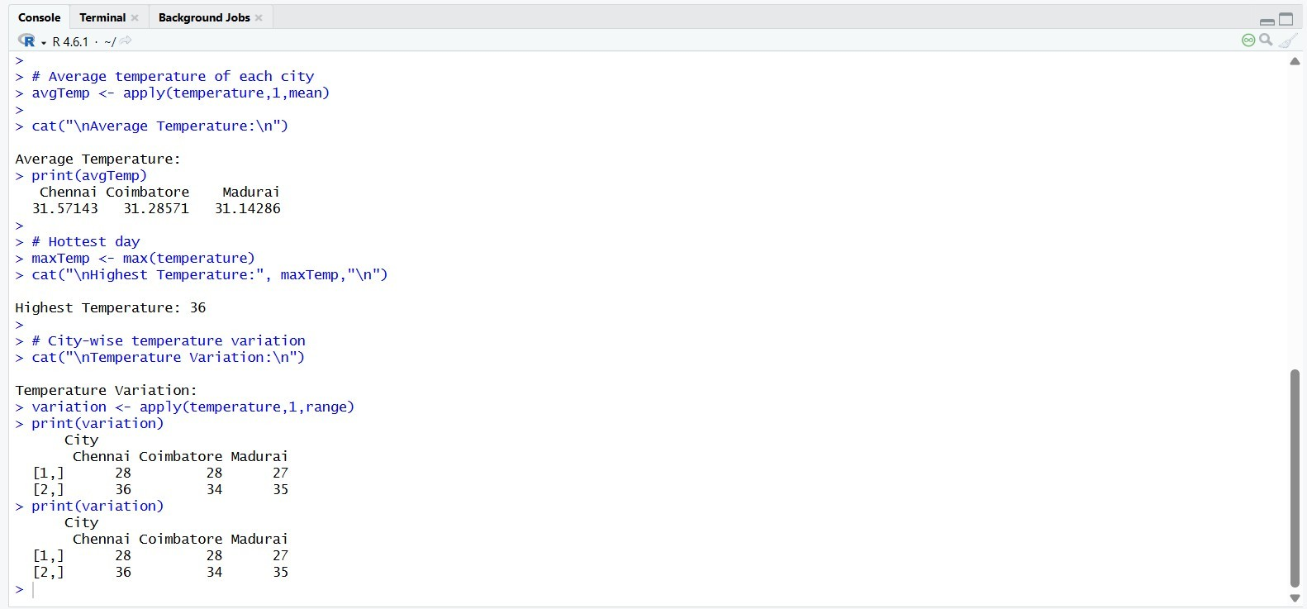

Student Performance Analysis

# Student Marks Matrix marks <- matrix(c( 80,75,90,
65,70,68,
88,92,85,
76,81,79,
90,89,94,
55,60,58,
72,74,70,
85,80,82,
91,95,93,
67,69,71
), nrow=10, byrow=TRUE)

colnames(marks) <- c("Maths","Physics","Chemistry") print(marks)

# Subject-wise Average print(colMeans(marks))

# Highest Marks print(apply(marks,2,max))

# Lowest Marks print(apply(marks,2,min))

# Overall Average overall <- mean(marks) print(overall)

# Student Average
studentAvg <- rowMeans(marks)

# Students Above Overall Average print(studentAvg) print(which(studentAvg > overall))

OUTPUT:

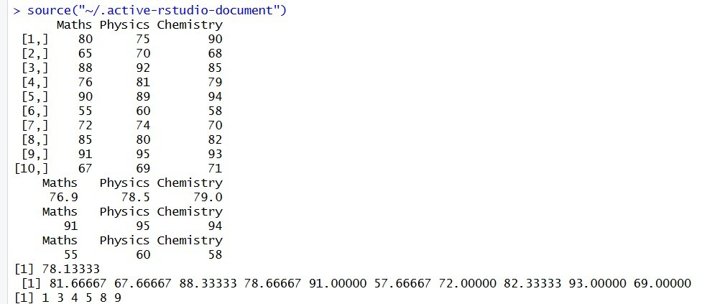

Code of Conduct:

I (Name / Reg No) certify that this submission is my original work and that I have adhered to the guidelines specified for this assessment.
I understand that any violation of academic integrity rules will result in disciplinary action.

Signature of the student:

RUBRICS FOR CALCULATION:

Criteria | Weightage | Level 4 –  Exemplary | Level 3 –  Proficient | Level 2 –  Developing | Level 1 –  Beginning
Understanding of Problem Context | 20 | Clearly understands the problem and accurately identifies all  requirements | Good understanding with minor gaps | Basic understanding; some requirements unclear | Poor understanding or misinterpretation of the problem
Application of Concepts | 30 | Accurately applies appropriate concepts to solve complex  problems | Applies relevant concepts correctly with minor errors | Applies basic concepts with limited accuracy | Fails to apply appropriate concepts
Problem-Solving Approach | 20 | Logical, well-structured, and efficient  approach | Mostly logical approach with minor gaps | Basic approach with some inconsistencies | Illogical or unclear approach
Accuracy of Solution | 20 | Completely correct solution with proper  justification | Mostly correct with minor errors | Partially correct solution | Incorrect or incomplete solution
Clarity | 10 | Clear, well-organized, and properly explained  solution | Understandable with minor clarity issues | Limited clarity and explanation | Poorly presented and difficult to understand

