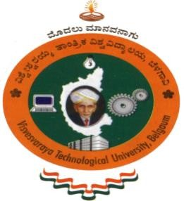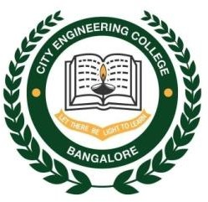

# VISVESVARAYA TECHNOLOGICAL UNIVERSITY

## JnanaSangama, Belgaum-590014

**A DBMS Mini Project Report**

**On**

**“SMART INTELLIGENT SYSTEM FOR WOMEN SAFETY”**

**Submitted in Partial fulfillment of the Requirements for the V Semester of the Degree of**

**Bachelor of Engineering In**

**Computer Science & Engineering By**

**AKSHAY AMRUT MORAB(1CE17CS008)**

**BHUVANESHWARI M(1CE17CS024)**

**Under the Guidance of Mrs. ARCHANA BHAT**

**Asst. Professor, Dept. of CSE**

**CITY ENGINEERING COLLEGE**

**Doddakallasandra, Kanakapura Road, Bengaluru-560061**

**CITY ENGINEERING COLLEGE**

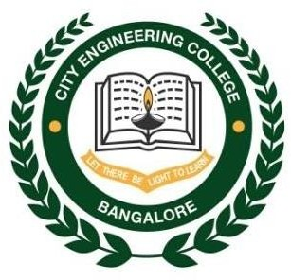

**Doddakallasandra, Kanakapura Road, Bengaluru-560061 DEPARTMENT OF COMPUTER SCIENCE AND ENGINEERING**

**CERTIFICATE**

Certified that the DBMS Mini Project work entitled **“COMBATIVE DATABASE MANAGEMENT SYSTEM”** has been carried out by **AKSHAY AMRUT MORAB (1CE17CS008) and BHUVANESHWARI M (1CE17CS024),** bonafide students of City Engineering College in partial fulfilment for the award of **Bachelor of Engineering in Computer Science and Engineering** of the Visveshvaraya Technological University, Belgaum during the year **2019-2020**. It is certified that all corrections/suggestions indicated for Internal Assessment have been incorporated in the Report deposited in the departmental library. The DBMS Mini Project Report has been approved as it satisfies the academic requirements in respect of project work prescribed for the said Degree.

|  |  |  |
| --- | --- | --- |
| **Mrs.Archana Bhat** | **Mr. B Vivekavardhana Reddy** | **Dr. V. S Rama Murthy** |
| Asst.Prof, Dept.of CSE | Head, Dept. of CSE | Principal |
|  |  |  |
|  | External Viva |  |
| Name of the examiners |  | Signature with date |

1.

2.

**DECLARATION**

We student of 5th semester BE, Computer Science and Engineering College hereby declare that project work entitled “Combative Database Management System” has been carried out by us at City Engineering College, Bengaluru and submitted in partial fulfillment of the course requirement for the award of the degree of **Bachelor of Engineering in Computer Science and Engineering of Vivesvaraya Technological University, Belgaum**, during the academic year 2019-2020.

We also declare that, to the best of our knowledge and belief, the work reported here does not from the part of dissertation on the basis of which a degree or award was conferred on a earlier occasion on this by any other student.

Date**:**

Place: Bangalore

**AKSHAY AMRUT MORAB BHUVANESHWARI M**

**(1CE17CS008) (1CE17CS024)**