**MATPLOTLIB**

**1.Importing matplotlib**

import matplotlib.pyplot as plt

**2.To create line graph:**

import matplotlib.pyplot as plt

from matplotlib import style

style.use('ggplot')

x=[5,8,10]

y=[12,16,6]

x2=[6,9,11]

y2=[6,15,7]

plt.plot(x,y,'r',label="line one",linewidth=5)

plt.plot(x2,y2,'y',label="line two",linewidth=5)

plt.legend()

plt.grid(True,color='k')

plt.title("Line Graph")

plt.xlabel("x axis")

plt.ylabel("y axis")

plt.show()

output:

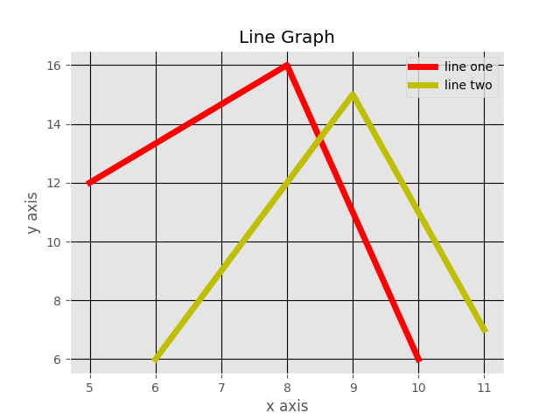

**3.To Create Bar chart:**

import matplotlib.pyplot as plt

x=[1,3,5,7,9]

y=[5,2,7,8,2]

x2=[4,5,6,7,9]

y2=[8,9,10,8,9]

plt.bar([1,3,5,7,9],[5,2,7,8,2],label="Bar 1",width=0.4)

plt.bar([4,5,6,7,9],[8,9,10,8,9],label="Bar 2",width=0.4)

plt.legend()

plt.title("Bar Graph")

plt.xlabel("x axis")

plt.ylabel("y axis")

plt.show()

Output:

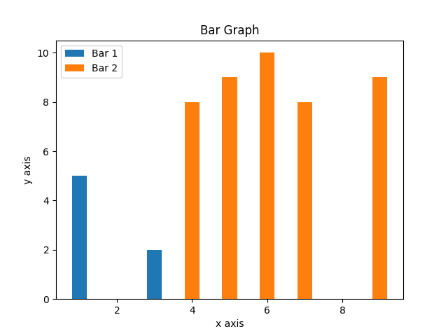

**4.To create Histogram:**

import matplotlib.pyplot as plt

pop_ages=[10,20,30,40,50,60]

bins=[11,20,34,44,55,66]

plt.hist(pop_ages,bins,histtype='bar',width=0.8)

plt.title(“Ages”)

plt.xlabel("x axis")

plt.ylabel("y axis")

plt.show()

**Output:**

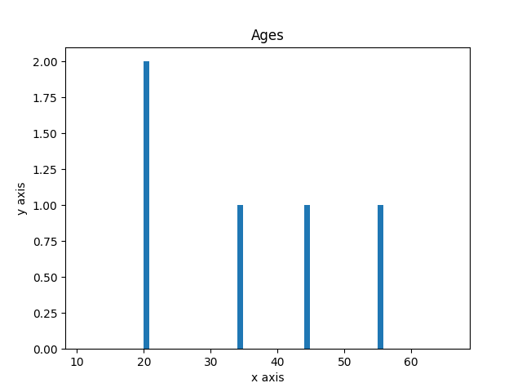

**5.To create scatter plot:**

import matplotlib.pyplot as plt

x=[1,2,3,4,5]

y=[9,7,5,3,2]

plt.scatter(x,y,label='skitscat',color='k')

plt.title('scatter')

plt.legend()

plt.grid(True,color='g')

plt.show()

**Output:**

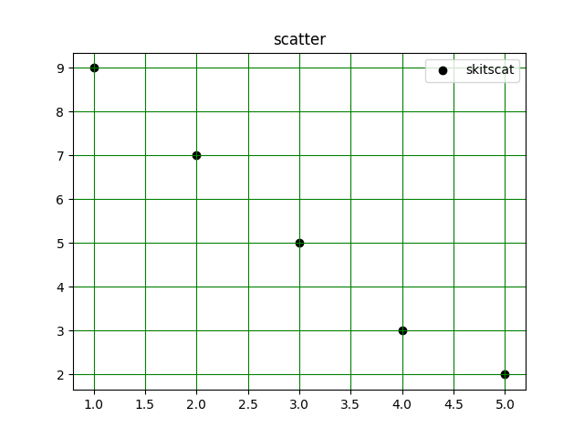

**6.To create Pie chart:**

import matplotlib.pyplot as plt

slices=[7,2,3,13]

activities=['sleeping','eating','working','playing']

cols=['c','m','r','b']

plt.pie(slices,labels=activities,

        colors=cols,

        startangle=90,

        shadow=True,

        explode=(0,0.1,0,0),

        autopct='%1.1f%%'

)

plt.show()

**Output:**

