**GGPLOT**

**# to view datasets**

View(iris)

|  | **Sepal.Length** | **Sepal.Width** | **Petal.Length** | **Petal.Width** | **Species** |
| --- | --- | --- | --- | --- | --- |
|  |  |  |  |  |  |
| **1** | 5.1 | 3.5 | 1.4 | 0.2 | setosa |
| **2** | 4.9 | 3.0 | 1.4 | 0.2 | setosa |
| **3** | 4.7 | 3.2 | 1.3 | 0.2 | setosa |
| **4** | 4.6 | 3.1 | 1.5 | 0.2 | setosa |
| **5** | 5.0 | 3.6 | 1.4 | 0.2 | setosa |
| **6** | 5.4 | 3.9 | 1.7 | 0.4 | setosa |
| **7** | 4.6 | 3.4 | 1.4 | 0.3 | setosa |
| **8** | 5.0 | 3.4 | 1.5 | 0.2 | setosa |
| **9** | 4.4 | 2.9 | 1.4 | 0.2 | setosa |
| **10** | 4.9 | 3.1 | 1.5 | 0.1 | setosa |
| **11** | 5.4 | 3.7 | 1.5 | 0.2 | setosa |
| **12** | 4.8 | 3.4 | 1.6 | 0.2 | setosa |
| **13** | 4.8 | 3.0 | 1.4 | 0.1 | setosa |
| **14** | 4.3 | 3.0 | 1.1 | 0.1 | setosa |
| **15** | 5.8 | 4.0 | 1.2 | 0.2 | setosa |

Showing 1 to 11 of 150 entries, 5 total columns

**# to select particular column**

table(iris$Species)

**setosa versicolor virginica**

**50 50 50**

**#scatterplot**

plot(iris$Sepal.Length~iris$Petal.Length)

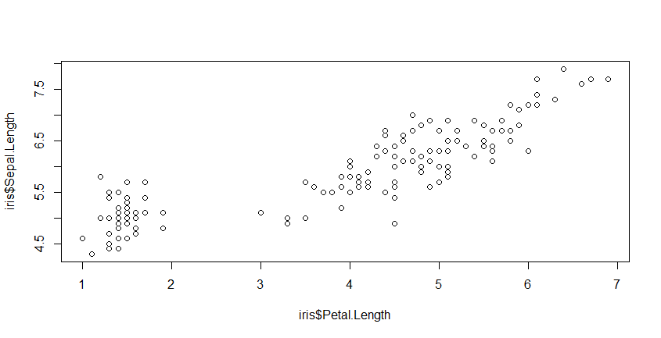

**#to modify the labels**

plot(iris$Sepal.Length~iris$Petal.Length,ylab='Sepal Length',xlab='Petal Length',main='Sepal length vs Petal Length')

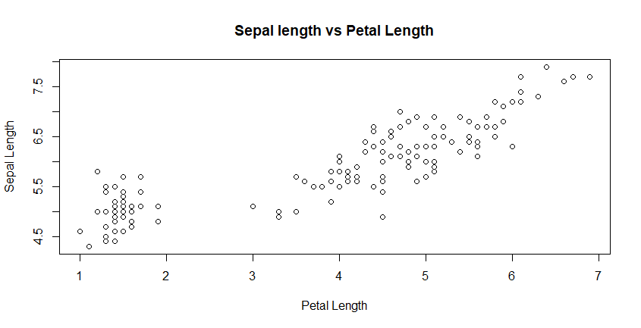

**#add some color**

plot(iris$Sepal.Length~iris$Petal.Length,ylab='Sepal Length',xlab='Petal Length',main='Sepal length vs Petal Length',col='blue',pch=16)

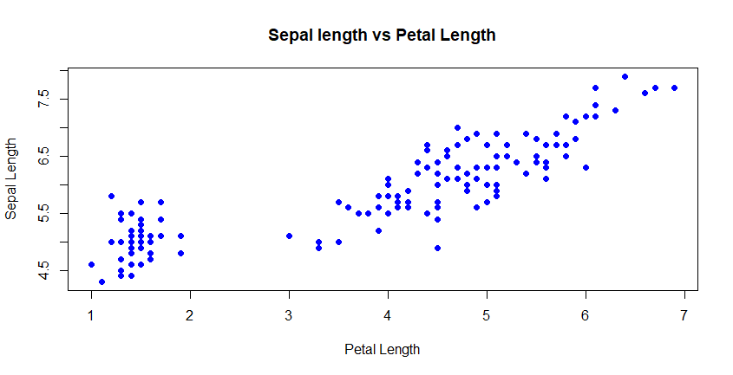

**#Histogram**

hist(iris$Sepal.Width)

hist(iris$Sepal.Width,xlab='sepal width',main='Distribution of sepal width',col='aquamarine')

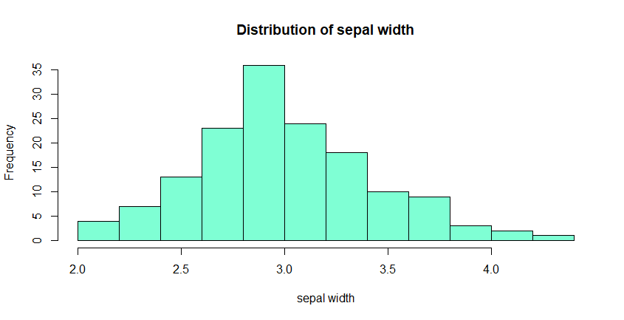

**#BoxPlot**

boxplot(iris$sepal Sepal.Length~iris$species)

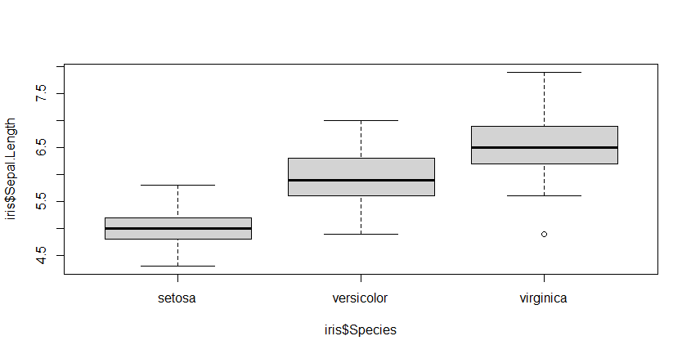

**#add color**

boxplot(iris$Sepal.Length~iris$Species,xlab='Species',ylab='Sepal Length',main='Sepal Length of different Species',col='burlywood')

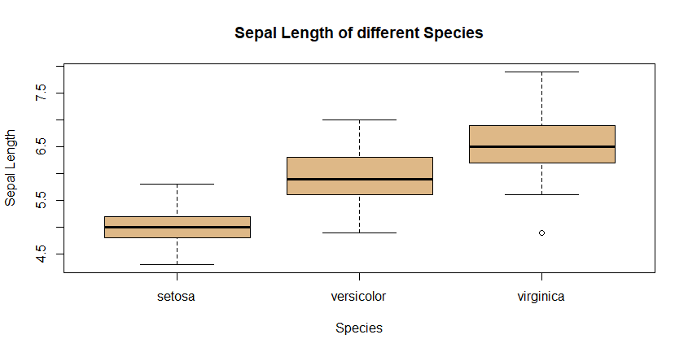

**#loading ggplot2 package**

library(ggplot2)

**#selection of data**

ggplot(data=iris)

**#plotting**

ggplot(data=iris,aes(y=Sepal.Length,x=Petal.Length))

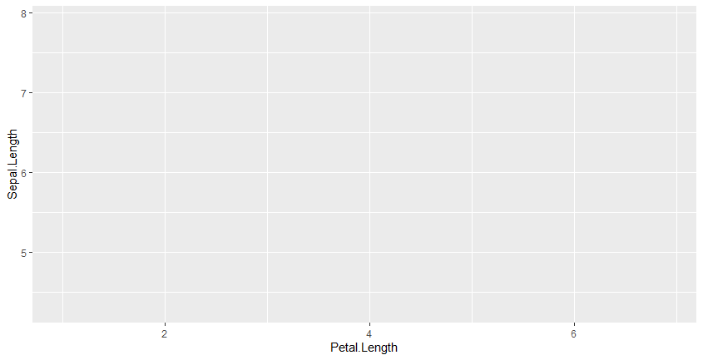

**#scatterplot**

ggplot(data=iris,aes(y=Sepal.Length,x=Petal.Length))+geom_point()

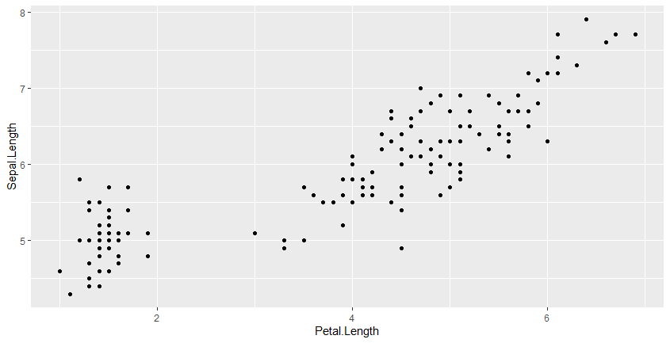

**#add color**

ggplot(data=iris,aes(y=Sepal.Length,x=Petal.Length,col=Species))+geom_point()

ggplot(data=iris,aes(y=Sepal.Length,x=Petal.Length,col=Species,shape=Species))+geom_point()

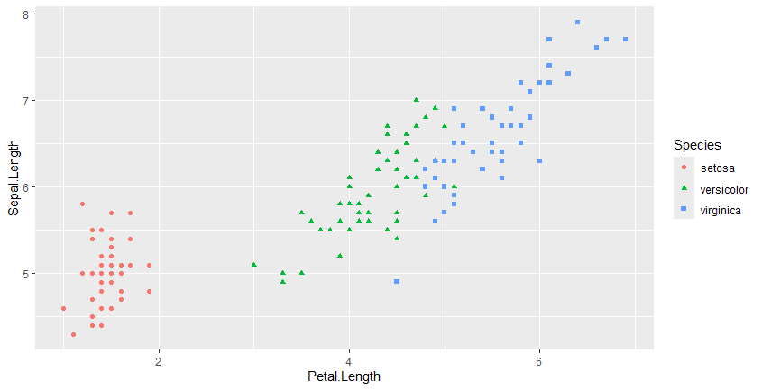

**#loading a dataset**

library(ggplot2)

attach(mtcars)

The following object is masked from package:ggplot2:

mpg

p1<-ggplot(mtcars,aes(factor(cyl),mpg))

**#boxplot**

p1+geom_boxplot()

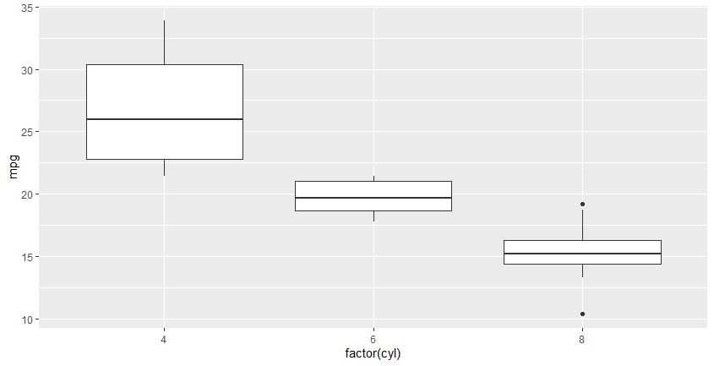

**#filling color**

p1+geom_boxplot(aes(fill=factor(cyl)))

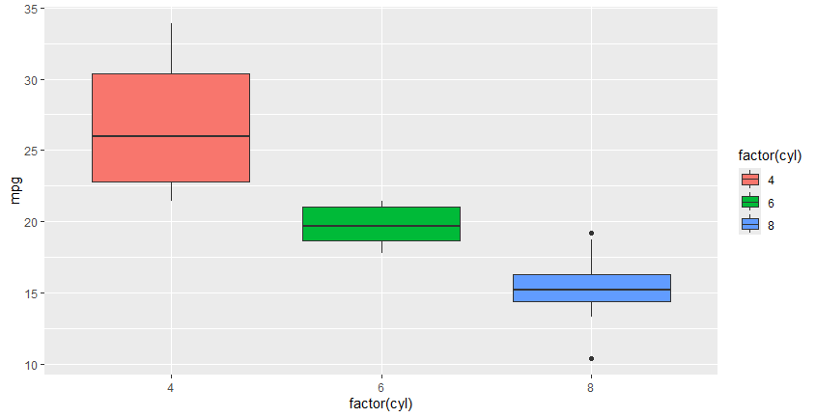

**#scatterplot**

ggplot(data=mtcars,mapping=aes(x=wt,y=mpg,color=as.factor(cyl)))+geom_point()

ggplot(data=mtcars,mapping=aes(x=wt,y=mpg,color='red',size=qsec))+geom_point()

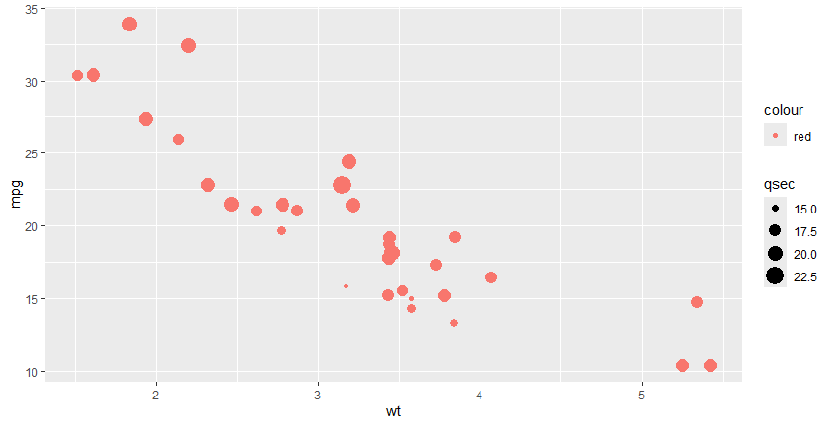

**#bar chart**

ggplot(data=mtcars,mapping=aes(x=mpg))+geom_bar()

