🏗️ System Architecture & Model Diagram

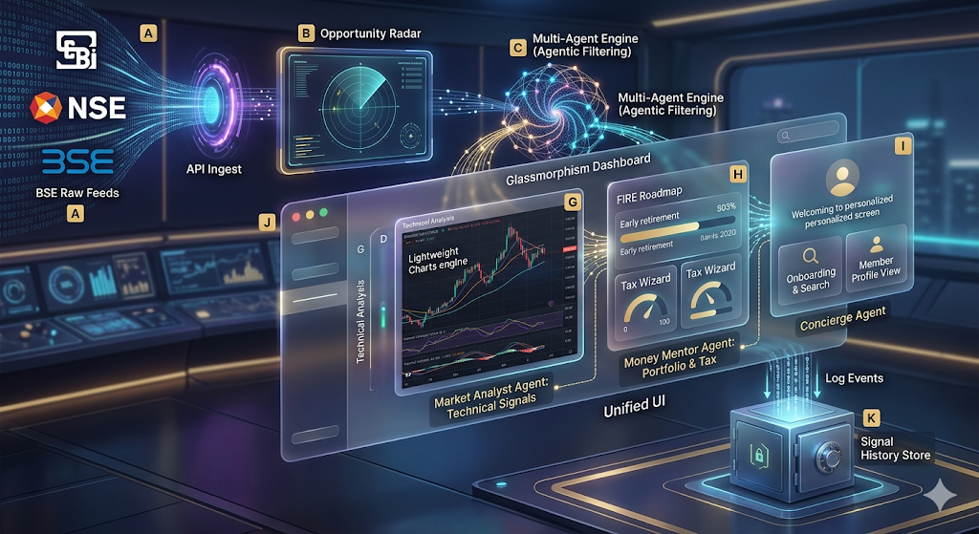

🛠️ The Multi-Agent Core

Our solution is built on a modular "Agentic Core" designed to handle the velocity and variety of Indian market data.

1. Agent Roles & Responsibilities
- Market Signal Agent: Continuously monitors the **Opportunity Radar**. It uses pattern-matching logic to surface high-conviction trades (Insider Accumulation, Bullish Breakouts).
- Wealth Mentor Agent: A specialized financial planning agent that calculates tax-saving optimizations and FIRE (Financial Independence, Retire Early) trajectories.
- Concierge Agent: An onboarding agent that builds a persistent **Investor Profile** to personalize the dashboard and content discovery.

2. High-Fidelity Tool Integrations
- Charting Tool: Integrated TradingView Lightweight Charts (v5.1.0).
- Iconography Tool: Lucide React for semantic visual cues.
- Design Tool: Custom Vanilla CSS Design System (Glassmorphism, Dark-mode-first).

3. State & Persistence Hub
- Simulated Auth Context: Manages member sessions and "Logged In" status app-wide.
- Signal History Log: A persistent record of all historical signals captured by the agents, ensuring no actionable insight is lost.

🤝 Agent Communication Logic
1. Event Bubbling: When the Radar Agent detects an "Insider Buy" at 10:15 AM, it triggers a `signalHistory` update in the Global Context.
2. Dynamic UI Adaptation: The Concierge Agent reads the `AuthContext` to determine if the user is an "ET Prime" member, which unlocks the Money Mentor's deep-dive tax logic.

🛡️ Error Handling & SEBI Compliance
- Reasoning Guardrails: Every "Signal" includes an "Agent's Rationale" (Source Cited) to ensure transparency.
- SEBI Compliant Reasoning: Our Money Mentor Agent is programmed to provide "Reasoning-only" outputs to avoid providing unauthorized financial advice.
- Fallback Logic: If the charting component fails to load, a static summary of the trend is rendered as a graceful fallback.

