### 10.  Behavioral modeling- State chart diagram

#### A state–chart diagram shows a state machine that depicts the control flow of an object from one state to another. A state machine portrays the sequences of states which an object undergoes due to events and their responses to events.

#### State–Chart Diagrams comprise of −States: Simple or Composite, Transitions between states Events causing transitions, Actions due to the events, State-chart diagrams are used for modeling objects which are reactive in nature.

#### *10.1   State chart diagram for an AI-based image / face recognition system*

##### Design and develop state chart diagram for AI-based image recognition system. A state chart diagram is a type of diagram used in computer science and engineering to describe the behavior of a system. For an AI-based image recognition system, the state chart diagram can represent the different states the system can be in and the transitions between those states. Below is a simplified example of a state chart diagram for an AI-based image recognition system:

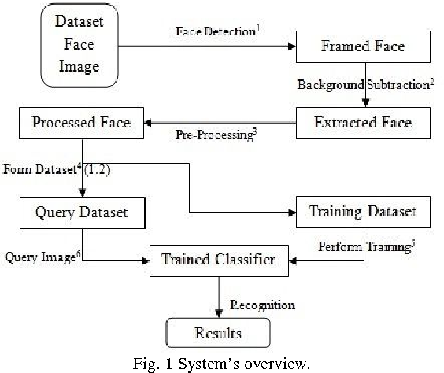

#### *10.2 State chart diagram for* *Augmented Reality (AR) Game:*

Design and develop state chart diagram for Augmented Reality (AR) Game. a state chart diagram for an Augmented Reality (AR) game involves illustrating the various states and transitions that the game can go through.

In this diagram:

Start: Represents the initial state of the game.

Loading: Represents the state where the game is loading resources, initializing AR components, etc.

Active: Represents the main state when the game is actively being played.

Paused: Represents the state when the game is paused, perhaps due to user input or other events.

Game Over: Represents the state when the game has ended, and the player has either won or lost.

Transitions between states are depicted by arrows. For example:

Transition from Start to Loading indicates the initialization phase.

Transition from Loading to Active indicates the completion of loading and the start of the game.

Transition from Active to Paused may occur when the player pauses the game.

Transition from Active to Game Over occurs when the game ends.

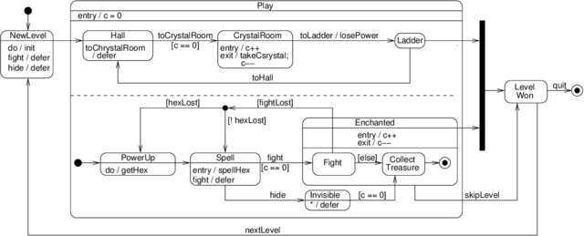

Figure 10. 3UML state machine for a magician in a computer game

***10.3 State chart diagram for Predictive Analytics System***

Draw and develop a state chart diagram for Predictive Analytics System. a state chart diagram for a Predictive Analytics System involves representing the various states and transitions that the system can undergo. State chart diagrams are part of Unified Modeling Language (UML) and are used to model the dynamic aspects of a system.

In this diagram:

Initializing: The system is in the process of initializing its components.

Idle: The system is ready and waiting for user input or a trigger to start processing.

Data Collection: The system collects data from various sources.

Data Preprocessing: The collected data undergoes preprocessing to clean and transform it for analysis.

Model Training: The system trains a predictive model using the preprocessed data.

Model Evaluation: The trained model is evaluated for its performance.

Prediction: The system uses the trained model to make predictions on new data.

Results Display: The results of predictions are displayed to the user.

Error Handling: If any errors occur during the process, the system handles them appropriately.

System Error: In case of critical errors, the system enters an error state.

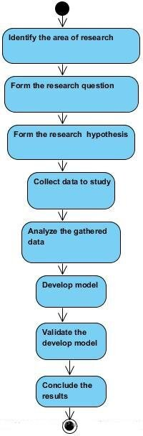

#### *10.4* *State Chart diagram for* *Educational Learning Management System*

Design and develop a state chart diagram for an Educational Learning Management System. In the context of an Educational Learning Management System (LMS), a state chart diagram can represent the various states and transitions that the system can undergo.

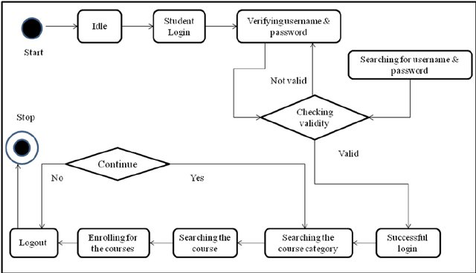

Fig:10.4 State Chart diagram for Educational Learning Management System

***10.5 State Chart diagram for Stock Trading Platform***

Design and develop a Stock Trading Platform. In the context of a Stock Trading Platform, a state chart diagram can illustrate the various states that the system and its components can go through and the transitions between these states.

Explanation:

This is a simplified representation, and the actual state chart for a Stock Trading Platform could be more detailed based on the specific features and requirements of the system.

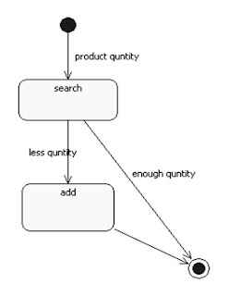

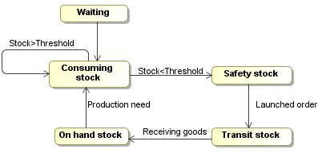

Fig 10.5 : State Chart diagram for Stock Trading Platform