***7.1. Sequence diagram for Traffic Monitoring System***

Design and develop a sequence diagram for Airline Reservation System. Creating a complete sequence diagram for a Traffic Monitoring System involves understanding the specific interactions between different components or actors in the system. However, I can provide you with a basic example to give you an idea of how a sequence diagram might look for a simple Traffic Management System. Keep in mind that the actual diagram may vary based on the specific requirements and architecture of your system.

m was designed successfully by following the steps described above

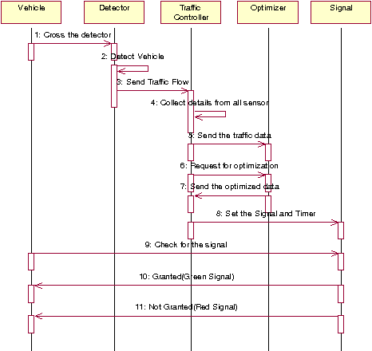

Fig.7.1. Sequence diagram for Adaptive Road traffic control system

***7.2 Sequence diagram for Machine Learning-Based Fraud Detection for a Financial Institution***

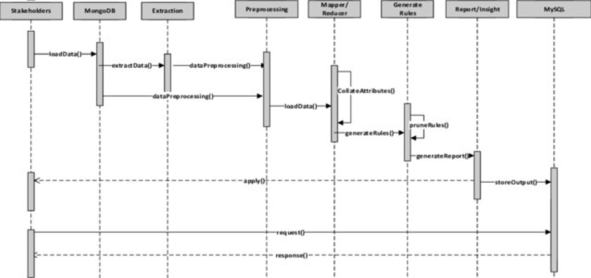

***7.3 Sequence diagram for IoT platform in a smart home company***

Creating a complete and accurate sequence diagram for an IoT platform in a smart home company would depend on the specific functionalities and interactions involved. However, I can provide you with a basic outline that you can customize based on your requirements. In this example, I'll illustrate a simplified sequence diagram for a smart home IoT platform that involves user authentication, device control, and data processing.

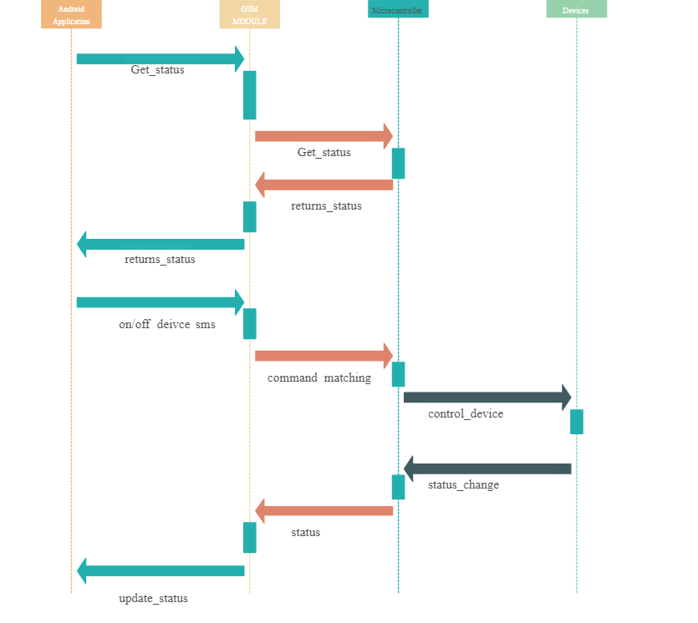

***7.4 Sequence diagram for Blockchain-Based Supply Chain Tracking system***

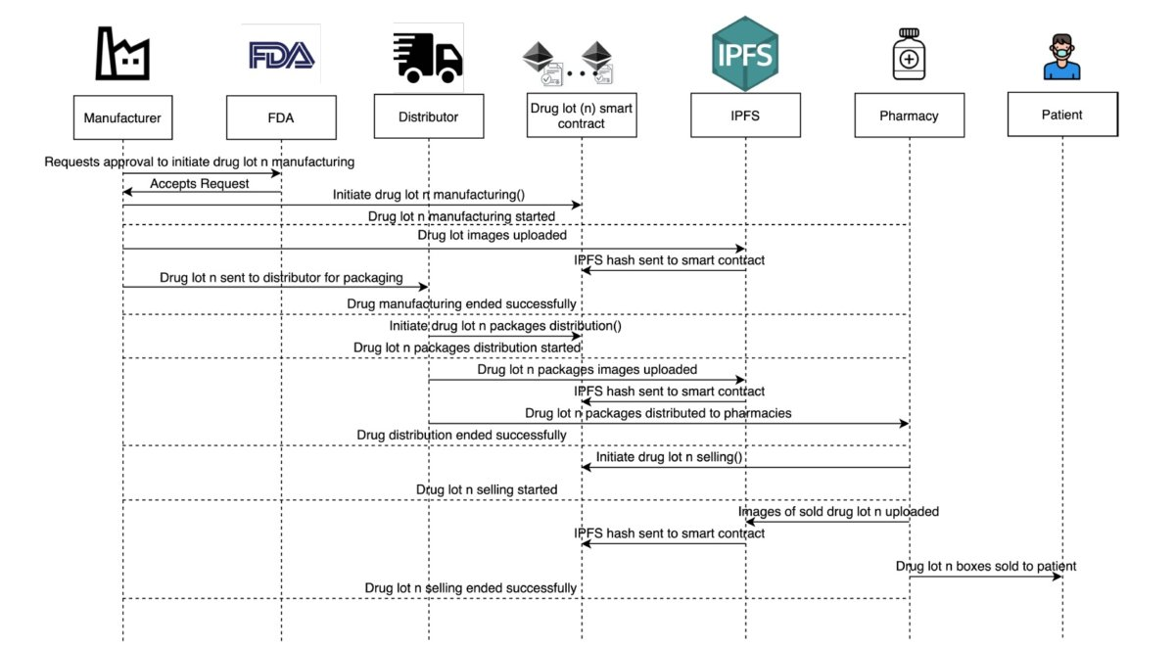

***7.5 Sequence diagram for Social Media Analytics Platform***

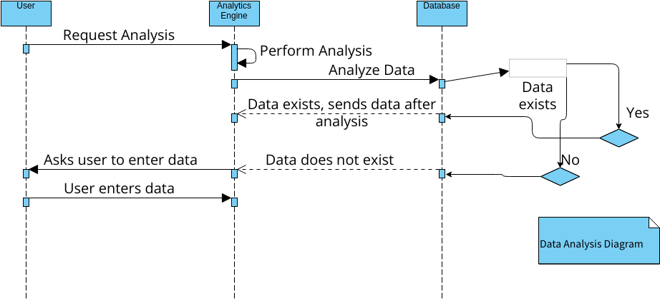

***7.6 Sequence diagram for Face Recognition Attendance System***

The sequence diagram of a face recognition attendance system is used to show how the parts of a system work together to make the online shopping operate. The Sequence Diagram for face recognition attendance system represents the scenario and the messages that must be passed between objects. It’s an interaction diagram that shows how activities are carried out, including when and how messages are send.

### 

### Fig.7.6 Sequence diagram for face recognition attendance system