### 8.  Behavioral modeling- Collaboration diagram

#### The collaboration diagram is used to show the relationship between the objects in a system. Both the sequence and the collaboration diagrams represent the same information but differently. Instead of showing the flow of messages, it depicts the architecture of the object residing in the system.

#### *8.1 Collaboration diagram for Stock Maintenance*

Stock maintenance has the details about the product, purchase, sales and stock what are the stocks we had. The product details contain product code, Product name, Opening Stock and Prices. These details are maintained in database. In the purchasing function we must have the details about the store, quantity and also price.

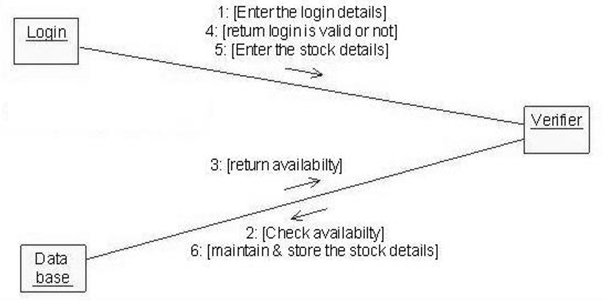

Fig.8.1 Collaboration diagram for Stock Maintenance

#### *8.2 Collaboration diagram for Agriculture Technology Software*

Design and develop a collaboration diagram for Agriculture Technology Software, in the context of Agriculture Technology Software, the diagram would showcase the collaboration between different components or modules involved in the system. Keep in mind that creating a specific diagram requires knowledge of the software's architecture and design, so the following is a simplified example to give you an idea.

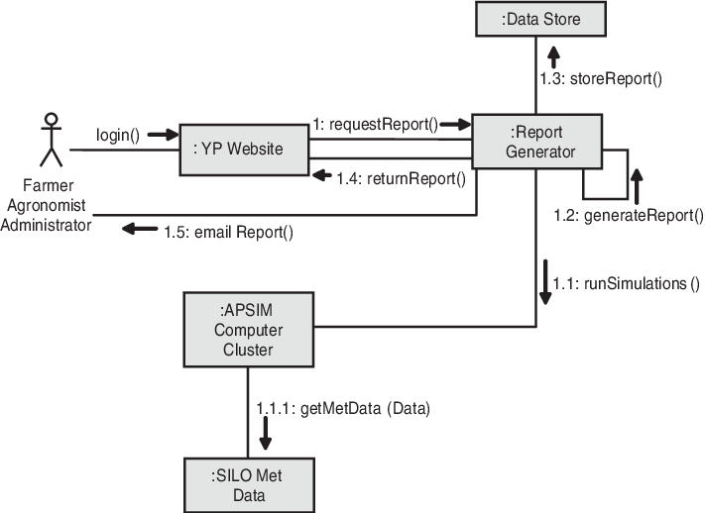

***8.3 Collaboration diagram for*** ***Cybersecurity Software for Banking***

Design and develop a collaboration diagram for Cybersecurity Software for Banking. in the context of cybersecurity software for banking, the diagram would represent the collaboration between various modules or components involved in ensuring the security of banking systems. Please note that creating a detailed collaboration diagram would depend on the specific functionalities and components of the cybersecurity software you have in mind. However, I can provide you with a high-level example to give you an idea.

In a cybersecurity software system for banking, you might have components such as:

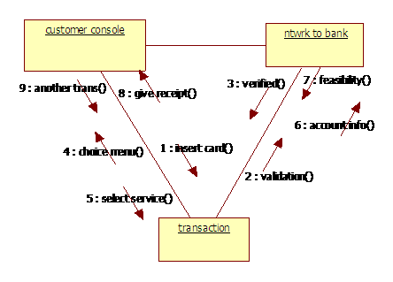

**LOAN DETAILS:**  
[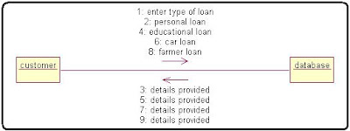](https://4.bp.blogspot.com/_Gmn-kEVg3hk/SwG2HYLD_WI/AAAAAAAABDo/MPRzZd74yoE/s1600/Banking+Software+Online+Banking+System+c%2B%2B+programming+algorithm+Loan+Details.JPG)

**CUSTOMER DETAILS:**  
[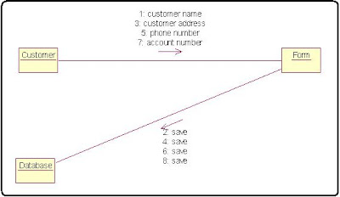](https://4.bp.blogspot.com/_Gmn-kEVg3hk/SwG2HKjsSYI/AAAAAAAABDg/S8RdYHVLTJM/s1600/Customer+Details++Internet+Bank+Software+Customer+Details+collabration+diagram+process+algorithm+in+c%2B%2B.JPG)  
[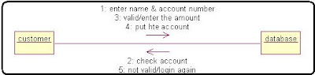](https://2.bp.blogspot.com/_Gmn-kEVg3hk/SwG2HGrqjkI/AAAAAAAABDY/3k6oEtjAK1g/s1600/DEPOSIT+MONEY+Collaboration+diagram++in+c%2B%2B+programming+algorithm.JPG)

**CREATE A NEW ACCOUNT:**

[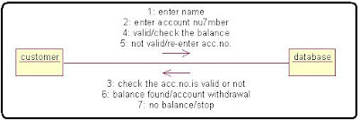](https://4.bp.blogspot.com/_Gmn-kEVg3hk/SwG2G8upIsI/AAAAAAAABDQ/kp_ULWTO9NQ/s1600/Internet+Bank+Software+Collaboration+diagram++algorithm+in+c%2B%2B.JPG)

**WITHDRAW THE MONEY:**  
[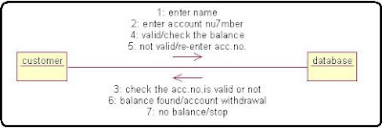](https://1.bp.blogspot.com/_Gmn-kEVg3hk/SwG2GQOYIiI/AAAAAAAABDI/DuCyEP-kL2s/s1600/Internet+Bank+Software+in+c%2B%2B+Withdraw+The+Money+algorithm.JPG)

***8.4 Collaboration diagram for E-commerce platform enhancement***

Design and develop a collaboration diagram for E-commerce platform enhancement. In the context of an E-commerce platform enhancement, the collaboration diagram can illustrate the communication and collaboration between various modules or components involved in the enhancement.

Here's a simplified example of a collaboration diagram for an E-commerce platform enhancement. In this example, let's consider a scenario where a new feature is being added to allow users to write and submit product reviews:

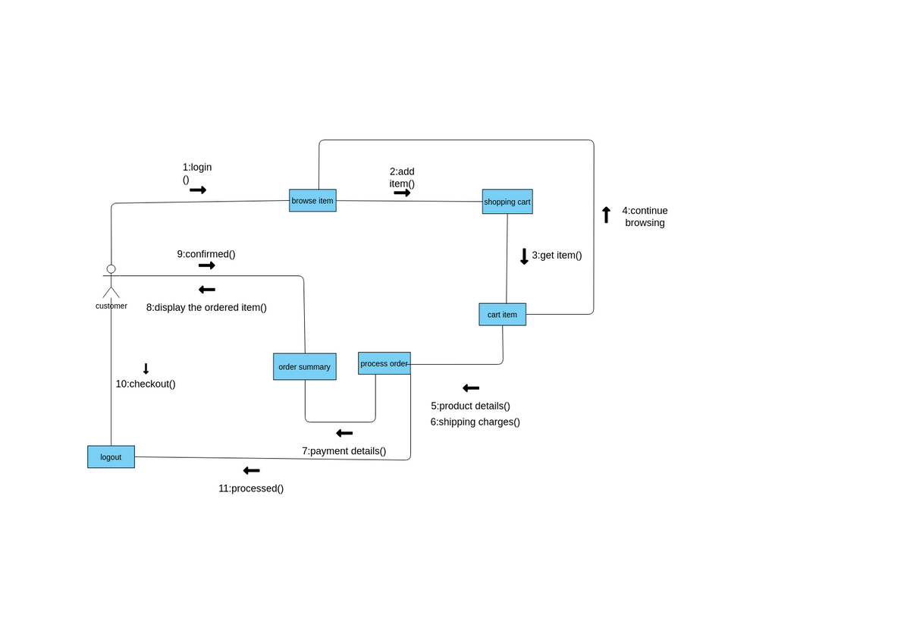

Fig.8.4 Collaboration diagram for E-commerce platform enhancement

***8.5*** ***Collaboration diagram for Weather Forecasting System***

Design and develop a collaboration diagram for Weather Forecasting System. A collaboration diagram, also known as a communication diagram, illustrates how objects interact to achieve a particular goal. In the case of a Weather Forecasting System, you might have various components and entities collaborating to gather, process, and display weather information

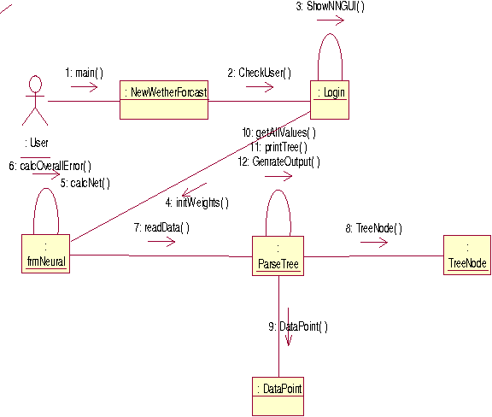

Fig 8.5: Collaboration diagram for Weather Forecasting System

#### *8.6 Collaboration Diagram for Music Streaming Service*

Design and develop a collaboration diagram for Music Streaming Service. A collaboration diagram, also known as a communication diagram, illustrates the interactions and relationships among different elements in a system. In the case of a Music Streaming Service, these elements might include users, the streaming server, the music database, and other components.

The "User" initiates a playback request, which is sent to the "Streaming Server."

The "Streaming Server" then communicates with the "Music Database" to retrieve the requested music.

The "Music Database" sends the music data back to the "Streaming Server."

The "Streaming Server" streams the music data to the "User" for playback

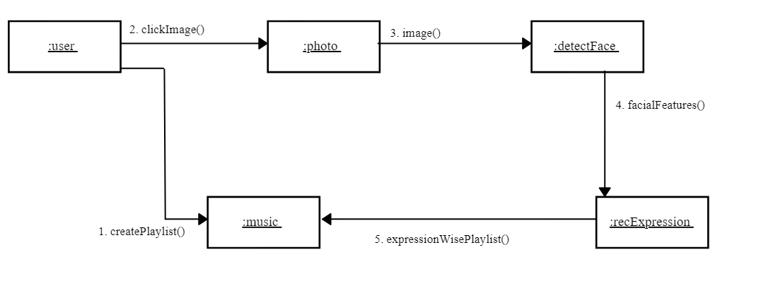

Fig 8.6: Collaboration Diagram - Intelligent Music Player