### 9.  Behavioral modeling- Activity diagram

#### The activity diagram is used to demonstrate the flow of control within the system rather than the implementation. It models the concurrent and sequential activities.

#### The activity diagram helps in envisioning the workflow from one activity to another. It put emphasis on the condition of flow and the order in which it occurs. The flow can be sequential, branched, or concurrent, and to deal with such kinds of flows, the activity diagram has come up with a fork, join, etc.

#### It is also termed as an object-oriented flowchart. It encompasses activities composed of a set of actions or operations that are applied to model the behavioral diagram.

#### *9.1 Activity Diagram for* *Garage Parking Solution*

Design and develop activity diagram for Garage Parking Solution. Creating an activity diagram for a Garage Parking Solution involves representing the flow of activities and actions that occur within the system. Below is a simplified example of an activity diagram for a Garage Parking Solution. This diagram assumes a basic process flow, and you may need to tailor it to fit the specific requirements of your system.

This activity diagram outlines a simple process for a Garage Parking Solution, including detecting a vehicle, checking available parking spaces, displaying the available spaces, user selection, reservation, parking the vehicle, and updating the availability status. The process ends once the vehicle is parked. Note that this is a basic representation, and real-world systems may involve more detailed steps and decision points.

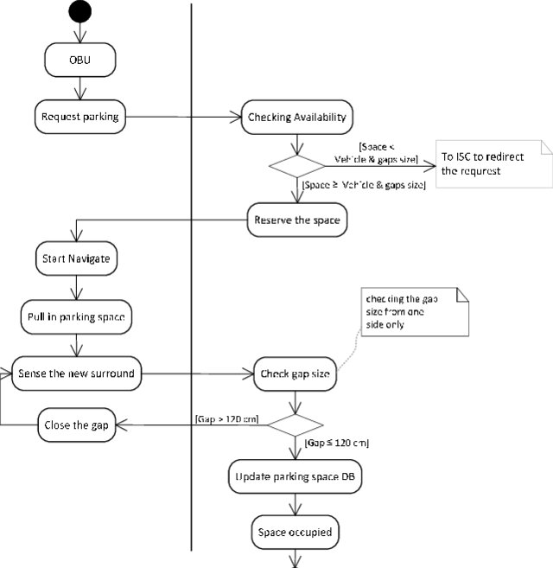

#### *9.2 Activity diagram for Greenhouse automation*

Design and develop activity diagram for Greenhouse automation. Creating a complete activity diagram for greenhouse automation involves understanding the specific functionalities and processes involved in the system. Below is a simplified example of an activity diagram for a greenhouse automation system. This diagram focuses on the main activities and interactions within the system.

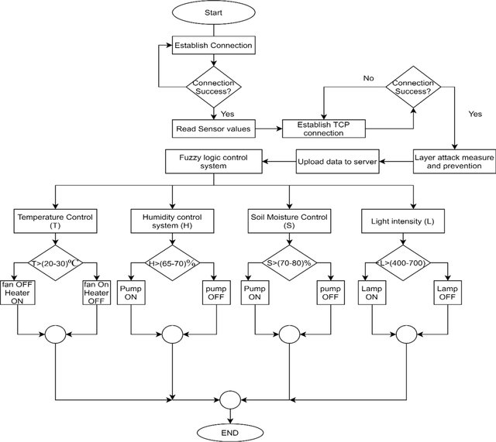

Figure.9.2 Activity diagram for Greenhouse automation

***9.3 Activity diagram for a chatbot system design***

Creating a detailed activity diagram for a chatbot system design involves multiple steps and interactions. Below is a simplified example of an activity diagram for a basic chatbot system. Please note that the actual design may vary based on specific requirements and features of your chatbot system.

Here's a brief explanation of each step:

#### 

#### Fig 9.3.1. Activity diagram for a chatbot system design

#### 

#### Figure 9.3: Chatbot for Employee Activity Diagram

#### *9.4 Activity diagram for Document Automation Process*

Design and develop activity diagram for Document Automation Process. Document Automation Process has some kind of formal and properly communicated document Automation process is usually required in any major corporation especially under a regulatory compliance. A document goes through different state or stages - it is designed, reviewed, updated, approved, and at some point, archived.

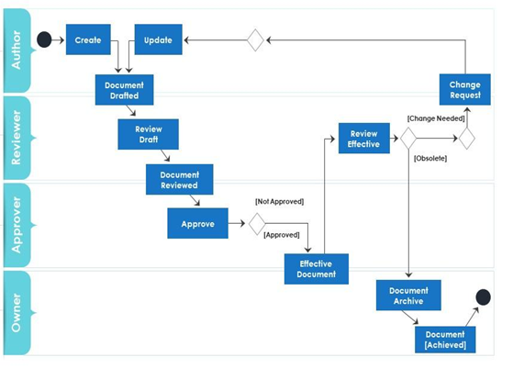

Figure 9.4: Activity Diagram for Document Automation Process

#### *9.5 Activity diagram for to resolve an issue in a software design*

Design and develop activity diagram for resolve an issue in a software design. which shows how to resolve an issue in a software design. After ticket is designed by some authority and the issue is reproduced, issue is identified, resolution is determined, issue is fixed and verified, and ticket is closed, if issue was resolved.

This example does not use partitions, so it is not very clear who is responsible for fulfilling each specific action.

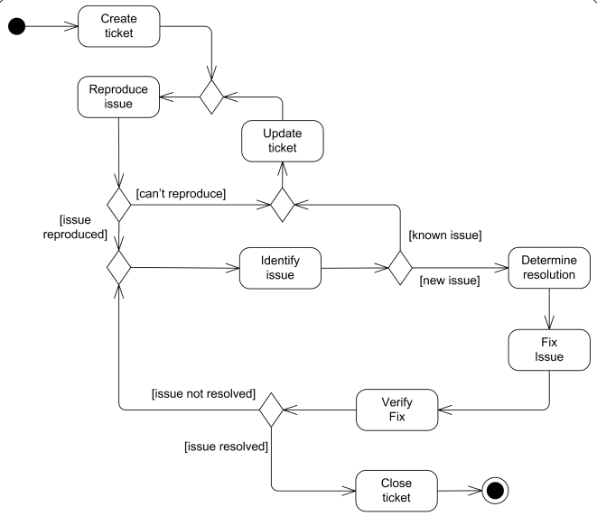

Figure.9.5: Activity diagram for to resolve an issue in a software design