PROJECT DOCUMENTATION

FITFLEX: Your personal fitness companion

1. INTRODUCTION:

* **Project Title**: FitFlex : Your Personal Fitness companion
* **Team ID:** NM2025TMID38018
* **Team leader:** BHUVANESWARI C & [bhuvanakanniyamal@gmail.com](mailto:bhuvanakanniyamal@gmail.com)
* **Team Members:**
* THAMAYANTHI S & [thamayanthisivakumar77@gmail.com](mailto:thamayanthisivakumar77@gmail.com)
* YAMINI S & [yaminisanthi2007@gmail.com](mailto:yaminisanthi2007@gmail.com)
* YUVARANI P & [yuvaranipalani041@gmail.com](mailto:yuvaranipalani041@gmail.com)

1. PROJECT OVERVIEW:

* Purpose:

Fitflex is a fitness and wellness platform that helps users track workouts, manage diet plans, and connect with trainers for personalized guidance. The platform promotes a healthier lifestyle through structured fitness programs, real-time progress tracking, and community engagement.

* Features:
* User registration and secure login
* Workout and diet plan management
* Trainer dashboard for managing clients
* Real-time chat system between users and trainers
* Admin control panel for monitoring users and trainers

1. ARCHITECTURE:

* Frontend: React.js with Bootstrap and Material UI
* Backend: Node.js and Express.js managing server logic and API endpoints
* Database: MongoDB stores user details, fitness data, diet plans, progress records, and trainer information

1. SETUP INSTRUCTION:

* Prerequisites:
* Node.js
* MongoDB
* Git
* React.js
* Express.js – Mongoose – Visual studio code
* Installation steps:
* Clone the repository from GitHub
* Run npm install to install dependencies
* Configure MongoDB connection in .env file
* Start backend using npm run server
* Start frontend using npm start

1. FOLDER STRUCTURE:

FitFlex/

|--client/ #React Frontend

| |--components/

| |--pages/

|

|--server/ #Node Backend

|--models/

|--routes/

|--controllers/

|--middleware/

1. RUNNING THE APPLICATION:

* **Clone Respository:**

git clone <repository_url>

cd fitflex

* **Install Dependance:**

npm install

* **Start Backend** **server:**

cd backend

node server.js

* **Start frontend:**

cd frontend

npm start

* **Access** **Application:**

Open browser and go to:

<http://localhost:3000>

1. API Documentation:

* **Users:**
* POST / api / user / register –Register a new user
* POST / api / user / login – User login
* **Projects (Workout / Diet Plans):**
* POST / api / projects / create – Create a new workout or diet paln
* GET / api / projects / :id – Get specific plan details
* **Chats:**
* POST / api / chat / send – Send a message in chat
* GET / api / chat / :userId – Fetch chat history with a user / trainer

1. AUTHENTICATION:

* JWT-based authentication for secure login
* Middleware protects private routes (workout details, trainer, dashboards, chat system

1. USER INTERFACE:

* Landing page – Overview of FitFlex platform and services
* User Dashboard – Track workouts, diet plans, and progress
* Trainer Dashboard – manage clients, assign workouts, and monitor progress
* Admin Panel – Manage users, trainers, and system data
* Project Details page – Details view of fitness / workout plans

10.TESTING:

* **Manual Testing:** All user flows tested
* **API Testing:** Postman for endpoints
* **UI Testing:** Browser dev tools

11.Screenshots or demo:

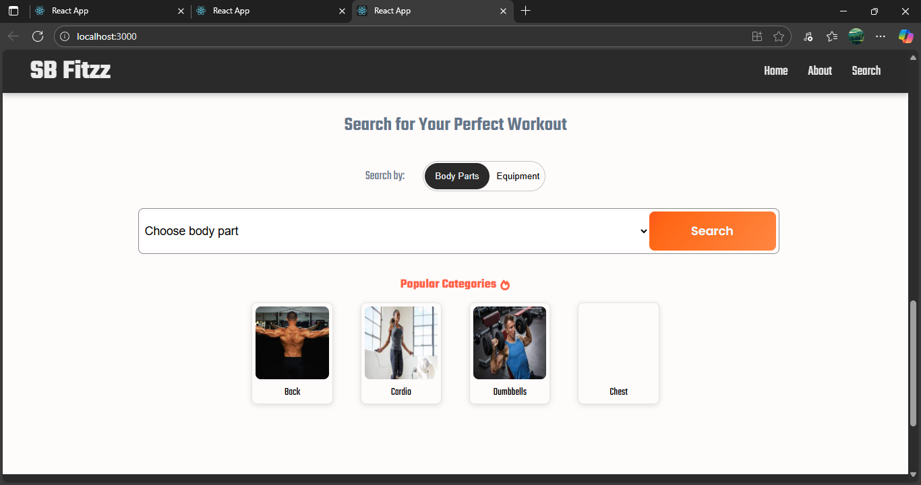

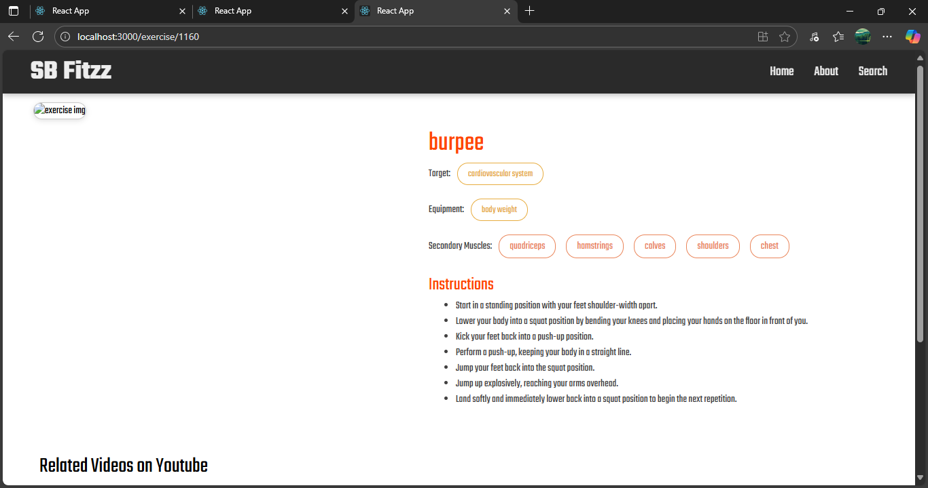

Demo link:

https://drive.google.com/file/d/1JBxu9x0dYtYTzVKNdOnI552QpLHXG1Rz/view?usp=drive_link

12. KNOWN ISSUES:

* Exercise images are not displaying on the exercise detail page (shows placeholder instead of the actual image).
* Some pages take longer to load due to high-resolution data fetch from the backend.
* Real-time chat occasionally experiences delays in message delivery.
* UI alignment issues appear on smaller mobile devices.
* Notifications are not consistently triggered in all user scenarios.

13. FUTURE ENHANCEMENTS:

* AI-powered workout and diet recommendations
* Mobile app version (Android & iOS)
* Integration with smart fitness wearables (smartwatch, fitness band)
* Gamification features (rewards, badges, streaks)
* Personalized notifications and reminders