**VCC Assignment 2: Use GCP cloud to create a VM to leverage auto scaling and security**

**M23AID053-Bhuvaneswari J**

**Table of content:**

Creation of a VM instance on GCP.

 Configuration of auto-scaling policies

 Implementation of security measures

* VPC network
* Subnet
* Configuring firewall rules to allow/deny traffic.
* IAM-Manage access and permissons

**Creation of a VM instance on GCP:**

Enable Compute Engine API and set billing account

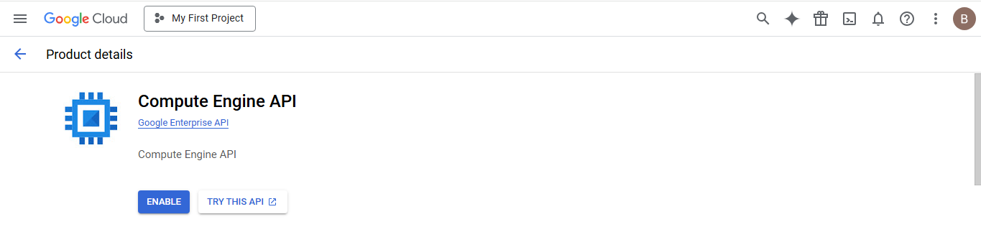

Navigate to compute engine->VM Instances

Click on create instance

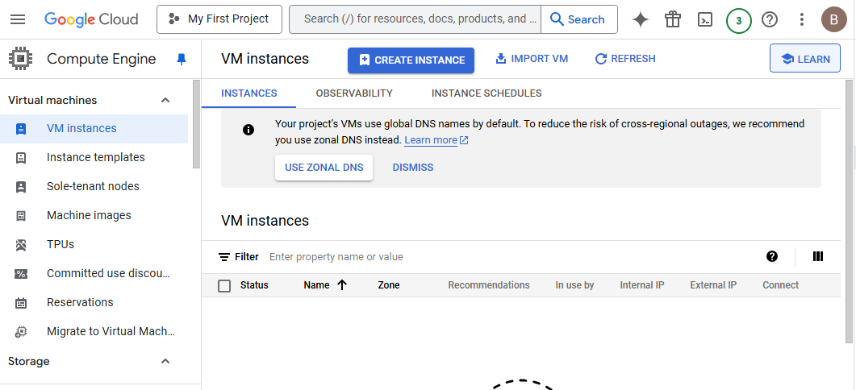

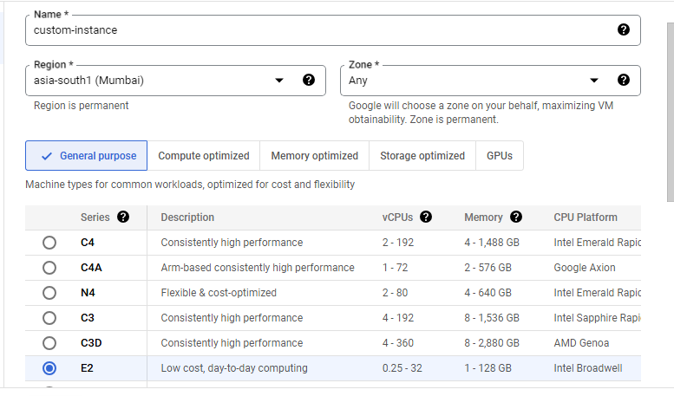

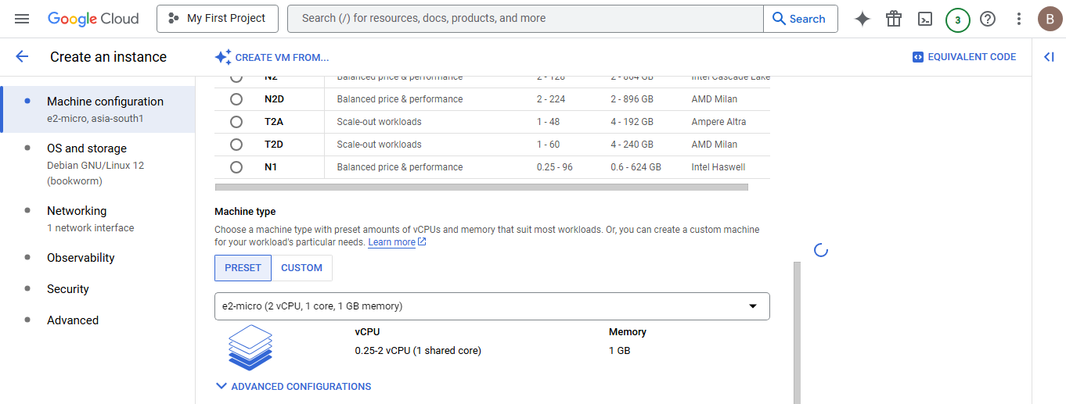

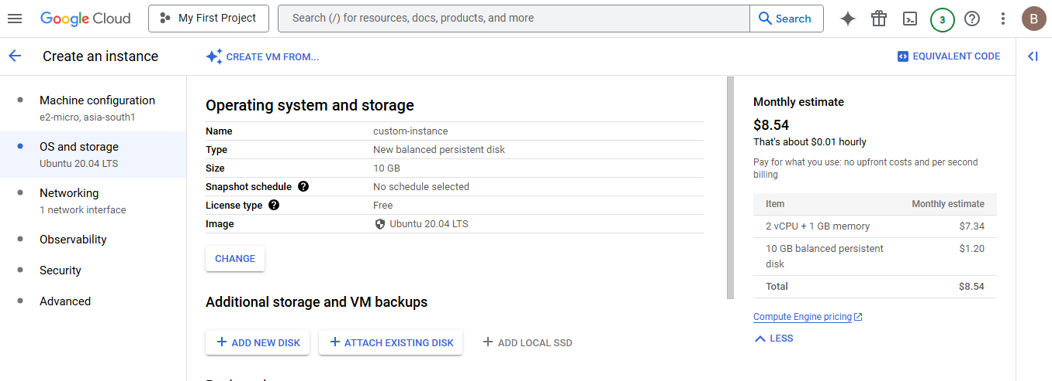

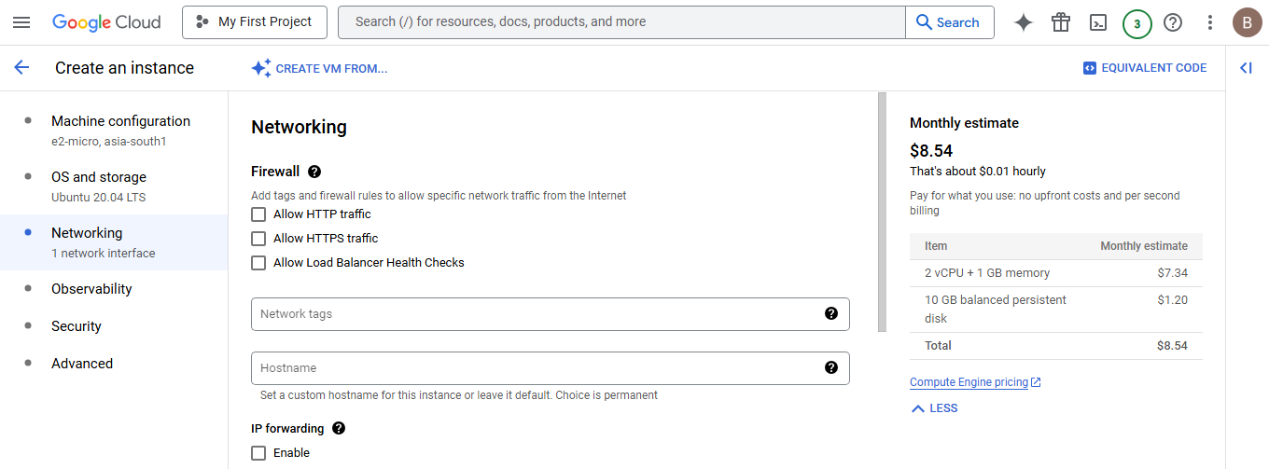

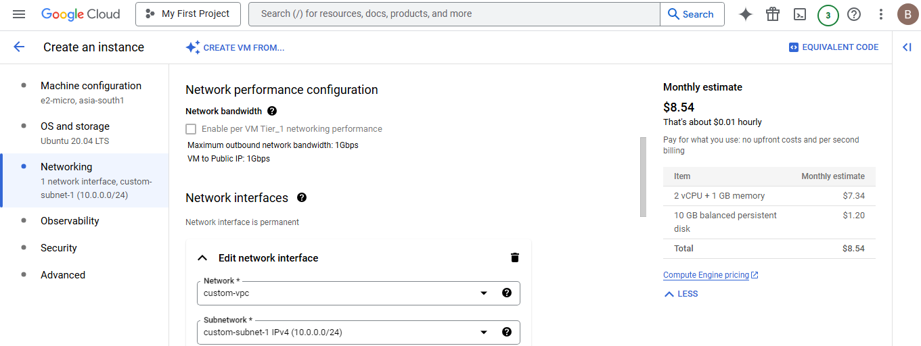

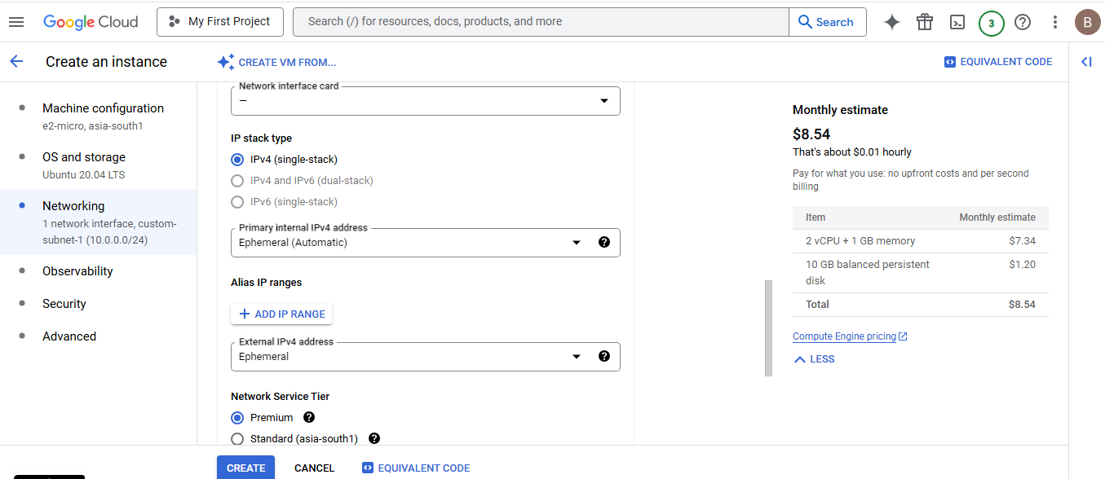

Click on done

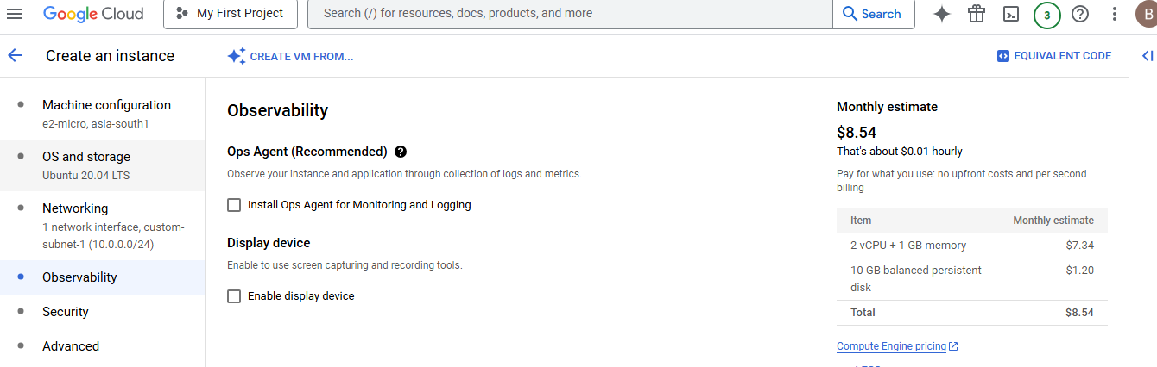

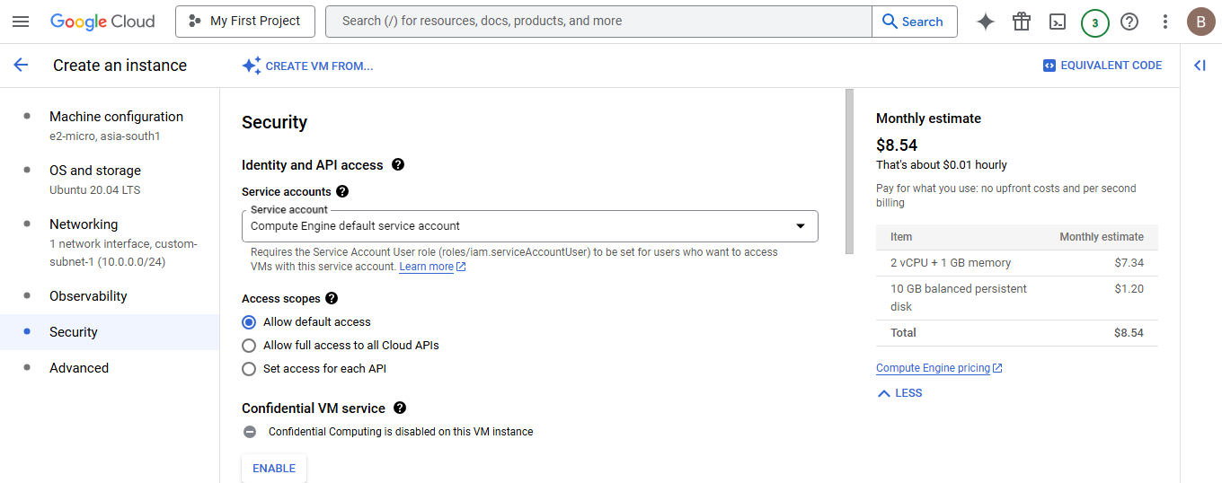

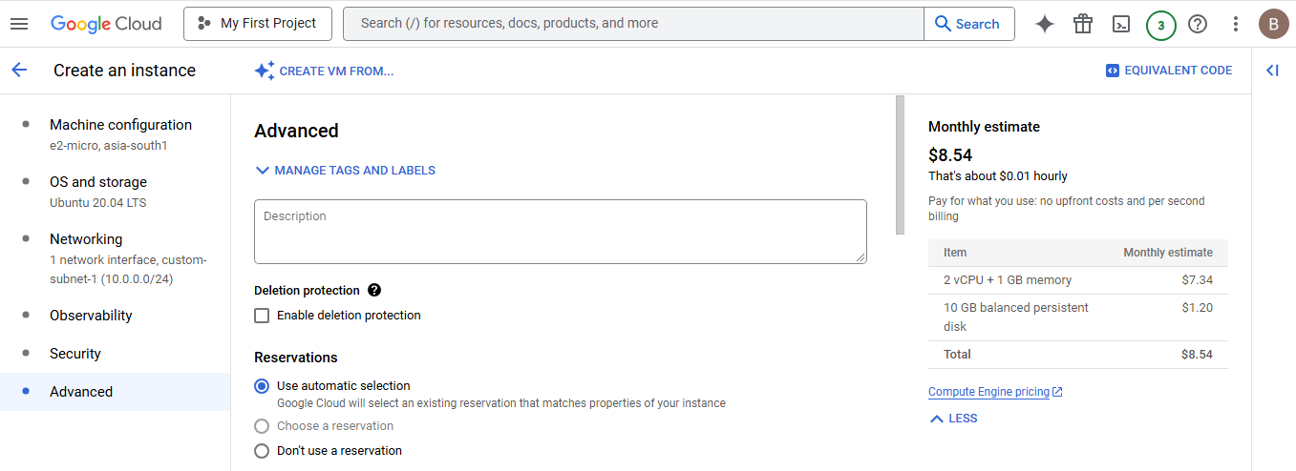

Add below Start-up Script in automation:

#!/bin/bash

# Update package list

sudo apt update -y

# Install Apache2

sudo apt install apache2 -y

# Start Apache2 service

sudo systemctl start apache2

# Enable Apache2 to start on boot

sudo systemctl enable apache2

# Get the private IP address

PRIVATE_IP=$(hostname -I | awk '{print $1}')

# Get the public IP address (if available)

PUBLIC_IP=$(curl -s ifconfig.me || echo "Not Available")

# Create a simple webpage displaying the IP addresses

cat <<EOF | sudo tee /var/www/html/index.html

<html>

<head>

<title>GCP VM IP Addresses</title>

</head>

<body>

<h1>GCP VM IP Addresses</h1>

<p><strong>Private IP:</strong> $PRIVATE_IP</p>

<p><strong>Public IP:</strong> $PUBLIC_IP</p>

</body>

</html>

EOF

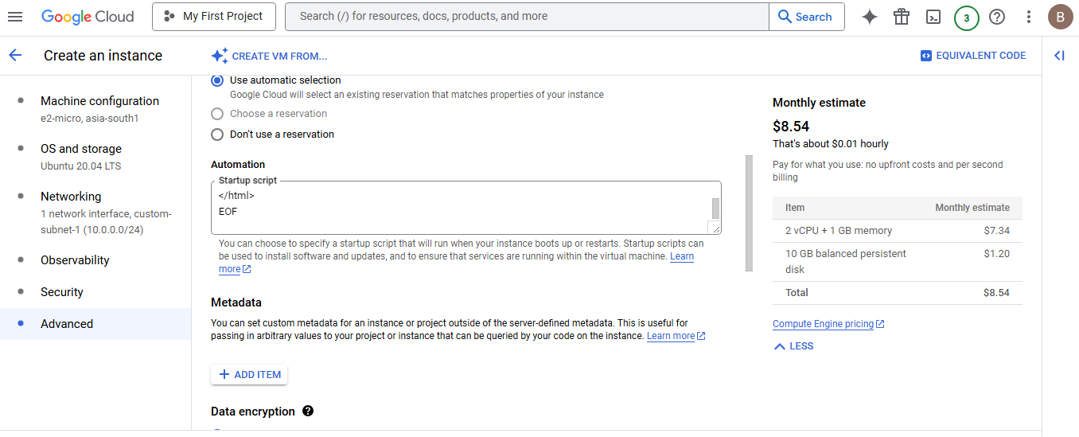

Click on create.

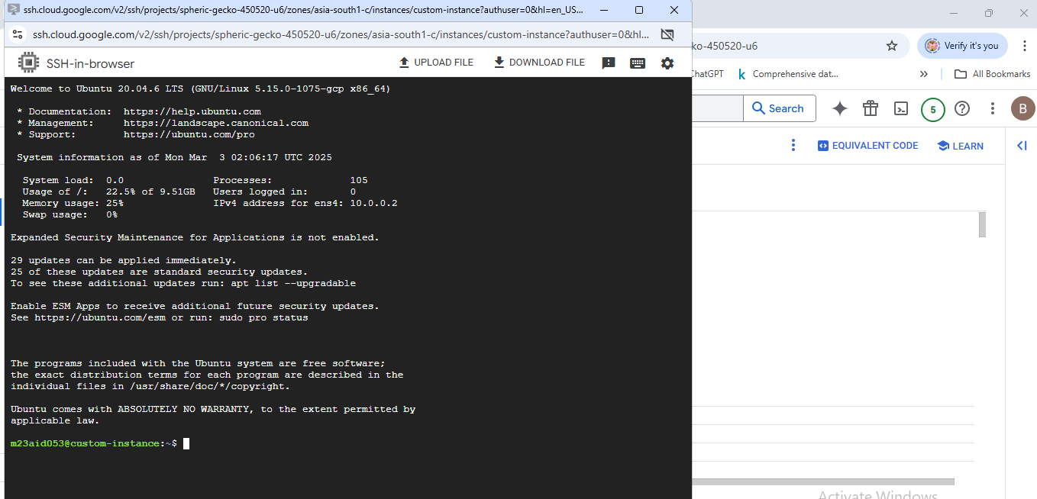

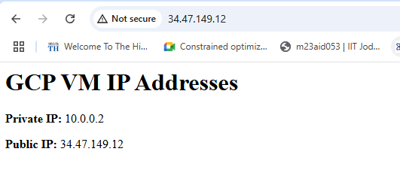

**Auto scaling**

Create instance template

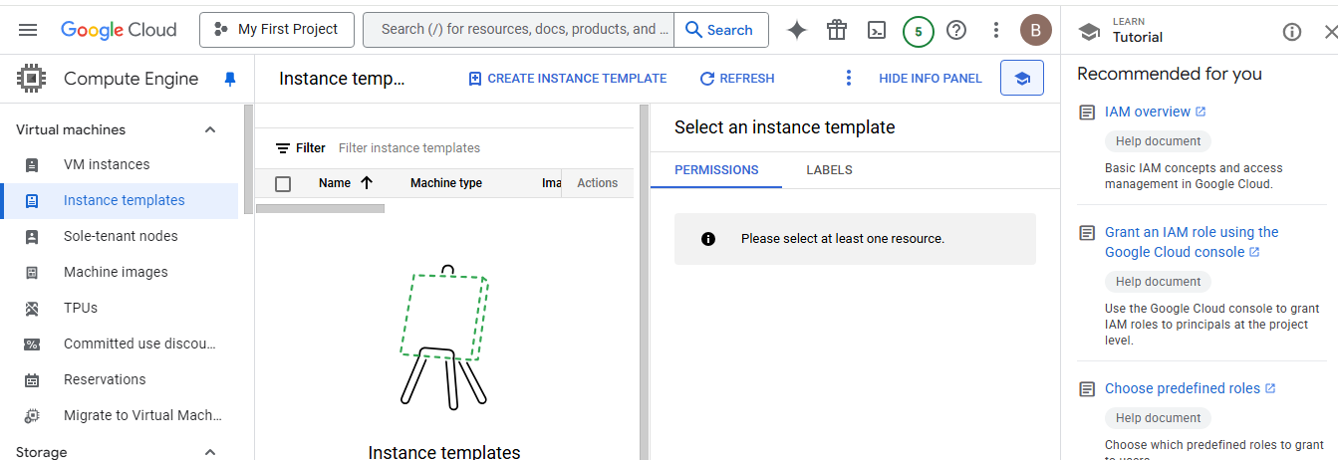

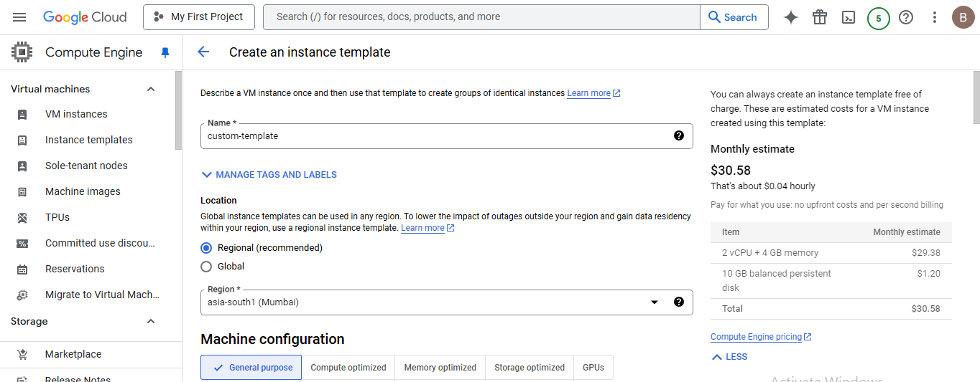

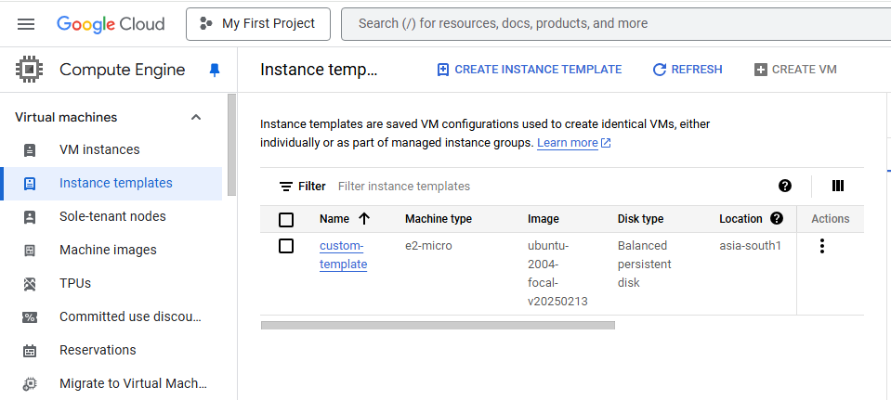

Create instance group

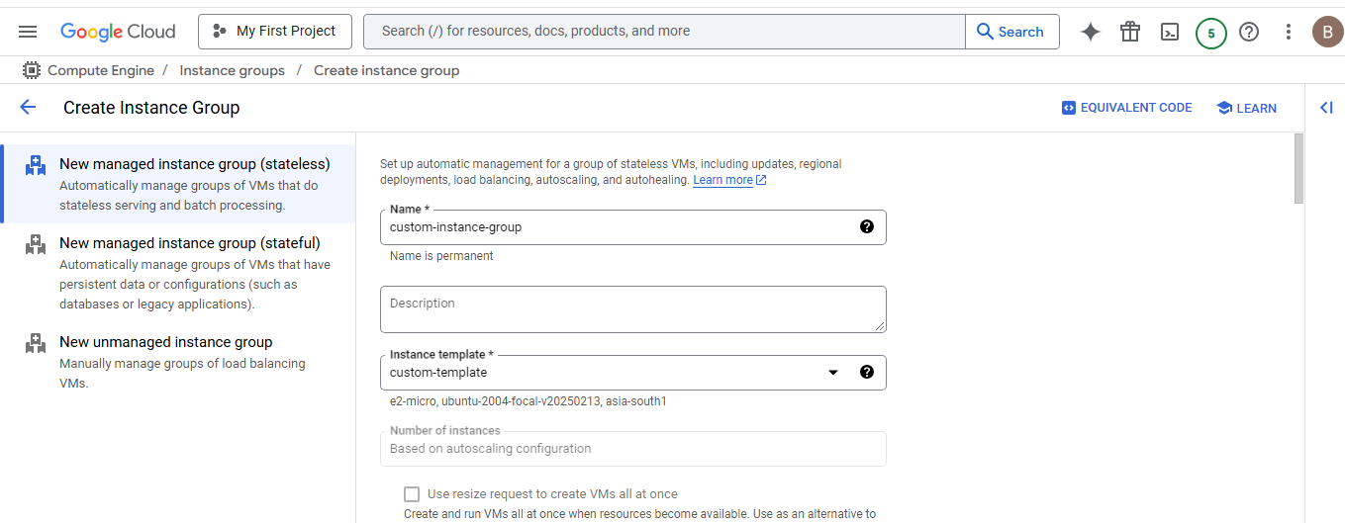

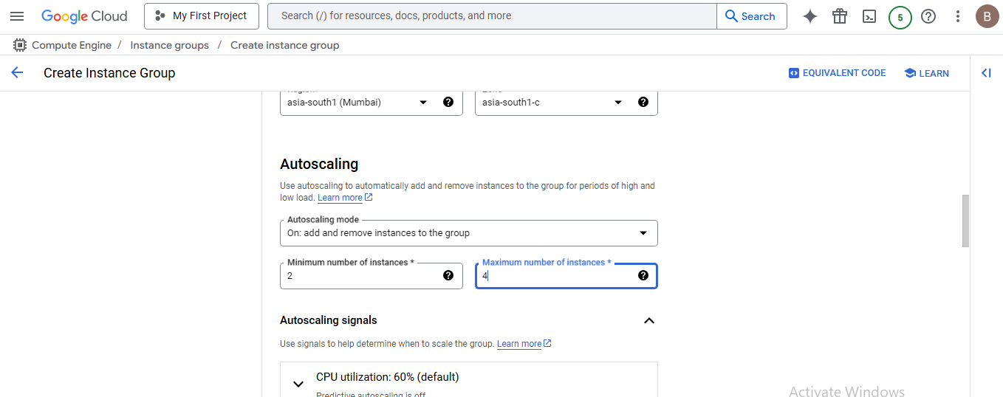

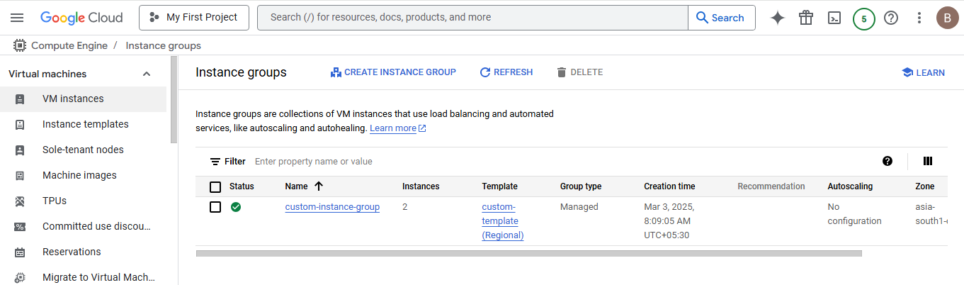

**Create VPC Network:**

Navigate to VPC network and click on create VPC network

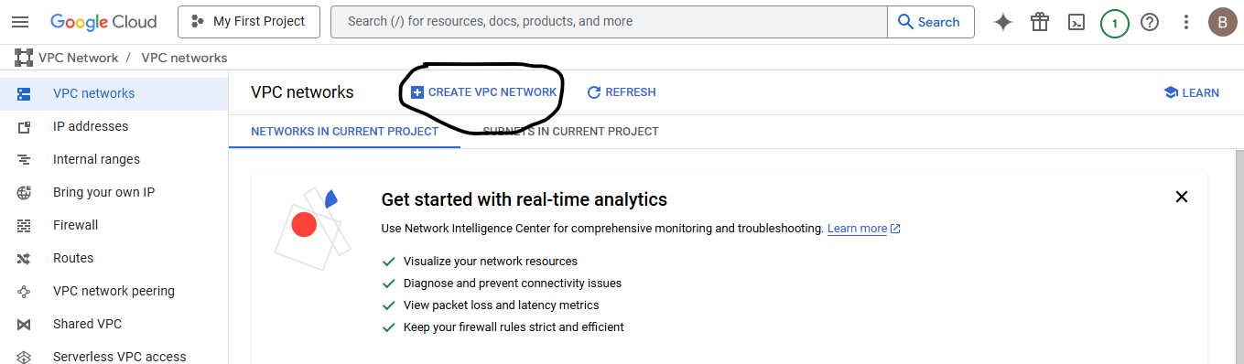

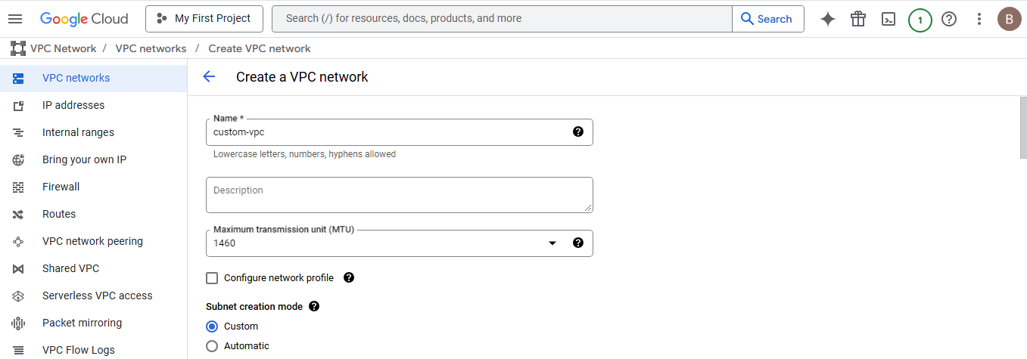

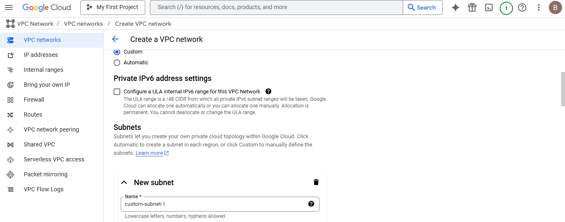

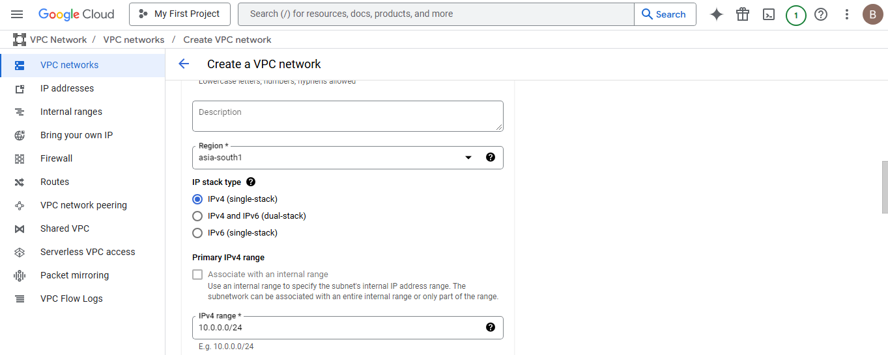

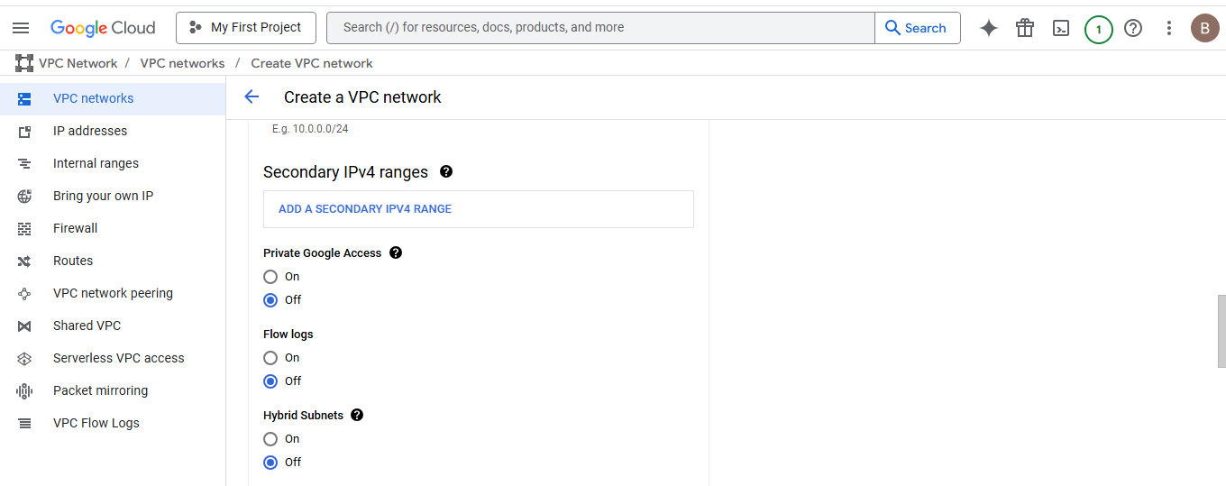

**Click on done**

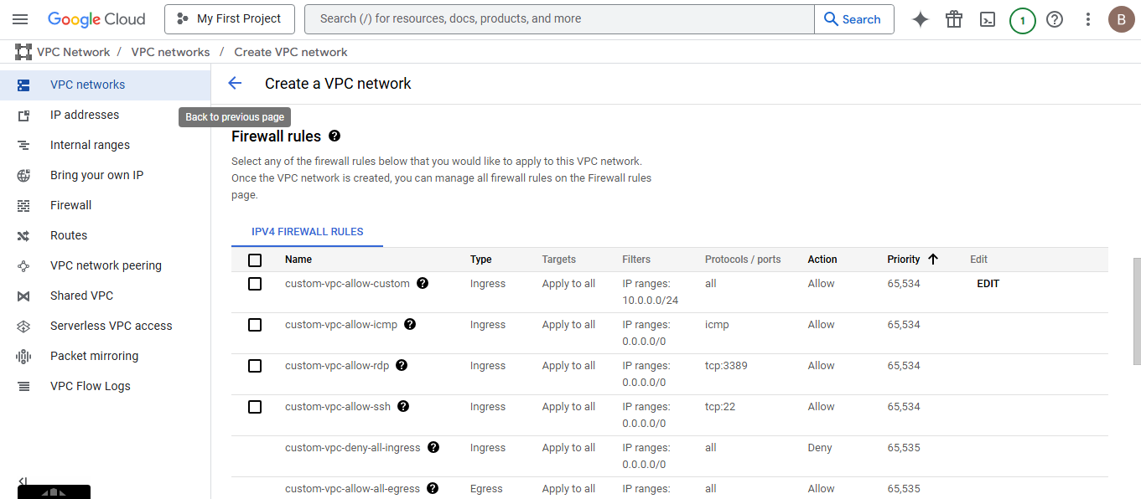

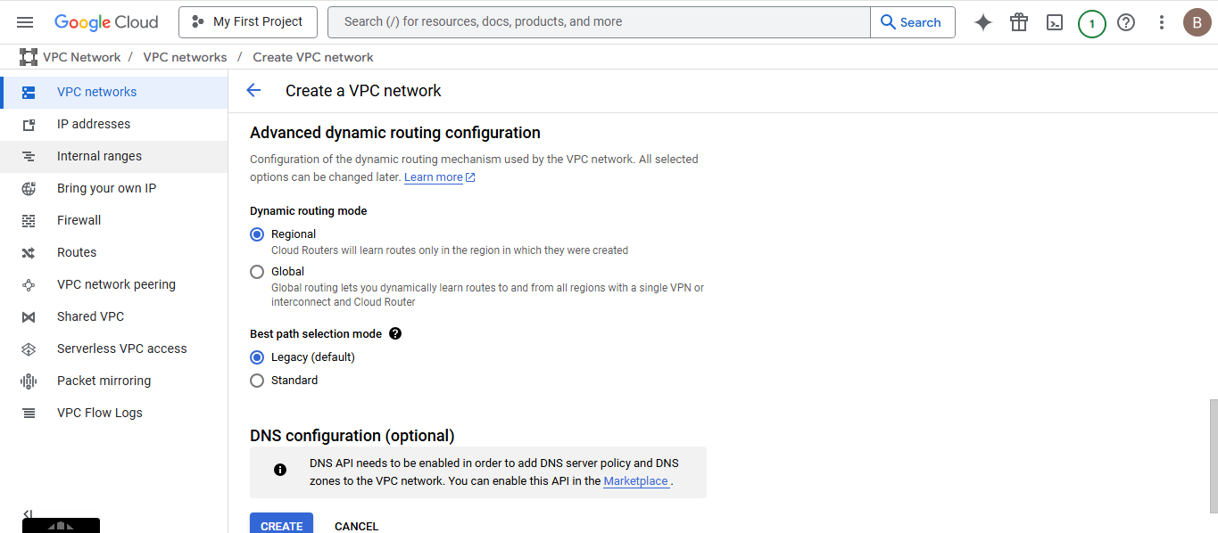

**Select create.**

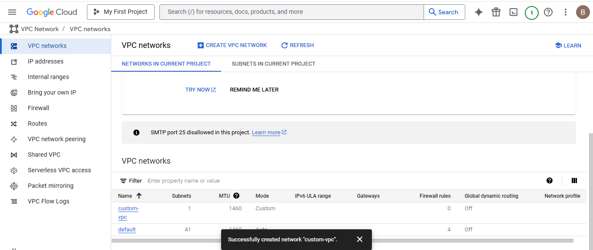

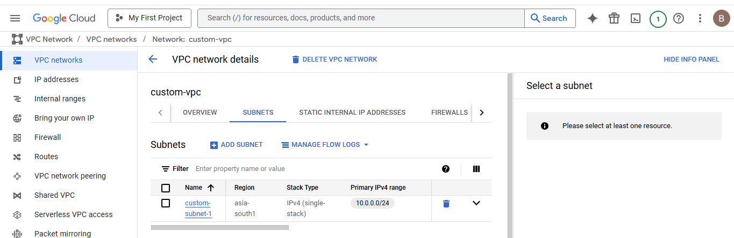

**Create Firewall:**

Click on add firewall rule and create firewall rule for ssh access

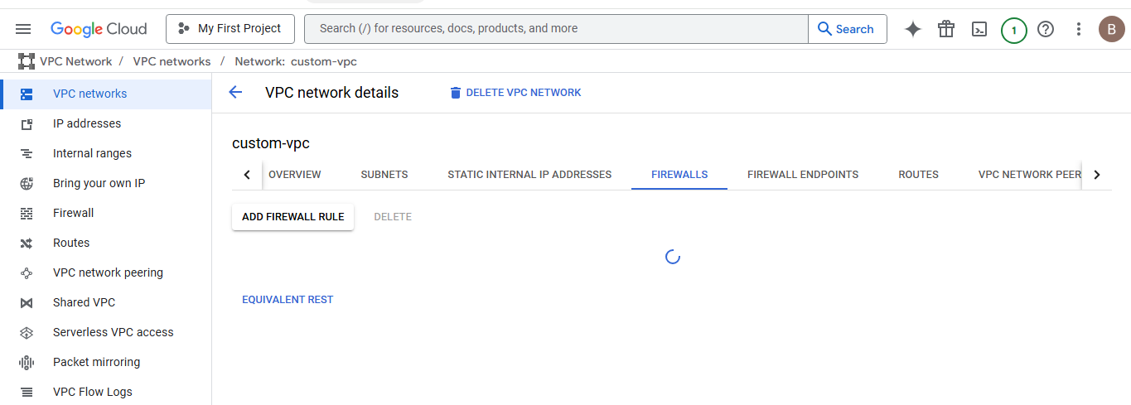

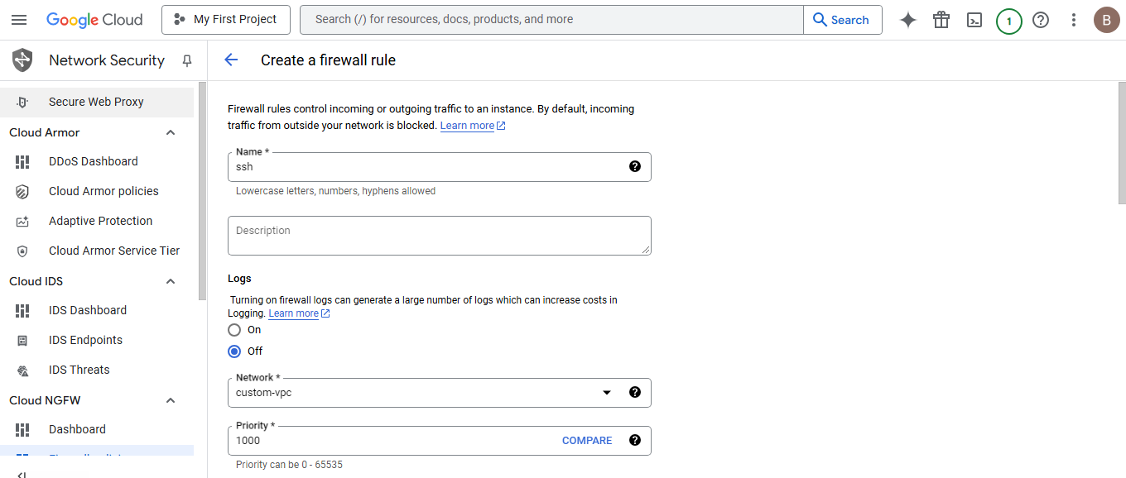

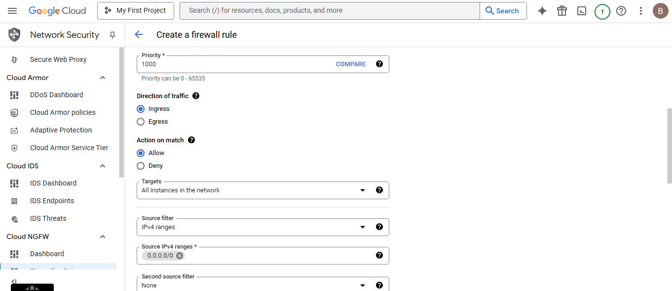

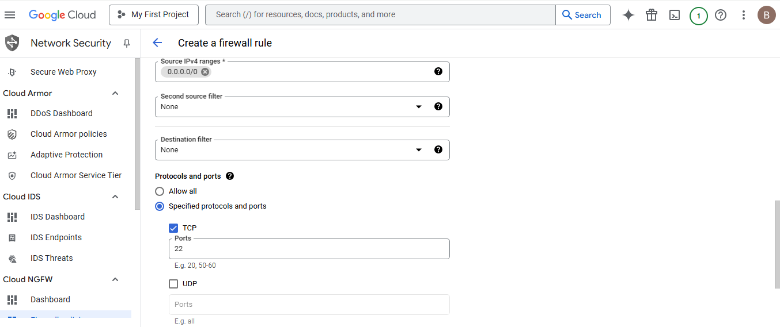

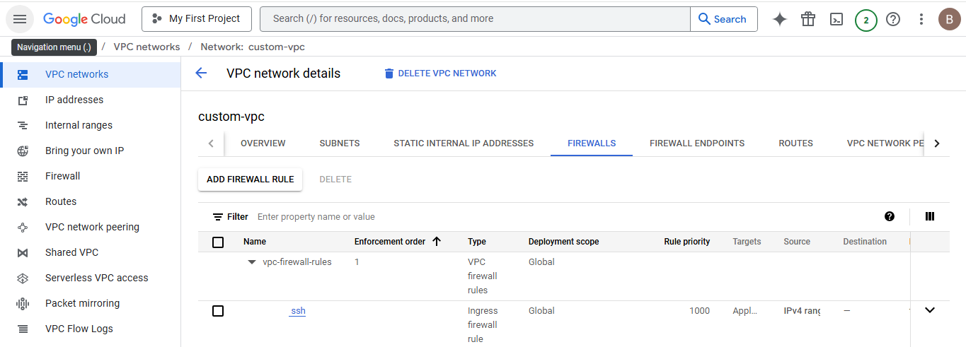

**Then click on create**

Click on add firewall rule and create firewall rule for apache2 access

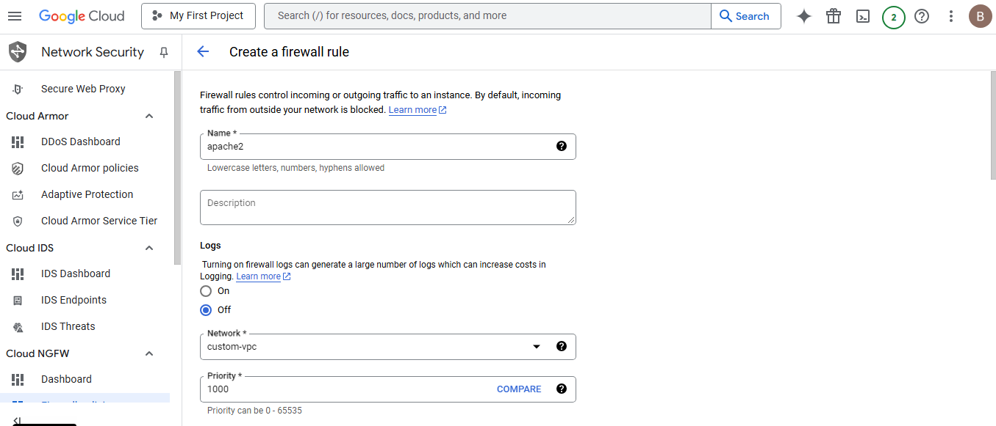

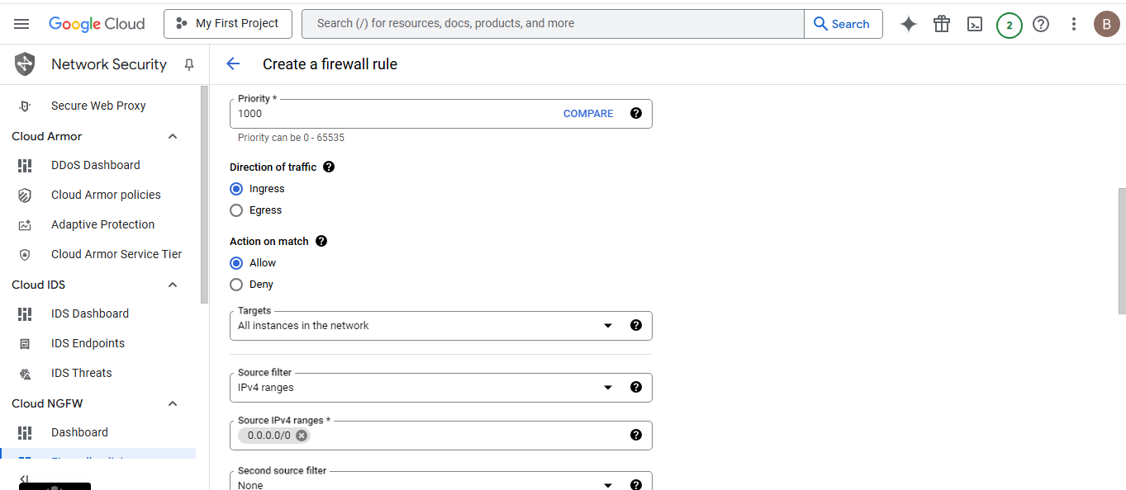

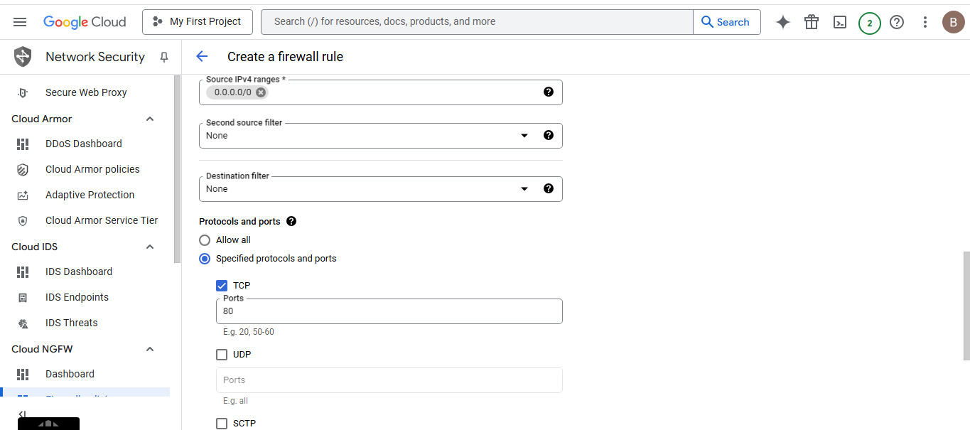

Then click on create

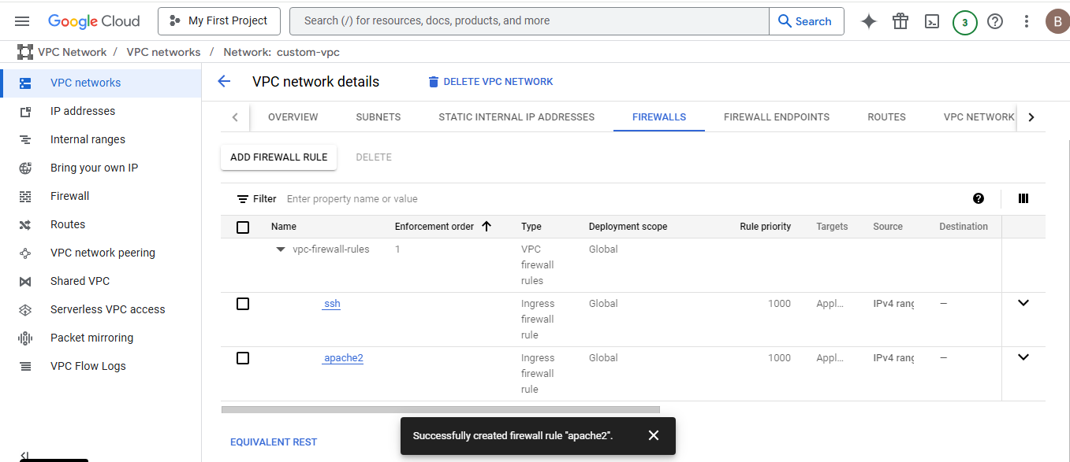

IAM –Access and permission

