Collection
Need of Collection:
Array
- an array is an indexed collection of fixed number of homogeneous data elements
- the main advantage of arrays is we can represent multiple values with a single variable
- so that reusability of the code will be improved

Limitation of Object type Arrays:
- arrays are fixed in size i.e once we created an array with some size there is no chance of increasing or decreasing it size based on our requirement.
- hence to use arrays compulsory we should know the size in advance which may not possible always.
- arrays can hold only homogenous data elements,
eg: Student[] s = new Student[10];
s[0]=new Student();//correct
s[1]=new Customer();// wrong
- but we can fix this above problem using object arrays.
Object [] o =new Object[10[;
o[0]=new Student();
o[1]= new Customer();
- Arrays concept is not implemented based on some standard data structure hence readymade method support is not available for every requirement we must write the code explicitly. which is complexity of programming.
- to overcome the above limitation of arrays we should go for Collections
- collections are growable in nature, i.e based on our requirement we can increase/decrease the size
- collection can hold both homogeneous /heterogeneous elements
- every collection class is implemented based on some standard data structure. hence readymade method support is available for every requirement. being a programmer we have to use this method and we are not responsible to provide implementation.

Collection:
- collection represents group of individual objects as a single entity
- group of classes/interfaces used to represent group of individual object as a single entity

Overview of Collection:
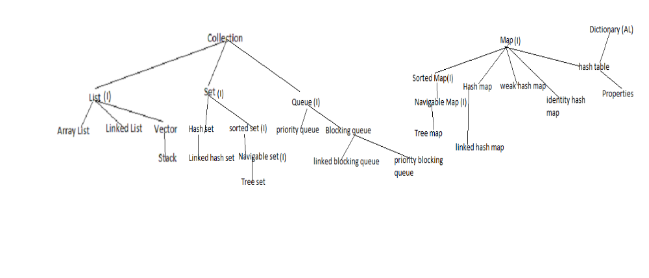
sorting
1.comparable(I) - default nature sorting order
2.comparator (I) - customized sorting order

Cursors - to fetch object one by one from collections
1.Enumeration(I)
2.Iterator(I)
3.List Iterator(I)

Utility classes
1.Collections - to define several utility methods for collection objects
2.Arrays - to defines several utility methods for Array objects

9 key Interfaces of collection framework:
1. Collection
- if we want to represent a group of individual obj as a single entity then we should go for collection
- collection i/f contains most common methods which are applicable for any collection object
- there is no concreate class which implements collection i/f directly

2.List
- it is child interface of collection interface
- if we want to represent a group of individual objects as a single entity where duplicates are allowed and insertion order preserved then we should go for List.
- we can differentiate duplicated by using index
- we can preserve insertion order by using index, hence index play very important role in list interface
- implemented class : Array list , linked list, vector -> stack
3.Set
- it is child interface of Collection interface
- if we want to represent group of individual objects as a single entity where duplicates are not allowed, and insertion order not preserved then we should ho for Set
- it does not contain any new methods.so we have to use collection interface methods only.
- Implementation class for set is hashset, linked hashset(implements hash set)
4.Sorted Set
- it is the child interface of Set
- if we want to represent group of individual objets as a single entity where duplicates are not allowed but all objects should be inserted according to some sorting order then we should go for SortedSet
5.Navigable Set
- it is child interface of Sorted Set
- it defines several methods for navigation purposes
- child class is Tree set

6.Queue
- it is child interface of collection
- if we want to represent a group of individual objects prior to processing then we should go for queue
- eg: before sending a mail all mail id's we have to store somewhere and in which order we saved in the same order mail's should be delivered (First in First Out) for this requirement queue concept is the best choice
- child classes are 1. priority queue 2. blocking queue
- blocking queue has two child classes 1. linked blocking queue 2. priority blocking queue

7.Map
- if we want represent a group of objects as key value pairs then we should go for map interface
- it is not child interface of collection Interface
- both key and values are objects, duplicated keys are not allowed but values can be duplicated
- each key value pair is known as entry.
- Hence, map is considered as collection of entry objects

8)Sorted Map
- it is the child interface of map
- if we want to represent a group of key value pairs according to some sorting order of keys then we should go for sorted map
- sorting is based on the key not based on value.
9)Navigable Map
- it is child interface of sorted map
- it defines the several utility methods for navigation purpose
- child class is tree map

Important Methods of Collection Interface:
1. boolean add(Object o) - add object o
2.boolean addAll(Collection c) - add group of objects collection c into current collection
3.boolean remove(Object o) - remove object o from current collection
4. boolean removeAll(Collection c) - remove collection c
5. void clear()- remove all objects
6.boolean retainAll(Collection c) - except collection c all the remaining objects are removed
7.boolean isEmpty()- to check my collection is emplty or not
8.int size() - to find the size of collection
9.boolean contains(Object o) - to check collection contains object o or not
10.boolean containsAll(Collection c)- to check group of objects collection c available or not
11.Object[] a= c.toArray(); - to convert collection c to array and return type is object array
12.Iterator iterator() - to get objects one by one from collection. return type by default is Iterator type
Note:
1. Collection Interface doesn't contain any method to retrieve objects .
2. there is no concreate class which implements collection Interface directly

Methods of List Interface:
1.add(int index, Object o) - to add object in index
2.addAll(int i, Collection c)- to add group of objects in specified index i
3.remove(index i)- remove the object o in the specified index
4.l.indexOf("A"); - find the first occurance of "A"
5. l.lastIndexof("A") - find the last occurance of "A"
6. get(index i) - return the element specified in index.if no obects return null.
7.ListIterator listIterator - to get the objects one by one.return ListIterator objects.
8.set(int index,object o)- replave the element locating the index i with object o
Classes of List Interface:
1. Array List
- this is the first implementation class of List
- underlying Data structure for array list is resizable array or growable array
- duplicates are allowed
- insertion order preserved
- heterogeneous objects are allowed, except tree set, tree map everywhere heterogeneous allowed
- null insertion is possible

Constructor:
1. ArrayList al = new ArrayList()
- Creates an empty array list object with default initial capacity 10.
- once array list is reaches its max capacity , new AL object will be created with
new capacity = (current capacity *3/2)+1 = 16
2. ArrayList al = new ArrayList(int initialCapacity);
- it is used to create arraylist object with initial capacity eg: if we want create 1000 obj we can use this constructor
3.ArrayList l = new ArrayList(Collection c)
- we can create array list for any collection objection. it is used for inter conversion like linked list to AL , vector to AL,treeset to AL

Note:
1.Usually we can use collections to hold and transfer objects from one place to another place, to provide support for this requirement every collection class by default implements serializable , clonable interfaces.
2. Interface does not contain any method is known as marker interface. eg: RandomAccess
3.RandomAccess present in java.utill package
4.ArrayList and vector classes implements RandomAccess Interface so that we can access our Random element with same speed.
5.Hence if our frequent operation is retrieval operation then array list is the best choice
6.if our frequent operation is add/remove element in middle then Array list is worst choice. because several shift operations are require

Difference b/w Array List & Vector:
ArrayList :
1. every method is present in array list is non synchronized
2.multiple threads are allowed to operate on ArrayList obejct.so it is not thread safe
3.perfomance is relatively high
4.1.2 v . so it is non legacy
Vector:
1. most of the methods are synchronized
2.at a time only one thread allow to operate on vector object.so it is by default thread safe.
3.performance is low
4. introduced in 1.0 so it is legacy class.

Note:
AL al= new AL(); - non synch
List l = Collections.synchronizedList(al); - synch
now l is synchronized list .
syntax: public static List synchronizedList(List l)
similarly we can get synchronized hash map and hash set also
syntax:
public static Set synchronizedSet(Set s)
public static Map synchronizedMap(Map m)

2.Linked List :
- the underlying Data structure is Double linked list
- insertion order is preserved
- Duplicates are allowed
- Heterogeneous Objects are allowed
- Null insertion is possible
- it implements serializable, cloneable Interfaces(every collection class implements)
- but it is not implements RandomAccess Interface
- it is worst choice if our frequent operation is retrieval(search)
- it is best choice if our frequent operation is insertion/deletion in middle
- usually we can use linked list to implement stacks and queues to provide support for this requirement LinkedList class defines following specific methods.
Methods:
- void addFirst();
- void addLast();
- Object getFirst();
- Object getLast();
- Object removeFirst();
- Object removeLast();

Constructors:
reserving memory capacity is not applicable here. so there is no initial/default capacity
- LinkedList l = new LinkedList(); - create empty linked list
- LinkedList l = new LinkedList(Collection c); -- for given collection creates equivalent LinkedList

3.Vector:
- the underlying data structure for the vector is resizable array or growable array
- duplicate objects are allowed
- insertion order is preservd
- null insertion is possible
- Hetrogeneous objets are allowed
- vector class impleemnts serialaizable, Clonable and RandomAccess Interfaces
- Most of the methods present in vector are synchronized. Hence Vector Object is thread-safe
- Best choice if the frequent operation is retrieval.
Methods:
- add (Object o) - available in Collection
- add(int index, Object o); - available in List
- addElement (Object o) - available in vector
- remove (Object o) - available in Collection
- clear() - available in collection
- remove(int index) -available in list
- removeElement(Object o)- available in vector
- removeElementAt(int index) -available in vector
- removeAllElements() -available in vector
- Object get(int index) - available in collection
- Object elementAt(int index) - available in vector
- Object firstElement() -available in vector
- Object lastElement() - available in vector
- int size()
- int capacity();
- Enumentation elements(); -available in vector

Constructors:
1.Vector v= new Vector();-- default initial capacity - 10
new capacity = 2*current capacity = 2* 10 = 20
2. Vector v = new Vector(int initialCapacity); -- create vector with specified capacity
3.Vector v = new Vector (int initialCapacity, int incrementalCapacity)
in 2 nd constructor if initial capacity is 1000 , after 1000 if i want to add 2 elements internally size will be double bcz of (2* cureentCapacity). so to overcome this issue we can specify our own incremental capacity
4. Vector v = new Vector (Collection c); -- create vector for any collection object

4. Stack
- it is a child of vector
- insertion order preserved
- it is specially designed for Last in First Out order (LIFO)
Construcotrs:
1. Stack s- new Stack();

Methods:
1.push(Object o) -- to inset the element
2. pop() -- to retrive and remove object from top of stack
3.peek() -- to retrive the object object from top of stack (not delete)
4.empty() -- to check stack is empty or not
5.search("A")-- returns offset- position object in stack

Cursors:
to retrieve elements one by one from the collection
types:
1.Enumeration
2.Iterator
3.ListIterator

1.Enumeration:
- introduction in 1.0 version (for Legacy)
- We can use Enumeration to get Objects one by one from the old Collection Objects (Legacy Collection)
- we can create enumeration object by using elements() method of vector class
Public Enumeration elements ();
Example:
Enumeration e = v.elements();
Methods:
1. public boolean hasMoreElements()
2. public Object nextElement();
Limitations:
- enumeration concept is applicable only for legacy classes and hence it is not a universal cursor
- By using enumeration, we can move only towards forward direction and we can't move to the backward direction, and hence these are single direction cursors.
- By using Enumeration, we can get only read access and we can't perform remove operation
- to overcome above limitation, we should go for Iterator

2.Iterator
- it is universal cursor
- by using iterator we can perform both read and remove operation
method signature:
Public Iterator iterator();
eg: Iterator itr=c.iterator();//-- c- any collection objects
Methods:
1. public boolean hasNext()
2. public Object next();
3.public void remove();

Limitations:
1. By using iterator we can move only towards forward direction and we can't move to the backward direction, and hence these are single direction cursors.
2. By using iterator we can perform only read and remove operation and we can't perform replacement of new objects
to overcome above limitations of iterator we should go for ListIterator

3.List Iterator:
- By using list iterator we can move either to the forward direction or to the backward direction and hence list iterator is bidirectional cursor
- By using list iterator we can perform replacement and additional of new objects in addition to read and remove operations
method signature:
Public ListIterator listIterator() -- available in list interface
eg: ListIterator ltr = c.listIterator(); - c any list object

Methods:
- list iterator is child interface of iterator. so all iterator methods applicable for list iterator
1. public boolean hasNext();
2. public Object next();
3. public int nextIndex();
4.public boolean hasPrevious()
5.public Object previous()
6.public int previousIndex();
7.public void remove();
8.public void set(Object new);
9.public void add(object new);

Limitation:
it is only applicable for list implemented class objects and it is not a universal cursor

Comparison of 3 cursors:
Enumeration:
1.applicable only for legacy classes
2.move only forward direction - single directional cursor
3. only read access
4. Elements() of vector class
5. 2 methods
6.legacy -1.0 version
Iterator:
1.applicable for any collection object
2.move only forward direction - single directional cursor
3.both read and remove operation
4. Iterator() of collection Interface
5. 3 methods
6.non legacy - 1.2 version

List Iterator:
1.only for List implements classes
2.move both forward , backward direction - bi-directional cursor
3.access to read,remove, add,replace of objects
4.listIterator() of List interface
5. 9 methods
6.non legacy -1.2 version

Implementation of classes of Cursor Interfaces:
Enumeration e= v.elements()
here inside vector class v we have elements() , we have inner class which implements Enumeration Interface, this object only going to return
it is applicable for other iterator also.

Classes Of Set:
1.Hash Set
- underlying data structure for hash set is hash table
- duplicates are not allowed
- if we add duplicated it won't throw any compile time/ run time exception. new object will not be added and add method returns false
- insertion order not preserved. and all objects inserted based on hashcode value of objects
- heterogeneous objects are allowed
- null insertion possible(Verfied)
- implements serializable/clonable interfaces. not Random Access interface
- if our frequent operation is search it is best choice because of hash code used to store the objects

Constructor:
1.HashSet h = new HashSet();
with default initial capacity- 16 and
default fill ratio/load factor : 0.75. which means after filling 75% of hash set the new hash set object is going to be created
2..HashSet h = new HashSet(int initialCapacity);
create hashset object with specified initial capacity and default load factor 0.75

3.HashSet h = new HashSet(int initialCapacity, float loadFactor);
create hash set object with specified initial capacity and load factor
4.HashSet h = new HashSet(Collection c);

2.Linked HashSet
- child class of hash set
- introduced in 1.4 v
- duplicates are not allowed
- insertion order is preserved
- it is the best choice to develop cache-based applications, where duplicates are not allowed and insertion order must be preserved.

difference between hash set and linked hash set
Hash set:
1. underlying data structure is HashTable
2.insertion order not preserved
3.introduced in 1.2 v

Linked HashSet
1. underlying data structure is combination of HashTable and linked list
2.insertion order preserved
3.introduced in 1.4 v

Sorted Set
Methods:
eg:[100,101,102,103,104,105,106]
1. Object first() //first() // to get first element
2.Object last() //last() // to get last element
3. SortedSet headSet(object o) // headSet(104) // [100,101,102,103]
4. SortedSet tailSet(Object o) //tailSet(104) // [104,105,106]
5.SortedSet subSet(Object o1, Object o2) // subSet(102,105) // [102,103,104,105]
6.comparator() //return comparator object which describes underlying sorting technique.it returns null if we are using default natural sorting order

Note:
Default Natural Soring order:
1.numbers - Ascending
2. For string - alphabetical order
3.we can apply above methods only on sorted set implemented class objects that is on the tree set object
Tree Set:
1.underlying data structure is balanced binary search Tree
2.duplicates are not allowed
3.insertion order not applicable
4.inserted according to some sorting order
5.Hetrogenous objects are not allowed - throws RE ClassCast exception
6. null can't accept.

Constructor
1. TreeSet t = new TreeSet();
--- create empty treeset according to default natural sorting order
2.TreeSet t = new TreeSet(Comparator c);
-- create empty tree set object where elements created according to customized sorting order described by Comparator object
3.TreeSet t = new TreeSet(Collection c);
-- create tree set object for any specified c collection object
4.TreeSet t = new TreeSet(SortedSet s);
-- create tree set object for any sorted set object

Note: while inserting data, internally compareTo() is called to compare two values to identify where it should be place. hence
1.if we are depending on default natural sorting order then objects should be homogeneous and comparable. otherwise we will get runtime exception saying ClassCastException
2.An object is said to be comparable if and only if the corresponding class implements java.lang.comparable interface
3. String Class and all wrapper classes already implements comparable interface. but StringBuffer doesn't implement comparable interface.
Eg: String implements Comparable Interface but StringBuffer not implements Comparable

Comparable Interface:
1. this interface present in java.lang.package it contains only one method CompareTo().
public int CompareTo(Object obj)
eg:
obj1.CompareTo(obj2);
1. returns - ve- iff obj 1 has to come before obj2
2. returns +ve -iif obj1 ha to come after obj2
3.returns 0 - iff obj 1 and obj2 are equal

1.s.op.("A".compareTo("Z")); -ve
2.s.o.p("z".compareTo("B")); +ve
3. s.o.p("A".compareTo("A")) - 0
4.s.o.p("A".compareTo(null)); RE: Null point Exception

1. we depending on default natural sorting order internally JVM will call compareTo() method to inserting objects in the tree set. hence the object should be comparable
2.here obj 1 is new value, obj2 element already present in tree set
3. and obj 2 is the root element always
Treeset t = new TreeSet();
t.add("B"); // B is the root element.
t.add("Z"); // "Z".compareTo("B"); = +ve // B is root, z is child
t.add("A");// "A".compareTo("B"); = -ve // A is root B is child
s.o.p(t); // [A,B,Z]

Note:
1.if we are not satisfied with default natural sorting order or if the default sorting order is not already available then we can define our own customized sorting by using Comparator.
2. Comparable meant for Default Natural Sorting order whereas Comparator meant for customized Sorting order

Comparator (I)
1.it is used to define our own customized sorting.
2.comparator interface present in java.utill package
3.it defines 2 methods compare and equals

eg:1) public int compare(Object obj1, Object obj2);
1. returns - ve- iff obj 1 has to come before obj2
2. returns + ve -iif obj1 ha to come after obj2
3.returns 0 - iff obj 1 and obj2 are equal
eg 2: public boolean equals();

4. if we implements comparator interface it is mandatory to provide implementation for compare method,
5.and implementing equals() method is optional, because it is already available in every java class from object class through inheritance. every java class is direct / in direct child of object class

Eg:1. to insert integer value in descending order
import java.util.*;
class TreeSetDemo{
public static void main(String[] args){
TreeSet t = new TreeSet(new MyComparator()); ---line 1
t.add(10);// will insert directly no comparision for first element
t.add(0); // compare(0,10)= 1 // tree order - 10,0
t.add(15);// compare(15,10)= -1 // tree order - 15, 10,0
t.add(20);// compare(20,10)= -1 // in left side one more node 15 is ther so one more comparition. // compare(20,15) = -1 // tree order - 20,15,10,0
t.add(20);// compare(20,10)= -1 // compare(20,15)= -1//compare(20,20)= 0//since it return 0 it is duplicate and will not return// tree order - 20,15,10,0
S.o.p(t);//-[ 20,15,10,0]- size 4
}
}

class MyComparator implements Comparator{
public int compare (Object obj1, Object obj2){
Integer i1 = (Integer) obj1;
Integer i2= (Integer) obj2;
if(i1<i2)
return 1;
else if (i1>i2)
return -1;
else
return 0;
}
}

1. at line-1 if we are not passing comparator object then internally JVM will call CompareTo() method which meant for default natural sorting order (asc order)
o/p: [0,10,15,20]
2. if we are passing comparator object at line 1 then internally JVM will call compare() method which is meant for customized sorting. (Desc order).
o/p:[20,15,10,0]

2. Possible implementation of compare method:

public int compare (Object obj1, Object obj2){
Integer i1 = (Integer) obj1;
Integer i2= (Integer) obj2;
Return i1.compareTo(i2); //[0,10,15,20] asc order
return -i1.compareTo(i2);//[20,15,10,0] desc order
return i2.compareTo(i1);//[20,15,10,0] desc order
return -i2.compareTo(i1); //[0,10,15,20] asc order
return +1//[10,0,15,20,20] insertion order and it will allow duplicates also
return -1//[20,20,15,0,10] reverse of insertion order and accepts duplicates also
return 0; [10] // only first element will be inserted and all the other elements are considered as duplicates
}

3. insert string buffer objects in asc order
TreeSet t =new TreeSet(new MyComparator());
t.add(new StringBuffer("A"));
t.add(new StringBuffer("Z"));
t.add(new StringBuffer("K"));
t.add(new StringBuffer("L"));

class MyComparator implements Comparator{
public int compare(Object obj1, Object obj 2)
{
String s1= obj1.toString(); // if internal object (obj1 value) is string we can do type casting , but here internal object is string buffer. so we are converting it to string
String s2= obj2.toString();
return s1.compareTo(s2);

o/p: [A,K,L,Z]
Note: if we are defining our own sorting by Comparator, the objects need not be comparable.

4. write a program to insert String/string buffer objects into the treeset where sorting order is inserting length order if 2 objects having same length then consider their alpha order
TreeSet t =new TreeSet(new MyComparator());
t.add("A");
t.add(new StringBuffer("ABC"));
t.add(new StringBuffer("AA"));
t.add("XX");
t.add("ABCD");
t.add("A");
s.o.p(t);

class MyComparator implements Comparator{
public int compare(Object obj1, Object obj 2)
{
String s1= obj1.toString();
String s2= obj2.toString();
in l1= s1.length();
int l2- s2.length();
if(l1<l2)
return -1;
else if(l1>l2)
return 1
else
return s1.compareTo(s2);
}
}

Note:
1.if we are depending on default natural sorting order then obj should be homogeneous and comparable. otherwise we will get runtime exception saying classcastexception
2.but if we are defining our own sorting by comparator then objects need not be homogenous and comparable. we can insert hetrogenous not comparable objects also

5.
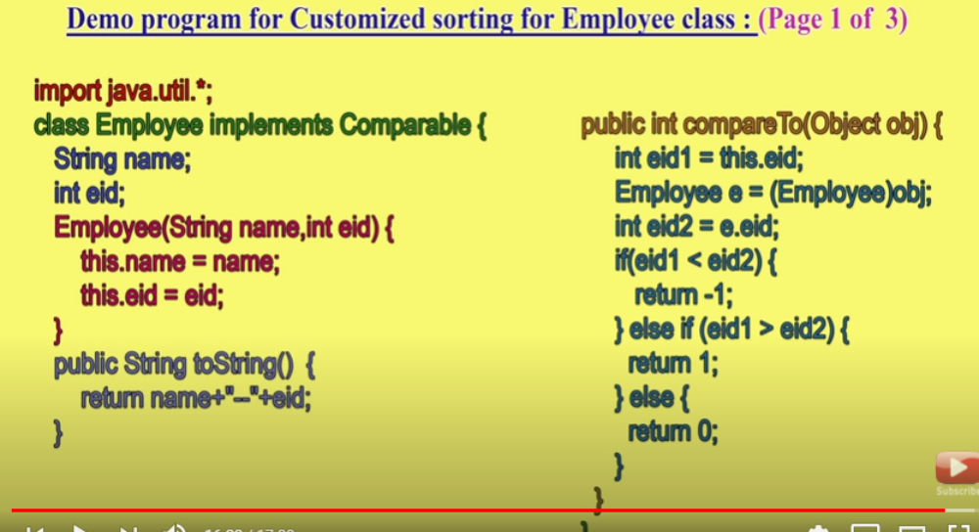

when we can go for comparable/comparator
1.for predefined Comparable classes like string default natural sorting order already available. if we are not satisfied with that, we can define our own sorting by comparator object.
2.for predefined non comparable classes like StringBuffer, default natural sorting order is not already available. We can define required sorting by implementing comparator interface
3. For our own classes like Employee,Student,Customer), the person who is writing our own class he is responsible to define default natural sorting order by implementing comparable interface
the person who is using our class if he is not satisfied with default natural sorting order then he can define his own sorting by using comparator
difference b/w comparable and comparator

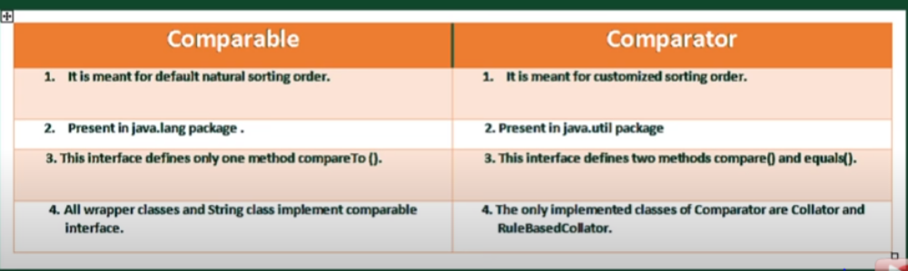

comparision of 3 set
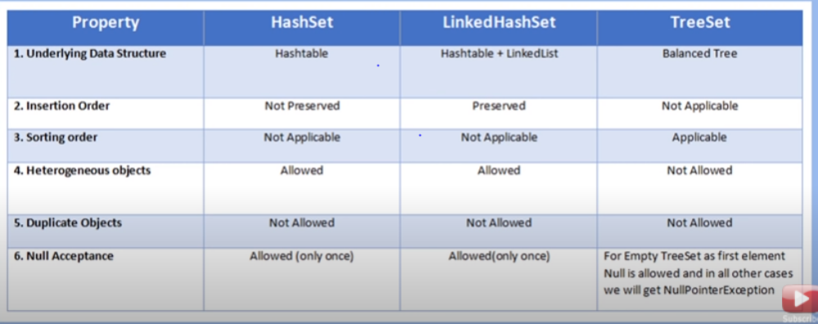

Methods of Map Interface:
1.put(Object key, Object value)
- it is used to add one entry at a time
- method signature: Object put (Object key, Object value)
- here object is (return value) replaced value for given key
- if key is not exist key value inserted and put method returns null
- if key exist replace the exist key value with new value and put method returns old value
eg: m.put(101,durga);//null
m.put(102,"shiva")//null
m.put(101,"Ravi")//durga
here durga replaced with ravi and returns durga
2. void putAll(Map m)
- allow to add group of key , value pair in map
- return type void
3. Object get(Object key) - get the value for given key. return null if no key// return type Object
4. Object remove(Object key) // remove the entire entry // return type object
5.boolean containsKey(Object key)// to verify whether key available or not//reurn type boolean
6 boolean containsValue(Object value)// to verify particular value available or not// return type boolean
7. boolean isEmpty() // check map is empty or not
8. int size(); // to get size of the map
9.void clear() // all entries will be removed

collection views of map
l0. Set keySet() // returns only keys stored in map. since set not allowed duplicate. in map keys are not duplicated. hence return type is set
11. Collection values()// returns values stored in map
12.Set entrySet()// returns entry set( both key, value) stored in map

Entry(I)
- A Map is a group of key value pairs. each key value pair is called an Entry. hence map is considered as a collection of entry objects.
- without existing map objects there is no chance of existing Entry object
- hence Entry interface is defined inside the Map interface.

Interface Map{
Interface Entry{
Object getKey(); // to get key of entry
Object getValue();// to get value of entry
Object setValue(Object new);// to set new value for entry
}
}
HashMap
- it is implements Map interface
- underlying Data structure for HashMap is Hashtable
- insertion order not preserved and order is based on hash code of keys
- duplicate keys are not allowed but duplicate values are allowed
- heterogeneous allowed in both key and values
- only one null key accepted , multiple null values accepted(any number of times. If we add multiple keys the values are ovveride)
- Implements serializabe, Clonable but not RandomAccess Interface
- hash map is best choice if our frequent operation is search.

Constructor:
1. HashMap m = new HashMap(); //creates an empty hash map object with default initial capacity 16, default fill ratio 0.75
2. HashMap m = new HashMap(int initialCapacity);// creates an empty hash map object with specified capacity and default fill ratio 0.75
3. HashMap m = new HashMap(int initialCapacity,float fillRatio);// create hash map with specified capacity and fill ratio
4.HashMap m = new HashMap(Map m); // convert other map object into HashMap

Write a simple HM program

public static void main(String[] args){
HashMap m = new HashMap);
m.put("a",700);
m.put("b",800);
m.put("c",200);
s.o.p(m); //{b=800,a=700,c=200}// there is no guarantee of insertion order. and inserted based on hashcode value of key// o/p style is {} bcz it is map object
s.o.p(m.put("a",100)); // 700 -- returns old value
Set s = m.keySet();
s.o.p(s)//o/p style is [k,k,k...] bcz it is collection object//[a,b,c]
Collection c = m.values();
s.o.p(c);//[800,200,100]// returns values of map
Set s1=m.entrySet();
s.o.p(s1);//[b=800,a=700,c=200]// returns entry set
Iterator itr=s1.iterator();
while(itr.hasNext()){
Map.Entry m1= (Map.Entry)itr.next();
s.o.p(m1.getKey()); //b
s.o.p(m1.getValue());//800
if(m1.getKey().equals("a")){
m1.setValue(10000));
}
s.o.p(m1)//{a=10000,b=800,c=200}
}
}
Difference b/w hashMap and Hashtable
HashMap:
- every methods present in hash map is non synchronized
- at a time multiple threads allow to operate
- it is not thread safe
- to operate on HM object thread is not require to wait. so performance is high
- one null key is allowed, null value also allowed
- it is not legacy, introduced in 1.2v

Hashtable:
- every methods present in hash table is synchronized
- at a time only one thread allows to operate
- it is thread safe
- to operate on Ht object thread is require to wait. so performance is low
- null is not applicable for both key and value. if we try to insert null key/value . we will get null pointer exception
- it is legacy class . introduced in 1.0 v

how to get Synchronized version of HM object
HashMap m = new HashMap();
Map m1= Collections.synchronizedMap(m); // here m is non synch but m1 is synchronized
Map synchronzedMap(Map m)

Linked HashMap
- it is the child class of HashMap
- underlying DS is Linked list and Hashtable
- insertion order preserved

Difference between HashMap and Linked HashMap
HashMap:
1.Data structure is Hashtable
2. Insertion order not preserved, and it is based on hash code of keys
3.it is introduced in version 1.2 v

Linked HashMap
1.underlying DS is combination of Linked list and Hashtable(Hybrid Data structure)
2. insertion order preserved
3.it is introduced in version 1.4v

Note:
- except these difference HashMap and LinkedHashMap are same(including methods and constructor).
- LHS and LHM are commonly used for developing cache based applications.

IdentityHashMap
- it is exactly same as hashmap(including methods and constructors) except the the below difference
- in hashmap JVM will use. equals() to identify duplicate keys, which is meant or content comparison.
- but in Identity hash map, jvm will use ' == ' operator to identify duplicate keys. which is meant for reference(Address) comparison.

eg:
HashMap m =new HashMap();
Integer i1= new Integer(10);
Integer i2= new Integer(10);
m.put(i1,'a');
m.put(i2,'b');
s.o.p(m) // {10=b}
- i1i2 are duplicate keys. i1.equals(i2) returns true, hence put method override exist key value.
- if we replace hashmap with identity hash map then i1,i2 are not duplicated keys.because i1==i2 returns false.hence both a, b value are allowed and o/p is {10=a,10=b}.

Week HashMap
- it is exactly same as HM (methods, constructor) except below difference
- in hashmap even object doesn't have any reference and associated with only hashmap, that object doesn't eligible for GC.
- HM is stronger(dominates) than GC

eg 1:
HashMap m= new HashMap();
Temp t= new Temp);
m.pu(t,"durga");
S.o.p(m);//{temp=durga}
t=null;
System.gc();
Thread.sleep(5000);
s.o.p(m)//{temp=durga}

- but in the case of Week hashmap if object doesn't contain any reference it is eligible for GC, even though object associated with week hash map.
- i.e GC dominates week hash map

eg 2:
WeekHashMap m= new WeekHashMap();
Temp t= new Temp);
m.pu(t,"durga");
S.o.p(m);//{temp=durga}
t=null;
System.gc();
Thread.sleep(5000);
s.o.p(m)//Finalize method called which is ovverien in temp class -- {}
bcz GC destroyed the temp object. here Garbage collector dominates week hash map.

Methods of Sorted Map:
Sorted map defines the following specific methods :
Object firstKey(); -- get first key
Object lastKey(); -- get last key
SortedMap headMap(Object key) -- returns map less than the key
SortedMap tailMap(Object key) -- return sorted map greater than or equal to key
SortedMap subMap(Object key1, Object key2) -- returns sorted map greadter than or equal to key 1 and less than key2
Comparator comparator() -- return comparator value
1.firstKay();101
2.lastKey();136
3.headMap(107);{101=a,103=b,105=c}
4.tailMap(107);//{107=d,125=e,136=f}
5.subMap(103,125)//{103-b,105=c,107=d}
comparator()// null -- if we follows defualt natural sorting order

TreeMap:
- underlying DS is Red-Black Tree
- insertion order is not preserved
- elements inserted based on sorting order of keys
- duplicate keys not allowed but duplicated values allowed
- if we are depending on default natural sorting order then the keys should be homogeneous and Comparable otherwise RE ClassCastException to be thrown. if we are defining our own sorting by comparator then keys can be hetrogenous and non-comparable.
- heterogeneous allowed for values in both types of sorting and both comparable , non comparable objects can be value.
- null not allowed as a key.throws RE NPE.(null value allowed????)

Constructor:
1. TreeMap t =new TreeMap() -- create empty tree map with default sorting order
2. TreeMap t =new TreeMap(Compartor c) -- create empty tree map with given customized sorting order
3. TreeMp t =new TreeMap(Map m) -- create empty tree map with defaault sorting order for given map object
4. TreeMap t =new TreeMap(SortedMap m) -- create empty tree map with default sorting order for given sorted map object
eg1 : default sorting order
TreeMap m =new TreeMap()
m.put(100,"aaa");
m.put(103,"ccc");
m.put(101,"bbb");
m.put(104,104);
s.o.p(m);//{100=aaa,101=bbb,103=ccc,104=104}

eg2 : default sorting order with hetrogenous keys or null keys
TreeMap m =new TreeMap()
m.put(100,"aaa");
m.put(103,"ccc");
m.put(101,"bbb");
m.put("FFF",104); // Classcast exception
m.put(null,"null key")//Null pointer Exception
s.o.p(m);

eg 3: customized sorting
TreeMap m =new TreeMap(new MyComparator());
m.put("100","aaa");
m.put("103","ccc");
m.put("101","bbb");
m.put("104",104);
s.o.p(m);//{104=104,103=ccc,101=bbb,100=aaa}

class MyComparator Implements Comparator
{
public int compare(Object obj1, Object obj2){
String s1=obj1.toString();
String s2-obj2.toString();
return s2.compareTo(s1);// reverse order
}
}

HashTable:
- underlying DS for hashtable is hash table only.
- insertion order not preserved and it is based on hashcode of keys
- duplicate keys not allowed but values can be duplicated
- heterogeneous allowed for both key and values
- null is not applicable in both key, value
- implements Serializabe, Clonable but not Random Access Interface
- if our frequent operation is search Hash table is best choice
- every method in the class is synchronized hence it is thread safe.

Constructors:
1.Hashtable h = new Hashtable(); -- creates empty hash table with default initial capacity 11 and fill ratio 0.75 ( hash set/map initial capacity is 16)
2. Hashtable h = new Hashtable(int initialCapacity); -- creates empty hash table with specified initial capacity and fill ratio 0.75
3.Hashtable h = new Hashtable(int initialCapacity,float fill ratio); -- creates empty hash table with specified initial capacity and specified fill ratio
4.Hashtable h = new Hashtable(Map m); -- creates empty hash for given Map (interconversion b/w Map objects)

Class Temp{
int i;
Temp(int i){
this.i=i;
}
public int hashCode(){
return i;
}
public String toString(){
return i +" ";
}
}

public static void main(String[] args){
Hashtable h = new Hashtable();
t.put(new Temp(5),"a");
t.put(new Temp(2),"b");
t.put(new Temp(6),"c");
t.put(new Temp(15),"d");
t.put(new Temp(23),"e");
t.put(new Temp(16),"f");
s.o.p(h);//{6=c,16=f,5=a,15=d,2=b,23=e}
}
How hashtable works internally:
- default initial capacity for hash table in 11.
- so in our created hash table 'h' contains 11 buckets.(0 to 10 buckets).
- t.put(new Temp(5),"a"); - here hashCode of this object is 5 hence '' a '' will be stored in 5 th bucket in the form of 5=a , similarly t.put(new Temp(2),"b"); stored in 2 nd bucket. t.put(new Temp(6),"c") - 6= c saved in 6 th bucket
- t.put(new Temp(15),"d") --- here hash code value is 15 but we have only 11 buckets (upto 10 index buckets). now to calculate bucket using the formula 15% 11 =4. 15=d stored in 4 th bucket
- t.put(new Temp(23),"e"); -- 22 nd buket not available . so as per formula 22%11=1. hence, 23=e stored in 1 st bucket.
- t.put(new Temp(16),"f");-- here also 16 th bucket not available so as per bucket formula 16%11=5, but in 5 th bucket already 5=a is there. along with that we have to add one more node 16=f.
- while printing o/p it is consider Top to bottom buckets , right to left for within buckets
- {6=c,16=f,5=a,15=d,2=b,23=e}

Properties:
- in our program, if anything which changes frequently(like user name,password,email id etc) are not recommended to hard code in java class. because if there is any change to reflect that change recompilation, rebuild,re deploy of application are required. even some time server restart also required. which creates a big bussiness impact to the client.
- we can over come this problem by using properties file, such type of variable things we have to configure in the properties file. form the properties file we have to read into java program and we can use those properties. the main advantage of this approach is if there is a change in properties file, to reflect that change just redeployment of application is enough, which wont create any bussiness impact to the client.
- we can use java properties object to hold properties which are comming from properties file.
- in other map key and value can be any type. but in properties key,value should be String type.

Constructor:
- Properties p = new Properties();

Methods:
- String getProperty(String propertyName); -- get value of given property name
- String setProperty(String property, String value); -- returns old value if key already there or null if property is new
- Enumeration propertyNames(); -- to get all property name
- void load(InputStream is); -- load properties from file to java property object
- void store(OutputStream os, String comment); -- to store proeprties from java properties object into properties file.

eg:
public static void main(String[] args){
Properties p =new Properties();
FileInputStream fis = new FileInputStream("abc.properties");
p.load(fis);
s.o.p(p); --{userName=maya,venki=999,pwd=AJhd}
String s= p.getProperty("userName");--
s.o.p(s) -- maya
p.setProperty("nag","8888"); -- '' empty space
FileOutputStream fos = new FileOutputStream ("abc.properties");
p.store(fos,"updated new property");
}

Concurrent Collection
- vector, Hash table object at a time only one thread can access, so even for read operation also total collection object locked, so other thread needs to wait. which means thread safe is there but performance very low.
- in other collection object like AL,LL,HS,HM thread safe is not there hence there may be a chance of data inconsistency. if one thread tries to perform read operation other thread does not allow to perform update operation. Throws concurrent modification exception
- hence these collection objects not suitable for multithreaded scalable application. to overcome this issue, we are going for concurrent collection
Concurrent modification exception
- while one thread iterate this AL,HS,HM,LL collection object if other thread try to modify the collection object(add, remove, update) then iterator fails and throws concurrent modification exception
- these iterators also called fail fast iterators.
- try to write a own program to throw concurrent class

Difference b/w usual collection and Concurrent collection
1. Traditional collection
- Not Thread Safe
- performance wise low (Vector,Hashtable)
- if one thread iterating collection remain thread not allowed to modify the collection object.throws concurrent modification exception

2. Concurrent Collection
- concurrent collection present in java.utill.concurrent package
- it is thread safe
- performance is relatively high, because of different locking mechanism
- if one thread iterating collection remain thread can modify the collection object in safe manner. hence it never throws concurrent modification exception

Type of concurrent collection
1.ConcurrentHashMap - Concurrent Map
2.CopyOnWriteArrayList
3.CopyOnWriteArraySet

Concurrent Map
- concurrentmap is child interface of Map interface
- all the map methods available to concurrentmap interface
- addition to that 3 methods available in concurrent map

Methods:
1.Object putIfAbsence(Object key, Object value); -- if put method if key is already available old value replaced with new value, here if value inserted if key not available only. if key already available it won’t do anything.
Note: check what returns. if key already available
2. bolean remove(Object key,Object Value); -- it will remove if the key associated with the given value then it will remove the entry.
3.Object replace(Object key, Object Value); -- if both key and value are matched then only the value will be replaced.
Note: check what returns. if key and value not available

1.ConcurrentH
ashMap
- it is the implementation class of ConcurrentMap
- underlying architecture is hashtable
- in hashtable, at a time only one thread allowed to operate on collection object. even read operation. hence it is thread safe.
- in concurrent hash map, if it is read operation multiple threads allowed to read. no restriction and no waiting time. Hence it is allowed concurrent read operations
- if it is update/write operation instead of locking total collection object(in hash table) we are locking bucket level. thread safe write operation allowed
- if capacity of concurrent hash map is 16 then at a time 16 thread can perform update operation. hence performance is increased.
- entire hashmap divided into 16 by default which is called as concurrency level. for each segment (part) separate lock will be maintained if thread want to update in one part, that segment only locked,
- hence for update/write thread locking only the particular part of the map which is bucket level or segment level locking.
- concurrent hash map divided into smaller parts which is defined by concurrency level. default concurrency level is 16.
- CHM allowed any read operation and 16 update operation allowed
- null is not allowed both key/value operation
- hence while one thread reading object if other thread modified the collection it won't throw concurrent modification exception

Constructor:

1. ConcurrentHashMap m = new ConcurrentHashMap (); -- create concurrent hashmap object with cpacity 16, load factor 0.75, and concurrencylevel 16.
2.ConcurrentHashMap m = new ConcurrentHashMap (int initialCapacity); -- create concurrent hashmap object with specified cpacity , load factor 0.75, and concurrencylevel 16.
3.ConcurrentHashMap m = new ConcurrentHashMap (int initialCapacity,flot fillRatio); -- create concurrent hashmap object with specified cpacity , specified load factor , and concurrencylevel 16.
4.ConcurrentHashMap m = new ConcurrentHashMap (int initialCapacity,flot fillRatio, int concurrencyLevel ); -- create concurrent hashmap object with specified cpacity , specified load factor , and specified concurrencylevel .
5.. ConcurrentHashMap m = new ConcurrentHashMap (Map m); -- create CHM object for given map.

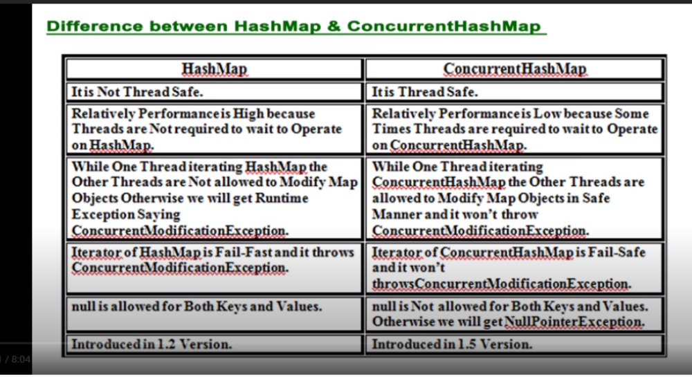

2.CopyOnWriteArrayList()
- it is the thread safe version of array list or concurrent version of array list
- it is available in java.utill.concurrent package
- it is child class of List interface
- for every write operation separate cloned copy will be created. in that clone copy write operation performed. after certain point both will synchronized automatically by JVM.
- if we are doing 1000 write operation then 1000 clone copy will be created, and performance will get impacted. hence it is not suitable if there is more write operation
- As update operation will be performed on cloned copy there is no effect for the threads which perform read operation
- it is costly to use because for every update operation cloned copy will be related. hence copyonwritearrayList is the best choice if several read operations and less number of write operations are required to perform.
- insertion order is preserved
- duplicates objects are allowed
- hetrogeeous objects are allowed
- null insertion is possible
- it implements seriallizable,clonable and RandomAcces interfaces.
- while one thread iterating CopyOnWriteArrayList, the other threads are allowed to modify and we won't get ConcurrentModificationException. that is iterator on CopyOnWriteArrayList is Fail Safe.
- Iterator of ArrayList can Perform Remove operation but iterator of CopyOnWriteArrayList can't perform remove operation. otherwise, will get RuntimeException saying UnsupportedOperationException

Constructors:
1.CopyOnWriteArrayList l = new CopyOnWriteArrayList();
2.CopyOnWriteArrayList l =new CopyOnWriteArrayList(Collection c) -- create cowl for any colelction object
3. CopyOnWriteArrayList l = new CopyOnWriteArrayList(Object[] a);-- create cowl for given object array.

Methods:
methods available to Collection, list availabel to this CopyOnWriteArrayList class.
1.boolean addIfAbsence(Object o) -- add object if it is not available
2. int addAllAbsence(Collection c) -- from colelction c add all the objects which are not present.

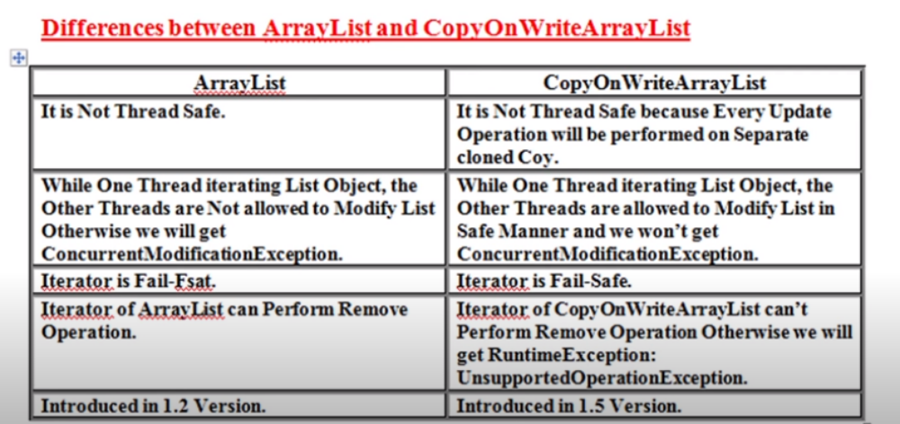

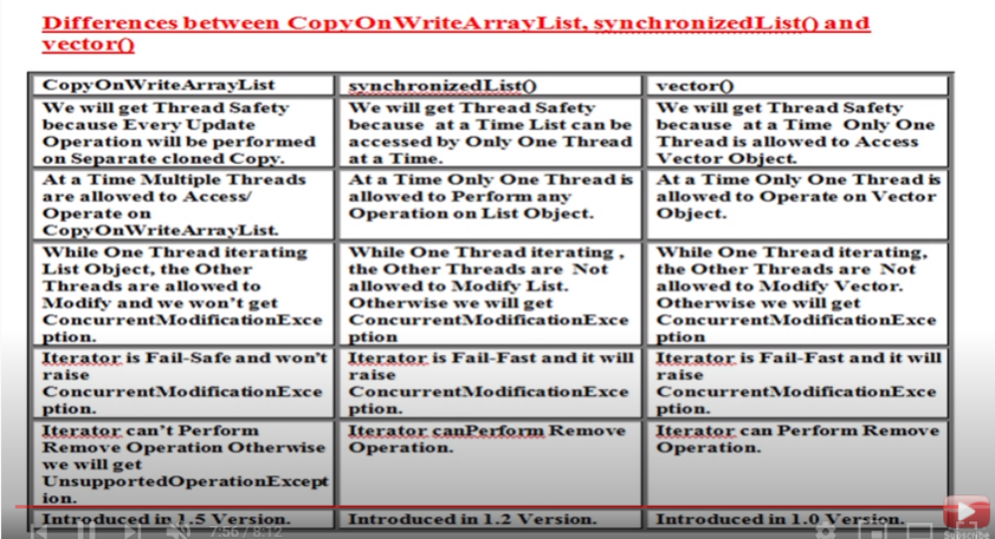

3.CopyOnWriteArraySet
- it is the thread safe verson of set.
- child class of set interface. present in java.utill.concurrent package
- internally it is using copyonwrite array list only
- insertion order is preserved
- Duplicates are not allowed . becuase it is Set
- multiple threads can able to perform read operation simultaneously but for every update operation a seperate cloned copy will be created.
- As of every update operation a seperate cloned copy will be created which is costly. hence if multiple update operation are required then it is not reommended to use copy on writeArray set
- while one thread iterating the set other threads are allowed to modify set and we wont get concurrentmodificationexception
- iteratoe of copyonwritearrayset can perform only read operation and wont't perform remove operation. otherwise we will get RE unsupportedOperationException

